

The International Committee on Taxonomy of Viruses
Taxonomy Proposal Form, 2026

Part 1a: Details of taxonomy proposals

Title: | Create one species in the genus Protoambidensovirus, family Parvoviridae.
Code assigned: | 2026.004D.N.v2.Protoambidensovirus_1nsp

Author(s), affiliation and email address(es):
Given name (+middle initial(s)) | Surname | Affiliation | Email address | Corr. author(s)
Zuwen | Chen | College of Biology and Agricultural Resources, Huanggang Normal University, Huanggang, China | zuwenchen@hgnu.edu.cn | X
Qian | Peng | College of Biology and Agricultural Resources, Huanggang Normal University, Huanggang, China | pq1210@hgnu.edu.cn
Part 1b: Taxonomy Proposal Submission
ICTV Subcommittee:
Animal DNA Viruses and Retroviruses |  | Bacterial viruses
Animal minus-strand and dsRNA viruses |  | Fungal and protist viruses
Animal positive-strand RNA viruses |  | Plant viruses
Archaeal viruses |  | General -

List the ICTV Study Group(s) that have seen or have been involved in creating this proposal:
N/A

Optional – complete only if formally voted on by an ICTV Study Group:
Study Group | Number of members
Study Group | Votes in support | Votes against | No vote

Submission date: | 12/08/2026

Part 1c: Feedback from ICTV Executive Committee (EC) meeting
Executive Committee Meeting Decision code: | X
A – Accept
Ac – Accept subject to revision by relevant subcommittee chair. No further vote required
U – Accept without revision but with re-evaluation and email vote by the EC
Uc – Accept subject to revision and re-evaluation and email vote by the EC
Ud – Deferred to the next EC meeting, with an invitation to revise based on EC comments
J - Reject
W - Withdrawn

Comments from the Executive Committee:

Part 1d: Revised Taxonomy Proposal Submission
Response of proposer:
Revision date: | 25/08/2026

Part 3: TAXONOMIC PROPOSAL
https://ictv.global/taxonomy/templates

Taxonomic changes proposed:
Establish new taxon |  | Split taxon
Abolish taxon |  | Merge taxon
Move taxon |  | Promote taxon
Rename taxon |  | Demote taxon
Move and rename

Etymology (origin) of proposed taxonomic names:
Taxon name | Etymology of the term
Protoambidensovirus lepidopteran2 | The first name, Protoambidensovirus, is the genus name, derived from the Greek protos (meaning "first" or "primitive"), the Latin “ambis” (meaning "both", alluding to the ambisense transcription strategy), and “densovirus” (from the Latin densus, meaning "dense" or "compact", referring to the densely packed virion arrays characteristic of infections by members of the subfamily Densovirinae). The second name, lepidoptera2, corresponds to the host order Lepidoptera (from the Greek lepis, meaning "scale", and pteron, meaning "wing"), with the progressive number 2 indicating its registration among lepidopteran viruses within the genus.

Permission for use of names derived from a living person:
Taxon name | Full name of person from whom the name is derived | Attached

Abstract of Taxonomy Proposal:
Description of current taxonomy:
The virus with genome accession PQ514133.1 (isolate Br, host Spodoptera frugiperda, Brazil, 2018) is currently listed in NCBI Taxonomy under the placeholder Protoambidensovirus incertum3 within the genus Protoambidensovirus, subfamily Densovirinae, family Parvoviridae.

Proposed taxonomic change(s):
Create a new species, Protoambidensovirus lepidopteran2, in the genus Protoambidensovirus. Designate the exemplar virus as Spodoptera frugiperda densovirus (SfDV). Reassign SfDV from the species Protoambidensovirus incertum3 to Protoambidensovirus lepidopteran2.

Demarcation criteria for new taxon/taxa:
SfDV encodes full NS1 (XJP19828.1) with SF3 helicase domain and complete VP1 (XJP19827.1), satisfying Parvoviridae coding requirements. Isolated from Spodoptera frugiperda (Lepidoptera) and verified by transcriptome and genome cloning, its host is unambiguous. Phylogenetic analyses of 75 species across six subfamilies and 30 genera, with bat viruses from three subfamilies as anchors, place SfDV within Protoambidensovirus; five Densovirinae bat viruses fall in four distinct genera, none in Protoambidensovirus, validating genus monophyly. NS1 and VP1 amino acid identities to P. incertum3 are 72.51% and 68.02%, below the species threshold.

Justification:
P. incertum3 is a ratified species for a Nigerian primate virus. SfDV, a lepidopteran virus, is erroneously mapped to P. incertum3 in NCBI, creating a host-taxonomy conflict. We propose P. lepidopteran2 to separate the lepidopteran SfDV from the primate P. incertum3, establish host-order nomenclature consistent with P. lepidopteran1 and P. dipteran1, preserve P. incertum3 for the primate virus, and provide a stable name for Spodoptera frugiperda densovirus research.

- Text of Taxonomy proposal:

Description of current taxonomy:
The genus Protoambidensovirus (subfamily Densovirinae, family Parvoviridae) currently includes two ratified species: Protoambidensovirus lepidopteran1 (exemplar: Galleria mellonella densovirus, L32896.1) and Protoambidensovirus dipteran1 (exemplar: Culex pipiens densovirus, FJ810126.1). The remaining entries are NCBI provisional placeholders (Protoambidensovirus incertum1, Protoambidensovirus incertum2, Protoambidensovirus incertum3, Protoambidensovirus incertum4, Protoambidensovirus incertum5).

The placeholder Protoambidensovirus incertum3 currently accommodates two distinct viruses: Ambidensovirus sp. (MN784124.1; NS1: QHN64367.1; VP1: QHN64368.1) and a densovirus from Spodoptera frugiperda (PQ514133.1; NS1: XJP19828.1; VP1: XJP19827.1). NS1 and VP1 phylogenies show that the “SfDV” and Ambidensovirus sp. form sister lineages (bootstrap 68 and 100, respectively). However, NS1 and VP1 amino acid similarities between the two viruses are only 72.51% and 68.02%, respectively. Their provisional grouping under P. incertum3 therefore lacks formal demarcation criteria.

Proposed taxonomic change(s):
We propose the species “Protoambidensovirus lepidopteran2” in the genus “Protoambidensovirus”, subfamily “Densovirinae”, family “Parvoviridae”. We designated the exemplar virus as “Spodoptera frugiperda densovirus” (“SfDV”, isolate Br, 2018; genome PQ514133.1; NS1 XJP19828.1; VP1 XJP19827.1).

Currently, “SfDV” (PQ514133.1) is provisionally mapped to P. incertum3 alongside Ambidensovirus sp. (MN784124.1). Phylogenetic analyses based on NS1 (bootstrap 68) and VP1 (bootstrap 100) sequences demonstrate robust sister-group clustering between the two viruses. Nevertheless, the NS1 amino acid sequence of “SfDV” (XJP19828.1) shares 72.51% identity with that of Ambidensovirus sp. (QHN64367.1), and the VP1 amino acid sequence (XJP19827.1) shares 68.02% identity with that of Ambidensovirus sp. (QHN64368.1), satisfying the species demarcation threshold for the genus. Upon ratification, “SfDV” will be reassigned from P. incertum3 to “P. lepidopteran2”; the remaining viruses in P. incertum3 await future resolution. The species name reflects the host order Lepidoptera, consistent with P. lepidopteran1 and P. dipteran1.

Demarcation criteria for new taxon/taxa:
The species demarcation criteria for genus “Protoambidensovirus” integrate the family “Parvoviridae” definition with genus-specific phylogenetic, genetic, and biological thresholds. A candidate virus is recognized as a distinct species in this genus if it meets the following requirements:

(1) Genomic integrity and coding capacity. The genome must contain the complete coding region of the large nonstructural protein (NS1) with an SF3 helicase domain, as well as the complete viral structural protein (VP) coding regions. The exemplar virus of the proposed species, “Spodoptera frugiperda densovirus” (“SfDV”; genome PQ514133.1, 5,413 bp), encodes a full-length NS1 (XJP19828.1) containing the SF3 helicase domain and a complete VP1 (XJP19827.1), satisfying the family-level definition. The near-complete congruence between the NS1 and VP1 phylogenies—with the sole exception of Protohepanvirus decapod1, which is misplaced in the VP1 tree due to sequence incompleteness—further confirms that the “SfDV” sequences are complete and phylogenetically informative.

(2) Authentic biological source and unambiguous host identity. The viral sequence must be derived from host tissues, secretions, or excretions, and the host must be unequivocally identified; otherwise, the species epithet must indicate “incertum”. “SfDV” was isolated from Spodoptera frugiperda (Lepidoptera: Noctuidae) larval tissues, reported in peer-reviewed literature, and independently verified in our laboratory through transcriptome sequencing (https://dataview.ncbi.nlm.nih.gov/object/PRJNA1441772?reviewer=6dnri829tbprps26vd06681qps) and full-genome cloning. The host is unequivocally established, precluding the need for an “incertum” designation.

(3) Phylogenetic placement and monophyly within the genus. The candidate must cluster within the Protoambidensovirus clade in robust phylogenies of the family Parvoviridae. We conducted maximum-likelihood analyses of 75 species across six subfamilies and 30 genera, incorporating bat-associated viruses from three subfamilies as phylogenetic anchors with established taxonomic positions. In the NS1 tree and VP1 tree, “Protoambidensovirus lepidopteran2” consistently groups within Protoambidensovirus. In the VP1 tree, “Protoambidensovirus lepidopteran2” and P. incertum3 form a sister lineage with 100% bootstrap support; the NS1 tree yields a congruent topology with 68% bootstrap support. The five bat-related viruses in subfamily Densovirinae are distributed across four distinct genera (all designated incertum), and none fall within Protoambidensovirus. The inclusion of these cross-subfamily bat sequences serves as an external calibration that confirms SfDV belongs to Protoambidensovirus rather than to any bat-containing or adjacent lineage, ruling out long-branch attraction or misplacement, and validates that the genus remains monophyletic within the broader family framework.

(4) Amino acid divergence threshold. The candidate must exhibit sequence divergence from its closest congeneric relative sufficient to warrant species-level separation. The NS1 amino acid sequence of “SfDV” (XJP19828.1) shares 72.51% identity with that of Ambidensovirus sp. currently assigned to the provisional species P. incertum3, and the VP1 amino acid sequence shares 68.02% identity with that of Ambidensovirus sp. (QHN64368.1). These values fall below the accepted species demarcation boundary for parvoviruses, supporting distinct species status.

(5) Host-order demarcation and ecological niche. The candidate virus must demonstrate a host association that supports its distinction from established congeneric species. “Protoambidensovirus lepidopteran2” is associated with Lepidoptera, consistent with P. lepidopteran1 (host: Galleria mellonella), whereas P. dipteran1 infects Diptera and P. incertum3 is associated with Primates. The pronounced host-order divergence between “Protoambidensovirus lepidopteran2” and P. incertum3 (Lepidoptera vs. Primates), corroborated by the phylogenetic separation from all bat-related parvoviruses in the family (which are distributed across three subfamilies and multiple genera, with none residing in Protoambidensovirus), reinforces the biological distinctness of “Protoambidensovirus lepidopteran2” at the species level.

Justification:
The current situation presents a taxonomic conflict that demands resolution. Protoambidensovirus incertum3 is an ICTV-ratified species whose exemplar virus, Ambidensovirus sp. strain NGR_2017_NHP_ADV (MN784124.1), was identified in Nigerian non-human primates. However, “SfDV” (PQ514133.1) is currently mapped to P. incertum3 in NCBI records, despite deriving from a lepidopteran host and sharing only 72.51% (NS1) and 68.02% (VP1) amino acid identity with the true P. incertum3 exemplar. This conflation of a primate virus and an insect virus under a single species name is biologically and taxonomically untenable.

We propose “Protoambidensovirus lepidopteran2” to: (i) resolve the host-taxonomy mismatch by formally separating the lepidopteran “SfDV” from Ambidensovirus sp. Of the primate P. incertum3, eliminating the current NCBI-ICTV discrepancy; (ii) establish a host-order-reflective nomenclature for a virus with confirmed S. frugiperda identity, paralleling P. lepidopteran1 and P. dipteran1; (iii) preserve the integrity of P. incertum3 as the legitimate species for the Nigerian primate virus; (iv) anchor the phylogenetic position of “P. lepidopteran2” within a robust family-wide framework that includes 75 species across six subfamilies and 30 genera, incorporating bat-associated viruses from three subfamilies as phylogenetic anchors—these bat sequences confirm that Protoambidensovirus remains monophyletic and distinct from all bat-related lineages in Densovirinae (which are distributed across four separate genera), thereby validating the genus boundary and the correct placement of “SfDV”; and (v) provide a definitive ICTV-endorsed name for “SfDV” to support ongoing research on “SfDV” pathogenesis, epidemiology, and biocontrol applications. This change replaces the erroneous incertum3 assignment with a biologically accurate and nomenclaturally consistent species name.

References:
[1] da Silva LA, de Camargo BR, Fisch AAFMS, Santos B, Ardisson-Araújo DMP, Ribeiro BM. Identification and detection of known and new viruses in larvae of laboratory-reared fall armyworm, Spodoptera frugiperda. J Invertebr Pathol. 2025. doi: 10.1016/j.jip.2025.108290.
[2] Zhang Y, Fan B, Gao Y, Yang J, Zhang W, Su S, Li L, Li H, Luo Z, Tang G, Wang C, Zhang X, Liu H, Gan J. Structural and functional studies of the main replication protein NS1 of human parvovirus B19. Nucleic Acids Res. 2025. 53(12). doi: 10.1093/nar/gkaf562.

Accompanying files:
Filename | Description of contents

Tables, Figures:

Figure 1. Ambisense genome organization of Spodoptera frugiperda densovirus (SfDV).
The linear single-stranded DNA genome (5413 kb) is organized in an ambisense configuration, flanked by terminal hairpin structures. The 5′-half of one strand encodes three non-structural proteins (NS1–NS3), while the 5′-end of the complementary (minus) strand contains ORF4, from which four viral structural proteins (VP1–VP4) are expressed via leaky scanning. The exemplar genome is represented by GenBank accession [PQ514133.1]. This architecture is characteristic of the genus Protoambidensovirus within the subfamily Densovirinae.

Figure 2. Construction strategy of SfDV infectious clone. (A) Results of PCR amplification of three segments of SfDV genome and linearized pBR322 vector. (B) Confirmation of the recombinant plasmid by digestion with EcoRI and SacI. (C) The plasmid map of the infectious clone pSfDV. (under publication)

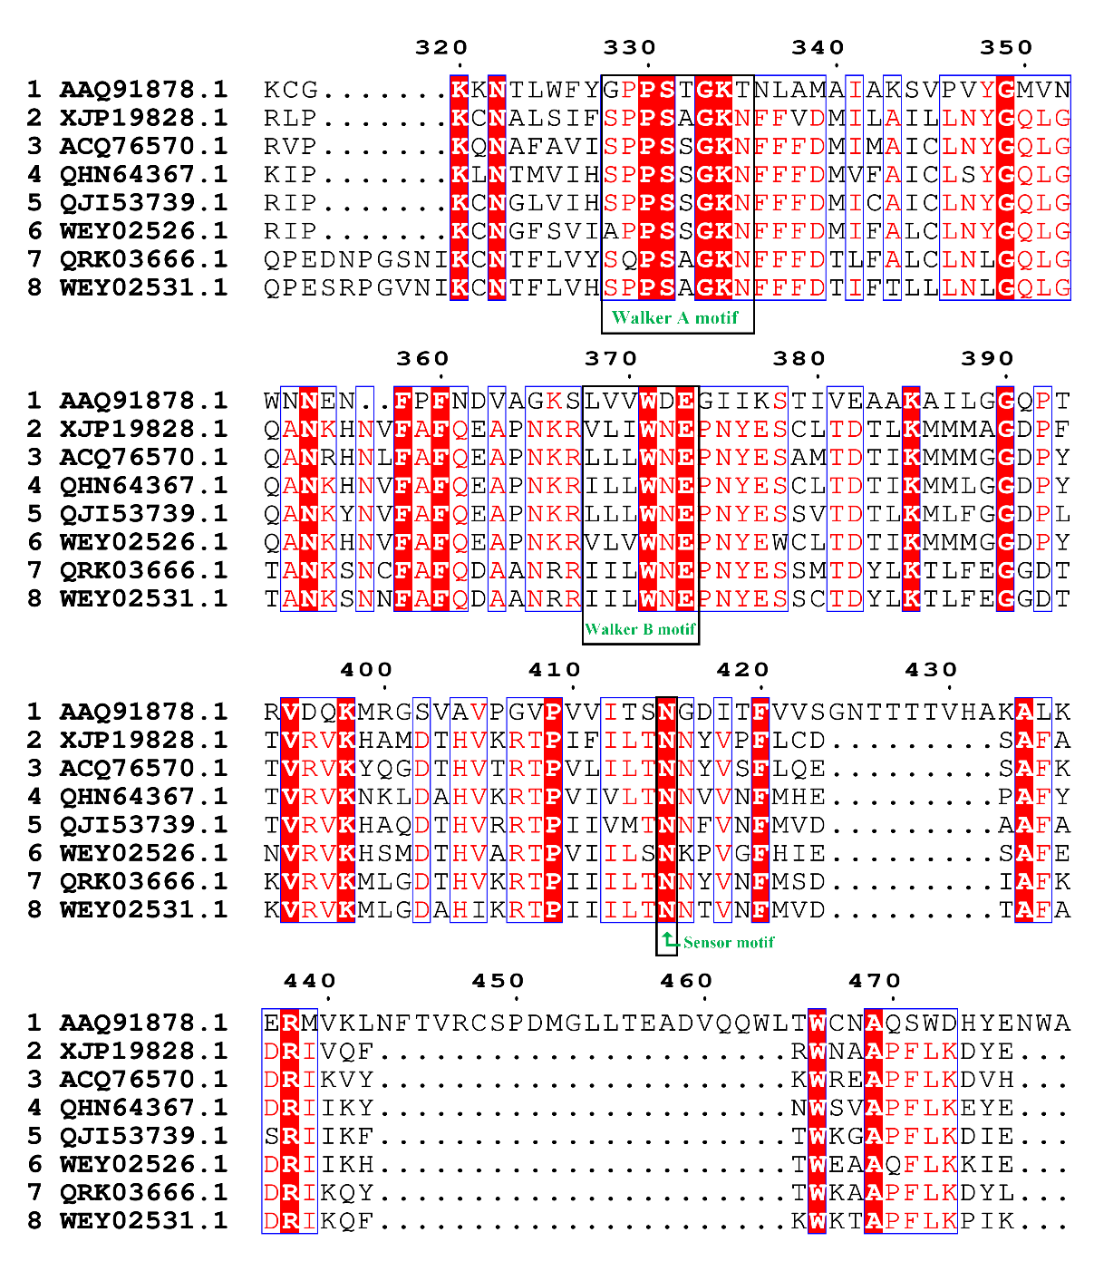
Figure 3. Sequence alignment of SF3 helicase domains in NS1 from human parvovirus B19 (Erythroparvovirus primate1) and exemplar viruses of selected Protoambidensovirus species.

Note: human parvovirus B19 (NS1: AAQ91878.1); Spodoptera frugiperda densovirus (NS1: XJP19828.1); Culex pipiens densovirus(NS1: ACQ76570.1); Ambidensovirus sp.(NS1: QHN64367.1); Densovirinae sp.(NS1: QJI53739.1); ParvoviridaeDogfe426C1(NS1: WEY02526.1); duck-associated ambidensovirus 1(NS1: QRK03666.1); ParvoviridaeDogfe420C1(NS1: WEY02531.1).

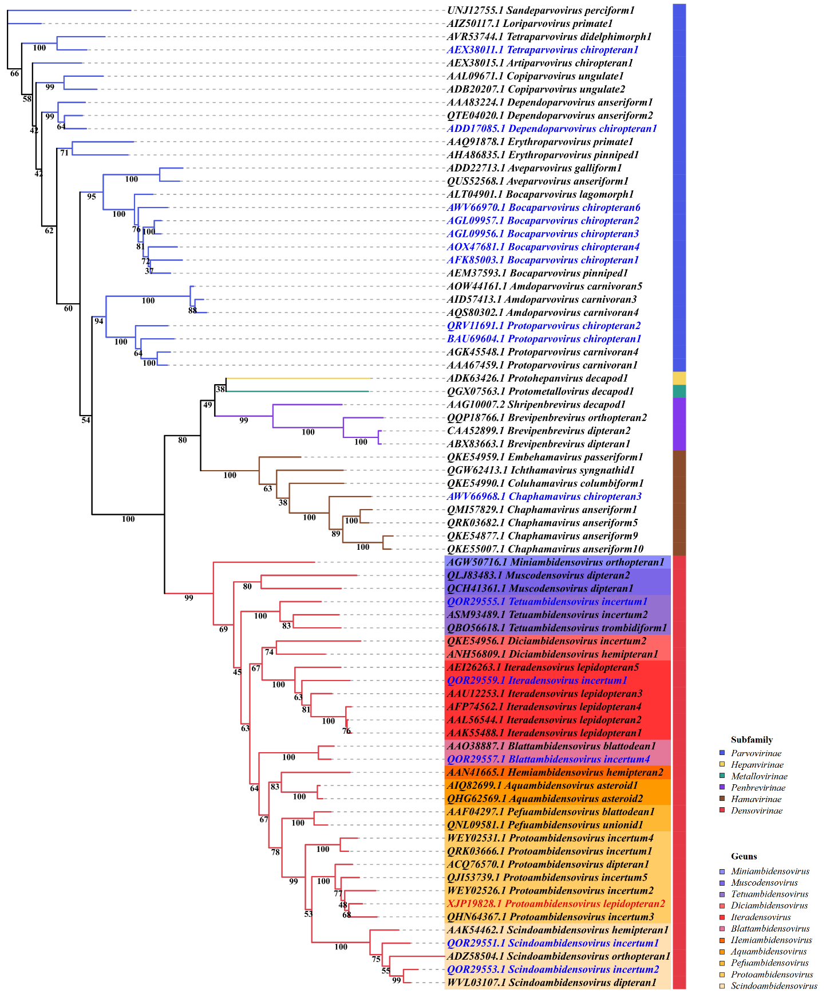

Figure 4. Maximum-likelihood phylogeny of the family Parvoviridae based on NS1 amino acid sequences.
The tree was reconstructed from an alignment of NS1 amino acid sequences sampled across the family Parvoviridae with 75 representatives. The proposed species Protoambidensovirus lepidopteran2 (SfDV) is shown in red, and bat-related virus species are shown in blue.

Table 1. Pairwise amino acid sequence identity matrix for the NS1 protein of members of the genus Protoambidensovirus

 | NS1 AA similarity | XJP19828.1 | QHN64367.1 | WEY02526.1 | QJI53739.1 | ACQ76570.1 | QRK03666.1 | WEY02531.1
Protoambidensovirus lepidopteran2 | XJP19828.1 | 100
Protoambidensovirus incertum3 | QHN64367.1 | 72.51 | 100
Protoambidensovirus incertum2 | WEY02526.1 | 54.19 | 49.01 | 100
Protoambidensovirus incertum5 | QJI53739.1 | 66.15 | 64.85 | 51.48 | 100
Protoambidensovirus dipteran1 | ACQ76570.1 | 69.49 | 65.82 | 47.38 | 69.63 | 100
Protoambidensovirus incertum1 | QRK03666.1 | 53.27 | 51.95 | 40.43 | 52.29 | 49.49 | 100
Protoambidensovirus incertum4 | WEY02531.1 | 51.8 | 53.46 | 44.52 | 52.67 | 50.86 | 78.18 | 100

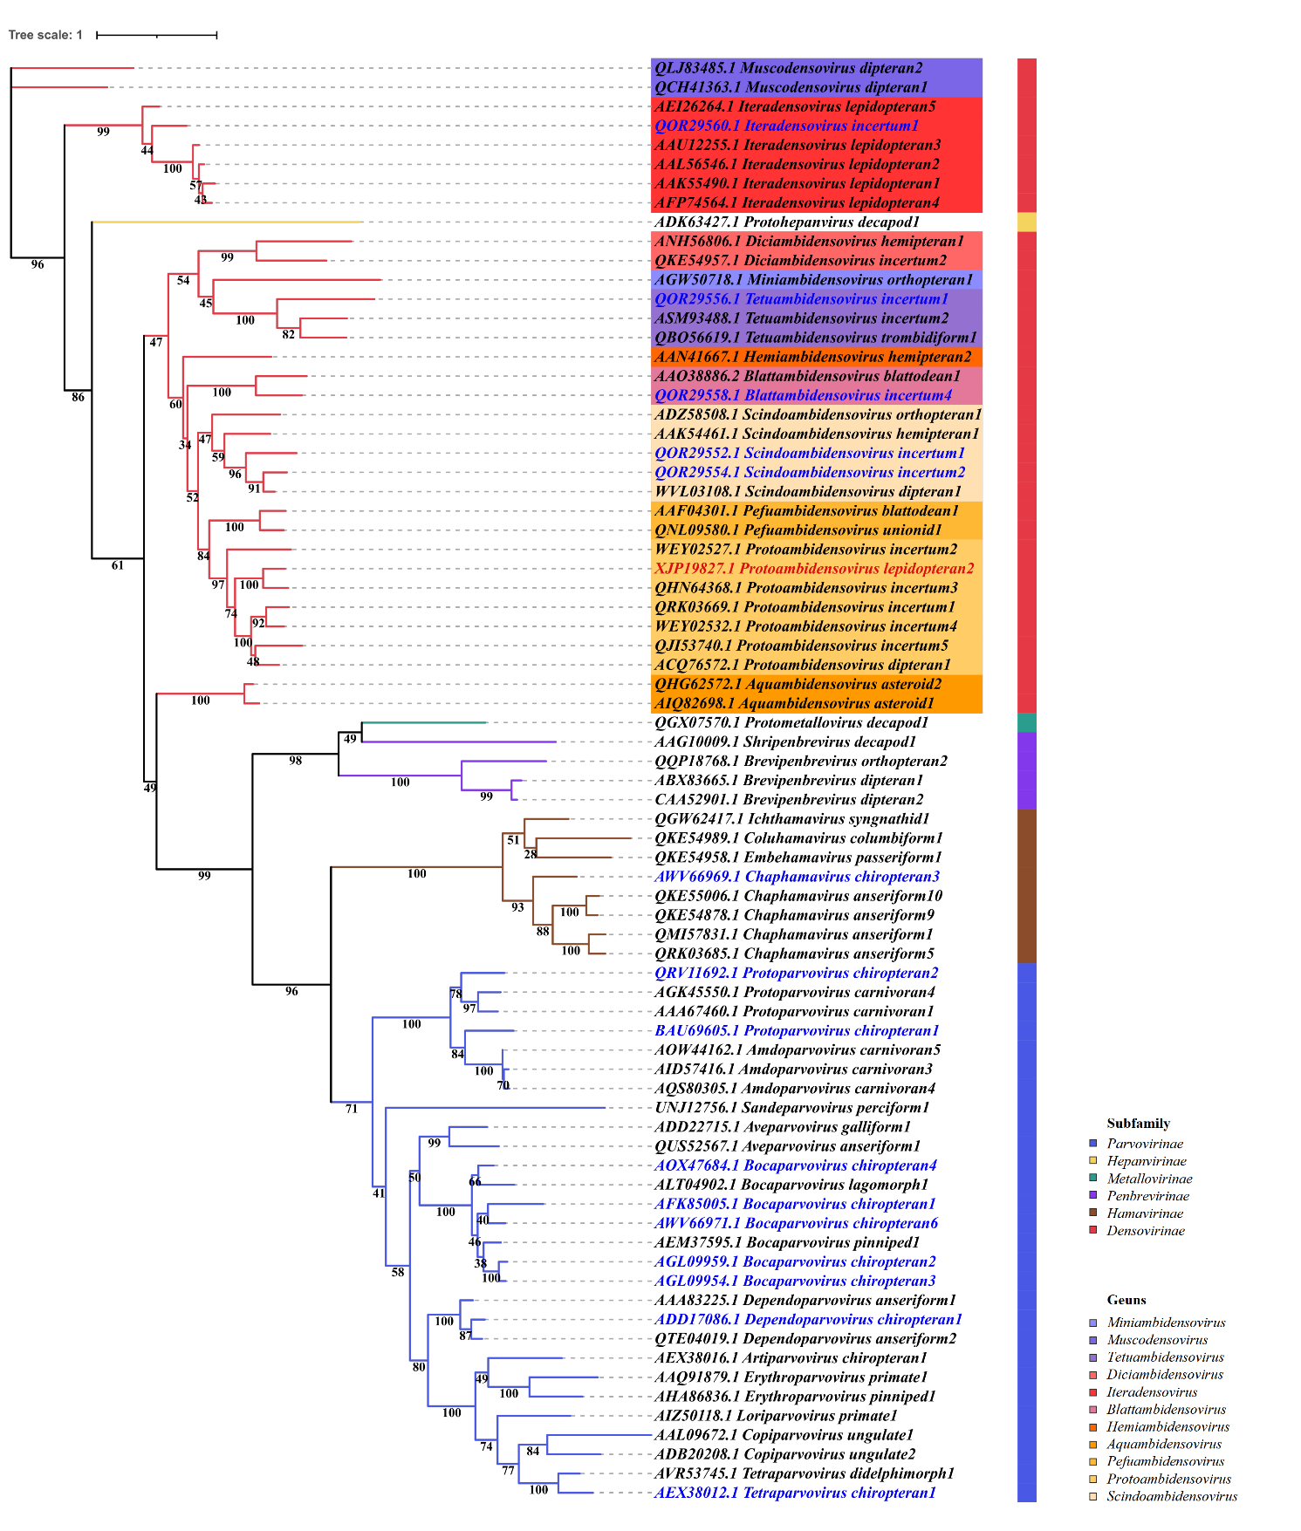Figure 5. Maximum-likelihood phylogeny of the family Parvoviridae based on VP1 amino acid sequences.
The tree was reconstructed from an alignment of VP1 amino acid sequences sampled across the family Parvoviridae with 75 representatives. The proposed species Protoambidensovirus lepidopteran2 (SfDV) is shown in red, and bat-related virus species are shown in blue.
Table 2. Pairwise amino acid sequence identity matrix for the VP1 protein of members of the genus Protoambidensovirus

 | VP1 AA similarity | XJP19827.1 | XJP19827.1 | XJP19827.1 | XJP19827.1 | XJP19827.1 | XJP19827.1 | XJP19827.1
Protoambidensovirus lepidopteran2 | XJP19827.1 | 100
Protoambidensovirus incertum3 | QHN64368.1 | 68.02 | 100
Protoambidensovirus incertum2 | WEY02527.1 | 33.96 | 32.53 | 100
Protoambidensovirus incertum5 | QJI53740.1 | 34.44 | 34.77 | 49.83 | 100
Protoambidensovirus dipteran1 | ACQ76572.1 | 46.43 | 46.17 | 37.91 | 46.28 | 100
Protoambidensovirus incertum1 | QRK03669.1 | 43.13 | 42.92 | 38.17 | 48.04 | 46.83 | 100
Protoambidensovirus incertum4 | WEY02532.1 | 44.02 | 42.68 | 40.68 | 45.01 | 47.5 | 66.33 | 100

