

The International Committee on Taxonomy of Viruses
Taxonomy Proposal Form, 2026

Part 1a: Details of taxonomy proposals

Title: | Establishing the family “Mininucleoviridae” and species for viruses found only in crustacean hosts
Code assigned: | 2026.006D.N.v1.Mininucleoviridae_1nf_1ng_3nsp

Author(s), affiliation and email address(es):
Given name (+middle initial(s)) | Surname | Affiliation | Email address | Corr. author(s)
Jamie | Bojko | National Horizons Centre, Teesside University, Darlington, UK | J.Bojko@tees.ac.uk | X
Donald | Behringer | School of forest resources and geomatic, University of Florida, Gainesville, FL, USA | behringer@ufl.edu

Part 1b: Taxonomy Proposal Submission
ICTV Subcommittee:
Animal DNA Viruses and Retroviruses | x | Bacterial viruses
Animal minus-strand and dsRNA viruses |  | Fungal and protist viruses
Animal positive-strand RNA viruses |  | Plant viruses
Archaeal viruses |  | General -

List the ICTV Study Group(s) that have seen or have been involved in creating this proposal:
Animal DNA Viruses and Retroviruses

Optional – complete only if formally voted on by an ICTV Study Group:
Study Group | Number of members
Study Group | Votes in support | Votes against | No vote

Submission date: | 26/07/2026

Part 1c: Feedback from ICTV Executive Committee (EC) meeting
Executive Committee Meeting Decision code: | X
A – Accept
Ac – Accept subject to revision by relevant subcommittee chair. No further vote required
U – Accept without revision but with re-evaluation and email vote by the EC
Uc – Accept subject to revision and re-evaluation and email vote by the EC
Ud – Deferred to the next EC meeting, with an invitation to revise based on EC comments
J - Reject
W - Withdrawn

Comments from the Executive Committee:

Part 1d: Revised Taxonomy Proposal Submission
Response of proposer:
Revision date:

Part 3: TAXONOMIC PROPOSAL
https://ictv.global/taxonomy/templates

Taxonomic changes proposed:
Establish new taxon | x | Split taxon
Abolish taxon |  | Merge taxon
Move taxon |  | Promote taxon
Rename taxon |  | Demote taxon
Move and rename

Etymology (origin) of proposed taxonomic names:
Taxon name | Etymology of the term
Mininucleoviridae | Named due to the small genomes and virion size relative to other members of the order Pimascovirales
Alphamininucleovirus | Referring to the first genus in this new viral family
Alphamininucleovirus dikhaemobaphidis | Species name derived from the host species, Dikerogammarus haemobaphes
Alphamininucleovirus carmaneas | Species name derived from the host species, Carcinus maenas
Alphamininucleovirus pavonealbus | pavonealbus is based on the original virus Panulirus argus Virus 1 (PaV1) that was found in 2004, followed by ‘albus’, referring to the white colour of the haemolymph when the lobster host is infected.

Permission for use of names derived from a living person:
Taxon name | Full name of person from whom the name is derived | Attached

Abstract of Taxonomy Proposal:
Description of current taxonomy:
Currently, the mininucleoviruses of crustaceans are not formally classified, but appear to phylogenetically group as a sister to the members of the families Iridoviridae and Ascoviridae. These formal families are included in the formal order, Pimascovirales.

Proposed taxonomic change(s):
We propose to formalize the family, Mininucleoviridae, which was first coined by Subramaniam et al. (2020). This new family contains a single genus – Alphamininucleovirus, which contains three newly designated species, which are based on complete viral genomes with accompanying morphological and pathological information.

Demarcation criteria for new taxon/taxa:
Four taxa are known of that could be included in the new viral family; however, only three have complete genomes available to support formalization. Inclusion in the Mininucleoviridae family and Alphamininucleovirus genus should be supported by phylogenetic clustering with emphasis on the PaV1 isolate. Using protein similarity as a basis for intra-familial demarcation, we suggest that a minimum protein similarity for the most conserved protein sequence (RPB2) be set at 40%. Inclusion in the three designated species (Alphamininucleovirus pavonealbus, Alphamininucleovirus carmaneas, Alphamininucleovirus dikhaemobaphidis) should be based on 90% protein similarity when comparing the RPB2.

Justification:
The new viruses (PaV1, CmV1, DhV1) have genome sizes of 70,886 bp, 73,581 bp, and 66,929 bp, with 61, 61, and 62 predicted protein-coding genes, respectively (Fig. 1). Figures presented in Subramaniam et al. (2020) represent the support of a new family, genus, and three species, highlighting an initial understanding of their phylogenetic position, gene synteny, and genome size relative to other members of the Nucleocytoviricota. Using the conserved DNA-dependent RNA polymerase subunit RPB2, a sequence similarity plot highlights the difference between the four known viruses (Fig. 2), with the fourth mined from a transcriptomic dataset derived from Gammarus lacustris, and is termed ‘Gammarus lacustris mininucleovirus 1’ (GlV1). This virus is incomplete and not included for formalization, but we have included it in the analysis for clarity. The original phylogenetic tree and caption are available in the Figure 3, from the open access publication (Subramaniam et al. 2020).

Text of Taxonomy proposal:
Description of current taxonomy:
Currently, the mininucleoviruses of crustaceans are not formally housed in the ICTV taxonomy, but appear to phylogenetically group as a sister family to the Iridoviridae, Ascoviridae and Marseilleviridae. These formal families are included in the formalised order, Pimascovirales. Three viral isolates have complete genomic data available (Subramaniam et al. 2020) and a fourth isolate has been defined using transcriptomic data (Burgess and Bojko, 2024), but is not considered for formalization in this report.

Proposed taxonomic change(s):
We propose to formalize the family, Mininucleoviridae, which was first coined by Subramaniam et al. (2020). This new family contains a single genus – Alphamininucleovirus, which contains three newly designated species (Alphamininucleovirus pavonealbus, Alphamininucleovirus carmaneas, Alphamininucleovirus dikhaemobaphidis), based on complete viral genomes with accompanying morphological and pathological information. This family is phylogenetically positioned within the order, Pimascovirales, alongside the families: Iridoviridae, Ascoviridae and Marseilleviridae. Please see attached excel sheet for further taxonomic detail.

The representative genus and species for the new family (Mininucleoviridae) will be Alphamininucleovirus, and Alphamininucleovirus pavonealbus (Genome: MN604017.1), respectively.

Demarcation criteria for new taxon/taxa:
Four taxa are known of that could be included in the new viral family; however, only three have complete genomes available to support formalization. Inclusion in the Mininucleoviridae family and Alphamininucleovirus genus should be supported by phylogenetic clustering with emphasis and primary representation based on the PaV1 isolate. Using protein similarity as a basis for intra-familial demarcation, we suggest that a minimum protein similarity for the most conserved protein sequence (RPB2) be set at 40%. Inclusion of any new isolate within the three designated species (Alphamininucleovirus pavonealbus, Alphamininucleovirus carmaneas, Alphamininucleovirus dikhaemobaphidis) should be based on >90% protein similarity when comparing the RPB2.

Justification:
Crustaceans are economically and ecologically valuable organisms. Mass mortalities and ongoing issues in the culture of crustaceans led to a greater effort to understand underlying viral communities that might drive mortality and reduced growth. Initial research into the spiny lobster, Panulirus argus, revealed a novel virus-like entity driving an intranuclear pathology in haemocytes that resulted in white haemolymph (Shields and Behringer, 2004). Shields and Behringer (2004) identified the virus based on its morphology, providing the first visual confirmation of the virus using Transmission Electron Microscopy. In later years, two further viruses with similar haemocyte infections were reported from the amphipod Dikerogammarus haemobaphes and the crab, Carcinus maenas, both from UK populations (Bojko et al. 2019; summarized in Bateman, 2021). Subramaniam et al. (2020) provided the first genome-level assemblies of these three viruses – Panulirus argus virus 1 (PaV1), Dikerogammarus haemobaphes virus 1 (DhV1), and carcinus maenas virus 1 (CmV1) have genomes of 70,886 bp, 73,581 bp, and 66,929 bp, with 61, 61, and 62 predicted protein-coding genes. The genome sequences of PaV1, CmV1, and DhV1were deposited under accession numbers: MN604017, MN604015, and MN604016, respectively. Most recently, transcriptomic evidence of a fourth mininucleovirus was published (Burgess and Bojko, 2024), and more a likely to be identified as metagenomic screening datasets become more common. Phylogenetic information provided in Burgess and Bojko (2024) suggest that mininucleoviruses from amphipod hosts group together, and that mininucleoviruses from decapod hosts group together; however, the sample sizes at this time are too small to suggest separate genera.

The Mininucleoviridae family currently has three prospective viral species to base its foundation upon, and a forth informal species derived from transcriptomic data. The justification for the 40% cut off for inclusion in the Mininucleoviridae family and Alphamininucleovirus genus, relates to the lowest (40.55%) similarity observed, specifically between the CmV1 RPB2 and GlM1 RPB2 proteins (Fig. 2).

References:
Bateman, K. S. (2021). Viruses affecting crustaceans. Studies in viral ecology, 305-340.

Bojko, J., Stentiford, G. D., Stebbing, P. D., Hassall, C., Deacon, A., Cargill, B., ... & Dunn, A. M. (2019). Pathogens of Dikerogammarus haemobaphes regulate host activity and survival, but also threaten native amphipod populations in the UK. Diseases of Aquatic Organisms, 136(1), 63-78.

Burgess, A., & Bojko, J. (2024). Transcriptomic evidence of a fourth mininucleovirus (Mininucleoviridae): A rapidly growing family among the Nucleo-Cytoplasmic Large DNA viruses (NCLDVs). Journal of Invertebrate Pathology, 204, 108096.

Shields, J. D., & Behringer Jr, D. C. (2004). A new pathogenic virus in the Caribbean spiny lobster Panulirus argus from the Florida Keys. Diseases of aquatic organisms, 59(2), 109-118.

Subramaniam, K., Behringer, D. C., Bojko, J., Yutin, N., Clark, A. S., Bateman, K. S., ... & Waltzek, T. B. (2020). A new family of DNA viruses causing disease in crustaceans from diverse aquatic biomes. MBio, 11(1), 10-1128.

Accompanying files:
Filename | Description of contents

Tables, Figures:

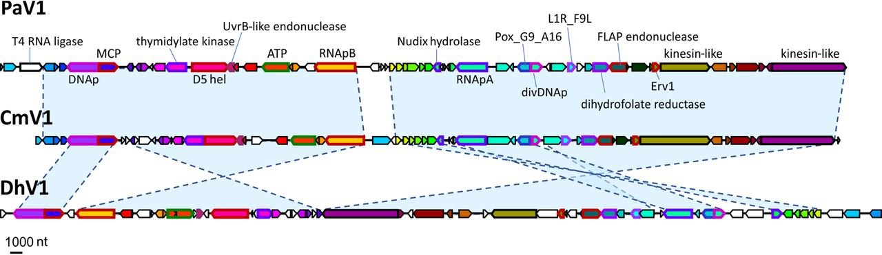

Figure 1. The gene synteny plot originally presented in the open access Subramaniam et al. (2020), with the caption: “Genome maps of the crustacean viruses PaV1 (Panulirus argus virus 1), DhV1 (Dikerogammarus haemobaphes virus 1), and CmV1 (Carcinus maenas virus 1). Predicted orthologous genes are marked with the same colors. nt, nucleotides. Gene abbreviations: DNAp, family B DNA polymerase; MCP, major capsid protein; D5 hel, D5-like primase-helicase; ATP, packaging ATPase; RNApB, DNA-dependent RNA polymerase subunit RPB2; RNApA, DNA-dependent RNA polymerase subunit RPB1; Pox_G9-A16, poxvirus entry-fusion complex G9-A16; divDNAp, divergent family B DNA polymerase; L1R_F9L, lipid membrane protein of large eukaryotic DNA viruses; Erv1, sulfhydryl/thiol oxidoreductase (ERV1/ALR/poxvirus E10 family).”

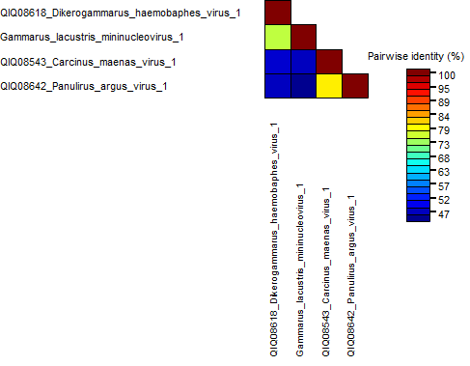

Figure 2. Sequence demarcation heat plot, highlighting the protein similarity for the most conserved protein (DNA-dependent RNA polymerase subunit RPB2) among the four viruses.

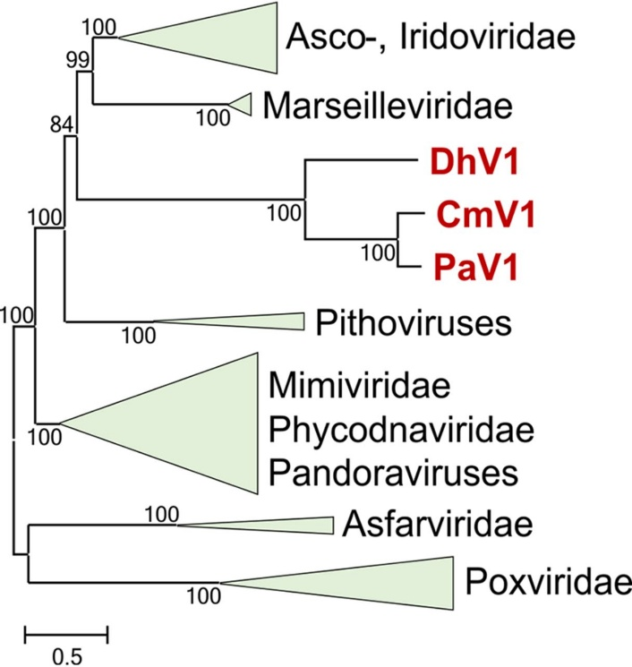

Figure 3. A phylogenetic tree initially presented in the open access Subramaniam et al. (2020) to display the branching position of the Mininucleoviridae group and its three members. The original text for the figure is here: “Phylogenetic tree of nucleocytoplasmic large DNA viruses (NCLDVs). The maximum likelihood (ML) tree depicting the relationship of the viruses PaV1, DhV1, and CmV1 to the rest of the NCLDVs is based on the concatenated amino acid sequence alignments of three core genes (major capsid protein, DNA polymerase, and primase-helicase). The bootstrap values are indicated at each node, and the branch lengths reflect the number of inferred substitutions, as indicated by the bar. Virus abbreviations: PaV1, Panulirus argus virus 1; DhV1, Dikerogammarus haemobaphes virus 1; CmV1, Carcinus maenas virus 1.” – Subramaniam et al. (2020)

