

The International Committee on Taxonomy of Viruses
Taxonomy Proposal Form, 2026

Part 1a: Details of taxonomy proposals

Title: | Create 1 new order, 1 new family, 1 new genus and 3 new species in the class Pharingeaviricetes (Polisuviricotina)
Code assigned: | 2026.007D.N.v1.Fictadevirales_1norder_1nfam_1ng_3ns

Author(s), affiliation and email address(es):
Given name (+middle initial(s)) | Surname | Affiliation | Email address | Corr. author(s)
Balázs | Harrach | HUN-REN Veterinary Medical Research Institute, Budapest, Hungary | harrach.balazs@vmri.hu | X
Thomas S. | Postler | Vaccine Design and Development Lab, IAVI, Jersey City, NJ, USA | TPostler@iavi.org
Mart | Krupovic | Institut Pasteur, Université Paris Cité, Cell Biology and Virology of Archaea Unit, Paris, France | mart.krupovic@pasteur.fr

Part 1b: Taxonomy Proposal Submission
ICTV Subcommittee:
Animal DNA Viruses and Retroviruses | X | Bacterial viruses
Animal minus-strand and dsRNA viruses |  | Fungal and protist viruses
Animal positive-strand RNA viruses |  | Plant viruses
Archaeal viruses |  | General -

List the ICTV Study Group(s) that have seen or have been involved in creating this proposal:
Adenoviridae Study Group

Optional – complete only if formally voted on by an ICTV Study Group:
Study Group | Number of members
Study Group | Votes in support | Votes against | No vote

Submission date: | 14/08/2026

Part 1c: Feedback from ICTV Executive Committee (EC) meeting
Executive Committee Meeting Decision code: | X
A – Accept
Ac – Accept subject to revision by relevant subcommittee chair. No further vote required
U – Accept without revision but with re-evaluation and email vote by the EC
Uc – Accept subject to revision and re-evaluation and email vote by the EC
Ud – Deferred to the next EC meeting, with an invitation to revise based on EC comments
J - Reject
W - Withdrawn

Comments from the Executive Committee:

Part 1d: Revised Taxonomy Proposal Submission
Response of proposer:
Revision date:

Part 3: TAXONOMIC PROPOSAL
https://ictv.global/taxonomy/templates

Taxonomic changes proposed:
Establish new taxon | X | Split taxon
Abolish taxon |  | Merge taxon
Move taxon |  | Promote taxon
Rename taxon |  | Demote taxon
Move and rename

Etymology (origin) of proposed taxonomic names:
Taxon name | Etymology of the term
“Fictadevirales” | after the Latin fictus, meaning "fake", and adenoviruses (i.e., fake adenoviruses) but in a cryptic form, so that it does not have obvious ties specifically to Adenoviridae
“Paradenoviridae” | after the virus family Adenoviridae, referring to a similar but still distinct virus clade
“Aradnavirus” | after the Greek ἀράχνη (arachne), meaning spider, and desoxyribonucleic acid, to indicate that these are DNA viruses that infect spiders
“Aradnavirus aranei“ | after the Latin araneum, meaning "spider web" (referring to host Anelosimus studiosus, tangle-web spider)
“Aradnavirus acanthizae” | after the genus name of the bird from which a feces sample containing the virus was collected: Acanthiza uropygialis (a thornbill species, Passeriformes)
“Aradnavirus flavi“ | After the Latin flavus, meaning “yellow” (referring to the English name of the fish from which a gut sample contained the virus, yellow catfish (Tachysurus fulvidraco))

Permission for use of names derived from a living person:
Taxon name | Full name of person from whom the name is derived | Attached

Abstract of Taxonomy Proposal:
Description of current taxonomy:
The class Pharingeaviricetes comprises 1 order (Rowavirales) and 1 family (Adenoviridae).

Proposed taxonomic change(s):
Adding 1 new order, 1 new family, 1 new genus and 3 new species in the class Pharingeaviricetes (subphylum Polisuviricotina).

Demarcation criteria for new taxon/taxa:
Family demarcation (both of the following characteristics):
- phylogenetic distance (>70% polymerase protein sequence divergence),
- genome organization.

Species demarcation (at least two of the following characteristics):
- phylogenetic distance (>10–15%, based on maximum likelihood analysis of the DNA polymerase amino acid sequences),
- genome organization (characteristically in the terminal regions),
- host range,
- nucleotide composition.

Justification:
Four highly similar unclassified virus sequences can be found in GenBank: 2 from spiders, 1 from bird feces and 1 from fish gut. Two are described as adenoviruses, 1 as “midsize eukaryotic linear dsDNA (MELD) virus”, and 1 as Cetobacterium. They show some similarity to adenoviruses, but they are clearly not adenoviruses nor a bacterium, and MELD viruses need a proper classification, too. They merit the establishment of a new family and a new order based on phylogenetic calculations, special genome order and the supposed host range including spiders.

Text of Taxonomy proposal:
Description of current taxonomy:
The class Pharingeaviricetes comprises 1 order (Rowavirales) and 1 family (Adenoviridae) (Fig. 1).

Proposed taxonomic change(s):
Adding 1 new order, 1 new family, 1 new genus and 3 new species in the class Pharingeaviricetes (subphylum Polisuviricotina).

Demarcation criteria for new taxon/taxa:
Family demarcation (both of the following characteristics):
- phylogenetic distance (>70% polymerase protein sequence divergence),
- genome organization.

Species demarcation (at least two of the following characteristics):
- phylogenetic distance (>10–15%, based on maximum likelihood analysis of the DNA polymerase amino acid sequences),
- genome organization (characteristically in the right terminal region),
- host range,
- nucleotide composition.

Justification:
Three complete or coding-complete genomes and 1 partial sequence have been recovered by metagenomics from tangle-web spider (Anelosimus studiosus) (Starret et al., 2021), from chestnut-rumped thornbill (Acanthiza uropygialis) feces (Buck et al, 2024), from yellow catfish (Tachysurus fulvidraco, or T. sinensis) gut (JBOGBR010000001), and from crab spider (Diaea subdola) (Buck et al, 2024). The thornbill and the crab spider viruses (Buck et al, 2024) are named in sequence databases as “adenoviruses”. Although these viruses indeed display remote similarity to adenovirids, they are clearly too different in genome organization (Fig. 2), pairwise distance (Fig. 3) and phylogenic analysis (Fig. 4), to be considered as members of the family Adenoviridae (Benkő et al., 2022; Harrach, 2025). Consistently, in a global maximum likelihood phylogenetic analysis of protein-primed family B DNA polymerases (pPolB) encoded by diverse eukaryotic viruses and plasmids, the three unclassified viruses formed a sister group to the clade including classified adenovirids (Fig. 5). Thus, we propose classifying the three viruses into a new family, “Paradenoviridae”, to be placed into a sister order to Rowavirales within the class Pharingeaviricetes.

Description of family members
The three viruses are relatively closely related to each other and encode a conserved set of 10 proteins (Fig. 2). Most of the encoded proteins could not be functionally annotated by comparison with reference protein sequences of other viruses. Nevertheless, using a combination of sequence and the profile-profile comparisons allowed identification of genes encoding the pPolB, double jelly-roll major capsid protein (DJR-MCP; called hexon in adenoviruses), Ulp1-like cysteine protease involved in capsid maturation (called adenain in adenoviruses), FtsK-family genome packaging ATPase, and dUTPase. Notably, dUTPase is conserved in adenovirids of the genus Aviadenovirus (Benkő et al., 2022). The order of the DNA polymerase, the penton base, the hexon and the protease is similar to that in adenoviruses, and the hexon and protease genes are adjacent to each other like in the adenoviruses. However, the direction of the polymerase gene is opposite to that in adenoviruses (Fig. 2). The virus genome assembled from the thornbill metagenome contains inverted terminal repeats (ITRs) of 128 bp, typical of all the adenovirids. Notably, the crab spider virus genome appears to be partial, missing the genome ends.

Two of the proteins conserved in “paradenovirids”, namely, pPolB and adenain, display closer similarity to adenovirid homologs. By contrast, the DJR-MCP and genome packaging ATPase are more closely related to those encoded by other members of the kingdom Bamfordvirae. In particular, in profile-profile comparisons, the DJR-MCP of “paradenovirids” displays the closest similarity to homologs encoded by members of the family Eupolintoviridae, despite low pairwise sequence identity (Koonin et al., 2024). The latter observation is consistent with the previous suggestion that adenovirids have evolved from an eupolintovirid-like ancestor (Koonin et al., 2024; Krupovic et al., 2024). Importantly, the terminal protein, identifiable only through structural modeling, is encoded by a gene immediately upstream of the pPolB gene, as in adenovirids, whereas in eupolintovirids, the terminal protein is encoded as an N-terminal domain fused to the pPolB (Krupovic et al., 2024). Thus, “paradenovirids” could represent a lineage which more closely resembles the ancestral state.

Thus, regardless of the seemingly different hosts, these viruses are closely related, and merit the establishment of a separate family for them. Given the phylogenetic affinity of the unclassified viruses to adenovirids and shared organization of the terminal protein-pPolB locus, we propose to name the new family “Paradenoviridae” and place this family into a new monotypic order, “Fictadevirales”, within class Pharingeaviricetes.

The ICTV requires the application of a binomial species naming system. For the species of the proposed new family, we propose using Latinized species epithets derived by applying various approaches just as in the case of members of Adenoviridae (Benkő et al., 2022; Postler et al., 2022; https://sites.google.com/site/adenoseq).
References:
Benkő M, Aoki K, Arnberg N, Davison AJ, Echavarría M, Hess M, Jones MS, Kaján GL, Kajon AE, Mittal SK, Podgorski II, San Martín C, Wadell G, Watanabe H, Harrach B (2022) ICTV Virus Taxonomy Profile: Adenoviridae 2022. J Gen Virol 103: 001721. PMID: 35262477, doi: 10.1099/jgv.0.001721
Buck CB, Welch N, Belford AK, Varsani A, Pastrana DV, Tisza MJ, Starrett GJ (2024) Widespread horizontal gene transfer among animal Viruses. bioRxiv [preprint]. PMID: 38712252, doi: 10.1101/2024.03.25.586562
Capella-Gutiérrez S, Silla-Martínez JM, Gabaldón T (2009) trimAl: a tool for automated alignment trimming in large-scale phylogenetic analyses. Bioinformatics. 25 (15) 1972-3. PMID: 19505945. doi: 10.1093/bioinformatics/btp348
Gilchrist CLM, Chooi Y-H (2021) clinker & clustermap.js: automatic generation of gene cluster comparison figures. Bioinformatics 37 (16) 2473-2475. PMID: 33459763, doi: 10.1093/bioinformatics/btab007
Harrach B (2025) What is an adenovirus, and what is not? 16th International Adenovirus Meeting (IAMXVI). Cardiff, Wales
Katoh K, Standley DM (2013) MAFFT multiple sequence alignment software version 7: improvements in performance and usability. Mol Biol Evol 30 (4) 772-80. PMID: 23329690. doi: 10.1093/molbev/mst010
Koonin EV, Fischer MG, Kuhn JH, Krupovic M (2024) The polinton-like supergroup of viruses: evolution, molecular biology, and taxonomy. Microbiol Mol Biol Rev 88 (3) e0008623. PMID: 39023254. doi: 10.1128/mmbr.00086-23
Krupovic M, Kuhn JH, Fischer MG, Koonin EV (2024) Natural history of eukaryotic DNA viruses with double jelly-roll major capsid proteins. Proc Natl Acad Sci U S A 121 (23) e2405771121. PMID: 38805295. doi: 10.1073/pnas.2405771121
Muhire BM, Varsani A, Martin DP (2014) SDT: a virus classification tool based on pairwise sequence alignment and identity calculation. PLoS One. 9 (9) e108277. PMID: 25259891, doi: 10.1371/journal.pone.0108277
Postler TS, Rubino L, Adriaenssens EM, Dutilh BE, Harrach B, Junglen S, Kropinski AM, Krupovic M, Wada J, Crane A, Kuhn JH, Mushegian A, Rumnieks J, Sabanadzovic S, Simmonds P, Varsani A, Zerbini M, Callanan J, Draper LA, Hill C, Stockdale RR (2022) Guidance for creating individual and batch latinized binomial virus species names. J Gen Virol 103: 001800. PMID: 36748479, doi: 10.1099/jgv.0.001800
Starrett GJ, Tisza MJ, Welch NL, Belford AK, Peretti A, Pastrana DV, Buck CB (2021) Adintoviruses: a proposed animal-tropic family of midsize eukaryotic linear dsDNA (MELD) viruses. Virus Evol 7 (1) veaa055. PMID: 34646575, doi: 10.1093/ve/veaa055
Wong TKF, Ly-Trong N, Ren H, Demotte P, Baños H, Roger AJ, Susko E, Bielow C, De Maio N, Goldman N, Hahn MW, Dos Reis M, Vinh LS, Huttley G, Lanfear R, Minh BQ (2026) IQ-TREE 3: phylogenomic inference software using complex evolutionary models. Mol Biol Evol. 43 (5) msag117. PMID: 42085559. doi: 10.1093/molbev/msag117

Accompanying files:
Filename | Description of contents

Tables, Figures:

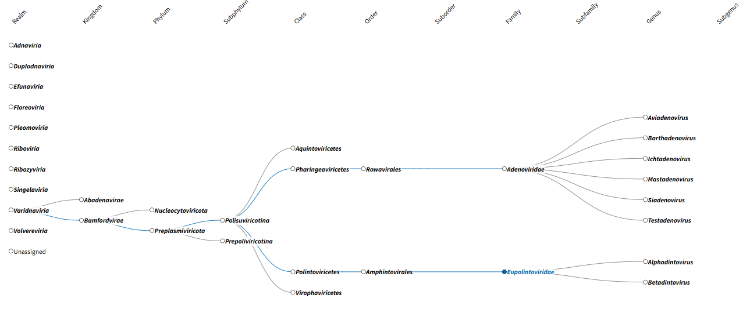

Fig. 1. The present taxonomy of adenoviruses and the related adintoviruses. ICTV, Visual Browser.

pIIIa pVII hexon DBP 33K U-exon
fowl AdV-1
Aviadenovirus
IVa2 pol pTP 52K III pX pVI prot 100K pVIII fibers
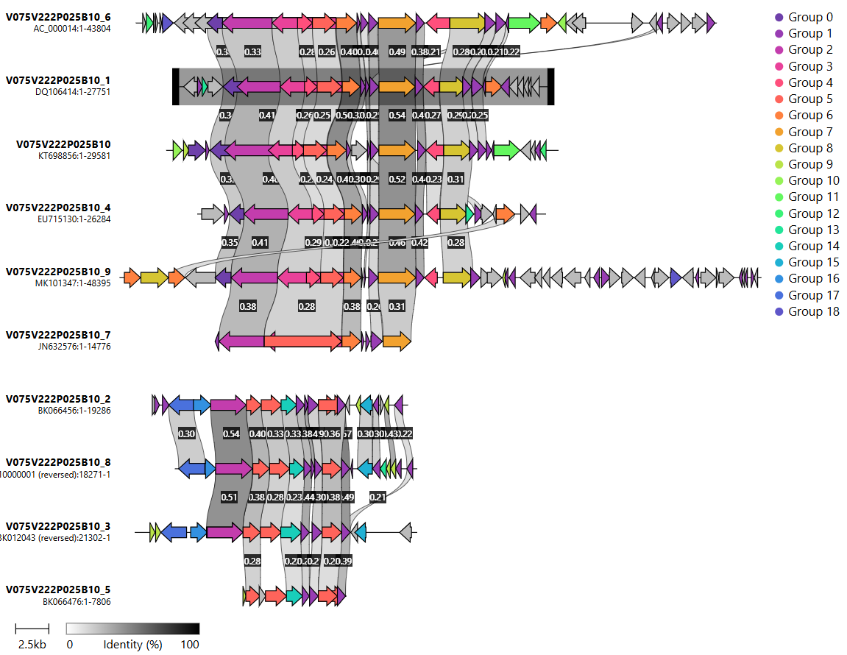
crab spider paradenovirus (partial)
yellow catfish-associated paradenovirus
pol penton hex prot
tangle-web spider paradenovirus
white sturgeon AdV-1
Ichtadenovirus
thornbill-associated
paradenovirus
bat AdV WIV12
Mastadenovirus
raptor AdV-1
(Harris’s hawk)
Siadenovirus
snake AdV-1
Barthadenovirus
red-eared slider AdV-1 (partial)
Testadenovirus1

Fig. 2. The genome organization of different official and proposed members of representatives of all the six species of Adenoviridae and the proposed new family. (Testadenovirus is represented by a partial genome.) Clinker; the grey color scale indicates the degree of identity of automatically identified homologs; the colors show proteins found to be homologous by the program (Gilchrist and Chooi, 2021; https://cagecat.bioinformatics.nl/tools/clinker). There are some homologous proteins, like the polymerase, the penton base (syn. protein III), the hexon and the protease, in a similar order as in adenoviruses, and the hexon gene followed by the protease gene like in the adenoviruses; but the direction of the polymerase gene is opposite to that in adenoviruses. The identity of the polymerases of the three full genome “paradenoviruses” with each other is more than 50%. This value and the very similar genome organization places them in the same genus. A 30% identity is proposed as demarcation criterion for these families, the identity of the “paradenoviruses” with the adenoviruses is below that, thus their separation to a new family (“Paradenoviridae”) seems to be legitime.

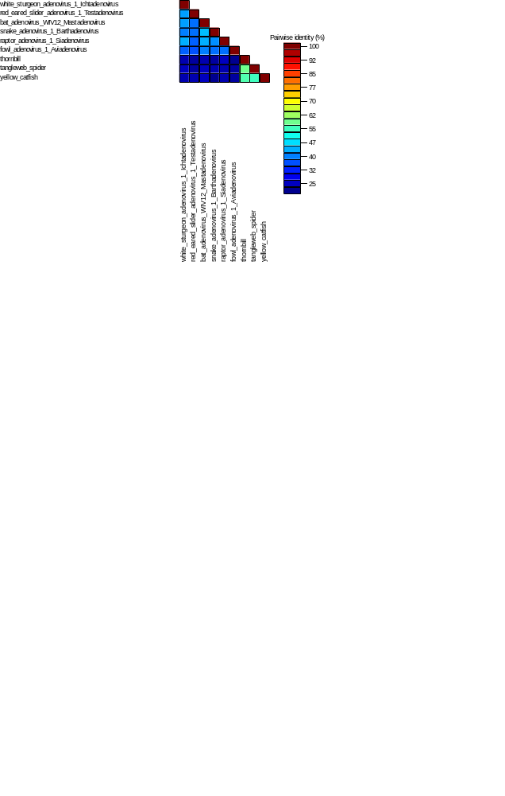
Fig. 3. Pairwise comparison of the DNA polymerase amino acid sequences of selected representatives of members of the different adenovirus species and the full genome paradenoviruses. While the adenoviruses presented show clear genus-level difference, the three paradenoviruses show >50% identity with each other and thus belong to the same genus, but they show less than 85% identity and thus must be classified as different species. Sequence demarcation tool v1.3 (Muhire et al., 2014). Alignment: Muscle. Full color mode.

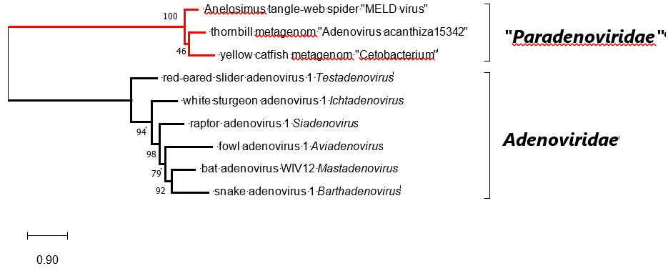
Fig. 4. Phylogenetic tree of representative members of adenovirid species and the tree full genome “paradenoviruses” based on complete DNA-dependent DNA polymerase amino acid sequences. Multiple alignment: MultAlin; manual edition: BioEdit 7.2.5., model selection: ProtTest 2.4; maximum likelihood calculation: PhyML 3.1 with model LG+I+G and branch support Shimodaira-Hasegawa (SH) on the Galaxy/Pasteur platform. Unrooted calculation; the phylogenetic tree was visualized using MEGA11, with midpoint rooting. SH branch support values are shown at the nodes. Genus names are shown for adenoviruses. The proposed family name is in quotation marks.

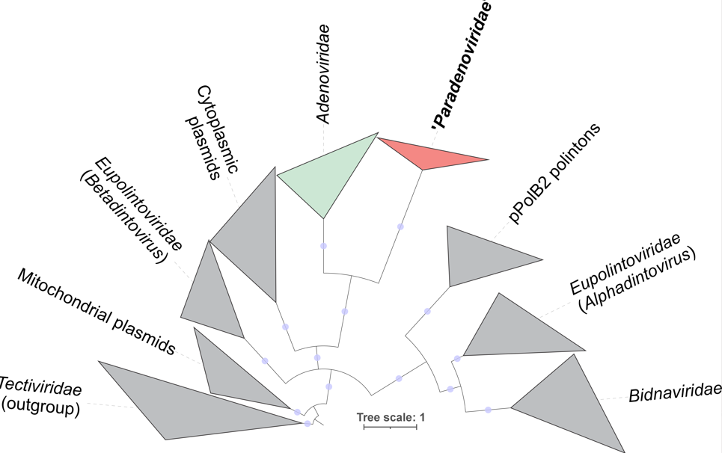

Fig. 5. Maximum likelihood phylogenetic tree protein-primed family B DNA-dependent DNA polymerases (pPolB) encoded by representative adenovirids and paradenovirids, and other eukaryotic viruses and plasmids. The tree is rooted with the pPolB sequences of bacterial tectivirids, which are considered to represent the ancestral group (Krupovic et al., 2024). The proposed family name is in quotation marks. For phylogenetic analysis, sequences were aligned using MAFFT (Katoh and Standley, 2013), trimmed with trimal (Capella-Gutiérrez et al., 2009). Maximum-likelihood phylogeny was reconstructed using IQ-tree v3 (Wong et al., 2026) with automatic model detection. The best selected model was Q.PFAM+F+R9. Blue circles indicate SH-aLRT (Shimodaira–Hasegawa-like approximate likelihood ratio test) supports greater than 90. Scale bar indicates amino acid substitutions per site.

