

The International Committee on Taxonomy of Viruses
Taxonomy Proposal Form, 2026

Part 1a: Details of taxonomy proposals

Title: | Establish a new species in the genus Alphapolyomavirus
Code assigned: | 2026.008D.N.v1.Alphapolyomavirus_1ns

Author(s), affiliation and email address(es):
Given name (+middle initial(s)) | Surname | Affiliation | Email address | Corr. author(s)
Elise N. | Paietta | The Biodesign Center for Fundamental and Applied Microbiomics, Center for Evolution and Medicine and School of Life Sciences, Arizona State University, Tempe, AZ 85287, USA | epaietta@asu.edu
Arvind | Varsani | The Biodesign Center for Fundamental and Applied Microbiomics, Center for Evolution and Medicine and School of Life Sciences, Arizona State University, Tempe, AZ 85287, USA | arvind.varsani@asu.edu | x

Part 1b: Taxonomy Proposal Submission
ICTV Subcommittee:
Animal DNA Viruses and Retroviruses | X | Bacterial viruses
Animal minus-strand and dsRNA viruses |  | Fungal and protist viruses
Animal positive-strand RNA viruses |  | Plant viruses
Archaeal viruses |  | General -

List the ICTV Study Group(s) that have seen or have been involved in creating this proposal:
Optional – complete only if formally voted on by an ICTV Study Group:
Study Group | Number of members
Study Group | Votes in support | Votes against | No vote
Polyomaviridae Study Group

Submission date: | 14/08/2026

Part 1c: Feedback from ICTV Executive Committee (EC) meeting
Executive Committee Meeting Decision code: | X
A – Accept
Ac – Accept subject to revision by relevant subcommittee chair. No further vote required
U – Accept without revision but with re-evaluation and email vote by the EC
Uc – Accept subject to revision and re-evaluation and email vote by the EC
Ud – Deferred to the next EC meeting, with an invitation to revise based on EC comments
J - Reject
W - Withdrawn

Comments from the Executive Committee:

Part 1d: Revised Taxonomy Proposal Submission
Response of proposer:
Revision date:

Part 3: TAXONOMIC PROPOSAL
https://ictv.global/taxonomy/templates

Taxonomic changes proposed:
Establish new taxon | X | Split taxon
Abolish taxon |  | Merge taxon
Move taxon |  | Promote taxon
Rename taxon |  | Demote taxon
Move and rename

Etymology (origin) of proposed taxonomic names:
Taxon name | Etymology of the term
Alphapolyomavirus avahia | The virus was identified in a woolly lemur (Avahi sp.) and thus we have latinized Avahi to avahia for the species epithet.

Permission for use of names derived from a living person:
Taxon name | Full name of person from whom the name is derived | Attached

Abstract of Taxonomy Proposal:
Description of current taxonomy:
Floreoviria; Shotokuvirae; Cossaviricota; Papovaviricetes; Sepolyvirales; Polyomaviridae; Alphapolyomavirus

Proposed taxonomic change(s):
We propose to add one new species to the Polyomaviridae family in particular to the Alphapolyomavirus genus to classify a divergent polyomavirus identified in a woolly lemur in Madagascar. We propose the name Alphapolyomavirus avahia.

Demarcation criteria for new taxon/taxa:
The polyomavirus (PyV) species demarcation threshold is 85% pairwise identity of the large T-antigen nucleotide sequence with that of the most closely related PyV species coupled with host specificity and tissue tropism.

Justification: Avahi PyV 1 shows sufficient sequence diversity to be classified as a species, it additionally was identified in a unique host species (Avahi sp.) in a unique geographic region (Madagascar).

As Avahi PyV 1 sequences share the highest LTag nucleotide identity, 67.5%, with that of Rhinolophus simulator polyomavirus 3 from horseshoe bats (LC269980), Avahi PyV 1 represents a novel PyV species. This is also supported by the phylogenetic analysis of the large T-antigen amino acid sequences.

Text of Taxonomy proposal:
Description of current taxonomy:
Floreoviria; Shotokuvirae; Cossaviricota; Papovaviricetes; Sepolyvirales; Polyomaviridae; Alphapolyomavirus

Proposed taxonomic change(s):
We propose to add one new species to the Polyomaviridae family/Alphapolyomavirus genus given our identification of a divergent polyomavirus in a woolly lemur in Madagascar (Paietta et al., 2026), Avahi polyomavirus 1, to be classified as Alphapolyomavirus avahia.

Demarcation criteria for new taxon/taxa:
The polyomavirus (PyV) species demarcation threshold is 85% large T-antigen nucleotide identity with that of the most closely related PyV species coupled with host specificity and tissue tropism (Moens et al., 2017).

Justification:
Avahi PyV 1 sequences were identified in oral swab samples from woolly lemurs in Madagascar. These viruses are thus from a unique geographic region with polyomavirus divergence likely the result of long-term geographic isolation of lemurs and rodents on the island of Madagascar.

As Avahi PyV 1 sequences share the highest LTag nucleotide identity, 67.5%, with Rhinolophus simulator polyomavirus 3 from horseshoe bats (LC269980), Avahi PyV 1 represents a novel PyV species (Figure 1).

Avahi PyV 1 sequences share 67% identity with 79% genome coverage based on Blastn analysis with genome-wide sequence similarity with Bornean orangutan polyomavirus (FN356900). Avahi PyV 1 LTag sequences display a phylogenetic relationship with a clade of primate PyVs including members of Alphapolyomavirus apaniscus from spider monkeys, Alphapolyomavirus octihominis [i.e. Trichodysplasia spinulosa-associated polyomavirus (TSPyV)] from humans and Alphapolyomavirus ponpygmaeus from orangutans (Figure 2).

As the woolly lemur is an Avahi sp., we suggest the name Alphapolyomavirus avahia.

References:
Paietta EN, Johnston RA, Kraberger S, Randrianarisoa SF, Razanamahenina TT, Ramboninarimalala A, Velontsara JB, Raherinirina TG, Raveloson L, Finley NL, Baitchman E, McAdoo BG, Yoder AD, Varsani A. Mammal-infecting DNA viruses identified in lemurs and rodents in Madagascar mirror the evolutionary history of their hosts. Microb Genom. 2026 May;12(5):001728. doi: 10.1099/mgen.0.001728. PMID: 42171625; PMCID: PMC13196890.

Moens U, Calvignac-Spencer S, Lauber C, Ramqvist T, Feltkamp MCW, Daugherty MD, Verschoor EJ, Ehlers B, Ictv Report Consortium. ICTV Virus Taxonomy Profile: Polyomaviridae. J Gen Virol. 2017 Jun;98(6):1159-1160. doi: 10.1099/jgv.0.000839. Epub 2017 Jun 22. PMID: 28640744; PMCID: PMC5656788.

Muhire BM, Varsani A, Martin DP. SDT: a virus classification tool based on pairwise sequence alignment and identity calculation. PLoS One. 2014 Sep 26;9(9):e108277. doi: 10.1371/journal.pone.0108277. PMID: 25259891; PMCID: PMC4178126.

Accompanying files:
Filename | Description of contents
Tables, Figures:

Figure 1: Large T antigen (LTag) nucleotide similarity of polyomaviruses identified in this study and related sequences computed with SDT v1.2 (Muhire et al. 2019)

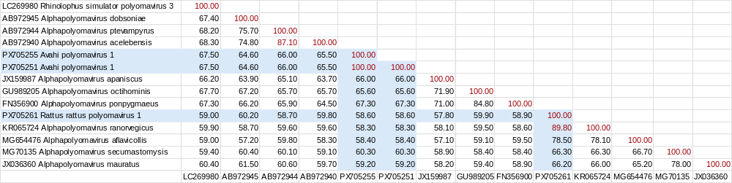

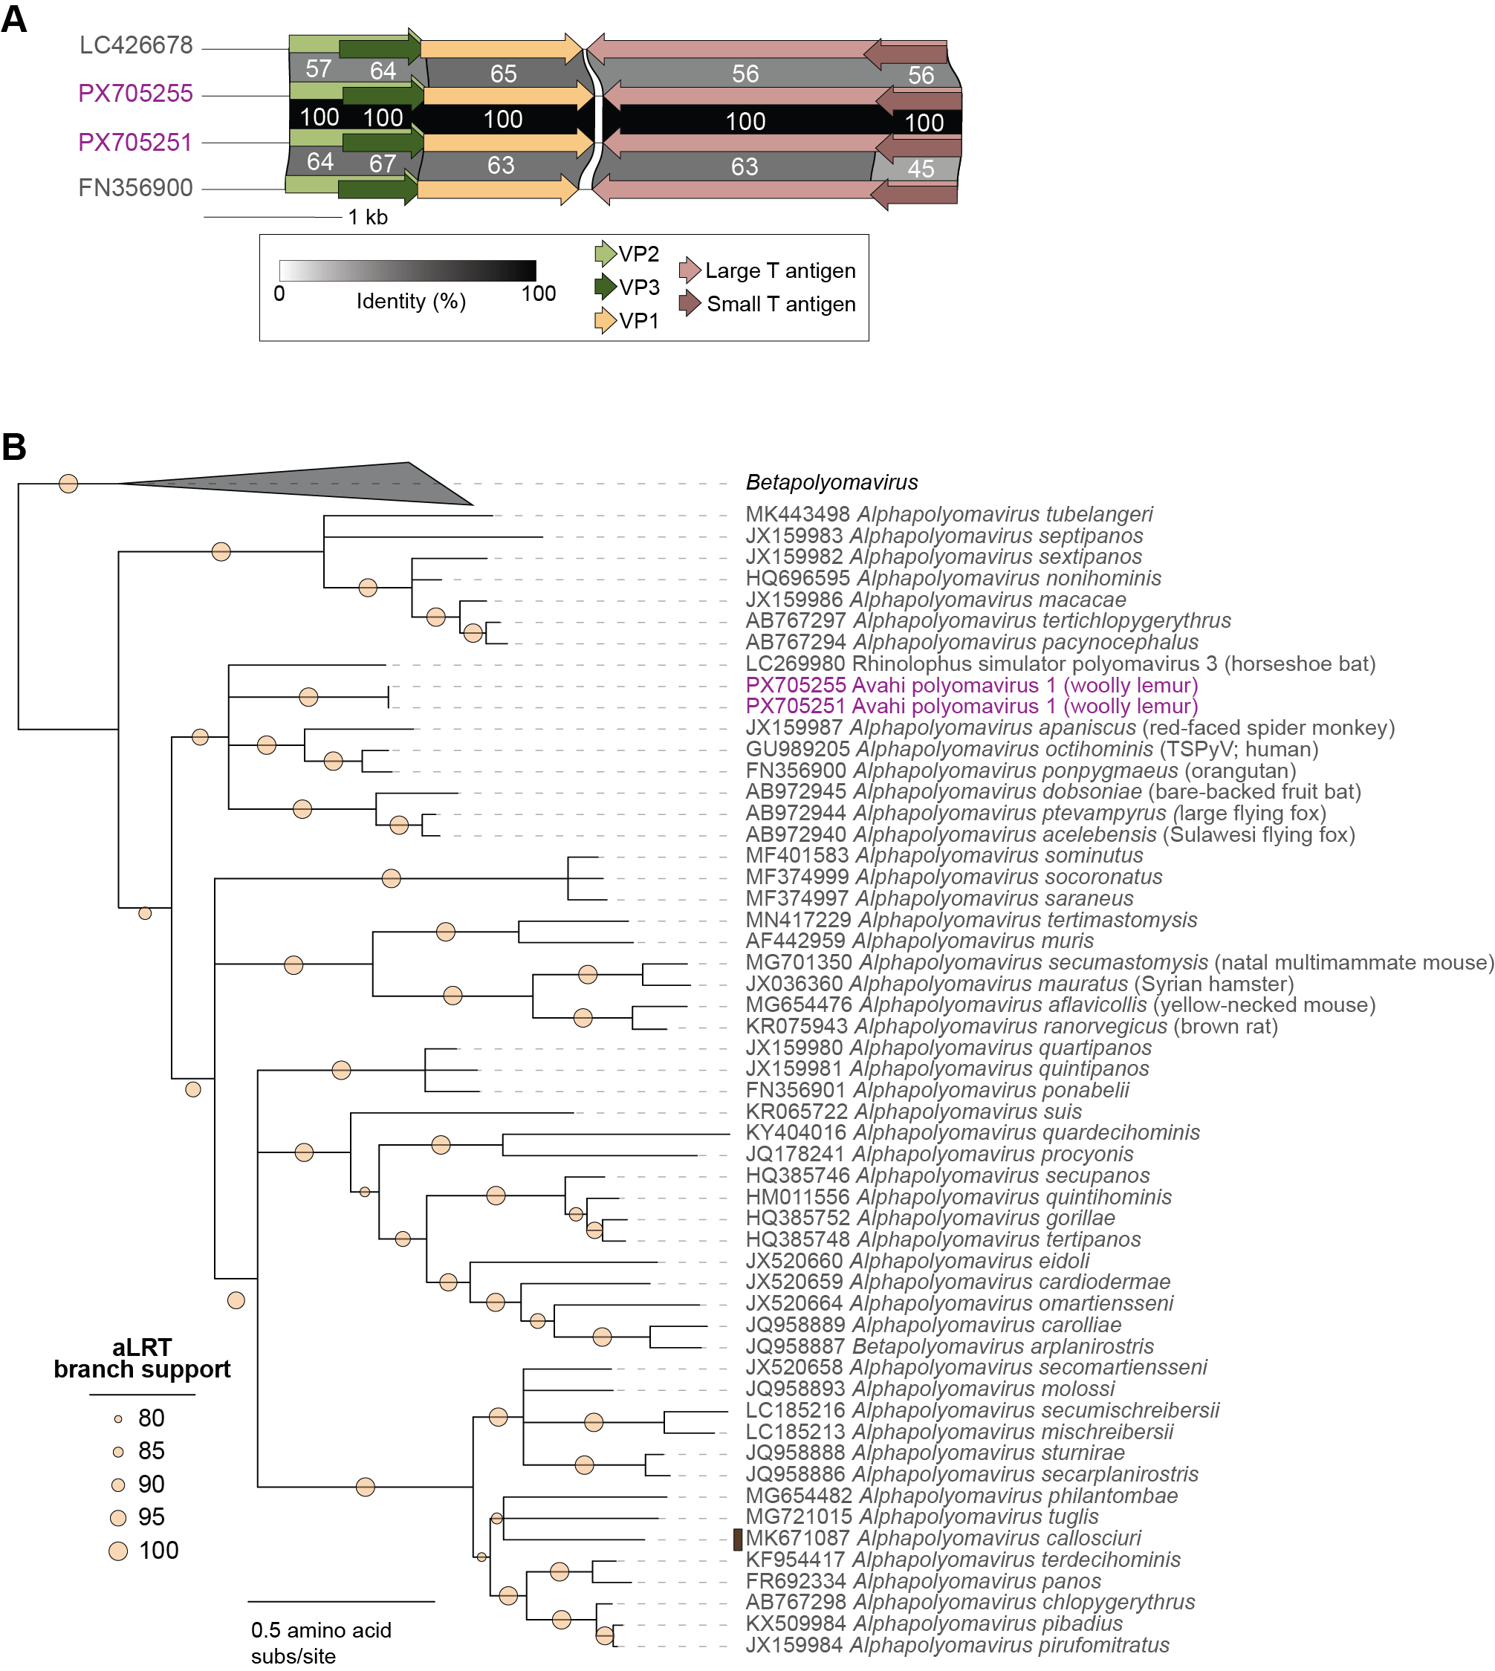

Figure 2. (A) Genome organization and protein sequence comparison of Avahi polyomavirus 1. (B) Maximum likelihood phylogenetic tree of large T-antigen amino acid sequences of representative viruses from established Alphapolyomavirus species and Avahi polyomavirus 1.

