

The International Committee on Taxonomy of Viruses
Taxonomy Proposal Form, 2026

Part 1a: Details of taxonomy proposals

Title: | Establishing the new genus “Rodentiapoxvirus” and new species “Rodentiapoxvirus madamurpox” in the subfamily Chordopoxvirinae
Code assigned: | 2026.009D.N.v1.Poxviridae_1ng_1nsp

Author(s), affiliation and email address(es):
Given name (+middle initial(s)) | Surname | Affiliation | Email address | Corr. author(s)
Elise N. | Paietta | The Biodesign Center for Fundamental and Applied Microbiomics, Arizona State University, Tempe, AZ, USA | epaietta@asu.edu | X
Elliot J. | Lefkowitz | Dept. of Microbiology, University of Alabama at Birmingham, Birmingham, AL, USA | elliotl@uab.edu | X
William J. | Van Der Pol | Dept. of Microbiology, University of Alabama at Birmingham, Birmingham, AL, USA | liamvdp@uab.edu
R. Curtis | Hendrickson | Dept. of Microbiology, University of Alabama at Birmingham, Birmingham, AL, USA | curtish@uab.edu
Rachel A. | Johnston | Broad Institute of MIT and Harvard, Cambridge, MA, USA | rjohnston@zoonewengland.org
Santatriniaina F. | Randrianarisoa | Mahaliana Labs SARL, Amboditsiry, Antananarivo, 101, Madagascar | santatra@mahaliana.org
Simona | Kraberger | The Biodesign Center for Fundamental and Applied Microbiomics, Arizona State University, Tempe, AZ, USA | simona.kraberger@asu.edu
Arvind | Varsani | The Biodesign Center for Fundamental and Applied Microbiomics, Arizona State University, Tempe, AZ, USA | Arvind.Varsani@asu.edu

Part 1b: Taxonomy Proposal Submission
ICTV Subcommittee:
Animal DNA Viruses and Retroviruses | X | Bacterial viruses
Animal minus-strand and dsRNA viruses |  | Fungal and protist viruses
Animal positive-strand RNA viruses |  | Plant viruses
Archaeal viruses |  | General -

List the ICTV Study Group(s) that have seen or have been involved in creating this proposal:
Poxviridae Study Group - consultation and approval pending.

Optional – complete only if formally voted on by an ICTV Study Group:
Study Group | Number of members
Study Group | Votes in support | Votes against | No vote

Submission date: | 11/08/2026

Part 1c: Feedback from ICTV Executive Committee (EC) meeting
Executive Committee Meeting Decision code: | X
A – Accept
Ac – Accept subject to revision by relevant subcommittee chair. No further vote required
U – Accept without revision but with re-evaluation and email vote by the EC
Uc – Accept subject to revision and re-evaluation and email vote by the EC
Ud – Deferred to the next EC meeting, with an invitation to revise based on EC comments
J - Reject
W - Withdrawn

Comments from the Executive Committee:

Part 1d: Revised Taxonomy Proposal Submission
Response of proposer:
Revision date:

Part 3: TAXONOMIC PROPOSAL
https://ictv.global/taxonomy/templates

Taxonomic changes proposed:
Establish new taxon | X | Split taxon
Abolish taxon |  | Merge taxon
Move taxon |  | Promote taxon
Rename taxon |  | Demote taxon
Move and rename

Etymology (origin) of proposed taxonomic names:
Taxon name | Etymology of the term
“Rodentiapoxvirus” | From Rodentia (the mammalian order that includes the animal from which the virus sequence was isolated) and poxvirus. The name indicates a rodent host source without asserting that rodents are the natural reservoir.
“Rodentiapoxvirus madamurpox” | The species epithet madamurpox is a contraction of Madagascar, Muridae and pox, following the derivation of the virus name madamurpox virus reported by Paietta et al., 2026.

Permission for use of names derived from a living person:
Taxon name | Full name of person from whom the name is derived | Attached
Not applicable | No proposed taxon name is derived from a living person.

Abstract of Taxonomy Proposal:
Description of current taxonomy: This proposal creates a new species and genus in the subfamily Chordopoxvirinae, family Poxviridae, order Chitovirales, class Pokkesviricetes, phylum Nucleocytoviricota, kingdom Bamfordvirae, realm Varidnaviria.
Proposed taxonomic change(s): We propose to create a new species “Rodentiapoxvirus madamurpox” (MAPV) that will be a member of a new genus “Rodentiapoxvirus” in the Poxviridae subfamily Chordopoxvirinae. We propose madamurpox virus isolate MNB22_067_17, GenBank accession number PZ016454 (coding complete genome sequence), as the exemplar virus of the new species.
Demarcation criteria for new taxon/taxa: Current genus demarcation criteria for the Poxviridae subfamily Chordopoxvirinae, includes natural host range, gene content, gene organization, and distinct phylogenetic branching as key criteria used to determine the need to create new taxa.
Justification: MAPV forms a distinct monophyletic lineage after phylogenetic inference with 100% bootstrap support. The branch lengths on the phylogenetic tree that distinguish MAPV from its nearest neighbors molluscum contagiosum virus (MCV) and Rousettus bat poxvirus (RPV) are consistent with branch lengths that distinguish other poxvirus genera. MAPV has a relatively low G+C content of 36.3% in comparison to the much higher GC content of MCV and RPV (61.6 and 63.4% respectively). Gene content comparison shows that MAPV has a distinct repertoire of immunomodulator genes compared to its poxvirus relatives despite broadly conserved central genome gene content and order. All of these unique characteristics justify creation of the new genus “Rodentiapoxvirus” and new species “Rodentiapoxvirus madamurpox” for the classification of the newly discovered poxvirus, madamurpox.

- Text of Taxonomy proposal:

The family Poxviridae comprises large, enveloped, brick-shaped or ovoid virions with linear double-stranded DNA genomes of 128–375 kbp. The family is divided into two subfamilies: Chordopoxvirinae, whose members infect vertebrates, and Entomopoxvirinae, whose members infect insects. The subfamily Chordopoxvirinae currently contains 18 recognized genera, including Molluscipoxvirus (the sole genus in which MCV, a human-specific virus, is classified). Genome sizes in Chordopoxvirinae range from approximately 128 to 360 kbp and G+C contents vary widely, from ~20% (Yokapoxvirus) to ~67% (Sciuripoxvirus) [McInnes et al., 2023].
The MAPV genome was assembled from Illumina NovaSeq X Plus sequencing of a metagenomic DNA library prepared from an oral swab of a black rat (Rattus rattus) collected in October 2022 at the Manombo Special Reserve, southeastern Madagascar [Paietta et al., 2026]. Four contigs were de novo assembled from the sequencing reads and gaps were resolved by PCR and Sanger sequencing. One small gap (63 bp) within ORF075 (a NUDIX domain protein) and the terminal repeat regions at both ends of the genome were not recovered. Therefore, the genome sequence was essentially coding complete. Coding ORFs were called and genes were annotated using four RefSeq poxvirus genomes, NC_003663 (cowpox virus), NC_063383 (monkeypox virus), NC_035468 (Murmansk poxvirus), and NC_035469 (NY_014 poxvirus). Of the 129 annotated ORFs, 25 correspond to the conserved core poxvirus genes used for subsequent phylogenetic inference.
MAPV shares similar genome organization with molluscum contagiosum virus MCV (U60315; 190.3 kbp, ~174 genes, 64% GC, Senkevich et al., 1996) and Rousettus bat poxvirus (PP711852; 154.9 kbp, partial, ~63% GC, Wang et al., 2024). However, MAPV is substantially smaller, 138.4 kbp (though this could be due to the absence of the terminal repeats) and has a dramatically lower GC content (36.3%), Table 1. Pairwise amino acid identities for 12 selected conserved proteins between MAPV, MCV, and Rousettus poxvirus are shown in Table 2. In general, MCV lacks homologs for several immune modulators found in many orthopoxviruses, while MAPV lacks additional immunomodulatory genes that are present in MCV, including MC054 (interleukin-18 binding protein), MC066 (apoptosis inhibitor),
MC080 (MHC class I homolog), MC132 (NF-κB inhibitor), and MC148 (secreted CC-chemokine). This pattern is shared with RPV and may reflect adaptation to distinct hosts and tissues.

Description of current taxonomy: This proposal creates a new species and genus in the subfamily Chordopoxvirinae, family Poxviridae, order Chitovirales, class Pokkesviricetes, phylum Nucleocytoviricota, kingdom Bamfordvirae, realm Varidnaviria.

Proposed taxonomic change(s): We propose to create a new species “Rodentiapoxvirus madamurpox” that will be a member of a new genus “Rodentiapoxvirus” in the Poxviridae subfamily Chordopoxvirinae. We propose madamurpox virus (MAPV) isolate MNB22_067_17, GenBank accession number PZ016454, as the exemplar virus of the new species. In comparison to MCV and RPV, MAPV has a distinct host, GC content, genome size, and gene content. On a phylogenetic tree, MAPV forms a monophyletic branch with MCV and RPV but with branch lengths sufficiently distinct to justify classification in a new genus.

Demarcation criteria for new taxon/taxa: As indicated in the current ICTV Poxviridae Report (https://ictv.global/report/poxviridae; McInnes CJ et al., 2023) genus demarcation criteria for the Poxviridae subfamily Chordopoxvirinae, include the following criteria used to assess the differences needed to create a new genus:
- Natural host range can be a defining characteristic;
- Gene content comparison. The variability in the content and conservation of gene sequences between poxvirus isolates can serve as a distinguishing characteristic;
- Organization of the genome. Syntenic relationships between genes may serve to distinguish taxa. However, conservation of gene synteny, particularly in the central core, can frequently be so high that the resolving power is not available to distinguish between taxa;
- Phylogenetic analysis. Taxonomic groupings can in most cases be readily inferred from the observation of distinct, monophyletic evolutionary clades using phylogenetic inference. Branch lengths consistent with those used to distinguish between other Chordopoxvirinae genera are also important criteria.
Since the species “Rodentiapoxvirus madamurpox” is proposed to be the sole member of the new genus “Rodentiapoxvirus”, no species demarcation are as yet defined for the genus. But as for other poxvirus genera, we expect the species demarcation criteria for the new genus to include:
- Host range and ecological niche;
- Growth characteristics in vitro;
- The level of amino acid or nucleotide sequence identity between specific, commonly shared genes. Nucleotide identity of <98% across the central core of the genome is frequently used to delineate species, whereas >98% identity would indicate separate strains of the same species.
- Phylogenetic analysis. Taxonomic groupings can in most cases be readily inferred from the observation of distinct, monophyletic evolutionary clades using phylogenetic inference.
- Disease characteristics. The morbidity, mortality and other distinguishing features of the disease resulting from poxvirus infection can be used to support taxonomic decisions;
- Serological criteria, including plaque neutralization tests and cross-protection in animals, may help to identify new, unique isolates and serve as a criterion for taxonomic demarcation.

Justification: MAPV forms a distinct monophyletic lineage after phylogenetic inference with 100% bootstrap support (Figure 1). The branch lengths on the phylogenetic tree that distinguish MAPV from its nearest neighbors MCV and RPV are consistent with branch lengths that distinguish between other poxvirus genera. MAPV has a relatively low G+C content of 36.3% in comparison to the much higher GC content of MCV and RPV (61.6-63.4% GC) (Table 1). Gene content comparison shows that MAPV has a distinct repertoire of immunomodulator genes compared to its poxvirus relatives despite broadly conserved central gene order (Table 2) [Paietta et al., 2026].
Robust phylogenetic separation, substantial core-protein divergence, distinct gene content, and a rodent-associated ecological source justify distinct genus-level separation for “Rodentiapoxvirus” and its constituent species “Rodentiapoxvirus madamurpox”,
References:
- International Committee on Taxonomy of Viruses. ICTV Report: Poxviridae; https://ictv.global/report /poxviridae (accessed 11 August 2026).
- McInnes CJ, Damon IK, Smith GL, McFadden G, Isaacs SN, Roper RL, Evans DH, Damaso CR, Carulei O, Wise LM, Lefkowitz EJ. ICTV Virus Taxonomy Profile: Poxviridae 2023. J Gen Virol. 2023 May;104(5):001849. PMCID: PMC12447285.
- Minh BQ, Schmidt HA, Chernomor O, Schrempf D, Woodhams MD, von Haeseler A, Lanfear R. IQ-TREE 2: New Models and Efficient Methods for Phylogenetic Inference in the Genomic Era. Mol Biol Evol. 2020 May 1;37(5):1530-1534. PMID: 32011700; PMCID: PMC7182206..
- Paietta EN, Lefkowitz EJ, Van Der Pol WJ, Hendrickson RC, Johnston RA, Randrianarisoa SF, Kraberger S, Razanamahenina TT, Ramboninarimalala A, Raherinirina TG, Raveloson L, Finley NL, Scotch M, Baitchman E, Yoder AD, Varsani A. Divergent poxvirus identified in a non-native black rat from Madagascar. Virology. 2026 Oct;623:111021. PMID: 42385547; PMCID: PMC13431258.
- Senkevich TG, Bugert JJ, Sisler JR, Koonin EV, Darai G, Moss B. Genome sequence of a human tumorigenic poxvirus: prediction of specific host response-evasion genes. Science. 1996 Aug 9;273(5276):813-6. PMID: 8670425.
- Wang D, Yang X, Ren Z, et al. Substantial viral diversity in bats and rodents from East Africa: insights into evolution, recombination, and cocirculation. Microbiome. 2024 Apr 10;12(1):72. PMID: 38600530; PMCID: PMC11005217.

Tables, Figures:

Table 1. Comparative genomic evidence for new poxvirus species
Feature | Madamurpox virus | Molluscum contagiosum virus | Rousettus poxvirus
INSDC Accession | PZ016454 | U60315 | PP711852
Host of isolation | Black rat (Rattus rattus) | Human (Homo sapien) | Rousettus bat (Rousettus aegyptiacus)
Genome size | 138.4 kb (coding complete) | 190.3 kb (complete) | 154.9 kb (partial)
G+C content | 36.3% | 63.4% | 61.6%
Gene content | 129 genes | 163 | 108
Overall Genomic nucleotide identity (blastn) with MAPV | - | 66% (19% genome coverage) | 67% (14% genome coverage)

Table 2. Amino acid identity between MAPV and its closest classified relatives for selected conserved proteins.

Protein (vaccinia virus designation) | MAPV ORF | % AA identity MAPV:MCV | % AA identity MAPV:RPV
RPO132 (A24) | ORF106 | 84.5% | 82.1%
VETF-S (D6) | ORF073 | 88.5% | 86.5%
VLTF-3 (A2) | ORF081 | 86.2% | 83.1%
RPO147 (J6) | ORF060 | 80.8% | 78.8%
ATPase DNA packaging (A32) | ORF114 | 73.9% | 72.7%
RAP94 (H4) | ORF064 | 68.6% | 68.1%
NTPase (D5) | ORF072 | 64.0% | 62.9%
DNA polymerase (E9) | ORF029 | 57.2% | 57.1%
Large capping enzyme (D1) | ORF068 | 58.5% | 65.4%
NPH-I (D11) | ORF077 | 66.6% | 66.2%
Holliday junction resolvase (A22) | ORF104 | 27.7% | 40.0%
FEN1 (G5) | ORF044 | 38.0% | 34.4%

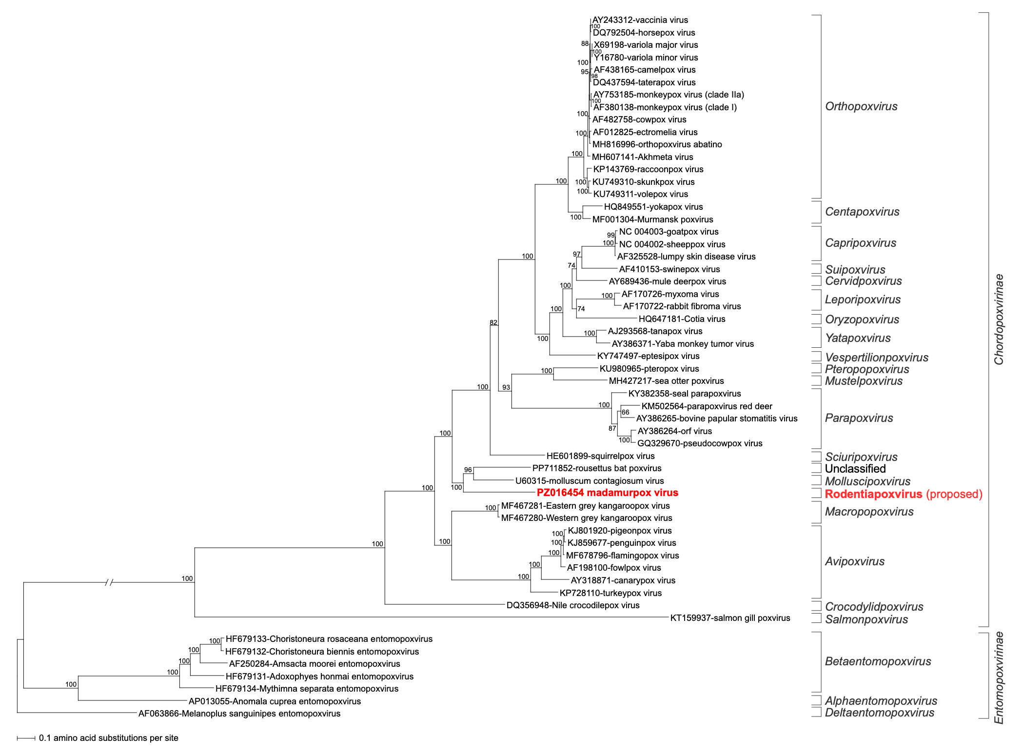

Figure 1. Maximum likelihood phylogenetic tree (IQ-TREE 2) of a concatenated amino acid alignment representing 25 core genes for 55 representative genomes spanning the diversity of the Poxviridae family. order [Paietta et al. (2026)].

