
h

The International Committee on Taxonomy of Viruses
Taxonomy Proposal Form, 2026

Part 1a: Details of taxonomy proposals

Title: | Create two new genera and seven novel species within the family Alloherpesviridae (Herpesvirales)
Code assigned: | 2026.010D.N.v1.Alloherpesviridae_2ng_7ns

Author(s), affiliation and email address(es):
Given name (+middle initial(s)) | Surname | Affiliation | Email address | Corr. author(s)
Andor | Doszpoly | HUN-REN Veterinary Medical Research Institute, Budapest, Hungary | doszpoly.andor@vmri.hun-ren.hu | X
Mária | Benkő | HUN-REN Veterinary Medical Research Institute, Budapest, Hungary | benko.maria@vmri.hun-ren.hu
Balázs | Harrach | HUN-REN Veterinary Medical Research Institute, Budapest, Hungary | harrach.balazs@vmri.hun-ren.hu

Part 1b: Taxonomy Proposal Submission
ICTV Subcommittee:
Animal DNA Viruses and Retroviruses | x | Bacterial viruses
Animal minus-strand and dsRNA viruses |  | Fungal and protist viruses
Animal positive-strand RNA viruses |  | Plant viruses
Archaeal viruses |  | General -

List the ICTV Study Group(s) that have seen or have been involved in creating this proposal:
Herpesvirales SG

Optional – complete only if formally voted on by an ICTV Study Group:
Study Group | Number of members
Study Group | Votes in support | Votes against | No vote

Submission date: | 19/08/2026

Part 1c: Feedback from ICTV Executive Committee (EC) meeting
Executive Committee Meeting Decision code: | X
A – Accept
Ac – Accept subject to revision by relevant subcommittee chair. No further vote required
U – Accept without revision but with re-evaluation and email vote by the EC
Uc – Accept subject to revision and re-evaluation and email vote by the EC
Ud – Deferred to the next EC meeting, with an invitation to revise based on EC comments
J - Reject
W - Withdrawn

Comments from the Executive Committee:

Part 1d: Revised Taxonomy Proposal Submission
Response of proposer:
Revision date:

Part 3: TAXONOMIC PROPOSAL
https://ictv.global/taxonomy/templates

Taxonomic changes proposed:
Establish new taxon | X | Split taxon
Abolish taxon |  | Merge taxon
Move taxon |  | Promote taxon
Rename taxon |  | Demote taxon
Move and rename

Etymology (origin) of proposed taxonomic names:
Taxon name | Etymology of the term
“Esovirus” | Derived from the Greek ἴσοξ (ee-soks, a large fish) and its Latin form "esox", referring to the genus (Esox) of pike (the host).
“Acivirus” | Derived from the Latin acipenser, meaning "sturgeon" (referring to the host).

Permission for use of names derived from a living person:
Taxon name | Full name of person from whom the name is derived | Attached

Abstract of Taxonomy Proposal:
Description of current taxonomy:
The family Alloherpesviridae currently comprises 4 genera and 13 species. Alloherpesviruses (AHVs) of amphibians belong to the genus Batravirus, AHVs of salmonids to the genus Salmovirus, while the genus Ictavirus comprises the AHVs of catfishes and sturgeons; and the genus Cyvirus comprises the AHVs of cyprinids and eel.

Proposed taxonomic change(s):
Here, we propose to create two new genera and seven new species within the family Alloherpesviridae, under the order Herpesvirales.

Demarcation criteria for new taxon/taxa:
At present, sequence data are used flexibly to support taxonomic proposals on the basis of phylogenetic grouping of viruses. Each case is considered on its merits and does not require the availability of a complete genome sequence, does not depend on any specified gene or group of genes, and does not specify genetic distance thresholds for differentiating taxa.

Justification:
New knowledge generated in the past few years by sequencing the complete or the coding-complete genomes of several fish and amphibian herpesviruses requires updates in the taxonomy of the family Alloherpesviridae by adding new taxa for seven AHVs that had not been previously classified.

Text of Taxonomy proposal:
Description of current taxonomy:

The family Alloherpesviridae currently comprises 4 genera and 13 species. Alloherpesviruses (three AHVs) of amphibians belong to the genus Batravirus, three AHVs of salmonids to the genus Salmovirus, while the genus Ictavirus comprises three AHVs of catfishes and sturgeons; and the genus Cyvirus comprises three known AHVs of cyprinids and one AHV of eel.

Proposed taxonomic change(s):
Here, we propose to create two new genera and seven new species within the family Alloherpesviridae, under the order Herpesvirales.

We have sequenced the coding-complete genome of cyprinid herpesvirus 5 (CyHV-5) and silurid herpesvirus 2 (SiHV-2) (partial genome sequences containing the core genes are available in the GenBank: Acc. Nos. PZ768230 and PZ768231). The complete or coding-complete genomes of the following unclassified AHVs are also available in GenBank: acipenserid herpesvirus 1 (AciHV-1) (GenBank Acc. No.: OR001786), bufonid herpesvirus 1 (BfHV-1) (MF143550), esocid herpesvirus 1 (EsHV-1) (PV991061), lake sturgeon herpesvirus 1 and 3 (LSHV-1 and -3) (OK485036, PQ863777) (1-4). These novel sequences allowed us to carry out extensive phylogenetic calculations for their classification and re-classification of some already accepted species in the family.

For the CyHV-5 described from roach (Rutilus rutilus, family Cyprinidae) (5), we propose establishing a novel species: “Cyvirus cyprinidallo5” in the genus Cyvirus; while for the SiHV-2 detected in wels catfish (Silurus glanis, family Siluridae) (6), we propose a novel species: “Cyvirus siluridallo1” in the genus Cyvirus as well. The LSHV-3 reported from lake sturgeon (Acipenser fulvescens, family Acipenseridae) should be assigned into the genus Ictavirus as a novel species: “Ictavirus acipenseridallo3”. For the AciHV-1 originating from white sturgeon (Acipenser transmontanus) (7) and LSHV-1 (4) we propose to create a new genus: “Acivirus”, and two novel species: “Acivirus acipenseridallo1” and “Acivirus acipenseridallo2”, respectively. For the EsHV-1 described from northern pike (Esox lucius, family Esocidae) (8) we propose to create a novel species within a new genus: “Esovirus esocidallo1” and “Esovirus”.
For the yet unclassified BfHV-1 (2), we propose the species name “Batravirus bufonidallo1” in the genus Batravirus. The novel species names were given following the scheme for naming species adopted by the Herpesvirales Study Group (2022.002D.A.Herpesvirales_9nsp.docx).

Demarcation criteria for new taxon/taxa:

At present, sequence data are used flexibly to support taxonomic proposals on the basis of phylogenetic grouping of viruses. Each case is considered on its merits and does not require the availability of a complete genome sequence, does not depend on any specified gene or group of genes, and does not specify genetic distance thresholds for differentiating taxa (2022.002D.A.Herpesvirales_9nsp.docx).

Justification:

New knowledge generated in the past few years by sequencing the complete or the coding-complete genome of several fish and amphibian herpesviruses require updates in the taxonomy of the family Alloherpesviridae. We constructed phylogenetic trees based on the concatenated deduced amino acid sequences of twelve marker (core) genes conserved in all known AHV genomes: ATPase subunit of terminase, primase, Allo64, capsid triplex protein, DNA helicase, Allo60, DNA polymerase, capsid protease and scaffolding protein, Allo54, Allo56, Allo37 and the major capsid protein (Figure 1). The phylogenetic distance of the newly proposed species shows adequate evolutionary distance to the already accepted AHV species.

References:
- Waltzek TB, Subramaniam K, Doszpoly A, Hughes J, Vučak M, Davison AJ. Genome sequence of white sturgeon herpesvirus 1 isolated from farmed white sturgeon (Acipenser transmontanus). Microbiol Resour Announc. 2023 Dec 14;12(12):e0057123.
- Origgi FC, Schmidt BR, Lohmann P, Otten P, Meier RK, Pisano SRR, Moore-Jones G, Tecilla M, Sattler U, Wahli T, Gaschen V, Stoffel MH. Bufonid herpesvirus 1 (BfHV1) associated dermatitis and mortality in free ranging common toads (Bufo bufo) in Switzerland. Sci Rep. 2018 Oct 3;8(1):14737.
- Leijon M, Tibblin P, Lilja T, Banihashem F, Persson BD. Genome characterisation of esocid herpesvirus 1 (EsHV-1). Viruses. 2025 Oct 11;17(10):1361.
- Walker L, Subramaniam K, Viadanna PHO, Vann JA, Marcquenski S, Godard D, Kieran E, Frasca S Jr, Popov VL, Kerr K, Davison AJ, Waltzek TB. Characterization of an alloherpesvirus from wild lake sturgeon Acipenser fulvescens in Wisconsin (USA). Dis Aquat Organ. 2022 Jun 2;149:83-96.
- Sellyei B, Baska F, Varga Á, Borzák R, Doszpoly A. Molecular detection of a novel cyprinid herpesvirus in roach (Rutilus rutilus) and asp (Leuciscus aspius) showing typical signs of carp pox disease. Arch Virol. 2020 Jul;165(7):1569-76.
- Tarján ZL, Doszpoly A, Eszterbauer E, Benkő M. Partial genetic characterisation of a novel alloherpesvirus detected by PCR in a farmed wels catfish (Silurus glanis). Acta Vet Hung. 2022 Dec 5;70(4):321-327.
- Watson LR, Yun SC, Groff JM, Hedrick RP. Characteristics and pathogenicity of a novel herpesvirus isolated from adult and subadult white sturgeon Acipenser transmontanus. Dis Aquat Organ. 1995;22:199–210.
- Yamamoto T, Kelly RK, Nielsen O. Epidermal hyperplasias of northern pike (Esox lucius) associated with herpesvirus and C-type particles. Arch Virol. 1984;79(3-4):255-72.
- van Beurden SJ, Bossers A, Voorbergen-Laarman MH, Haenen OL, Peters S, Abma-Henkens MH, Peeters BP, Rottier PJ, Engelsma MY. Complete genome sequence and taxonomic position of anguillid herpesvirus 1. J Gen Virol. 2010 Apr;91(Pt 4):880-7.
- Kuraku S, Zmasek CM, Nishimura O, Katoh K. aLeaves facilitates on-demand exploration of metazoan gene family trees on MAFFT sequence alignment server with enhanced interactivity. Nucleic Acids Research 2013;41:W22-8.
- Huelsenback JP, Ronquist F. MrBayes: Bayesian inference of phylogeny. Bioinformatics. 2001;17:754–5.
- Milne I, Wright F, Rowe G, Marshall DF, Husmeier D, McGuire G. TOPALi: software for automatic identification of recombinant sequences within DNA multiple alignments. Bioinformatics. 2004;20:1806–7.
- Guindon S, Dufayard J-F, Lefort V, Anisimova M, Hordijk W, Gascuel O. New algorithms and methods to estimate maximum-likelihood phylogenies: assessing the performance of PhyML 3.0. Systematic Biology. 2010;59(3):307–21.

Accompanying files:
Filename | Description of contents
2026.010D.Alloherpesviridae_2ng_7ns_PZ768231.txt | GenBank format entry for Cyprinid herpesvirus 5
2026.010D.Alloherpesviridae_2ng_7ns_PZ768230.txt | GenBank format entry for Silurid herpesvirus 2

Tables, Figures:
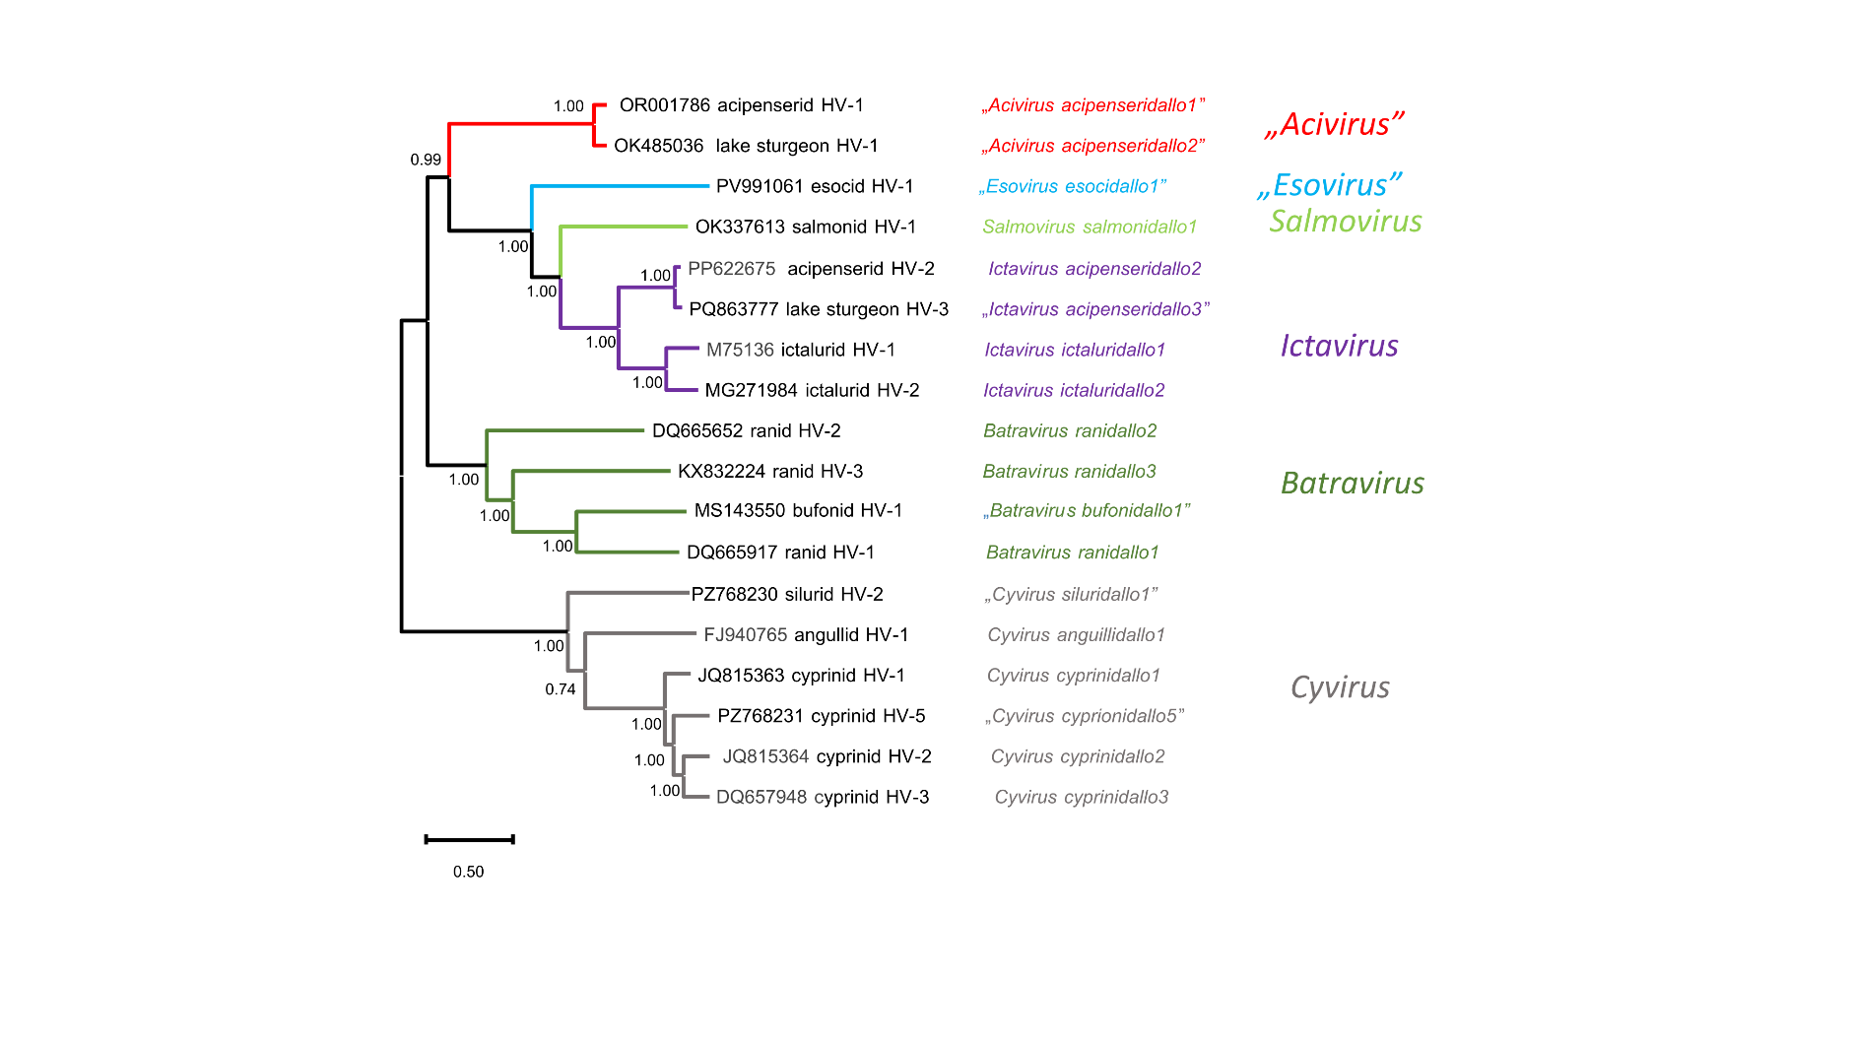

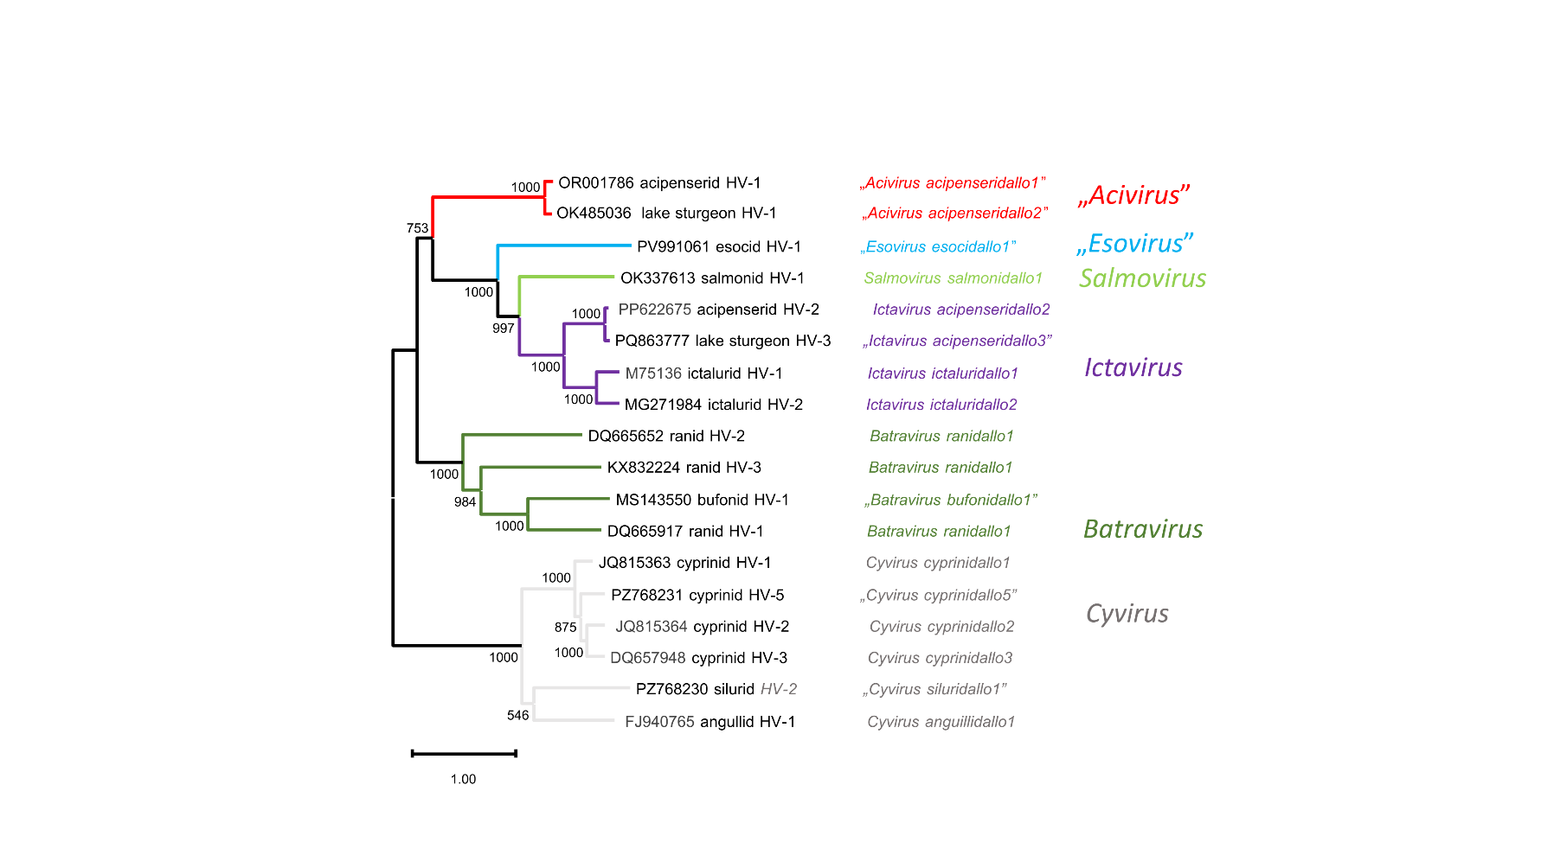Figure 1a and b. Phylogeny of the family Alloherpesviridae. Analyses were based on the Bayesian analysis (1a) (WAG amino acid substitution model found to be the best fit for the data by using the model selection of TOPALI v2.5 program) and maximum likelihood (1b) (ML) method (LG substitution model) based on a concatenated alignment of 12 core genes (9). The deduced amino acid sequences of all genes were aligned using MAFFT v7 (10) with default parameters. After removal of gaps, Bayesian phylogenetic analyses were performed using MrBayes (11) within the TOPALi v2.5 program package and interface (12) with the following parameters: default prior probability distribution, Markov chain run for 1 million generations, four independent analyses conducted, each with 1 cold and 3 heated chains. Sampling occurred every 10th generations with the first 25% of Markov chain Monte Carlo samples discarded as burn-in. The maximum likelihood (PhyML 3.1) method with LG+I+G amino acid substitution model (13) (1000 samplings) were carried out on the Galaxy Pasteur homepage (Galaxy Version 3.3_1) (https://galaxy.pasteur.fr). Both methods resulted in trees with very similar topology supported by high statistical values (probability values for Bayesian analysis and Shimodaira-Hasegawa (SH) branch support values for ML tree). Viruses are represented by GenBank accession number, virus name (with type designation), species and genus names (in quotation marks if proposed herein).

