

The International Committee on Taxonomy of Viruses
Taxonomy Proposal Form, 2026

Part 1a: Details of taxonomy proposals

Title: | Creating a new species, Orthopoxivurs borealpox, in the genus Orthopoxvirus
Code assigned: | 2026.011D.N.v1.Orthopoxvirus_1nsp

Author(s), affiliation and email address(es):
Given name (+middle initial(s)) | Surname | Affiliation | Email address | Corr. author(s)
Crystal M. | Gigante | Poxvirus and Rabies Branch, Centers for Disease Control and Prevention, Atlanta, United States | lzu1@cdc.gov | X
Joseph | McLaughlin | Alaska Section of Epidemiology  Division of Public Health, Anchorage, USA | joseph.mclaughlin@alaska.gov
Jeffrey B. | Doty | Arctic Investigations Program, US Centers for Disease Control and Prevention, Anchorage, United States | uwb7@cdc.gov
Julia H. | Rogers | Research Services, Alaska Native Tribal Health Consortium, Anchorage, USA | jhrogers@anthc.org
Andrea M. | McCollum | Division of Vector-borne Diseases, US Centers for Disease Control and Prevention, Atlanta, United States | azv4@cdc.gov
Eric Q. | Mooring | Center for Forecasting and Outbreak Analytics, US Centers for Disease Control and Prevention, Washington DC, United States | pgv5@cdc.gov
Katherine | Newell | Alaska Section of Epidemiology  Division of Public Health, Anchorage, USA | katherinegnewell@hotmail.com
Yoshinori J. | Nakazawa | Poxvirus and Rabies Branch, Centers for Disease Control and Prevention, Atlanta, United States | Inp7@cdc.gov

Part 1b: Taxonomy Proposal Submission
ICTV Subcommittee:
Animal DNA Viruses and Retroviruses | X | Bacterial viruses
Animal minus-strand and dsRNA viruses |  | Fungal and protist viruses
Animal positive-strand RNA viruses |  | Plant viruses
Archaeal viruses |  | General

List the ICTV Study Group(s) that have seen or have been involved in creating this proposal:
Poxviridae Study Group

Optional – complete only if formally voted on by an ICTV Study Group:
Study Group | Number of members
Study Group | Votes in support | Votes against | No vote

Submission date: | 08/15/2026

Part 1c: Feedback from ICTV Executive Committee (EC) meeting
Executive Committee Meeting Decision code: | X
A – Accept
Ac – Accept subject to revision by relevant subcommittee chair. No further vote required
U – Accept without revision but with re-evaluation and email vote by the EC
Uc – Accept subject to revision and re-evaluation and email vote by the EC
Ud – Deferred to the next EC meeting, with an invitation to revise based on EC comments
J - Reject
W - Withdrawn

Comments from the Executive Committee:

Part 1d: Revised Taxonomy Proposal Submission
Response of proposer:
Revision date:

Part 3: TAXONOMIC PROPOSAL

Taxonomic changes proposed:
Establish new taxon | X | Split taxon
Abolish taxon |  | Merge taxon
Move taxon |  | Promote taxon
Rename taxon |  | Demote taxon
Move and rename

Etymology (origin) of proposed taxonomic names:
Taxon name | Etymology of the term
Orthopoxvirus borealpox | Boreal- from Latin borealis, meaning "northern", referring to the geographic range of the virus and association with the boreal forest ecosystem;  The suffix –pox from the Old English poc, meaning “pustule”, referring to the disease associated with human infection

Permission for use of names derived from a living person:
Taxon name | Full name of person from whom the name is derived | Attached

Abstract of Taxonomy Proposal:
Description of current taxonomy: Alaskapox virus is currently listed as a related, unclassified virus in the Orthopoxvirus genus entry.

Proposed taxonomic change(s): We propose (1) Alaskapox virus assigned to a new species named to Orthopoxvirus borealpox (common name borealpox virus, BRPV) and (2) be included as a member species of the Orthopoxvirus genus.

Demarcation criteria for new taxon/taxa: Twelve near-complete viral genome sequences were evaluated by phylogenetic analysis to determine if they formed a monophyletic clade within the Orthopoxvirus genus and met the criteria for >98% nucleotide identity among all isolates within a species.

Justification: We request inclusion of Orthopoxvirus borealpox as a member species within Orthopoxvirus genus because all isolates meet the demarcation criteria described above based on nucleotide identity. The number of known cases and available viral genomes have increased from one to twelve (seven human cases and five from animals), and there is a wealth of new literature and research now publicly available on the virus, zoonotic source, and disease it causes in humans.

We request a naming change from “Alaskapox” to “borealpox” due to concerns of potential stigmatization and economic impact to the state of Alaska that were raised after the first fatal human case. The name borealpox was chosen as being representative of the current known geographic range of the virus in boreal forest ecosystem without being specific enough to stigmatize a specific location or entity.

Text of Taxonomy proposal:
Description of current taxonomy: Alaskapox virus is currently listed as a related, unclassified virus in the Orthopoxvirus genus ICTV entry.

Proposed taxonomic change(s): We propose (1) Alaskapox virus be renamed to Orthopoxvirus borealpox (common name borealpox virus, BRPV) and (2) be included as a member species of the Orthopoxvirus genus.

Demarcation criteria for new taxon/taxa: Demarcation criteria were adopted as defined by ICTV from the Orthopoxvirus genus chapter. Twelve complete or near-complete viral genome sequences are now available for borealpox virus (previously Alaskapox virus). All twelve viral genome sequences form a monophyletic clade within the Orthopoxvirus genus by phylogenetic analysis (see figure) (Gigante et al., Viruses 2019; Juman et al., bioRxiv 2026; Mooring et al., Clinical Infectious Diseases 2026; Springer et al., Clinical Infectious Diseases 2017). In phylogenetic analysis of the orthopoxvirus central conserved genomic region, borealpox virus sequences fall between “New World” and “Old World” orthopoxvirus clades, with higher overall genetic identity to “Old World” orthopoxviruses such as ectromelia virus, cowpox virus, variola virus, and monkeypox/mpox virus (Gigante et al., Viruses 2019). The borealpox virus central region was, on average, 92.9% identical to the Old World OPXVs examined (ranging from 92.4–93.5%), compared to 87.1% average identity to New World OPXVs (range: 86.9–87.4%) (Gigante et al., Viruses 2019). In contrast, the average identity for the same genomic region within Old World OPXVs examined was 97.52% (95.1–99.7%), much higher than the identity of borealpox virus to Old World orthopoxviruses (Gigante et al., Viruses 2019).

Among the twelve borealpox virus genomic sequences, nucleotide identity was >99% among conserved regions, meeting the criteria for >98% nucleotide identity within a species for species within the Orthopoxvirus genus as defined by ICTV.

With the scientific information available at the current time, there is insufficient evidence for further demarcation of these 12 viral sequences or associated isolates into separate species based on the criteria listed in the ICTV Orthopoxvirus genus entry, namely: amino acid differences between specific genes, growth characteristics, host range, disease characteristics, or serologic criteria. Although viral genetic differences were observed between isolates with increased geographic distance (Juman et al., bioRxiv 2026), there is insufficient evidence to indicate these differences warrant different species designation as viral genetic identity is >99.5% within the conserved regions.

Justification:
- Inclusion as a member species is requested based on the following:
- The viral genetic sequences available meet the demarcation criteria described above based on nucleotide identity among conserved regions.
- Although limited, current viral characterization data are consistent with criteria listed in ICTV Orthopoxvirus chapter including virion characterization by electron microscopy, viral genome (size, composition, and GC content), and serologic cross-reactivity (Gigante et al., Viruses 2019; Juman et al., bioRxiv 2026; Springer et al., Clinical Infectious Diseases 2017).
- The number of known cases and available viral genomes have increased from 1 to 12 (seven human cases and five from animals) (Juman et al., bioRxiv 2026). There is now sufficient evidence to support a proposal for inclusion as a member species.
- Two studies have observed evidence of orthopoxvirus immunity and borealpox circulation through molecular detection and viral isolation in wildlife in the Alaskan boreal forest in areas where borealpox virus has been identified in human cases or animal surveillance has been conducted (Juman et al., bioRxiv 2026; Mooring et al., Clinical Infectious Diseases 2026).
- A wealth of new literature and research is now available on the virus and the disease it causes in humans (Gigante et al., Viruses 2019; Juman et al., bioRxiv 2026; Mooring et al., Clinical Infectious Diseases 2026; Rogers et al., Clinical Infectious Diseases 2025; Springer et al., Clinical Infectious Diseases 2017).
- There is a need to standardize nomenclature and taxonomy for this virus given the surge of interest in research on this virus after identification of a fatal human case.

- Change from “alaskapox” to “borealpox” was requested after the American state of Alaska experienced stigma from mentions of Alaskapox in the media after the first fatal human case. Please see the articles linked here washingtonexaminer.com/news/2953045/alaskapox-renamed-prevent-stigmatizing-state-hurting-tourism/; https://www.science.org/content/article/alaskapox-virus-renamed-avoid-stigmatizing-state-and-hurting-tourism. Limited information is known about the natural reservoir of the virus or its true geographic range which may extend beyond Alaskan borders. It has thus far only been identified in or near Alaska’s boreal forest. In a group collaboration with different stakeholders in Alaska, the name borealpox was chosen as being representative of the current known geographic association of the virus with the boreal forest ecosystem. This virus cannot be named with any certainty for the animal reservoir (currently the reservoir is unknown, presumed to be a small mammal, similar to many other zoonotic orthopoxviruses). The species can also not be named after the species where it was first identified (human). While there is some speculation that the virus may circulate in northern red-backed voles (Juman et al., bioRxiv 2026), Orthopoxvirus volepox species name already exists for a different species. Lastly, the name “borealpox virus” has been now used in several key publications, has been implemented on NCBI public databases, and is used by the Alaska Department of Health due to community concerns about stigmatization (https://health.alaska.gov/en/education/borealpox/).

References:
Gigante, Crystal M., et al. "Genome of Alaskapox virus, a novel orthopoxvirus isolated from Alaska." Viruses 11.8 (2019): 708.

Juman, Maya, et al. "Historic and contemporary museum specimens implicate Northern Red-backed Vole (Clethrionomys rutilus) as borealpox host as early as 1990s." bioRxiv (2026): 2026-03.

Mooring, Eric Q., et al. "Six Cases of Borealpox and Evidence of a Zoonotic Source: Alaska, 2020–2023." Clinical Infectious Diseases 82.6 (2026): e1200-e1207.

Rogers, Julia H., et al. "Fatal borealpox in an immunosuppressed patient treated with antivirals and vaccinia immunoglobulin—Alaska, 2023." Clinical Infectious Diseases 80.5 (2025): 1053-1059.

Springer, Yuri P., et al. "Novel orthopoxvirus infection in an Alaska resident." Clinical Infectious Diseases 64.12 (2017): 1737-1741.

Accompanying files:
Filename | Description of contents

Tables, Figures:

Figure 1. Phylogenetic tree based on orthopoxvirus central genomic region spanning DNA polymerase coding sequence to rpo132 coding sequence. Representative viruses from all recognized orthopoxviruses (OPXV) are included. Position of newly proposed species is shown by the teal box; all 12 isolate sequences were included. Additional details on the 12 isolate sequences is available in the lower phylogeny. Tree was rooted using Yokapox virus sequence NC_015960, NY_014 poxvirus sequence NC_035469 and Murmansk poxvirus sequence NC_035468 (not shown due to long branch). Phylogenetic tree was generated using iqtree 2.2.6 -m MFP. Support values on the nodes are based on 2000 bootstrap replicates. Scale is in substitutions per site.

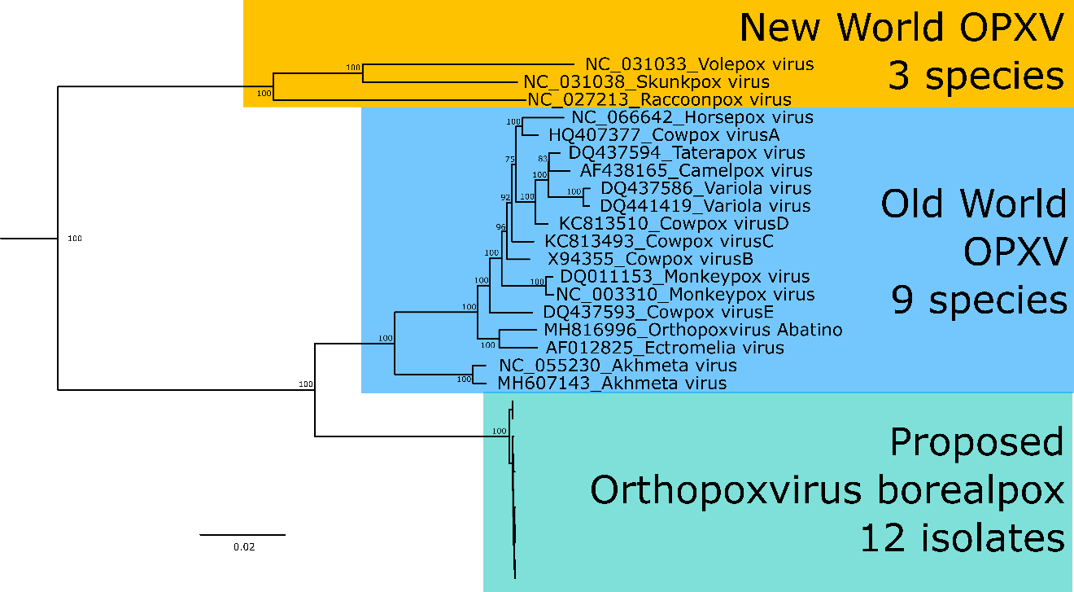

Figure 2. Phylogenetic tree based on whole genome sequences from 12 isolates of the proposed Orthopoxvirus borealpox species. Isolates are the same as used in the GenBank records, although accessions are still processing and have not been released at time of submission of this proposal. Tree was rooted using raccoonpox virus sequence NC_027213 and monkeypox virus sequence NC_063383 (not shown due to long branch). Phylogenetic tree was generated using iqtree 2.2.6 -m MFP. Support values on the nodes are based on 2000 bootstrap replicates. Scale is in substitutions per site.

