

The International Committee on Taxonomy of Viruses
Taxonomy Proposal Form, 2026

Part 1a: Details of taxonomy proposals

Title: | Create new taxa, including realm “Telodnaviria”, for classification of arthropod-infecting viruses
Code assigned: | 2026.012D.N.v1.Telodnaviria_1nr_1nf

Author(s), affiliation and email address(es):
Given name (+middle initial(s)) | Surname | Affiliation | Email address | Corr. author(s)
Mart | Krupovic | Institut Pasteur, Université Paris Cité, Cell Biology and Virology of Archaea Unit, Paris, France | mart.krupovic@pasteur.fr | X
Fasséli | Coulibaly | Department of Biochemistry and Molecular Biology, Monash University, Clayton, Victoria, Australia | fasseli.coulibaly@monash.edu
Monique M. | van Oers | Laboratory of Virology, Wageningen University and Research, Wageningen, the Netherlands | monique.vanoers@wur.nl
Elisabeth A. | Herniou | Institut de Recherche sur la Biologie de l’Insecte, UMR 7261, CNRS - University of Tours, 37200, Tours, France | elisabeth.herniou@univ-tours.fr
Robert L | Harrison | Invasive Insect Biocontrol and Behavior Laboratory, Beltsville Agricultural Research Center, USDA Agricultural Research Service, Beltsville, MD, 20705, USA | Robert.L.Harrison@usda.gov
Jens H. | Kuhn | Frederick, Maryland, USA | jens_h_kuhn@comcast.net
Eugene V. | Koonin | Computational Biology Branch, Division of Intramural Research, National Library of Medicine, National Institutes of Health, Bethesda, Maryland, USA | koonin@ncbi.nlm.nih.gov
Arvind | Varsani | The Biodesign Center for Fundamental and Applied Microbiomics, Center for Evolution and Medicine, School of Life Sciences, Arizona State University, Tempe, Arizona, USA | Arvind.Varsani@asu.edu
Part 1b: Taxonomy Proposal Submission
ICTV Subcommittee:
Animal DNA Viruses and Retroviruses | X | Bacterial viruses
Animal minus-strand and dsRNA viruses |  | Fungal and protist viruses
Animal positive-strand RNA viruses |  | Plant viruses
Archaeal viruses |  | General -

List the ICTV Study Group(s) that have seen or have been involved in creating this proposal:
Optional – complete only if formally voted on by an ICTV Study Group:
Study Group | Number of members
Study Group | Votes in support | Votes against | No vote

Submission date:

Part 1c: Feedback from ICTV Executive Committee (EC) meeting
Executive Committee Meeting Decision code: | X
A – Accept
Ac – Accept subject to revision by relevant subcommittee chair. No further vote required
U – Accept without revision but with re-evaluation and email vote by the EC
Uc – Accept subject to revision and re-evaluation and email vote by the EC
Ud – Deferred to the next EC meeting, with an invitation to revise based on EC comments
J - Reject
W - Withdrawn

Comments from the Executive Committee:

Part 1d: Revised Taxonomy Proposal Submission
Response of proposer:
Revision date:

Part 3: TAXONOMIC PROPOSAL

Taxonomic changes proposed:
Establish new taxon | X | Split taxon
Abolish taxon |  | Merge taxon
Move taxon | X | Promote taxon
Rename taxon |  | Demote taxon
Move and rename

Etymology (origin) of proposed taxonomic names:
Taxon name | Etymology of the term
Telodnaviria | from the Latin word “telum” for spear, “dna”, and realm suffix “-viria”.
Anansivirae | from Anansi, a prominent West African trickster deity and culture hero originating from the Akan people of Ghana, who is traditionally depicted as a spider or a human-spider hybrid; and kingdom suffix”-virae”.
Pifaffiniviricota | from “related to PIF [per os infectivity]” and phylum suffix “-viricota”.
Neritevirales | after the nereid Nerites, a minor Greek sea god who was transformed into a shellfish or shrimp, and order suffix “-virales”.
Mellonaviridae | from Mellona, the Roman goddess and protector of bees and honey, and family suffix “-viridae”.
Amfivirus | sigil of Apis mellifera filamentous [virus] and genus suffix “-virus”.
Amfivirus alatorum | from Latin genitive plural of alatus/alata ("winged ones").

Permission for use of names derived from a living person:
Taxon name | Full name of person from whom the name is derived | Attached

Abstract of Taxonomy Proposal:
Description of current taxonomy:
Arthropod-infecting viruses with helical capsids and large double-stranded DNA genomes are classified into the orphan class Naldaviricetes, which is currently not assigned to any of the 10 established realms. Naldaviricetes includes five families, four of which are included within the order Lefavirales.

Proposed taxonomic change(s):
We propose assigning class Naldaviricetes to a new realm, “Telodnaviria”, kingdom “Anansivirae” and phylum “Pifaffiniviricota”, and classifying Apis mellifera filamentous virus into a new family, “Mellonaviridae” within the existing order Lefavirales, within class Naldaviricetes. In addition, we propose assigning the floating family Nimaviridae to a new order “Neritevirales”.

Demarcation criteria for new taxon/taxa:
Membership in “Telodnaviria” will be contingent on the conservation of a set of proteins implicated in the formation of characteristic filamentous virions, and infectivity factors, most notably, the per os infectivity factors (PIFs). The relationships between viruses of taxa within the realm will be determined based on comparative genomics and phylogenetic analysis of conserved proteins.

Justification:
Naldaviricetes do not encode the hallmark proteins that are used for classification of other viruses into realms, such as HK97-fold major capsid protein (MCP) for duplodnavirians or double jelly-roll MCP for varidnavirians. Accordingly, naldaviricetes do not belong to any of the established realms. Instead, naldaviricetes encode a distinct set of conserved proteins implicated in virion morphogenesis and infectivity, justifying their assignment to a separate realm.

Text of Taxonomy proposal:
Description of current taxonomy:
Arthropod-infecting viruses with helical capsids and large double-stranded DNA genomes are classified into the class Naldaviricetes, which was established in 2021 (van Oers et al., 2023). Naldaviricetes includes five families: Baculoviridae, Filamentoviridae, Hytrosaviridae, Nudiviridae, and Nimaviridae. Based on phylogenetic analysis and an expanded set of shared genes, the first four families are unified within the order Lefavirales, whereas Nimaviridae was placed within Naldaviricetes as an orphan family, i.e., unassigned to an order.
Discovered nearly 50 years ago in honeybees and several other winged insects, Apis mellifera filamentous virus (AmFV) has a large (≈500-kb) double-stranded DNA genome. However, only a few complete or near-complete genome sequences are available in public databases, with most displaying ambiguous regions (Figures 1 and 2). Thus, the genome sequence of AmFV strain CtN3 (Bandoo et al., 2026) was chosen as a representative (GenBank accession number: PV347098). The DNA pol gene analysis showed that there are 3 genotypes (Figure 3) of AmFV circulating globally (Figure 4). AmFV shares a conserved gene set with naldaviricetes and is considered to share a common ancestry with the viruses of this class (Bandoo et al., 2026; Gauthier et al., 2015; Hartmann et al., 2015; Yang et al., 2022). However, AmFV remains to be formally classified with 8 viral genomes available in GenBank sharing >95% pairwise identity (Figure 2).
Another group of unclassified viruses related to naldaviricetes is represented by the ant-infecting Camponotus japonicus labial gland disease virus (CjLGD; Jiang et al., 2025). The latter group appears to be most closely related to AmFV and was suggested to represent a separate family (Jiang et al., 2025).

Proposed taxonomic change(s):
We propose assigning class Naldaviricetes to a new realm, “Telodnaviria”, kingdom “Anansivirae” and phylum “Pifaffiniviricota”, and classifying Apis mellifera filamentous virus into a new family, “Mellonaviridae” within the existing order Lefavirales, within class Naldaviricetes. In addition, we propose assigning the floating family Nimaviridae to a new order “Neritevirales”.
N.B. A separate proposal is being prepared for 2027 for the classification of Camponotus japonicus labial gland disease virus infecting ants.

Demarcation criteria for new taxon/taxa:
Membership in “Telodnaviria” will be contingent on the conservation of a set of proteins implicated in the formation of characteristic, helically symmetric virions, most notably the baculovirid VP39-like MCP. All members of the realm characterized thus far also encode per os infectivity factors (PIFs), which represent one of the hallmarks of “Telodnaviria”. However, we do not exclude the possibility that viruses in which pif genes were replaced by functionally equivalent but unrelated genes will be discovered in the future.
The relationships between viruses of taxa within the realm will be determined based on comparative genomics and phylogenetic analysis of conserved proteins.
Kingdom “Anansivirae”, and phylum “Pifaffiniviricota” are monotypic taxa; thus, demarcation criteria previously established for the class Naldaviricetes apply.

Justification:
The core gene set conserved in members of Naldaviricetes, as well as AmFV and CjLGD, has been described previously (van Oers et al., 2023, Guinet et al., 2024; Jiang et al., 2025). These genes can be broadly assigned to four functional categories: (i) DNA replication, (ii) transcription, (iii) infectivity, and (iv) virion assembly and morphogenesis (Figure 5). Below we consider the provenance of genes in the four categories.

Information processing genes in Naldaviricetes (categories i and ii)
Naldaviricetes encode a number of proteins shared with other viruses with large dsDNA genomes, namely, those of realms Duplodnaviria and Varidnaviria. These proteins are implicated in genome replication and transcription. However, careful evolutionary analyses showed that many of these genes have been convergently and independently acquired by the corresponding viruses from the host or through horizontal transfer between viruses that share the same host (Johnstone et al., 2024). For instance, detailed phylogenetic analysis of family B DNA polymerases revealed a complex evolutionary history of these enzymes within Naldaviricetes, Nucleocytoviricota, and Herpesvirales. DNA polymerases encoded by viruses within each of these three taxa are not monophyletic, but rather display phylogenetic affinities to different groups of eukaryotic DNA polymerases, either Delta or Epsilon, indicative of horizontal gene transfer and replacement events occurring in the history of each virus group (Kazlauskas et al., 2020). DNA polymerases of baculovirids cluster with Epsilon-like polymerases and form a distinct monophyletic group that is only distantly related to the homologs from poxvirids, malacoherpesvirids and alloherpesvirids (Rosani et al., 2023). Consistently, in structure-based comparisons, Epsilon DNA polymerases were identified as the closest structural homologs of the baculovirid DNA polymerase. Similarly complex evolutionary history is observed for the largest RNA polymerase subunits encoded by baculovirid genes lef-8 and lef-9. At the sequence level, the encoded baculovirid LEF-8 and LEF-9 proteins are not recognizably similar to any viral or cellular protein (outside of Naldaviricetes). However, in structure-based searches, cellular RNA polymerases were identified as the closest homologs (Johnstone et al., 2024). Regardless, in the absence of proper phylogenetic analysis (precluded by the extreme sequence divergence of baculovirid lef-8 and lef-9 sequences), the provenance of baculovirid RNA polymerases remains uncertain beyond their closer similarity to homologs from eukaryotes and their viruses. Another protein involved in mRNA biogenesis, with both eukaryotic and viral homologs is LEF-4, an enzyme participating in the synthesis of the mRNA cap structure. LEF-4 represents a fusion of the N-terminal metal-dependent 5’-triphosphatase domain and the C-terminal guanylyltransferase domain (Shuman, 2002). Unlike in certain nucleocytoviricots, LEF-4 does not contain the C-terminal cap methyltransferase domain and in its domain organization is most similar to the capping enzyme of Entamoeba histolytica Schaudinn, 1903 (Shuman, 2002). In structure-based searches, the triphosphatase domain was most similar to Cet1 from Trypanosoma cruzi Chagas, 1909 (PDB ID: 6l7v), whereas the guanylyltransferase domain was more similar to the archaeal DNA ligase than to structurally related mRNA guanylyltransferases of eukaryotes or viruses. Notably, the structures of capping enzymes from nucleocytoviricots, such as vaccinia virus, phycodnavirus PBCV-1, and Acanthamoeba polyphaga mimivirus, were available in the databases, indicating genuine distinctiveness of LEF-4. The informational module of naldaviricetes also includes a helicase exemplified by the baculovirid protein Ac95, which is sometimes considered to be related to the D5 primase-helicase of vaccinia virus, a core gene in nucleocytoviricots. However, unlike D5-like proteins, the N-terminal region of Ac95 is unrelated to primases and structural models of this domain are not significantly similar to any protein structures in either DALI or FoldSeek searches. The similarity to D5 primase-helicase is limited to the C-terminal superfamily 3 helicase domain, one of the hallmark virus proteins widespread across viruses with RNA and DNA genomes from all three domains of life. Indeed, in profile-profile searches the helicase domain of Ac95 is only marginally more similar to the D5 homologs from nucleocytoviricots than to homologs from prokaryotic viruses, with protein sequence identity between the helicase domains in both cases being ≈10% (Johnstone et al., 2024). Thus, the helicase appears to be homologous but not orthologous to the D5-like primases-helicases of nucleocytoviricots and hence does not provide support for an ancestral relationship between the two virus groups. Instead, naldaviricetes encode a genuine eukaryotic-like heterodimeric primase, LEF-1, which corresponds to the catalytic DNA primase subunit with structural similarity to eukaryotic and archaeal primases rather than to viral homologs (Iyer et al., 2005). Accordingly, the structure-based searches showed that LEF-2, previously shown to be a cofactor of the LEF-1 primase, is homologous to the non-catalytic large subunit of archaeo-eukaryotic primases (Johnstone et al., 2024).

Thus, analysis of the DNA replication and transcription modules does not support common origin of naldaviricetes and other large DNA viruses from the realms Varidnaviria and Duplodnaviria.

Infectivity-related genes (category iii)
This functional category includes a set of genes encoding per os infectivity factors (PIFs) that were first described in baculovirids in which they are required for oral infectivity in insect hosts (Boogaard et al., 2018). Ten PIFs (PIF0–9) have been reported to be essential for baculovirid oral infection. Except for PIF5, PIFs form a protein complex (Peng et al, 2010; Boogaard et al 2017; Wang et al., 2019), which prevents proteolytic degradation and is predicted to mediate attachment and membrane fusion (Johnstone et al., 2024). Homologs of baculovirid PIFs are found in all naldaviricetes although not all pif genes have been identified in all groups within the class; in some cases, likely due to high sequence divergence rather than genuine absence. Importantly, it has been recently demonstrated that PIFs encoded by parasitoid wasps producing nudivirid-derived virus like elements are general entry factors essential for systemic infection (Wang et al., 2026). For the nudivirids themselves, PIFs are also likely to have a broader function in cell entry, as these viruses do not have a homolog of the baculovirus F or GP64 proteins. Thus, the original function of the PIF complex has likely been to promote entry of enveloped virions of naldaviricetes. Importantly, none of the PIFs have homologs in other viruses identifiable through sequence or structure comparisons (Johnstone et al., 2024). Thus, PIFs are a hallmark of naldaviricetes, further emphasizing the distinctiveness of this group of viruses.

Virions assembly and morphogenesis (category iv)
All naldaviricetes form rod-shaped or filamentous nucleocapsids, a morphology not observed among viruses of realms Varidnaviria and Duplodnaviria, which typically form icosahedral capsids (or odd-shaped ovoid-shaped particles in several groups of varidnavirians) (Krupovic and Koonin, 2026). High resolution virion structures are available only for baculovirids (Johnstone et al., 2024; Benning et al., 2024; Jia et al., 2023). However, low-resolution cryo-EM analysis of the nimavirid white spot syndrome virus particles suggested that the overall virion organization is broadly conserved (Sun et al., 2023).

The baculovirid nucleocapsid forms a tubular container accommodating the genomic DNA in an internal cavity (Figure 6). The two ends of the baculovirid particles are capped by complex, distinct terminal structures, denoted the cap and the base (Johnstone et al., 2024). The base resembles a crown with triangular spikes pointing out of a flat base, whereas the cap has a distinct conical shape. The main baculovirid tube of the nucleocapsid is made of 14 helical strands of dimers of the major capsid protein (MCP; also called VP39 or Ac89), organized with a C14 cyclic symmetry (Figure 7; Johnstone et al., 2024). The fold of the MCP, centered around the conserved zinc finger domain (Figure 8), and its assembly into a helical capsid are unique among known viruses.

Until now, homologs of the baculovirid MCP (VP39) were identifiable only in nudivirids. Accordingly, the MCP is typically not included among the core naldaviricete genes. However, detailed analysis of viral protein structures allowed us to identify homologs of baculovirid MCPs in all other naldaviricete families, except for Nimaviridae (Figure 8). However, given the overall similar organization of the nimavirid capsid (Sun et al., 2023), it is highly likely that the MCP ortholog evaded detection due to high sequence divergence. Notably, we identified VP39-like MCP orthologs also in AmFV and CjLGD.

Besides the structural components of the virion, the morphogenetic module of naldaviricetes includes an Erv-like flavin adenine dinucleotide (FAD)-dependent sulfhydryl oxidase (called AC92 or P33), which catalyzes the formation of disulfide bonds, likely in viral proteins, such as PIF5 and MCP (Figure 9). Although some nucleocytoviricots, such as vaccinia virus, also encode homologous sulfhydryl oxidases, such as vaccinia virus E10R protein (Senkevich et al., 2002), comparison of the viral and cellular homologs suggests that naldaviricetes and nucleocytoviricots have recruited these enzymes independently of each other from cellular organisms (Johnstone et al., 2024).

Thus, none of the components of the naldaviricete morphogenetic module have orthologs in other DNA viruses, supporting the independent provenance of these viruses. Conversely, naldaviricetes do not encode any of the hallmark proteins which form the basis for the classification of other viruses into realms, such as HK97-fold major capsid protein (MCP) for duplodnavirians or double jelly-roll MCP for varidnavirians (Krupovic and Koonin, 2026). Accordingly, we propose assigning Naldaviricetes to a new realm, “Telodnaviria”.

Classification of Apis mellifera filamentous virus into a new family, new genus, and new species
As mentioned above, AmFV shares a conserved set of genes with members of Naldaviricetes, including the VP39-like MCP (Figure 5) and several PIF homologs (Guinet et al., 2024; Jiang et al., 2025). In particular, analysis of the complete AmFV genome sequence revealed the homologs of PIF0 through PIF5 (Bandoo et al., 2026). Furthermore, AmFV encodes homologs of all four core components of the RNA polymerase, LEF-4, LEF-5, LEF-8 and LEF9, conserved in lefavirals (Jiang et al., 2025). Thus, we propose classifying AmFV into a new species, new genus, new family, “Mellonaviridae” with the order Lefavirales.

Assignment of Nimaviridae to a new order, “Neritevirales”, within class Naldaviricetes
Due to high sequence divergence compared to viruses within the order Lefavirales and lack of identifiable homologs of the signature lefaviral genes, namely, those encoding components of the RNA polymerase, Nimaviridae has been assigned to the class Naldaviricetes as a floating family (van Oers et al., 2023). Here we propose assigning this family to a new monotypic order “Neritevirales”.

The proposed taxonomy is schematically depicted in Figure 10.

References:
Bandoo RA, Kraberger S, Ozturk C, Zhu Q, Smith B, Krupovic M, Cook C, Varsani A. Genetic diversity of Apis mellifera filamentous virus in bees sampled in the USA and Jamaica. Arch Virol. 2026; 171(4):125. doi: 10.1007/s00705-026-06573-w. PMID: 41811537
Benning FMC, Jenni S, Garcia CY, Nguyen TH, Zhang X, Chao LH. Helical reconstruction of VP39 reveals principles for baculovirus nucleocapsid assembly. Nat Commun. 2024; 15(1):250. doi: 10.1038/s41467-023-44596-y. PMID: 38177118
Boogaard B, van Oers MM, van Lent JWM. An advanced view on baculovirus per os infectivity factors. Insects. 2018; 9(3):84. doi: 10.3390/insects9030084. PMID: 30018247
Boogaard B, van Lent JWM, Theilmann DA, Erlandson MA, van Oers MM. Baculoviruses require an intact ODV entry-complex to resist proteolytic degradation of per os infectivity factors by co-occluded proteases from the larval host. J Gen Virol. 2017; 98(12):3101-3110. doi: 10.1099/jgv.0.000974. PMID: 29134933
Darling AC, Mau B, Blattner FR, Perna NT. Mauve: multiple alignment of conserved genomic sequence with rearrangements. Genome Res. 2004; 14(7):1394-403. doi: 10.1101/gr.2289704. PMID: 15231754
Gauthier L, Cornman S, Hartmann U, Cousserans F, Evans JD, de Miranda JR, Neumann P. The Apis mellifera Filamentous Virus Genome. Viruses. 2015; 7(7):3798-815. doi: 10.3390/v7072798. PMID: 26184284
Guinet B, Leobold M, Herniou EA, Bloin P, Burlet N, Bredlau J, Navratil V, Ravallec M, Uzbekov R, Kester K, Gundersen Rindal D, Drezen JM, Varaldi J, Bézier A. A novel and diverse family of filamentous DNA viruses associated with parasitic wasps. Virus Evol. 2024; 10(1):veae022. doi: 10.1093/ve/veae022. PMID: 38617843
Hartmann U, Forsgren E, Charrière JD, Neumann P, Gauthier L. Dynamics of Apis mellifera filamentous virus (AmFV) infections in honey bees and relationships with other parasites. Viruses. 2015; 7(5):2654-67. doi: 10.3390/v7052654. PMID: 26008705
Iyer LM, Koonin EV, Leipe DD, Aravind L. Origin and evolution of the archaeo-eukaryotic primase superfamily and related palm-domain proteins: structural insights and new members. Nucleic Acids Res. 2005; 33(12):3875-96. doi: 10.1093/nar/gki702. PMID: 16027112
Jia X, Gao Y, Huang Y, Sun L, Li S, Li H, Zhang X, Li Y, He J, Wu W, Venkannagari H, Yang K, Baker ML, Zhang Q. Architecture of the baculovirus nucleocapsid revealed by cryo-EM. Nat Commun. 2023; 14(1):7481. doi: 10.1038/s41467-023-43284-1. PMID: 37980340
Jiang S, Zhang L, Guo X, Li J, Hu J, He H, Chen H. Discovery of a novel double-stranded DNA virus associated with ant labial gland disease reveals its long-term interaction with ants. J Virol. 2025; 99(10):e0117825. doi: 10.1128/jvi.01178-25. PMID: 40960313
Johnstone BA, Hardy JM, Ha J, Butkovic A, Koszalka P, Accurso C, Venugopal H, de Marco A, Krupovic M, Coulibaly F. The nucleocapsid architecture and structural atlas of the prototype baculovirus define the hallmarks of a new viral realm. Sci Adv. 2024 Dec 20;10(51):eado2631. doi: 10.1126/sciadv.ado2631. PMID: 39693434
Kazlauskas D, Krupovic M, Guglielmini J, Forterre P, Venclovas Č. Diversity and evolution of B-family DNA polymerases. Nucleic Acids Res. 2020; 48(18):10142-10156. doi: 10.1093/nar/gkaa760. PMID: 32976577
Kim RS, Levy Karin E, Mirdita M, Chikhi R, Steinegger M. BFVD-a large repository of predicted viral protein structures. Nucleic Acids Res. 2025; 53(D1):D340-D347. doi: 10.1093/nar/gkae1119. PMID: 39574394
Krupovic M, Koonin EV. Organization and evolution of the virosphere and the replicator space. C R Biol. 2026; 349:35-75. doi: 10.5802/crbiol.193. PMID: 42112913
Moraru C, Varsani A, Kropinski AM. VIRIDIC-A Novel Tool to Calculate the Intergenomic Similarities of Prokaryote-Infecting Viruses. Viruses. 2020; 12(11):1268. doi: 10.3390/v12111268. PMID: 33172115
Nishimura Y, Yoshida T, Kuronishi M, Uehara H, Ogata H, Goto S. ViPTree: the viral proteomic tree server. Bioinformatics. 2017; 33(15):2379-2380. doi: 10.1093/bioinformatics/btx157. PMID: 28379287
Peng K, van Oers MM, Hu Z, van Lent JW, Vlak JM. Baculovirus per os infectivity factors form a complex on the surface of occlusion-derived virus. J Virol. 2010; 84(18):9497-504. doi: 10.1128/JVI.00812-10. PMID: 20610731
Rosani U, Gaia M, Delmont TO, Krupovic M. Tracing the invertebrate herpesviruses in the global sequence datasets. Front Mar Sci. 2023; 10:1159754. doi: 10.3389/fmars.2023.1159754
Senkevich TG, White CL, Koonin EV, Moss B.Complete pathway for protein disulfide bond formation encoded by poxviruses. Proc Natl Acad Sci U S A. 2002; 99(10):6667-72. doi: 10.1073/pnas.062163799. PMID: 11983854
Shuman S. What messenger RNA capping tells us about eukaryotic evolution. Nat Rev Mol Cell Biol. 2002; 3(8):619-25. doi: 10.1038/nrm880. PMID: 12154373
Sun M, Liu M, Shan H, Li K, Wang P, Guo H, Zhao Y, Wang R, Tao Y, Yang L, Zhang Y, Su X, Liu Y, Li C, Lin J, Chen XL, Zhang YZ, Shen QT. Ring-stacked capsids of white spot syndrome virus and structural transitions with genome ejection. Sci Adv. 2023; 9(8):eadd2796. doi: 10.1126/sciadv.add2796. PMID: 36812312
van Kempen M, Kim SS, Tumescheit C, Mirdita M, Lee J, Gilchrist CLM, Söding J, Steinegger M. Fast and accurate protein structure search with Foldseek. Nat Biotechnol. 2024; 42(2):243-246. doi: 10.1038/s41587-023-01773-0. PMID: 37156916
van Oers MM, Herniou EA, Jehle JA, Krell PJ, Abd-Alla AMM, Ribeiro BM, Theilmann DA, Hu Z, Harrison RL. Developments in the classification and nomenclature of arthropod-infecting large DNA viruses that contain pif genes. Arch Virol. 2023; 168(7):182. doi: 10.1007/s00705-023-05793-8. PMID: 37322175
Wang X, Lin Z, Wang F, Hu H, Na H, Zhang T, Vlak JM, Zou Z, Wang M, Hu Z. Per os infectivity factors are essential for bracovirus infection and wasp parasitism. Proc Natl Acad Sci U S A. 2026; 123(28):e2609861123. doi: 10.1073/pnas.2609861123. PMID: 42418486
Wang X, Shang Y, Chen C, Liu S, Chang M, Zhang N, Hu H, Zhang F, Zhang T, Wang Z, Liu X, Lin Z, Deng F, Wang H, Zou Z, Vlak JM, Wang M, Hu Z. Baculovirus per os infectivity factor complex: components and assembly. J Virol. 2019; 93(6):e02053-18. doi: 10.1128/JVI.02053-18. PMID: 30602603
Yang D, Wang J, Wang X, Deng F, Diao Q, Wang M, Hu Z, Hou C. Genomics and proteomics of Apis mellifera filamentous virus isolated from honeybees in China. Virol Sin. 2022; 37(4):483-490. doi: 10.1016/j.virs.2022.02.007. PMID: 35527222

Accompanying files:
Filename | Description of contents

Tables, Figures:

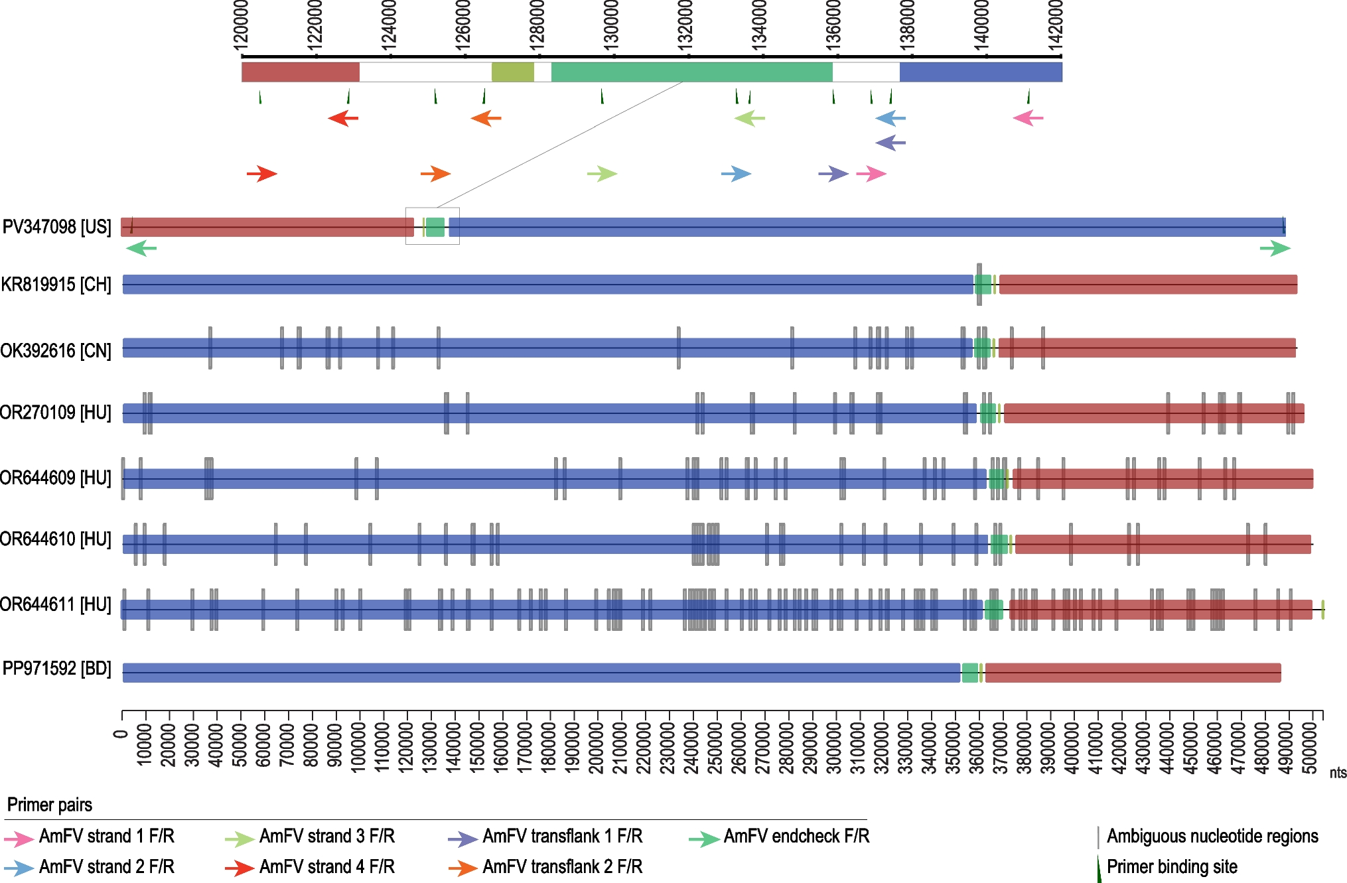

Figure 1. Illustration of primer binding sites for the verification of the inverted translocation/genome rearrangement region in the AmFV – CTN3 (PV347098) genome. A comparison of the relative genome arrangement is provided with the output from the Mauve (Darling et al., 2004) genome alignment. The ambiguous nucleotide regions in the genomes available in GenBank are highlighted as grey vertical bars. Adapted from Bandoo et al. (2026).
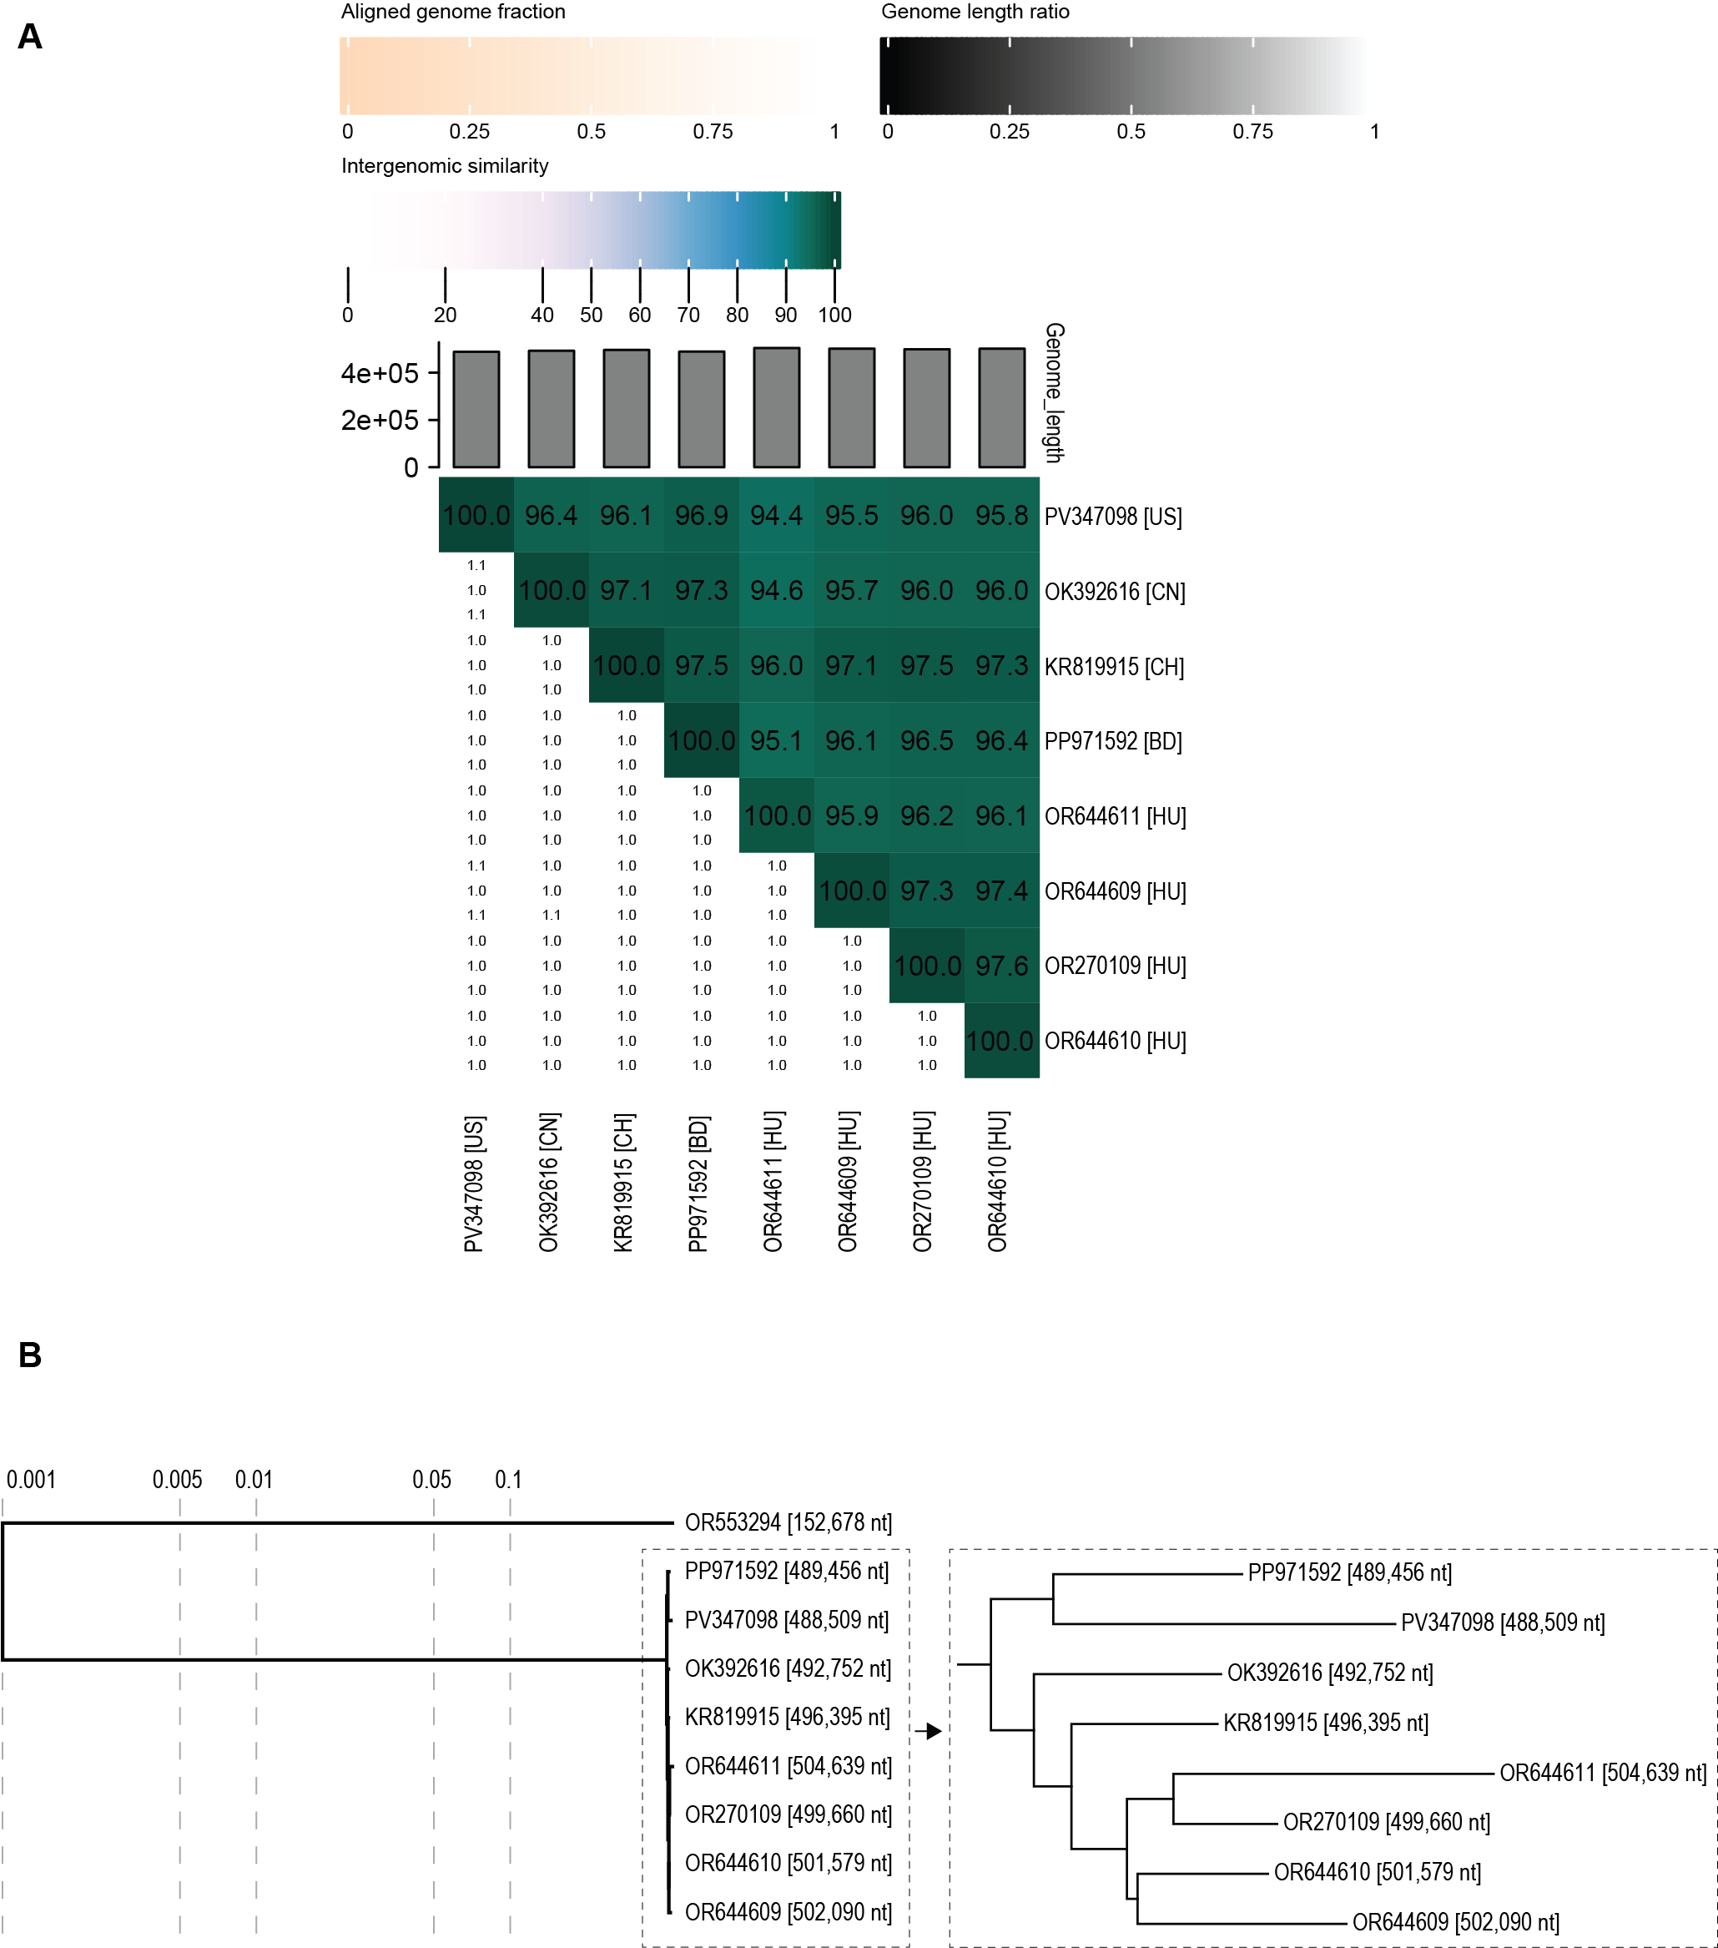

Figure 2: A. Intergenomic identity plot of AmFV genomes available in GenBank determined using VIRIDIC (Moraru et al., 2020). B. Proteomic tree inferred using ViPTree (Nishimura et al., 2017) of the AmFV sequences. Apis mellifera filamentous-like virus (OR553294), a divergent relative of AmFV, was used as an outgroup. The log branch length scaling is shown and a zoomed in section of the tree with AmFV sequences is provided on the right. Adapted from Bandoo et al. (2026).

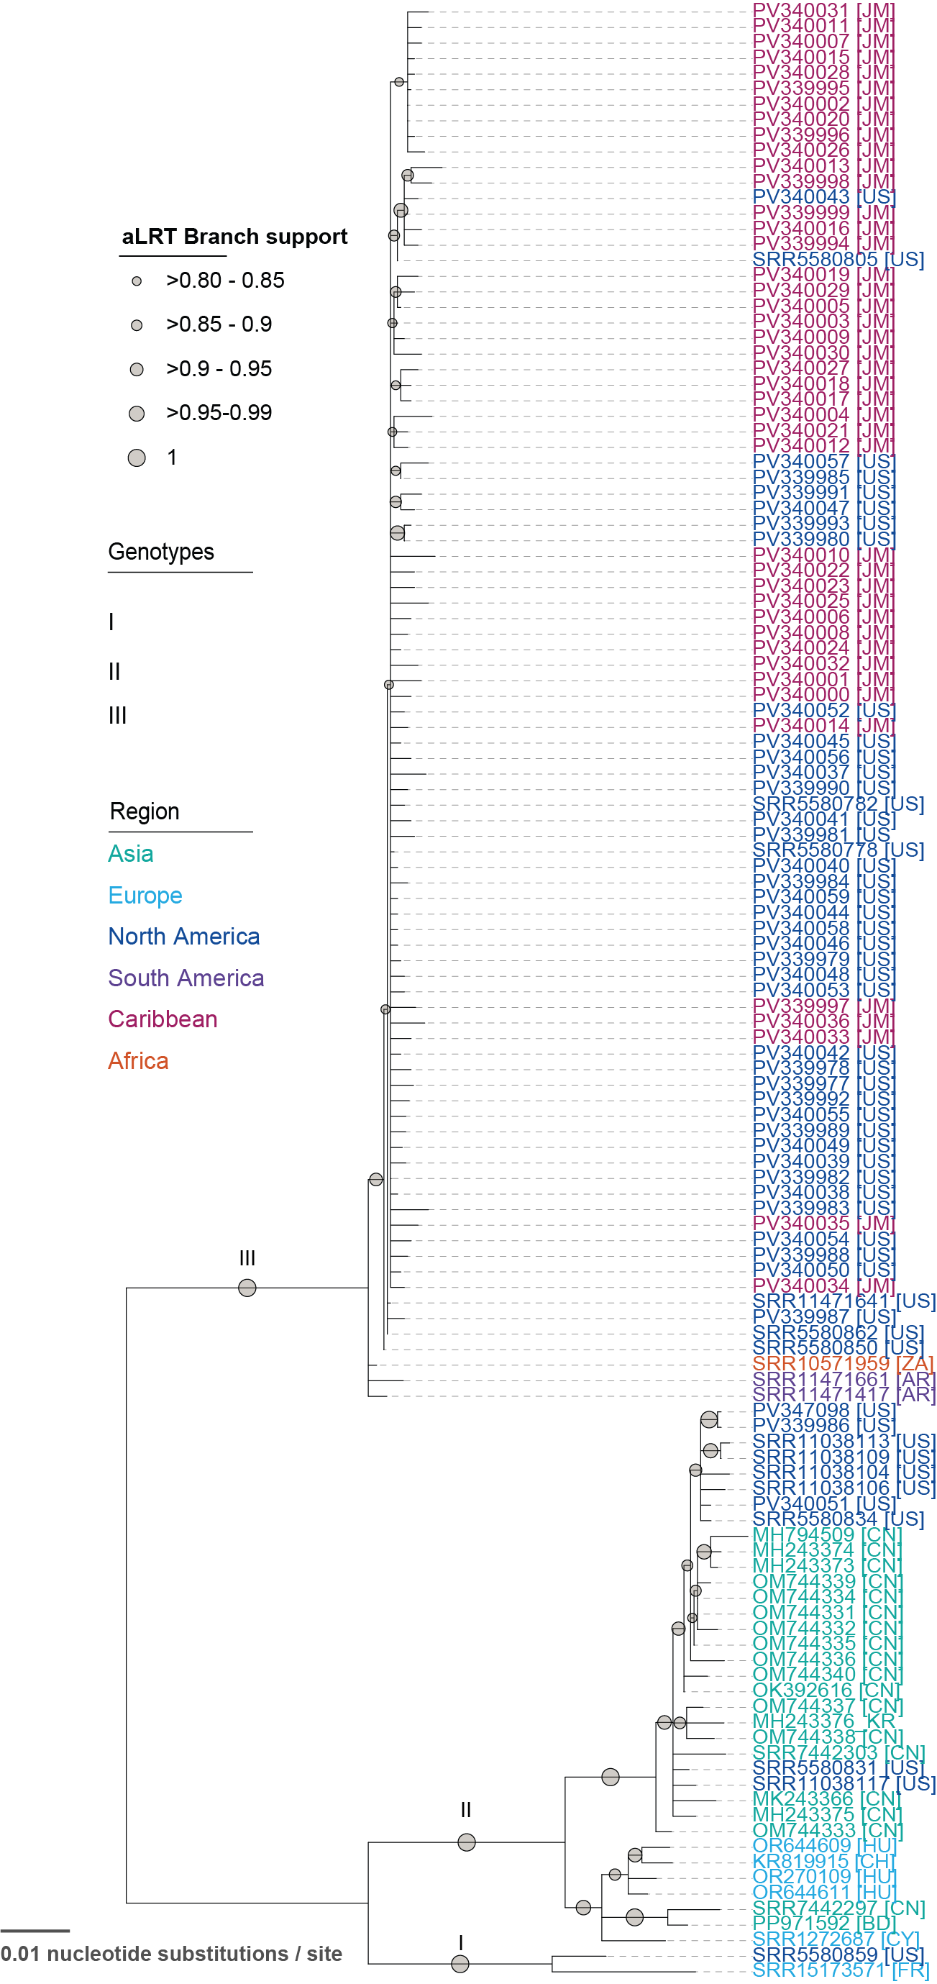

Figure 3: Midpoint rooted maximum-likelihood phylogenetic tree of the AmFV DNA polymerase nucleotide sequences available in GenBank, along with those from SRA-based assemblies. Adapted from Bandoo et al. (2026).

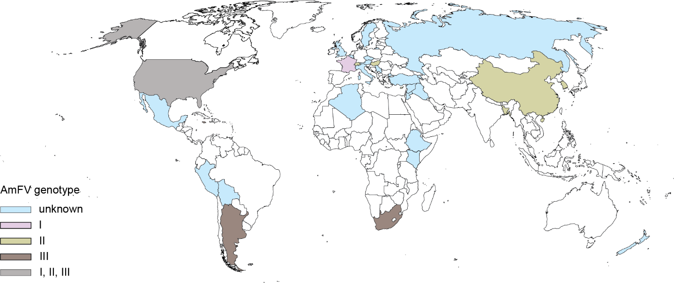

Figure 4: The current known distribution of AmFV across the world includes Algeria, Argentina, Armenia, Bangladesh, Belgium, China, Cyprus, England, Ethiopia, France, Hungary, Italy, Jamaica, Jordan, Kenya, Mexico, New Zealand, Peru, the Plurinational state of Bolivia, the Republic of Kosovo (not recognized by the UN), Scotland, South Africa, the State of Palestine, Sweden, Switzerland, the Syrian Arab Republic, the Czech Republic, the Republic of Korea, the Russian Federation, the United States of America, and Turkey. The countries are color-coded based on the genotypes from the AmFV DNA pol sequence analyses with the USA shown in grey to indicate all three genotypes that have been identified circulating in bees. Unknown = no sequence information to determine genotype. Adapted from Bandoo et al. (2026).

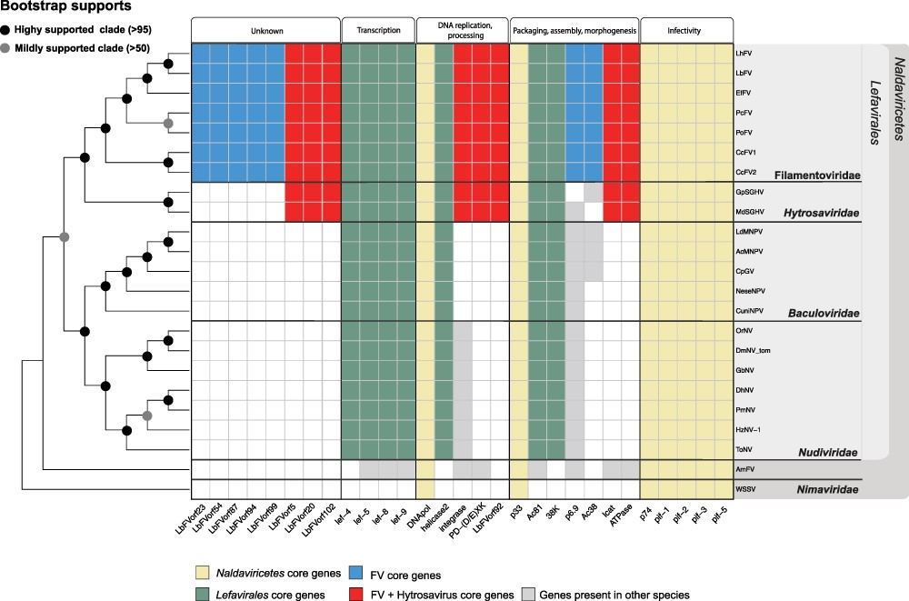Figure 5. Heatmap representing the core gene content of filamentovirids related to Leptopilina boulardi filamentous virus (LbFV) compared to virus representatives of Naldaviricetes. A cladogram phylogeny is reported on the left. Taxonomic affiliation of considered viruses is reported on the right. The rows represent the viral species, and the columns represent the genes grouped according to their potential functions. Colored cells indicate the presence of the gene in viral genomes. Of note, the homolog of baculovirid helicase is the helicase 2 in nudivirids, hytrosavirids, and filamentovirids. The figure is reproduced from Guinet et al., 2024.

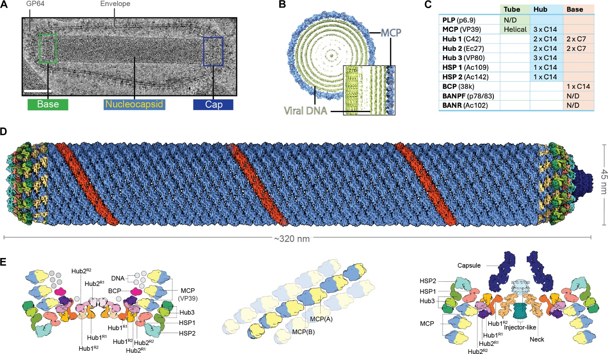

Figure 6. The baculovirid nucleocapsid has a unique helical organization sealed by complex base and cap structures. (A) Representative image of a purified AcMNPV BV imaged under cryogenic conditions. Scale bar, 50 nm. (B) Clipped, top view of the helical reconstruction of the nucleocapsid with the MCP VP39 represented in blue and the internal DNA in green. Inset: Clipped side view of the nucleocapsid tube. (C) Composition of the base and tube including the symmetry and stoichiometry determined by cryo-EM. N/D, not determined. (D) Cryo-EM reconstruction of the entire nucleocapsid, assembled from individual reconstructions of the base, tube, and cap. Base (left) and cap (right) colored according to individual subunits. The nucleocapsid tube is colored blue with an individual strand represented in red. (E) Molecular organization of the base (left), tube (middle), and cap (right) as a schematic representation. (Middle) An individual MCP strand of the nucleocapsid helical tube is highlighted with adjacent strands shown in a semitransparent representation. The figure is reproduced from Johnstone et al., 2024.

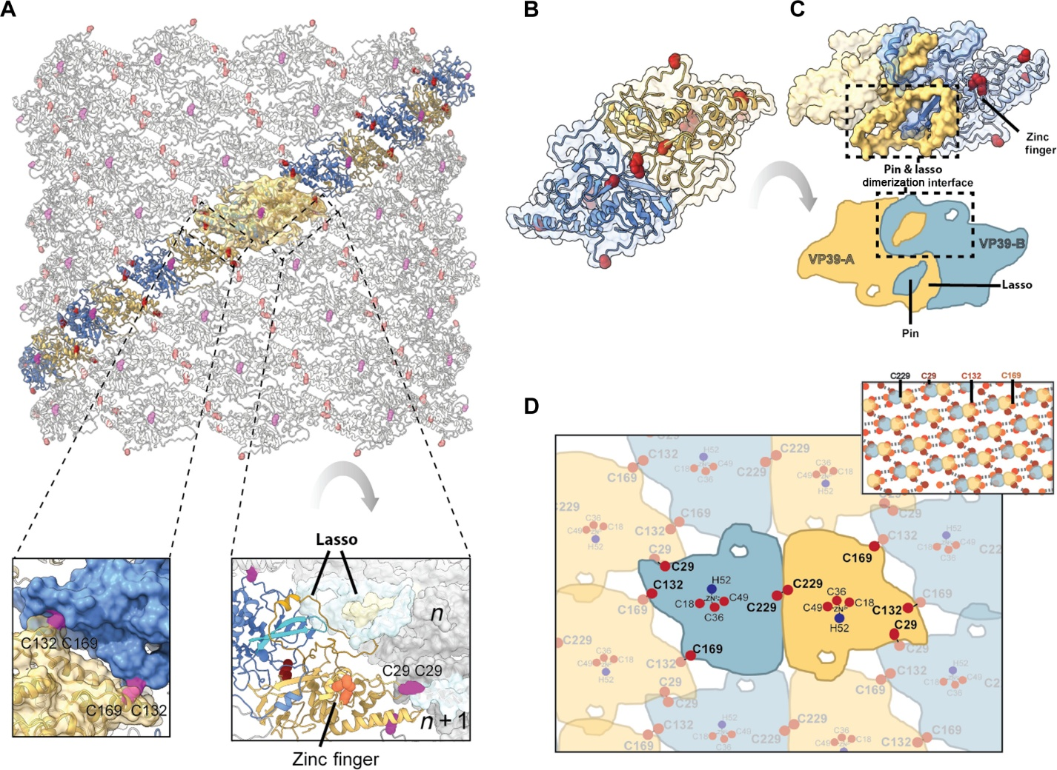

Figure 7. The baculovirid nucleocapsid is a cross-linked helical tube stabilized by intermolecular cross-links and a tight pin/lasso interaction. (A) Arrangement of the MCP subunits in the helical tube seen from the outside of the particle. A single, helical strand is highlighted by coloring of the dimer subunits in yellow and blue, with adjacent strands shown in gray. A single asymmetric unit is shown overlaid with the cryo-EM reconstruction as a semitransparent yellow surface. Cysteines potentially involved in intradimer and interdimer disulfide bonds are shown as pink and red spheres, respectively. Bottom left inset: Zoomed-in view of the intra-strand disulfide bond between the adjacent Cys169 and Cys132 residues. Bottom right inset: Zoomed-in view of the interstrand interactions viewed from the inside of the virion, including the putative Cys29-Cys29 disulfide bond and associated zinc finger motif, and the β sheet interaction of two adjacent lassos. (B) MCP dimer formed by two subunits shown in cartoon and semitransparent surface representations as in (A). (C) (Top) MCP dimer, rotated 180° around the y axis with respect to (B). The interdimer pin-lasso interaction is shown by darker yellow and blue coloring with respect to the rest of the molecule (black dashed box). (Bottom) Schematic representation of the dimer and pin-lasso interaction. (D) Schematic of the disulfide network between adjacent MCP dimers. Top right inset: Extended representation of the disulfide network. The dimer is represented by two circles at the center of mass of each subunit. Disulfide bonds are represented by dashed lines with Cys29, Cys132, and Cys169 shown as maroon, red, and orange spheres, respectively. The figure is reproduced from Johnstone et al., 2024.

Figure 8. Structures and topological diagrams of VP39-like MCP orthologs. Baculovirids are represented by the experimental structure of the MCP of Autographa californica multiple nucleopolyhedrovirus (AcMNPV; PDB id: 8VWH), whereas the other virus groups are represented by AlphaFold models (GenBank accession numbers are shown under the corresponding models). Homologs of the baculovirus VP39 MCP were identified by iterative FoldSeek (van Kempen et al., 2024) searches against the BFVD structure database (Kim et al., 2025) initiated with the experimentally determined structure of AcMNPV VP39 (PDB id: 8VWH). The structures and topological diagram are colored using the rainbow scheme from blue (N-terminus) to red (C-terminus). The legend in the bottom right corner explains the key elements shown in the topological diagrams (Johnstone et al., 2024). Unstructured N- or C-terminal regions were removed from some models for visualization purposes.

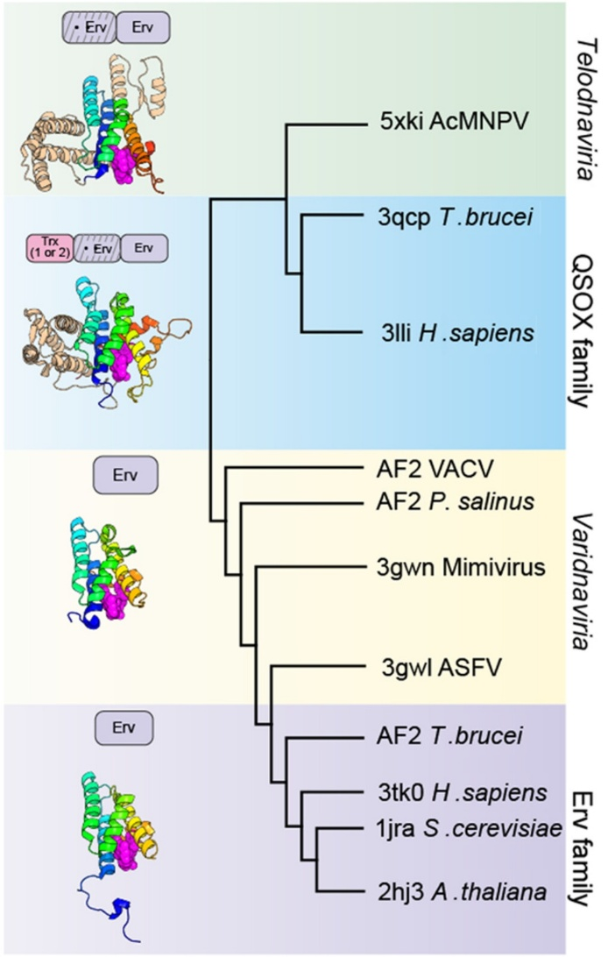

Figure 9. Structure-based relationships between cellular and viral sulfhydryl oxidases represented as a cluster dendrogram constructed based on the pairwise z-score comparisons calculated using DALI. (Left) Domain organizations for proteins in the four highlighted groups of sulfhydryl oxidases and representative structures (PDB IDs: 3tk0, 3gwn, 3lli, and 3pk0) and their cartoon representation with the Erv domain colored as a rainbow and unique domains in the baculovirus and QSOX proteins in light brown. The FAD molecule is shown as magenta spheres. The figure is reproduced from Johnstone et al., 2024.

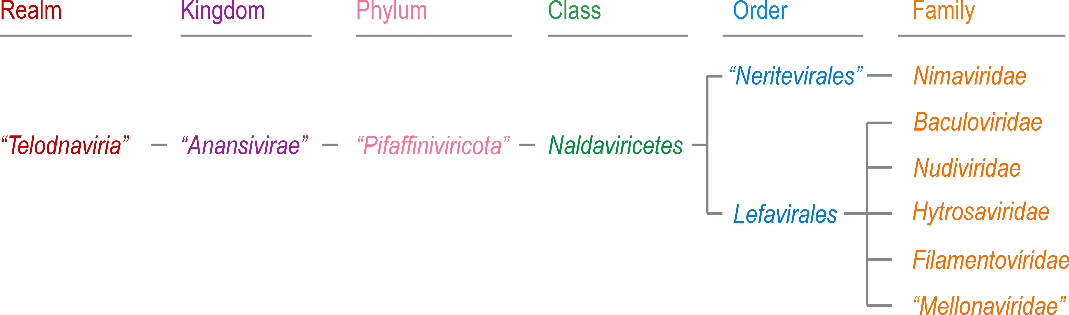
Figure 10. Proposed taxonomic structure of the realm “Telodnaviria”.

