

The International Committee on Taxonomy of Viruses
Taxonomy Proposal Form, 2025

Part 1a: Details of taxonomy proposals

Title: | Create a novel genus within the Family Phenuiviridae :genus Cotylvirus and 7 novel species
Code assigned: | 2026.001M.N.v2.Phenuiviridae_1ng_7ns

Author(s), affiliation and email address(es):
Surname | Initials | Affiliation | Email address | Corresponding author(s)
Dheilly | NMD | Institut Pasteur, Pathogen Discovery laboratory | nolwenn.dheilly@pasteur.fr | X
Capai | LC | Institut Pasteur, Pathogen Discovery laboratory | lisandru.capai@pasteur.fr

Part 1b: Taxonomy Proposal Submission
ICTV Subcommittee:
Animal DNA Viruses and Retroviruses |  | Bacterial viruses
Animal minus-strand and dsRNA viruses | X | Fungal and protist viruses
Animal positive-strand RNA viruses |  | Plant viruses
Archaeal viruses |  | General -Submit to Proposals Secretary

List the ICTV Study Group(s) that have seen or have been involved in creating this proposal:.
Phenuiviridae SG
Optional – complete only if formally voted on by an ICTV Study Group: <
Study Group | Number of members
Study Group | Votes in support | Votes against | No vote

Submission date: | 24/09/2026

Part 1c: Feedback from ICTV Executive Committee (EC) meeting <
Executive Committee Meeting Decision code: | X
A – Accept
Ac – Accept subject to revision by relevant subcommittee chair. No further vote required
U – Accept without revision but with re-evaluation and email vote by the EC
Uc – Accept subject to revision and re-evaluation and email vote by the EC
Ud – Deferred to the next EC meeting, with an invitation to revise based on EC comments
J - Reject
W - Withdrawn

Comments from the Executive Committee:

Part 1d: Revised Taxonomy Proposal Submission >
Response of proposer:
Revision date:

Enter date of the revised version (DD/MM/YYYY).

Part 3: TAXONOMIC PROPOSAL

Taxonomic changes proposed:
Establish new taxon | X | Split taxon
Abolish taxon |  | Merge taxon
Move taxon |  | Promote taxon
Rename taxon |  | Demote taxon
Move and rename

Etymology (origin) of proposed taxonomic names:.
Taxon name | Etymology of the term
Cotylvirus | derived from Kotyle, the Greek word for cup/socket, referencing to ventral sucker of trematodes
Cotylvirus japonicum | Named after the host Schistosoma japonicum
Cotylvirus schistojap | Named after the host Schistosoma japonicum
Cotylvirus sinensis | Named after the host Clonorchis sinensis
Cotylvirus viverrini | Named after the host Opisthorchis viverrini
Cotylvirus orientalis | Named after the host Metorchis orientalis
Cotylvirus regenti | Named after the host Trichobilharzia regenti
Cotylvirus pseudoglobulus | Named after the host Sphaeridiotrema pseudoglobulus

Permission for use of names derived from a living person
Taxon name | Full name of person from whom the name is derived | Attached X
NA | NA

Abstract of Taxonomy Proposal:
Taxonomic rank(s) affected: Orthonavirae; Negarnaviricota; Polyploviridae; Bunyaviricetes; Hareavirales; Phenuiviridae

Description of current taxonomy: There are currently 24 genera and 223 species in the family Phenuiviridae

Proposed taxonomic change(s): Establishment of a novel genera “Cotylvirus” in the Family Phenuiviridae, and 7 novel species. All viruses were discovered in parasitic flatworms, all trematodes as follow:
- two novel species identified in Schistosoma japonicum (Shi et al. 2016)
- A novel species identified in Clonorchis sinensis (Dheilly et al., 2022)
- A novel species identified in Opisthorchis viverrini (Chaiyadet et al. 2025)
- A novel species identified in Metorchis orientalis (Dheilly et al., 2022)
- A novel species identified in Trichobilharzia regenti (Dheilly et al., 2022)
- A novel species identified in Sphaeridiotrema pseudoglobulus (Dheilly et al., 2022)

Justification: All viruses within proposed genus “Cotylvirus” have been discovered within parasitic flatworms, enclose a bi-segmented genome, and constitute a very distinct phylogenetic clade within the family Phenuiviridae.

Text of Taxonomy proposal

Taxonomic rank(s) affected: Orthonavirae; Negarnaviricota; Polyploviridae; Bunyaviricetes; Hareavirales; Phenuiviridae

Taxonomic rank(s) affected: Orthonavirae; Negarnaviricota; Polyploviridae; Bunyaviricetes; Hareavirales; Phenuiviridae

Description of current taxonomy: There are currently 24 genera in the family Phenuiviridae

Proposed taxonomic change(s): Establishment of a novel genus in the Family Phenuiviridae, and 7 novel species. All viruses were discovered in parasitic flatworms as follow:
- two novel species identified in Schistosoma japonicum (Shi et al. 2016)
- A novel species identified in Clonorchis sinensis (Dheilly et al., 2022)
- A novel species identified in Opisthorchis viverrini (Chaiyadet et al. 2025)
- A novel species identified in Metorchis orientalis (Dheilly et al., 2022)
- A novel species identified in Trichobilharzia regenti (Dheilly et al., 2022)
- A novel species identified in Sphaeridiotrema pseudoglobulus (Dheilly et al., 2022)

ICTV genus demarcation criteria
The coding-complete sequences of all genome segments may be sufficient for phenuivirids classification. Demarcation of genera is based on a comprehensive assessment of virus phylogenetic relationships, genome organization, and ecology, including host range, pathobiology, and transmission patterns.

Justification:
All viruses assigned to the proposed genus “Cotylvirus” were identified in trematodes and possess a bi-segmented genome organization. Phylogenetic analyses based on the amino acid sequences of the RNA-dependent RNA polymerase (RdRp) place all proposed “Cotylvirus” viruses within a well-supported and clearly distinct monophyletic clade within the family Phenuiviridae, separate from all currently recognized genera. RdRp protein sequences of the genus “Cotylvirus” present less than 30% identity to the RdRp of all other genera within the Phenuiviridae. The overall topology of RdRp and nucleoproteins viral phylogenies are highly consistent with each other and with flatworms’ evolution confirming virus-parasite co-diversification and strong host specificity with no evidence of host switching (Figure 1).

The genomes of all proposed “Cotylvirus” members encode recognizable viral RNA-dependent RNA polymerase (RdRp) and nucleoprotein (N) genes, which show phylogenetic relationships consistent with their assignment to the family Phenuiviridae. Only viruses for which both genome segments were available were considered for the proposed species classification.
Terminal nucleotide analyses revealed complementary 3’ and 5’ termini conserved among segments of the same virus (Table 2), a hallmark of viruses within the order Hareavirales forming non-covalently closed ribonucleoprotein complexes. Combined with Shan et al. demonstration that these RNAs are not encoded within S. japonicum genome, that the RdRp catalyzes replication of RNA and can be inhibited by the antiviral treatment Favipiravir, and that dsRNA intermediates are detectable using J2 antibodies, these data unequivocally demonstrate viral replication machinery, viral genomic architecture, and sensitivity to antiviral compounds - definitive evidence that these RNAs represent bona fide viruses.

Notably, none of the viruses within the proposed family encode a glycoprotein (Dheilly et al. 2022). Recently Shan et al. (2025) prepared enriched viral fractions that were further sequenced but the absence of a third segment was confirmed. Shan et al. (2025) also showed HBFV1/2 persistence across eggs, schistosomula and adult worms, and provide in situ hybridization and single cell sequencing data demonstrating the tropism of HBFV1/2 for ovaries, testes and eggs which further suggest strict vertical transmission of these viruses. Likewise, Chaiyadet et al. (2025) demonstrate OPLV localization within eggs. Together with the previously reported co-diversification of the viruses with their parasitic hosts, these data suggest that the viruses are vertically transmitted, likely as an adaptation to their parasitic host's lifestyle that limits opportunities for horizontal transmission. Vertical transmission could explain the absence of glycoprotein and suggest that the genomes are indeed complete.

Thus, the proposed viruses share a common ecological association with trematodes and exhibit a conserved genome organization consistent with their placement within the family. Collectively, these phylogenetic, genomic, and ecological characteristics support the establishment of “Cotylvirus” as a distinct genus within the family Phenuiviridae.

ICTV species demarcation criteria
The criteria demarcating species within the genus are based on the amino acid sequence identity of the RdRp. Viruses assigned to different species have less than 95% amino acid identity in the RdRp sequence.

Justification:
The proposed “Cotylvirus” species are genetically distinct from one another (Table 1), with pairwise amino acid identities of the RdRp below the 95% species demarcation threshold. In addition to this sequence divergence, the proposed species form distinct phylogenetic lineages within the “Cotylvirus” clade. The combination of RdRp sequence divergence and consistent phylogenetic separation supports their classification as distinct species within the proposed genus “Cotylvirus”.

References:
- Shi, M. et al. Redefining the invertebrate RNA virosphere. Nature 540, 539–543 (2016).
- Dheilly, N. M., Lucas, P., Blanchard, Y. & Rosario, K. A World of Viruses Nested within Parasites: Unraveling Viral Diversity within Parasitic Flatworms (Platyhelminthes). Microbiol Spectr 10, e0013822 (2022).
- Chaiyadet, S. et al. Fluke-borne viruses are a risk factor for diseases caused by carcinogenic trematodes. Preprint at https://doi.org/10.1101/2025.10.22.683923 (2025).
- Shan, T. et al. Non-parasite genome encoded virus-like RNAs reprogram the pathogenicity of human blood flukes. Nat Commun https://doi.org/10.1038/s41467-025-67822-1 (2025) doi:10.1038/s41467-025-67822-1.

Accompanying files:
Filename | Description of contents
2026.001M.PercentageIdentityMatric_Phenuiviridae_1ng_7ns | Complete RdRp protein identity matrix of viruses in Phenuiviridae family and Cotylvirus

Tables, Figures:

Table 1| Percentage identity matrix of the RdRp of the seven novel species enclosed within the genus “Cotylvirus” compared with representative species of the family Phenuiviridae.
Phenuiviridae | Cotylvirus | DAZ87746.1_Sphaeridio_phenuili_virus | 100 | 43,3 | 44,4 | 43,3 | 42,7 | 49,5 | 42,3 | 22,1 | 22,2 | 21,6
Phenuiviridae | Cotylvirus | DAZ87768.1_Metorchi_phenuili_virus | 43,3 | 100 | 67,6 | 66,8 | 44,1 | 52,3 | 44 | 21,7 | 22,2 | 20,4
Phenuiviridae | Cotylvirus | DAZ87849.1_Clonorchi_Phenuili_virus | 44,4 | 67,6 | 100 | 89,1 | 44,2 | 51,6 | 44,8 | 22,5 | 22,2 | 21,7
Phenuiviridae | Cotylvirus | YAW77665.1_Opisthorphenuilivirus | 43,3 | 66,8 | 89,1 | 100 | 43,4 | 52 | 43,8 | 21,9 | 22 | 20,9
Phenuiviridae | Cotylvirus | DAZ87991.1_Trichobi_phenuili_virus_1 | 42,7 | 44,1 | 44,2 | 43,4 | 100 | 53,5 | 47,6 | 20,7 | 21,2 | 19,9
Phenuiviridae | Cotylvirus | APG79250.1_Hubei_blood_fluke_virus_2 | 49,5 | 52,3 | 51,6 | 52 | 53,5 | 100 | 63,8 | 24,8 | 25,2 | 24,4
Phenuiviridae | Cotylvirus | APG79252.1_Hubei_blood_fluke_virus_1 | 42,3 | 44 | 44,8 | 43,8 | 47,6 | 63,8 | 100 | 21,8 | 21,9 | 19,6
Phenuiviridae | Horwuvirus | AJG39260.1_Wuhan_Horsefly_virus | 22,1 | 21,7 | 22,5 | 21,9 | 20,7 | 24,8 | 21,8 | 100 | 28,1 | 25,2
Phenuiviridae | Phlebovirus | WJL97919.1_Rift_valley_fever_virus | 22,2 | 22,2 | 22,2 | 22 | 21,2 | 25,2 | 21,9 | 28,1 | 100 | 26,3
Phenuiviridae | Pidchovirus | AOX47534.1_Pidgey_virus | 21,6 | 20,4 | 21,7 | 20,9 | 19,9 | 24,4 | 19,6 | 25,2 | 26,3 | 100

Table 2| Terminal nucleotides of the RNA segments of Hubei Blood Fluke virus 1 and 2.
Virus | Segments | 3’ termini | 5’termini
HBFV1 | L | ACACAACGACACCAG | UGGUGGUCAAUGUGU
HBFV1 | S | ACACAUCGACAGCCA | GGCUGGUCGUUGUGU
HBFV 2 | L | ACACAACGCCGCCAA | UGGUGGUCGUUGUGU
HBFV 2 | S | ACACAACGCCGUCCA | GGACGGUCGUUGUGU

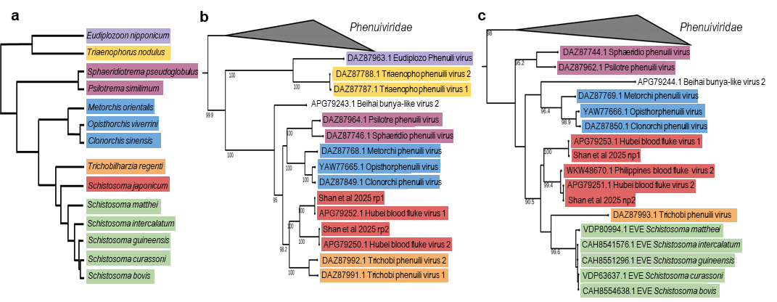
Figure 1| Phylogenetic relationships of Neodermata-associated “Cotylvirus” viruses inferred from RdRp and Nucleoprotein sequences, alongside host parasite cladogram. (a) Cladogram representing the phylogenetic relationships among parasite taxa. The tree includes color-coded parasite species for which “cotylvirus” sequences were found. (b and c) Maximum likelihood phylogenetic tree based on amino acid sequences of the RdRp (b), or Nucleoprotein (c) inferred using PhyML with the best-fit substitution model and 1,000 bootstrap replicates. Bootstrap support values are indicated at the nodes. Phenuiviridae viruses are used as outgroup. Color code is conserved across panels. Sequences shown in green represent endogenous viral elements detected within the genomes of closely related Schistosomes.

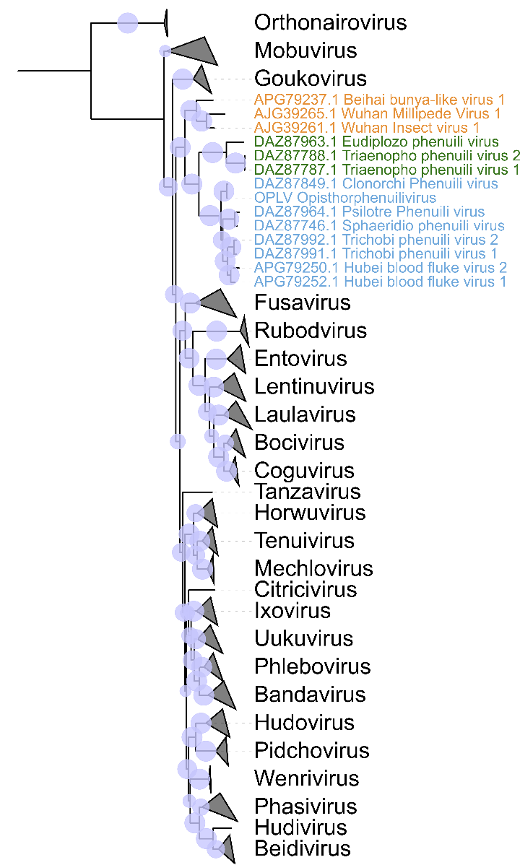
Figure 2. Maximum-likelihood phylogenetic tree showing the proposed new species in blue, within the novel genus Cotylvirus and their phylogenetic position within the family Phenuiviridae.
Phylogenetic analyses were performed using amino acid sequences of the RNA-dependent RNA polymerase (RdRp) representing all recognized genera within the family Phenuiviridae. Sequences were aligned using MAFFT v7.526 with the “auto” option. The resulting alignment was trimmed using trimAl with the “automated1” setting to remove poorly aligned and gap-rich positions. A maximum-likelihood phylogenetic tree was reconstructed using IQ-TREE v3.1.0. The best-fitting amino acid substitution model was selected using ModelFinder based on the Bayesian Information Criterion (BIC). Branch support was assessed using the SH-like approximate likelihood ratio test (SH-aLRT) with 10,000 replicates. The newly proposed viral species within the genus Cotylvirus are highlighted in blue the tree. Viruses of other platyhelminthes, namely the Eudiplozo phenuili virus (from a monogenanean parasite) and Triaenopho phenuili virus (from a cestode parasite) are shown in green whereas viruses of arthropods are shown in orange. They each form distinct clades on the tree.

