

The International Committee on Taxonomy of Viruses
Taxonomy Proposal Form, 2026
Part 1a: Details of taxonomy proposals

Title: | Create one new species in the genus Ephemerovirus (Rhabdoviridae: Alpharhabdovirinae)
Code assigned: | 2026.004M.N.v1.Ephemerovirus_1nsp

Author(s), affiliation and email address(es):
Given name (+middle initial(s)) | Surname | Affiliation | Email address | Corr. author(s)
Peter J | Walker | School of Chemistry and Molecular Biosciences, The University of Queensland, St Lucia, Australia | peter.walker@uq.edu.au | X
Nicolas | Bejerman | Consejo Nacional de Investigaciones  Científicas y Técnicas and Instituto Nacional de Tecnología Agropecuaria, Argentina | nicobejerman@gmail.com
Kim R | Blasdell | CSIRO Biosecurity, Geelong, Australia | kim.blasdell@csiro.au
Humberto | Debat | Instituto Nacional de Tecnología Agropecuaria, Argentina | humbertodebat@gmail.com
Ralf G | Dietzgen | University of Queensland, St Lucia, Australia | r.dietzgen@uq.edu.au
Anthony R | Fooks | Animal and Plant Health Agency, Addlestone, UK | Tony.Fooks@apha.gov.uk
Juliana | Freitas-Astúa | EMBRAPA Mandiocae e Fruticultura, Cruz das Almas, Brazil | juliana.astua@embrapa.br
Kyle | Garver | Pacific Biological Station, Fisheries and Oceans Canada, Nanaimo, Canada | kyle.garver@dfo-mpo.gc.ca
Pedro L | Ramos-Gonzáles | Instituto Biológico, São Paulo, Brazil | plrg1970@gmail.com
Hideki | Kondo | Okayama University, Kurashiki, Japan | hkondo@rib.okayama-u.ac.jp
Robert B | Tesh | University of Texas Medical Branch, Galveston, USA | Rbtesh22@gmail.com
Noel | Tordo | Institut Pasteur, Conakry, Guinée | ntordo@pasteur.fr
Nikos | Vasilakis | University of Texas Medical Branch, Galveston, USA | nivasila@utmb.edu
Anna E | Whitfield | NC State University, Raleigh, USA | awhitfi@ncsu.edu

Part 1b: Taxonomy Proposal Submission
ICTV Subcommittee:
Animal DNA Viruses and Retroviruses |  | Bacterial viruses
Animal minus-strand and dsRNA viruses | X | Fungal and protist viruses
Animal positive-strand RNA viruses |  | Plant viruses
Archaeal viruses |  | General -

List the ICTV Study Group(s) that have seen or have been involved in creating this proposal:
Rhabdoviridae Study Group
Optional – complete only if formally voted on by an ICTV Study Group:
Study Group | Number of members
Study Group | Votes in support | Votes against | No vote
Rhabdoviridae SG | 14 | o

Submission date: | 17/08/2026

Part 1c: Feedback from ICTV Executive Committee (EC) meeting
Executive Committee Meeting Decision code: | X
A – Accept
Ac – Accept subject to revision by relevant subcommittee chair. No further vote required
U – Accept without revision but with re-evaluation and email vote by the EC
Uc – Accept subject to revision and re-evaluation and email vote by the EC
Ud – Deferred to the next EC meeting, with an invitation to revise based on EC comments
J - Reject
W - Withdrawn

Comments from the Executive Committee:

Part 1d: Revised Taxonomy Proposal Submission
Response of proposer:
Revision date:

Part 3: TAXONOMIC PROPOSAL

Taxonomic changes proposed:
Establish new taxon | X | Split taxon
Abolish taxon |  | Merge taxon
Move taxon |  | Promote taxon
Rename taxon |  | Demote taxon
Move and rename

Etymology (origin) of proposed taxonomic names:
Taxon name | Etymology of the term
Ephemerovirus anhui | From Anhui Province, China, the collection locality of the exemplar virus (wild boar ephemerovirus, strain WilAH01/2019; GenBank PP975074).

Permission for use of names derived from a living person:
Taxon name | Full name of person from whom the name is derived | Attached
NONE

Abstract of Taxonomy Proposal:
Description of current taxonomy:
The genus Ephemerovirus (family Rhabdoviridae, subfamily Alpharhabdovirinae) currently comprises 16 species. Its members are negative-sense RNA viruses of mammals transmitted by haematophagous arthropods, and include bovine ephemeral fever virus, the cause of an economically important disease of cattle and water buffalo.
Proposed taxonomic change(s):
We propose the creation of one new species (Ephemerovirus anhui) in the genus Ephemerovirus, represented by an exemplar virus (wild boar ephemerovirus; WBEV) with a coding-complete genome sequence available from GenBank.
Demarcation criteria for new taxon/taxa:
The candidate virus was assessed against the amino acid sequence divergence and genome organisation criteria defined for the genus Ephemerovirus.
Justification:
Wild boar ephemerovirus exceeds the L, N and G protein amino acid divergence thresholds relative to all existing species in the genus.

Text of Taxonomy proposal:
Description of current taxonomy:
The genus Ephemerovirus (Rhabdoviridae: Alpharhabdovirinae) currently comprises 16 species.
Proposed taxonomic change(s):
1. Create one new species in the genus Ephemerovirus
Wild boar ephemerovirus (WBEV) was detected by metagenomic sequencing of the liver of wild boar (Sus scrofa) in China [1]. The exemplar strain, WilAH01/2019, was collected in 2019 in Anhui Province (GenBank PP975074; 14,615 nt), and a second, conspecific strain, GX05/2020, was collected in 2020 in Guangxi Province (GenBank PP975076; 14,614 nt).
We propose that WBEV be assigned to the new species Ephemerovirus anhui.
Ecology
Ephemeroviruses are arthropod-borne rhabdoviruses of mammals. Bovine ephemeral fever virus causes an economically important febrile disease of cattle and water buffalo across Africa, Asia and Australia, and several other ephemeroviruses infect or have been isolated from cattle. Member viruses have been isolated from or detected in cattle and pigs and haematophagous insects, including mosquitoes and biting midges that act as vectors; two species have been detected in ticks by metagenomic sequencing. Two porcine ephemeroviruses, porcine ephemerovirus 1 (PoEV1; species Ephemerovirus henan) and porcine ephemerovirus 2 (PoEV2; species Ephemerovirus guangdong), were identified in pigs in China [2]. The detection of WBEV in wild boar in China is consistent with this ecology and extends the known suid host range of the genus.
Phylogenetic analysis
Based on ML trees using the complete L protein sequences, WBEV falls with ephemeroviruses in a well-supported monophyletic clade, in a subclade with PoEV1 and PoEV2 (Figure 1).
Genome organisation
The coding-complete genome sequence of WBEV (exemplar strain WilAH01/2019; GenBank PP975074; 14,615 nt) has been reported. The genome lacks only the 3′ and 5′ termini. The genome organisation is typical of viruses in the genus Ephemerovirus, containing the five canonical rhabdovirus structural protein genes (N, P, M, G and L), a gene encoding the non-virion glycoprotein G_{NS} between the G and L genes, and a set of small accessory ORFs (α1, α2, β and γ) in the region between the G_{NS} and L genes, comprising nine transcription units in total, consistent with the genome organisation of bovine ephemeral fever virus and other ephemeroviruses (Figure 2).
Amino acid sequence identities
Pairwise sequence identities (p-distances) calculated from FAMSA [1] amino acid sequence alignments indicate that WBEV is most closely related to PoEV2 in the L, N and G proteins (75.1%, 87.0% and 69.8% identity, respectively) (Tables 1–3).
Species demarcation criteria
Viruses assigned to different species within the genus Ephemerovirus have several of the following characteristics: A) minimum amino acid sequence divergence of 15% in the L proteins; B) minimum amino acid sequence divergence of 8% in the N proteins; C) minimum amino acid sequence divergence of 12% in the G proteins; D) they can be distinguished in serological tests; and E) significant differences in genome organisation as evidenced by numbers and locations of ORFs.
WBEV meets demarcation criteria A, B and C, with amino acid sequence divergence of 24.9% in the L protein, 13.0% in the N protein and 30.2% in the G protein relative to its closest relative, PoEV2, exceeding the thresholds relative to all existing species in the genus. Serological tests (criterion D) have not been conducted as no virus isolate is currently available. The genome organisation is similar to those of other ephemeroviruses (criterion E).
References:
1. Deorowicz S, Debudaj-Grabysz A, Gudyś A (2016) FAMSA: Fast and accurate multiple sequence alignment of huge protein families. Scientific Reports 6:e33964. https://doi.org/10.1038/srep33964
2. Tu Z, Wang T, Xu Y, Sun H, Peng P, Qin S, Tu C (2025) Identification and genetic analysis of new ephemeroviruses in wild boars in China. Virologica Sinica 40:186-191. https://doi.org/10.1016/j.virs.2025.02.002.
3. He B, Zhu G, Gong W, Tu C. (2022) Identification of two novel ephemeroviruses in pigs infected by classical swine fever virus. Infection, Genetics and Evolution 100: e105273. https://doi.org/10.1016/j.meegid.2022.105273.

Accompanying files:
Filename | Description of contents

Tables, Figures:
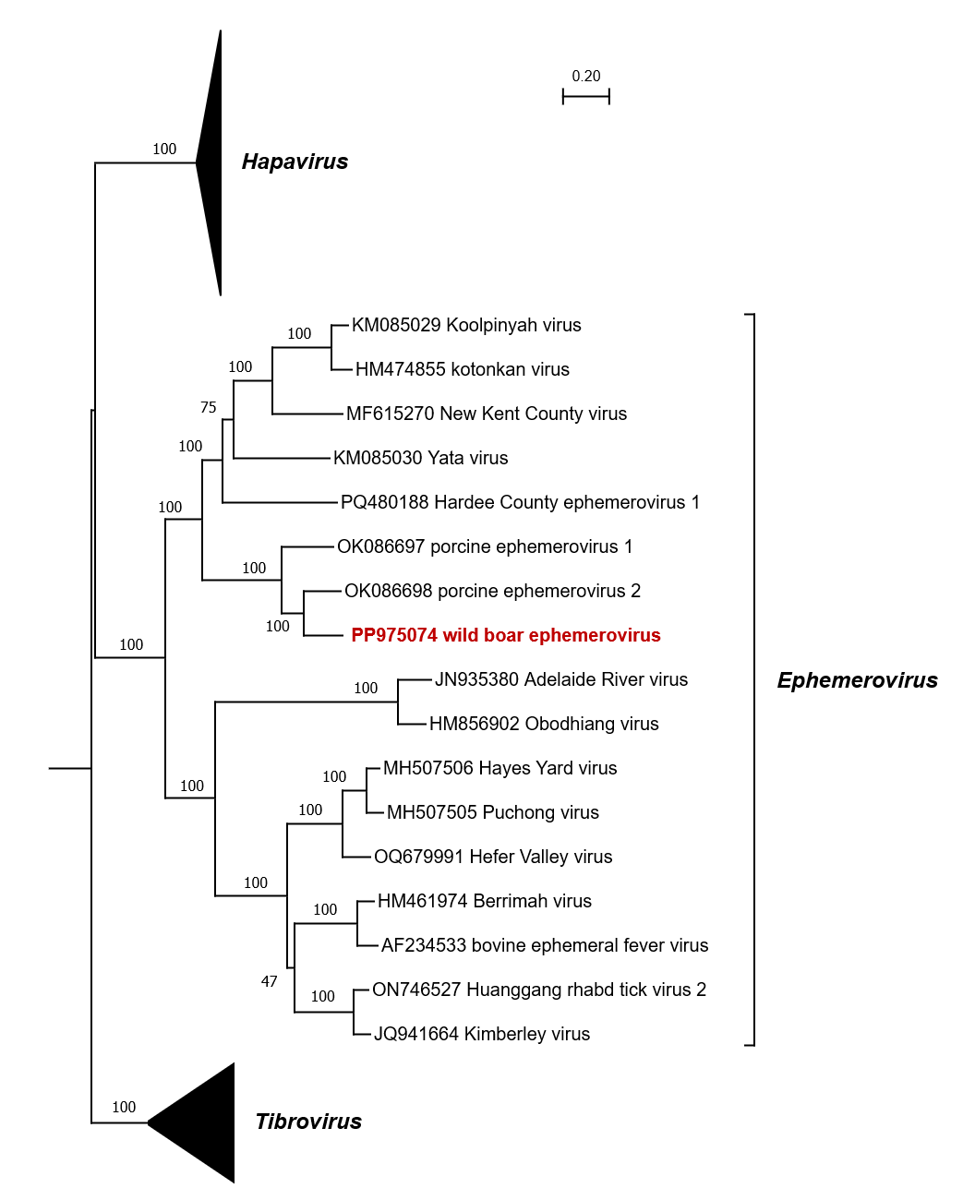

Figure 1. The evolutionary history was inferred from a multiple sequence alignment of complete L protein sequences of all 42 classified members of the genera Ephemerovirus, Tibrovirus and Hapavirus, as well as wild boar ephemerovirus which is proposed to be assigned to the new species Ephemerovirus anhui. The alignment was constructed in MAFFT using the E-INS-I iterative refinement method. Phylogenetically informative sites were selected from the alignment using TrimAl, resulting in 1863 positions in the final dataset. The tree was inferred in MEGA11 by using the Maximum Likelihood method based on the best-fit Le and Gascuel model with gamma distribution of evolutionary rates and invariable sites. The tree with the highest log likelihood (-89733.24) is shown. Initial tree(s) for the heuristic search were obtained automatically by applying Neighbor-Join and BioNJ algorithms to a matrix of pairwise distances estimated using a JTT model and then selecting the topology with superior log-likelihood values. The tibrovirus and hapavirus clades have been collapsed. The tree is drawn to scale, with branch lengths measured in the number of substitutions per site. Bootstrap values (100 iterations) are shown for each node.

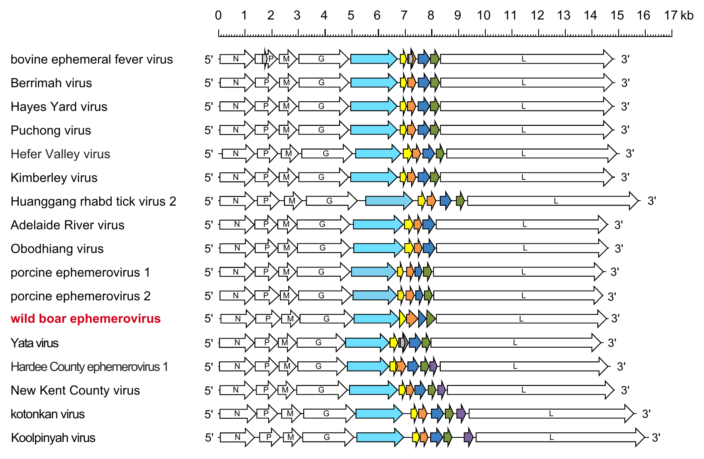
Figure 2. Schematic illustration of the genome organisations of ephemeroviruses. Arrows represent long open reading frames (ORFs) with the N, P, M, G and L ORFs shown and additional ORFs encoding homologous proteins shown in the same colour. The G_{NS} ORF is shown in light blue and the α1 ORF (encoding a viroporin) is shown in yellow.

Table 1. Ephemerovirus L protein amino acid sequence identities (%).
 | BEFV | KIMV | KOOLV | BRMV | YATV | ARV | KOTV | OBOV | HYV | PUCV | NKCV | PoEV1 | PoEV2 | HgRTV2 | HCEV1 | HVV | WBEV
BEFV
KIMV | 64.8
KOOLV | 51.2 | 50.7
BRMV | 84.0 | 65.1 | 51.1
YATV | 50.8 | 50.9 | 59.0 | 51.1
ARV | 49.5 | 48.5 | 47.5 | 49.1 | 47.1
KOTV | 50.7 | 50.6 | 84.2 | 51.4 | 58.9 | 47.5
OBOV | 49.8 | 49.7 | 48.3 | 49.1 | 47.0 | 78.1 | 48.0
HYV | 63.7 | 63.6 | 50.1 | 64.5 | 51.1 | 47.6 | 50.6 | 48.3
PUCV | 63.5 | 63.3 | 49.9 | 63.8 | 50.8 | 47.6 | 50.1 | 48.5 | 86.8
NKCV | 51.7 | 51.4 | 65.7 | 52.0 | 59.8 | 46.5 | 64.8 | 46.9 | 50.6 | 50.0
PoEV1 | 50.0 | 50.0 | 56.5 | 49.8 | 56.0 | 47.0 | 56.9 | 47.5 | 49.0 | 49.2 | 56.5
PoEV2 | 49.5 | 50.2 | 56.8 | 49.7 | 55.8 | 47.7 | 56.8 | 47.5 | 48.8 | 48.9 | 56.5 | 70.5
HgRTV2 | 65.0 | 86.4 | 50.8 | 65.3 | 50.9 | 48.2 | 50.9 | 49.2 | 63.3 | 62.8 | 51.0 | 49.8 | 50.0
HCEV1 | 50.5 | 51.2 | 56.6 | 50.6 | 58.6 | 46.2 | 56.5 | 46.1 | 49.5 | 49.5 | 58.7 | 55.1 | 54.9 | 50.5
HVV | 63.8 | 64.2 | 50.3 | 64.3 | 51.1 | 48.5 | 50.3 | 48.9 | 78.4 | 77.5 | 50.1 | 49.5 | 48.2 | 64.1 | 50.0
WBEV | 49.4 | 50.4 | 57.0 | 49.2 | 55.2 | 46.3 | 56.7 | 46.2 | 49.6 | 49.1 | 57.1 | 70.5 | 75.1 | 50.6 | 55.4 | 48.2

Table 2. Ephemerovirus N protein amino acid sequence identities (%).
 | BEFV | KIMV | KOOLV | BRMV | YATV | ARV | KOTV | OBOV | HYV | PUCV | NKCV | PoEV1 | PoEV2 | HgRTV2 | HCEV1 | HVV | WBEV
BEFV
KIMV | 77.3
KOOLV | 51.8 | 52.2
BRMV | 91.6 | 77.0 | 52.0
YATV | 45.5 | 47.4 | 51.1 | 46.5
ARV | 48.1 | 50.3 | 46.8 | 49.1 | 41.5
KOTV | 51.3 | 52.7 | 92.7 | 51.8 | 51.5 | 47.1
OBOV | 49.3 | 50.6 | 47.3 | 49.5 | 39.2 | 86.9 | 46.6
HYV | 75.4 | 74.1 | 52.7 | 77.0 | 46.5 | 50.3 | 53.6 | 51.5
PUCV | 75.6 | 73.6 | 52.9 | 77.5 | 46.0 | 50.3 | 53.2 | 51.5 | 95.1
NKCV | 50.0 | 52.1 | 71.7 | 51.4 | 51.4 | 46.7 | 71.7 | 46.4 | 54.0 | 53.8
PoEV1 | 47.3 | 49.6 | 58.7 | 48.2 | 49.9 | 44.2 | 59.2 | 43.7 | 50.1 | 51.3 | 61.1
PoEV2 | 49.6 | 51.5 | 58.5 | 48.7 | 48.0 | 47.5 | 58.3 | 47.0 | 48.7 | 49.2 | 59.7 | 78.1
HgRTV2 | 75.6 | 93.5 | 52.9 | 76.6 | 48.1 | 50.3 | 53.4 | 50.3 | 75.5 | 75.0 | 52.9 | 49.6 | 50.8
HCEV1 | 49.1 | 48.6 | 58.4 | 49.5 | 52.0 | 46.0 | 59.1 | 44.8 | 50.2 | 50.7 | 57.9 | 53.4 | 53.0 | 48.8
HVV | 72.3 | 71.9 | 52.1 | 74.5 | 45.8 | 50.6 | 53.1 | 50.6 | 87.7 | 87.7 | 52.7 | 49.4 | 48.4 | 73.1 | 48.5
WBEV | 49.9 | 52.2 | 58.3 | 50.8 | 50.6 | 47.0 | 59.2 | 44.7 | 50.1 | 51.1 | 60.4 | 78.9 | 87.0 | 52.5 | 53.4 | 50.9

Table 3. Ephemerovirus G protein amino acid sequence identities (%).
 | BEFV | KIMV | KOOLV | BRMV | YATV | ARV | KOTV | OBOV | HYV | PUCV | NKCV | PoEV1 | PoEV2 | HgRTV2 | HCEV1 | HVV | WBEV
BEFV
KIMV | 48.8
KOOLV | 29.3 | 30.6
BRMV | 75.3 | 47.8 | 28.3
YATV | 29.8 | 30.6 | 38.4 | 30.1
ARV | 29.6 | 26.2 | 27.7 | 29.1 | 30.0
KOTV | 29.2 | 31.3 | 80.0 | 28.5 | 39.6 | 27.4
OBOV | 29.9 | 28.5 | 27.8 | 30.1 | 31.0 | 68.6 | 27.5
HYV | 48.6 | 46.0 | 26.8 | 48.4 | 28.8 | 28.1 | 27.6 | 30.2
PUCV | 49.0 | 44.9 | 27.1 | 48.1 | 28.8 | 29.4 | 28.3 | 30.3 | 76.0
NKCV | 27.9 | 29.4 | 61.7 | 28.1 | 40.5 | 28.5 | 59.1 | 29.3 | 28.1 | 28.1
PoEV1 | 27.9 | 29.2 | 35.7 | 27.9 | 32.8 | 29.4 | 35.9 | 28.8 | 25.8 | 26.3 | 35.6
PoEV2 | 27.3 | 27.7 | 38.6 | 29.3 | 34.6 | 30.3 | 38.7 | 28.8 | 24.9 | 26.7 | 36.1 | 59.8
HgRTV2 | 48.5 | 75.1 | 30.2 | 49.3 | 30.6 | 26.9 | 30.7 | 29.1 | 45.4 | 45.3 | 30.7 | 29.3 | 29.9
HCEV1 | 30.7 | 30.2 | 37.0 | 30.0 | 41.2 | 30.8 | 35.8 | 32.0 | 29.2 | 30.8 | 35.2 | 35.8 | 36.8 | 30.1
HVV | 48.5 | 47.5 | 29.0 | 47.3 | 29.7 | 28.6 | 29.5 | 30.0 | 64.1 | 65.4 | 29.6 | 25.8 | 26.7 | 46.6 | 28.6
WBEV | 27.4 | 29.7 | 37.7 | 26.9 | 34.3 | 29.6 | 37.7 | 29.1 | 25.4 | 25.4 | 37.2 | 58.4 | 69.8 | 28.8 | 35.7 | 26.5

1. Deorowicz S, Debudaj-Grabysz A, Gudyś A (2016) FAMSA: Fast and accurate multiple sequence alignment of huge protein families. Scientific Reports 6:e33964

