

The International Committee on Taxonomy of Viruses
Taxonomy Proposal Form, 2026

Part 1a: Details of taxonomy proposals

Title: | Create 6 new species in the genus Yingvirus (family Qinviridae)
Code assigned: | 2026.008M.N.v1.Qinviridae_6nsp

Author(s), affiliation and email address(es):
Given name (+middle initial(s)) | Surname | Affiliation | Email address | Corr. author(s)
Alexander G. | Litov | Laboratory of Biology of Arboviruses, FSASI Chumakov Federal Scientific Center for Research and Development of Immune-and-Biological Products of RAS, Moscow, Russia | novosti-wxo@yandex.ru | X
Alexei Yu. | Kostygov | Zoological Institute of Russian Academy of Sciences, St Petersburg, Russia;  Life Science Research Centre, Faculty of Science, University of Ostrava, Ostrava, Czechia | kostygov@gmail.com
Phuoc T. | Truong Nguyen | Department of Virology, Faculty of Medicine, University of Helsinki, Helsinki, Finland | phuoc.truong@helsinki.fi
Vyacheslav | Yurchenko | Life Science Research Centre, Faculty of Science, University of Ostrava, Ostrava, Czechia | Vyacheslav.Yurchenko@osu.cz

Part 1b: Taxonomy Proposal Submission
ICTV Subcommittee:
Animal DNA Viruses and Retroviruses |  | Bacterial viruses
Animal minus-strand and dsRNA viruses | X | Fungal and protist viruses
Animal positive-strand RNA viruses |  | Plant viruses
Archaeal viruses |  | General -

List the ICTV Study Group(s) that have seen or have been involved in creating this proposal:
Qinviridae Study Group

Optional – complete only if formally voted on by an ICTV Study Group:
Study Group | Number of members
Study Group | Votes in support | Votes against | No vote
Qinviridae Study Group | 4 | 0 | 0

Submission date: | 20/07/2026

Part 1c: Feedback from ICTV Executive Committee (EC) meeting
Executive Committee Meeting Decision code: | X
A – Accept
Ac – Accept subject to revision by relevant subcommittee chair. No further vote required
U – Accept without revision but with re-evaluation and email vote by the EC
Uc – Accept subject to revision and re-evaluation and email vote by the EC
Ud – Deferred to the next EC meeting, with an invitation to revise based on EC comments
J - Reject
W - Withdrawn

Comments from the Executive Committee:

Part 1d: Revised Taxonomy Proposal Submission
Response of proposer:
Revision date:

Part 3: TAXONOMIC PROPOSAL

Taxonomic changes proposed:
Establish new taxon | X | Split taxon
Abolish taxon |  | Merge taxon
Move taxon |  | Promote taxon
Rename taxon |  | Demote taxon
Move and rename

Etymology (origin) of proposed taxonomic names:
Taxon name | Etymology of the term
Yingvirus trifolii | Named after the generic name of the plant Trifolium pratense, in which the virus was discovered.
Yingvirus australiense | Named after Western Australia, where mosquitoes carrying the virus were collected.
Yingvirus qingdaoense | Named after the city of Qingdao, China, where the plants carrying the virus were collected.
Yingvirus ditylenchi | Named after the generic name of the nematode Ditylenchus destructor, in which the virus was discovered.
Yingvirus cattienense | Named after the Cat Tien National Park, Vietnam, where millipedes carrying the virus were collected.
Yingvirus leptomonadis | Named after the generic name of the flagellate Leptomonas pyrrhocoris, in which the virus was discovered.

Permission for use of names derived from a living person:
Taxon name | Full name of person from whom the name is derived | Attached
NONE

Abstract of Taxonomy Proposal:

Description of current taxonomy:
The family Qinviridae comprises negative-sense RNA viruses with two genomic segments (L and S). Yingvirus is currently the only genus in this family and contains eight recognized species.

Proposed taxonomic change(s):
We propose the establishment of six additional species within the genus Yingvirus.

Demarcation criteria for new taxon/taxa:
Current demarcation criteria, as specified in the ICTV Report Chapter, require new species to be “phylogenetically distinct based upon analysis of the RdRp”, with no explicit numerical divergence threshold. Here, we used phylogenetic analysis based on the amino acid sequences of the RdRp-containing ORF and pairwise amino acid divergence values to assess the novelty of viruses.

Justification:
Since the establishment of the family Qinviridae, several novel qin-related viruses have been discovered and their sequences deposited in GenBank. From these data, we identified six viruses with complete coding genomes (defined here as viruses with complete coding L and S segments). Phylogenetic analysis of their RdRp sequences showed that each virus represents a distinct lineage. Pairwise amino acid identities also support their recognition as separate species, with the closest relatives differing by approximately 35%.

Text of Taxonomy proposal:
Description of current taxonomy:
The family Qinviridae unites negative-sense RNA viruses with two genomic segments, L and S. Yingvirus is currently the only genus within the family and contains eight recognized species.

Proposed taxonomic change(s):
Establish six new species in the genus Yingvirus:
“Yingvirus trifolii”
“Yingvirus australiense”
“Yingvirus qingdaoense”
“Yingvirus ditylenchi”
“Yingvirus cattienense”
“Yingvirus leptomonadis”

Demarcation criteria for new taxon/taxa:
The current demarcation criteria, as stated in the ICTV Report Chapter, require new species to be “phylogenetically distinct based upon analysis of the RdRp” with no explicit numerical divergence threshold. Here, we used phylogenetic analysis based on amino acid sequences of the RdRp-containing ORF and pairwise divergence values to assess novelty of viruses as supporting evidence.

Justification:
Since the establishment of the family Qinviridae, several novel qin-related viruses have been discovered and their sequences deposited in GenBank [1–8]. From these sequences, we searched for viruses with complete coding genomes, defined here as viruses with coding-complete L and S segments. When additional genomic segments were reported, their completeness was also considered. From the GenBank data, we identified six candidate viruses with complete coding genomes.
Current demarcation criteria for the genus Yingvirus does not specify a numerical threshold for species delimitation. Our analysis suggests that species of this genus are separated by 10–20% amino acid divergence in L protein sequences. However, because the genetic diversity of qinviruses remains poorly characterized, it may be preferable not to specify a rigid divergence threshold for species demarcation until further supporting data becomes available.

Based on the phylogenetic analysis (Figure 1), all candidate viruses are phylogenetically distinct. Their pairwise amino acid sequence divergence is also very high (Table 1). Complete sequences of all genomic segments are available in GenBank for all proposed species. Thus, we propose the establishment of six new species in the genus Yingvirus.

References:
1. Macedo, D.H.; Grybchuk, D.; Režnarová, J.; Votýpka, J.; Klocek, D.; Yurchenko, T.; Ševčík, J.; Magri, A.; Dolinská, M.U.; Záhonová, K.; et al. Diversity of RNA Viruses in the Cosmopolitan Monoxenous Trypanosomatid Leptomonas Pyrrhocoris. BMC Biol 2023, 21, 191, doi:10.1186/s12915-023-01687-y.
2. Truong Nguyen, P.T.; Culverwell, C.L.; Suvanto, M.T.; Korhonen, E.M.; Uusitalo, R.; Vapalahti, O.; Smura, T.; Huhtamo, E. Characterisation of the RNA Virome of Nine Ochlerotatus Species in Finland. Viruses 2022, 14, 1489, doi:10.3390/v14071489.
3. Lazareva, E.A.; Lezzhov, A.A.; Chergintsev, D.A.; Tolstyko, E.A.; Selifonov, I.V.; Atabekova, A.K.; Morozov, S.Y.; Solovyev, A.G. Red Clover RNA Virus 1: Functional Analysis of ORF2 Protein, Associations with Co-Infecting Viruses, and Seed Transmission. Arch Virol 2026, 171, 148, doi:10.1007/s00705-026-06598-1.
4. Shi, M.; Neville, P.; Nicholson, J.; Eden, J.-S.; Imrie, A.; Holmes, E.C. High-Resolution Metatranscriptomics Reveals the Ecological Dynamics of Mosquito-Associated RNA Viruses in Western Australia. J Virol 2017, 91, e00680-17, doi:10.1128/JVI.00680-17.
5. Huang, H.; Mao, H.; Wu, T.; Xie, J.; Zheng, J.; Cheng, J.; Fu, Y.; Cai, Q.; Lin, Y.; Chen, T.; et al. Expansion of the Plant-Parasitic Nematode RNA Viruses: Unprecedented Diversity, Intron-Bearing Viruses, and Cross-Kingdom Evolutionary Links. NPJ Biofilms Microbiomes 2025, 12, 2, doi:10.1038/s41522-025-00867-8.
6. Cao, X.; Liu, J.; Pang, J.; Kondo, H.; Chi, S.; Zhang, J.; Sun, L.; Andika, I.B. Common but Nonpersistent Acquisitions of Plant Viruses by Plant-Associated Fungi. Viruses 2022, 14, 2279, doi:10.3390/v14102279.
7. Litov, A.G.; Semenyuk, I.I.; Belova, O.A.; Polienko, A.E.; Thinh, N.V.; Karganova, G.G.; Tiunov, A.V. Extensive Diversity of Viruses in Millipedes Collected in the Dong Nai Biosphere Reserve (Vietnam). Viruses 2024, 16, 1486, doi:10.3390/v16091486.
8. Grybchuk, D.; Galan, A.; Klocek, D.; Macedo, D.H.; Wolf, Y.I.; Votýpka, J.; Butenko, A.; Lukeš, J.; Neri, U.; Záhonová, K.; et al. Identification of Diverse RNA Viruses in Obscuromonas Flagellates (Euglenozoa: Trypanosomatidae: Blastocrithidiinae). Virus Evol 2024, 10, veae037, doi:10.1093/ve/veae037.
9. Katoh, K.; Standley, D.M. MAFFT Multiple Sequence Alignment Software Version 7: Improvements in Performance and Usability. Mol Biol Evol 2013, 30, 772–780, doi:10.1093/molbev/mst010.
10. Capella-Gutiérrez, S.; Silla-Martínez, J.M.; Gabaldón, T. trimAl: A Tool for Automated Alignment Trimming in Large-Scale Phylogenetic Analyses. Bioinformatics 2009, 25, 1972–1973, doi:10.1093/bioinformatics/btp348.
11. Minh, B.Q.; Schmidt, H.A.; Chernomor, O.; Schrempf, D.; Woodhams, M.D.; von Haeseler, A.; Lanfear, R. IQ-TREE 2: New Models and Efficient Methods for Phylogenetic Inference in the Genomic Era. Mol Biol Evol 2020, 37, 1530–1534, doi:10.1093/molbev/msaa015.
12. Tamura, K.; Stecher, G.; Kumar, S. MEGA11: Molecular Evolutionary Genetics Analysis Version 11. Molecular Biology and Evolution 2021, 38, 3022–3027, doi:10.1093/molbev/msab120.

Accompanying files:
Filename | Description of contents

Tables, Figures:

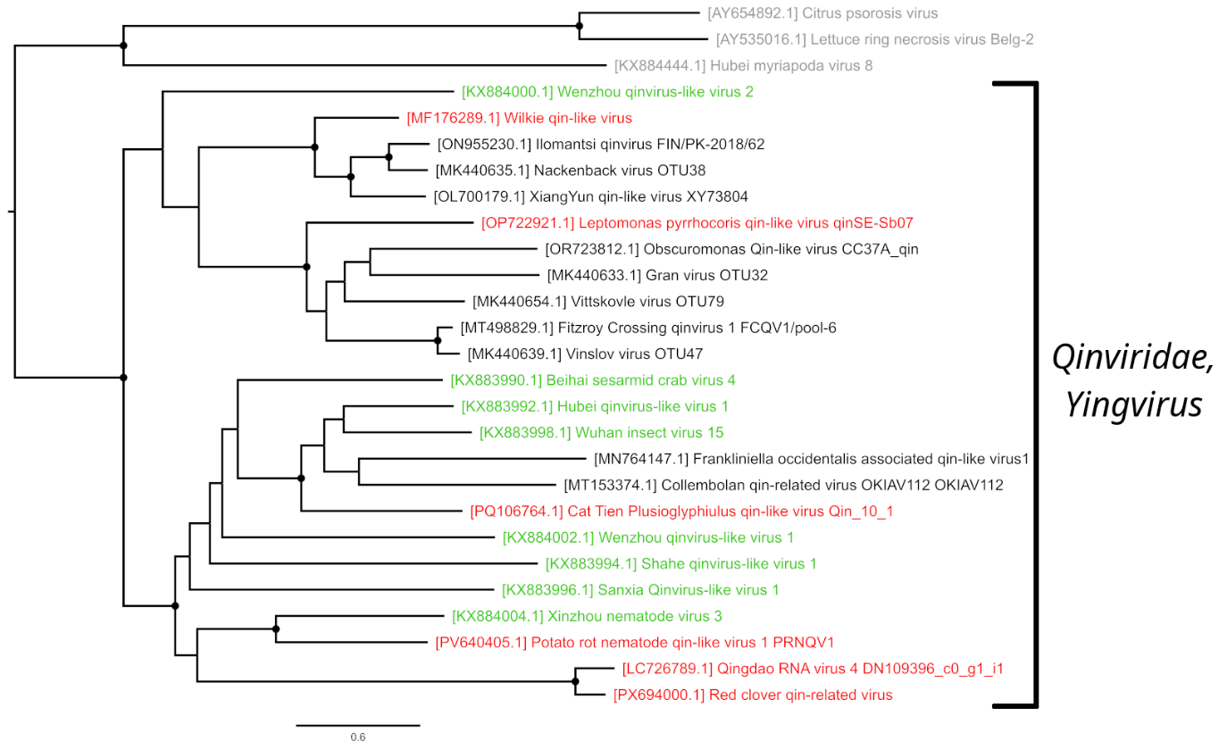
Figure 1. Phylogenetic tree of the family Qinviridae. Alignment of the L protein included established representatives of the family Qinviridae (in green), proposed new species (in red), related unclassified viruses with coding-complete L segments (in black), and viruses from Aspiviridae and Myriaviridae used as the outgroup (in grey). Amino acid sequences were aligned using MAFFT v. 7.490 (E-ins-i algorithm) [9], followed by trimming ambiguously aligned regions with trimAl v.1.5.rev0 in automated mode [10]. Maximum likelihood phylogenetic tree was inferred with IQ-TREE v.2.4.0 [11] using Q.pfam+F+R4 substitution model (chosen by automatic model selection) and 1 000 standard bootstrap replicates. Highly supported nodes (bootstrap value ≥85%) are marked with black dots.

 | APG78067 | APG78077 | APG78069 | APG78073.1 | APG78071 | APG78079.1 | APG78075.1 | APG78081.1 | XGJ13261.1 | XUA29585.1 | BDR95913.1 | ASA47357.1 | YDE70579.1
APG78067.1
APG78077.1 | 0,81
APG78069.1 | 0,74 | 0,79
APG78073.1 | 0,80 | 0,82 | 0,79
APG78071.1 | 0,80 | 0,83 | 0,78 | 0,81
APG78079.1 | 0,77 | 0,82 | 0,76 | 0,80 | 0,80
APG78075.1 | 0,75 | 0,81 | 0,63 | 0,78 | 0,78 | 0,77
APG78081.1 | 0,78 | 0,82 | 0,77 | 0,80 | 0,81 | 0,79 | 0,77
XGJ13261.1 | 0,75 | 0,80 | 0,67 | 0,80 | 0,79 | 0,77 | 0,68 | 0,79
XUA29585.1 | 0,79 | 0,81 | 0,78 | 0,79 | 0,80 | 0,79 | 0,76 | 0,71 | 0,78
BDR95913.1 | 0,84 | 0,86 | 0,83 | 0,83 | 0,85 | 0,83 | 0,83 | 0,82 | 0,84 | 0,83
ASA47357.1 | 0,80 | 0,76 | 0,79 | 0,81 | 0,83 | 0,81 | 0,80 | 0,80 | 0,79 | 0,79 | 0,85
YDE70579.1 | 0,82 | 0,86 | 0,82 | 0,82 | 0,84 | 0,83 | 0,83 | 0,82 | 0,84 | 0,82 | 0,35 | 0,84
WMB96346 | 0,80 | 0,77 | 0,79 | 0,84 | 0,82 | 0,82 | 0,80 | 0,80 | 0,81 | 0,80 | 0,83 | 0,74 | 0,83

Table 1. Estimates of evolutionary divergence (p-distance) between sequences. The number of amino acid differences per site between sequences is shown. The alignment of the L protein included established representatives of the family Qinviridae (in green) and proposed new species (in orange). Sequences were aligned using MAFFT with E-ins-I algorithm. Evolutionary analyses were conducted using MEGA11 [12]. All ambiguous positions were removed for each sequence pair (pairwise deletion option). The final dataset comprised 2 815 positions.

