

The International Committee on Taxonomy of Viruses
Taxonomy Proposal Form, 2026
Part 1a: Details of taxonomy proposals

Title: | Create 18 new genera and 18 new species in the family Xinmoviridae, order: Mononegavirales
Code assigned: | 2026.012M.N.v1.Xinmoviridae_18ng_18nsp

Author(s), affiliation and email address(es):
Given name (+middle initial(s)) | Surname | Affiliation | Email address | Corr. author(s)
Luis | Hernández-Pelegrin | Department of Genetics, University of Valencia, Valencia, Spain | luis.hernandez.pelegrin@gmail.com
Binit | Lamichhane | Department of Microbiology, PathWest Laboratory Medicine WA, Nedlands, Australia | binit.lamichhane@health.wa.gov.au
Stephen R | Sharpe | Biosecurity, CSIRO, East Geelong, Australia | stephen.sharpe@csiro.au | X

Part 1b: Taxonomy Proposal Submission
ICTV Subcommittee:
Animal DNA Viruses and Retroviruses |  | Bacterial viruses
Animal minus-strand and dsRNA viruses | X | Fungal and protist viruses
Animal positive-strand RNA viruses |  | Plant viruses
Archaeal viruses |  | General -

List the ICTV Study Group(s) that have seen or have been involved in creating this proposal:
ICTV Xinmoviridae Study Group

Optional – complete only if formally voted on by an ICTV Study Group:
Study Group | Number of members
Study Group | Votes in support | Votes against | No vote
ICTV Xinmoviridae Study Group | 3

Submission date: | 10/09/2026

Part 1c: Feedback from ICTV Executive Committee (EC) meeting
Executive Committee Meeting Decision code: | X
A – Accept
Ac – Accept subject to revision by relevant subcommittee chair. No further vote required
U – Accept without revision but with re-evaluation and email vote by the EC
Uc – Accept subject to revision and re-evaluation and email vote by the EC
Ud – Deferred to the next EC meeting, with an invitation to revise based on EC comments
J - Reject
W - Withdrawn

Comments from the Executive Committee:

Part 1d: Revised Taxonomy Proposal Submission
Response of proposer:
Revision date:

Part 3: TAXONOMIC PROPOSAL

Taxonomic changes proposed:
Establish new taxon | X | Split taxon
Abolish taxon |  | Merge taxon
Move taxon |  | Promote taxon
Rename taxon |  | Demote taxon
Move and rename

Etymology (origin) of proposed taxonomic names:
Taxon name | Etymology of the term
Plusiovirus tienense | From Plusioglyphiulus ampullifer in which Cat Tien Plusioglyphiulus xinmo-like virus was discovered by HTS. The species epithet tienense refers to Cat Tien National Park, Vietnam, the sampling location.
Recsavirus fujianense | From Recilia dorsalis in which Yunxiao leafhopper virus 1 was discovered by HTS. The species epithet fujianense refers to Yunxiao, Fujian Province, China, the sampling location.
Pimvirus israelense | From Apis meliffera in which Bee xinmovirus 1 was discovered by HTS. The species epithet israelense refers to Israel, the sampling location.
Tesilovirus hiaense | From Cotesia chilonis in which Cotesia chilonis xinmo-like virus 1 was discovered by HTS. The species epithet hiaense refers to China, the sampling location.
Logravirus suwonense | From Locusta migratoria in which Locusta migratoria xinmovirus 1 was discovered by metatranscriptomic analysis. The species epithet suwonense refers to Suwon, South Korea, the location of the laboratory population.
Schistamvirus arizonense | From Schistocerca americana in which Schistocerca americana xinmovirus 1 was discovered by metatranscriptomic analysis. The species epithet arizonense refers to the Arizona, United States of America, the location of the laboratory population.
Larmilvirus karnatakaense | From Aularches miliaris in which Aularches miliaris xinmovirus 1 was discovered by metatranscriptomic analysis. The species epithet karnatakaense refers to Karnataka India, the sampling location.
Osturnivirus chinaense | From Ostrinia furnicalis in which Ostrinia furnicalis xinmovirus 1 was discovered by metatranscriptomic analysis. The species epithet chinaense refers to China, the location of the laboratory population.
Amtranvirus kernense | From Amyelois transitella in which Amyelois transitella xinmovirus 1 was discovered by metatranscriptomic analysis. The species epithet kernense refers to Kern County, California, United States of America, the sampling location.
Papmacvirus sichuanense | From Papillo machaon in which Papillo machaon xinmovirus 1 was discovered by metatranscriptomic analysis. The species epithet sichuanense refers to Ya’an Sichuan, China, the sampling location.
Felticulivirus champaignense | From Feltia jaculifera in which Feltia jaculifera xinmovirus 1 was discovered by metatranscriptomic analysis. The species epithet champaignense refers to the Champaign-Urbana United States of America, the location of the laboratory population.
Parasinivirus qinghaiense | From Paratrioza sinica in which Paratrioza sinica mononegavirus 1 was discovered by metatranscriptomic analysis. The species epithet qinghaiense refers to Qinghai University, China.
Sitolivirus niameyense | From Sitophilus linearis in which Sitophilus linearis xinmovirus 1 was discovered by metatranscriptomic analysis. The species epithet niameyense refers to Niamey, Niger, the sampling location.
Susvenuvirus tehamaense | From Susulus venustus in which Susulus venustus xinmovirus 1 was discovered by metatranscriptomic analysis. The species epithet tehamaense refers to Tehama, United States of America, the sampling location.
Phorvarivirus berkeleyense | From Phortica variegata in which Phortica variegata xinmovirus 1 was discovered by metatranscriptomic analysis. The species epithet berkeleyense refers to UC Berkeley, USA, the location of the laboratory population.
Sarcomelvirus fuyangense | From Sarcophaga melanura in which Sarcophaga melanura xinmovirus 1 was discovered by metatranscriptomic analysis. The species epithet fuyangense refers to Fuyang, Hangzhou, China, the sampling location.
Chitamvirus juanense | From Toxorhynchites amboinensis in which Toxorhynchites amboinensis xinmovirus 1 was discovered by metatranscriptomic analysis. The species epithet juanense refers to San Juan, Puerto Rico, the location of the laboratory population.
Fortaivirus taichungense | From Forcipomyia taiwana in which Forcipomyia taiwana xinmovirus 1 was discovered by metatranscriptomic analysis. The species epithet taichungense refers to Taichung, Taiwan, the sampling location.

Permission for use of names derived from a living person
Taxon name | Full name of person from whom the name is derived | Attached

Abstract of Taxonomy Proposal:

Description of current taxonomy: The family Xinmoviriae is currently made up of 27 genera and 30 species.

Proposed taxonomic change(s): We propose the demarcation of 18 new genera and 18 new species within the family Xinmoviridae.

Demarcation criteria for new taxon/taxa: Members of different species within a genus have RdRP amino acid identities of 66% or less. Members of different genera have RdRP amino acid identities of 60% or less.

Justification: We have based this proposal on the current demarcation criterion for species: Members of different species within a genus have RdRP amino acid identities of 66% or less, and the criterion for genus: Members of different genera have RdRP amino acid identities of 60% or less.

Therefore, based on the phylogenetic analysis shown in Figure 1 and BLASTP match data in Table 1, we propose the demarcation of 18 new genera and 18 new species.

Text of Taxonomy proposal:
Description of current taxonomy: There are currently 27 genera and 30 species within the family Xinmoviridae.

Proposed taxonomic change(s): We propose the demarcation of 18 new genera and 18 new species within the family Xinmoviridae. The new genera are proposed to be named “Plusiovirus”, “Recsavirus”, “Pimvirus”, and “Tesilovirus”, “Logravirus”, “Schistamvirus”, “Larmilvirus”, “Osturnivirus”, “Amtranvirus”, “Papmacvirus”, “Felticulivirus”, “Parasinivirus”, “Sitolivirus”, “Susvenuvirus”, “Phorvarivirus”, “Sarcomelvirus”, “Chitamvirus”, “Fortaivirus”. The new species are proposed to be named “Plusiovirus tienense”, “Recsavirus fujianense”, “Pimvirus israelense”, “Tesilovirus hiaense”, “Logravirus suwonense”, “Schistamvirus arizonense”, “Larmilvirus karnatakaense”, “Osturnivirus chinaense”, “Amtranvirus kernense”, “Papmacvirus sichuanense”, “Felticulivirus champaignense”, “Parasinivirus qinghaiense”, “Sitolivirus niameyense”, “Susvenuvirus tehamaense”, “Phorvarivirus berkeleyense”, “Sarcomelvirus fuyangense”, “Chitamvirus juanense”, “Fortaivirus taichungense”.

Etymologies:

“Plusiovirus tienense”. From Plusioglyphiulus ampullifer in which Cat Tien Plusioglyphiulus xinmo-like virus was discovered by HTS. The species epithet tienense refers to Cat Tien National Park, Vietnam, the sampling location.

“Recsavirus fujianense”. From Recilia dorsalis in which Yunxiao leafhopper virus 1 was discovered by HTS. The species epithet jianense refers to Yunxiao, Fujian Province, China, the sampling location.

“Pimvirus israelense”. From Apis meliffera in which Bee xinmovirus 1 was discovered by HTS. The species epithet israelense refers to Israel, the sampling location.

“Tesilovirus hiaense”. From Cotesia chilonis in which Cotesia chilonis xinmo-like virus 1 was discovered by HTS. The species epithet hiaense refers to China, the sampling location.

“Logravirus suwonense”. From Locusta migratoria in which Locusta migratoria xinmovirus 1 was discovered by metatranscriptomic analysis. The species epithet suwonense refers to Suwon, South Korea, the location of the laboratory population.

“Schistamvirus arizonense”. From Schistocerca americana in which Schistocerca americana xinmovirus 1 was discovered by metatranscriptomic analysis. The species epithet arizonense refers to the Arizona, United States of America, the location of the laboratory population.

“Larmilvirus karnatakaense”. From Aularches miliaris in which Aularches miliaris xinmovirus 1 was discovered by metatranscriptomic analysis. The species epiphet karnatakaense refers to Karnataka India, the sampling location.

“Osturnivirus chinaense”. From Ostrinia furnicalis in which Ostrinia furnicalis xinmovirus 1 was discovered by metatranscriptomic analysis. The species epiphet chinaense refers to China, the location of the laboratory population.

“Amtranvirus kernense”. From Amyelois transitella in which Amyelois transitella xinmovirus 1 was discovered by metatranscriptomic analysis. The species epiphet kernense refers to Kern County, California, United States of America, the sampling location.

“Papmacvirus sichuanense”. From Papillo machaon in which Papillo machaon xinmovirus 1 was discovered by metatranscriptomic analysis. The species epithet sichuanense refers to Ya’an Sichuan, China, the sampling location.

“Felticulivirus champaignense”. From Feltia jaculifera in which Feltia jaculifera xinmovirus 1 was discovered by metatranscriptomic analysis. The species epithet champaignense refers to the Champaign-Urbana United States of America, the location of the laboratory population.

“Parasinivirus qinghaiense”. From Paratrioza sinica in which Paratrioza sinica mononegavirus 1 was discovered by metatranscriptomic analysis. The species epithet qinghaiense refers to Qinghai University, China.

“Sitolivirus niameyense”. From Sitophilus linearis in which Sitophilus linearis xinmovirus 1 was discovered by metatranscriptomic analysis. The species epithet niameyense refers to Niamey, Niger, the sampling location.

“Susvenuvirus tehamaense”. From Susulus venustus in which Susulus venustus xinmovirus 1 was discovered by metatranscriptomic analysis. The species epithet tehamaense refers to Tehama, United States of America, the sampling location.

“Phorvarivirus berkeleyense”. From Phortica variegata in which Phortica variegata xinmovirus 1 was discovered by metatranscriptomic analysis. The species epithet berkeleyense refers to UC Berkeley, USA, the location of the laboratory population.

“Sarcomelvirus fuyangense”. From Sarcophaga melanura in which Sarcophaga melanura xinmovirus 1 was discovered by metatranscriptomic analysis. The species epiphet fuyangense refers to Fuyang, Hangzhou, China, the sampling location.

“Chitamvirus juanense”. From Toxorhynchites amboinensis in which Toxorhynchites amboinensis xinmovirus 1 was discovered by metatranscriptomic analysis. The species epithet juanense refers to San Juan, Puerto Rico, the location of the laboratory population.

“Fortaivirus taichungense”. From Forcipomyia taiwana in which Forcipomyia taiwana xinmovirus 1 was discovered by metatranscriptomic analysis. The species epithet taichungense refers to Taichung, Taiwan, the sampling location.

Demarcation criteria for new taxon/taxa:
Species demarcation - Members of different species within a genus have RdRP amino acid identities of 66% or less.

Genus demarcation - Members of different genera have RdRP amino acid identities of 60% or less.

Sharpe, S. and Paraskevopoulou, S., 2023. ICTV Virus Taxonomy Profile: Xinmoviridae 2023. Journal of General Virology, 104(10), p.001906.

Justification: We have based this proposal on the current demarcation criterion for species: Members of different species within a genus have RdRP amino acid identities of 66% or less, and the criterion for genus: Members of different genera have RdRP amino acid identities of 60% or less.

Therefore, based on the phylogenetic analysis shown in Figure 1 and BLASTP match data in Table 1, we propose the demarcation of 18 new genera and 18 new species.

References:
Cao, Z., Xue, C., Wang, F., Wang, F., Fang, Q., Song, Q., Ye, G. (2025). Unveiling the RNA virus landscape of Cotesia chilonis: geographic distribution, diversity, and potential roles in parasitoid-host interactions. Virus Evol, 12(1), veag001.

Edgar, R. C. (2022). Muscle5: High-accuracy alignment ensembles enable unbiased assessments of sequence homology and phylogeny. Nat Commun 13, 6968.

Hernández-Pelegrín L. (2026). The evolutionary history of insect-associated xinmoviruses. Mol Phylogenet Evol, 214:108453.

Jones, B.H., Daughenbaugh, K.F., Carey, C.C., Kahnonitch, I., Erez, T., Arkin, N., Sadeh, A., Chejanovsky, N., Mandelik, Y., Flenniken, M.L. (2026). Bee xinmovirus 1 near-complete genome sequenced from honey bees and mining bees in Israel. Microbiol Resour Announc, 15(3), e0096025.

Litov, A. G., Semenyuk, I.I., Belova, O.A., Polienko, A.E., Thinh, N.V., Karganova, G.G., Tiunov, A.V. (2024). Extensive diversity of viruses in millipedes collected in the Dong Nai Biosphere Reserve (Vietnam). Viruses, 16(9), 1486.

Naseem, M., Li, B., Xiao, G., Xu, Z., Wei, T., Wang, H. (2025). Discovery and genome analysis of Yunxiao leafhopper virus 1 in Recilia dorsalis. Virus Genes, 61(6), 767-771.

Sharpe, S. and Paraskevopoulou, S. (2023). ICTV Virus Taxonomy Profile: Xinmoviridae 2023. Journal of General Virology, 104(10), p.001906.

Tamura, K., Stecher, G. & Kumar, S. (2021). MEGA11: Molecular evolutionary genetics analysis Version 11. Mol Biol Evol, 38, 3022-3027.

Accompanying files:
Filename | Description of contents
2026.012M.N.Xinmoviridae.Table 1 |  | Details of the proposed new virus species and BLASTP search results for the amino acid sequences of the RdRP region.
2026.012M.N.Xinmoviridae.Figure 1 |  | Phylogenetic tree of the RdRP amino acid sequences of current  exemplar members of Xinmoviridae (black) with the proposed new species’ virus names (blue), the virus used as the outgroup (red) was Wǔchāng romanomermis nematode virus 2 (family Lispiviridae). Sequences were aligned using MUSCLE v5.1 (Edgar, 2022) and a neighbour-joining tree of amino acid distances was created using the Poisson correction and 1000 bootstraps within MEGA11 (Tamura et al., 2021).
2026.012M.N.Xinmoviridae.nwk |  | Newik tree file

Tables, Figures:

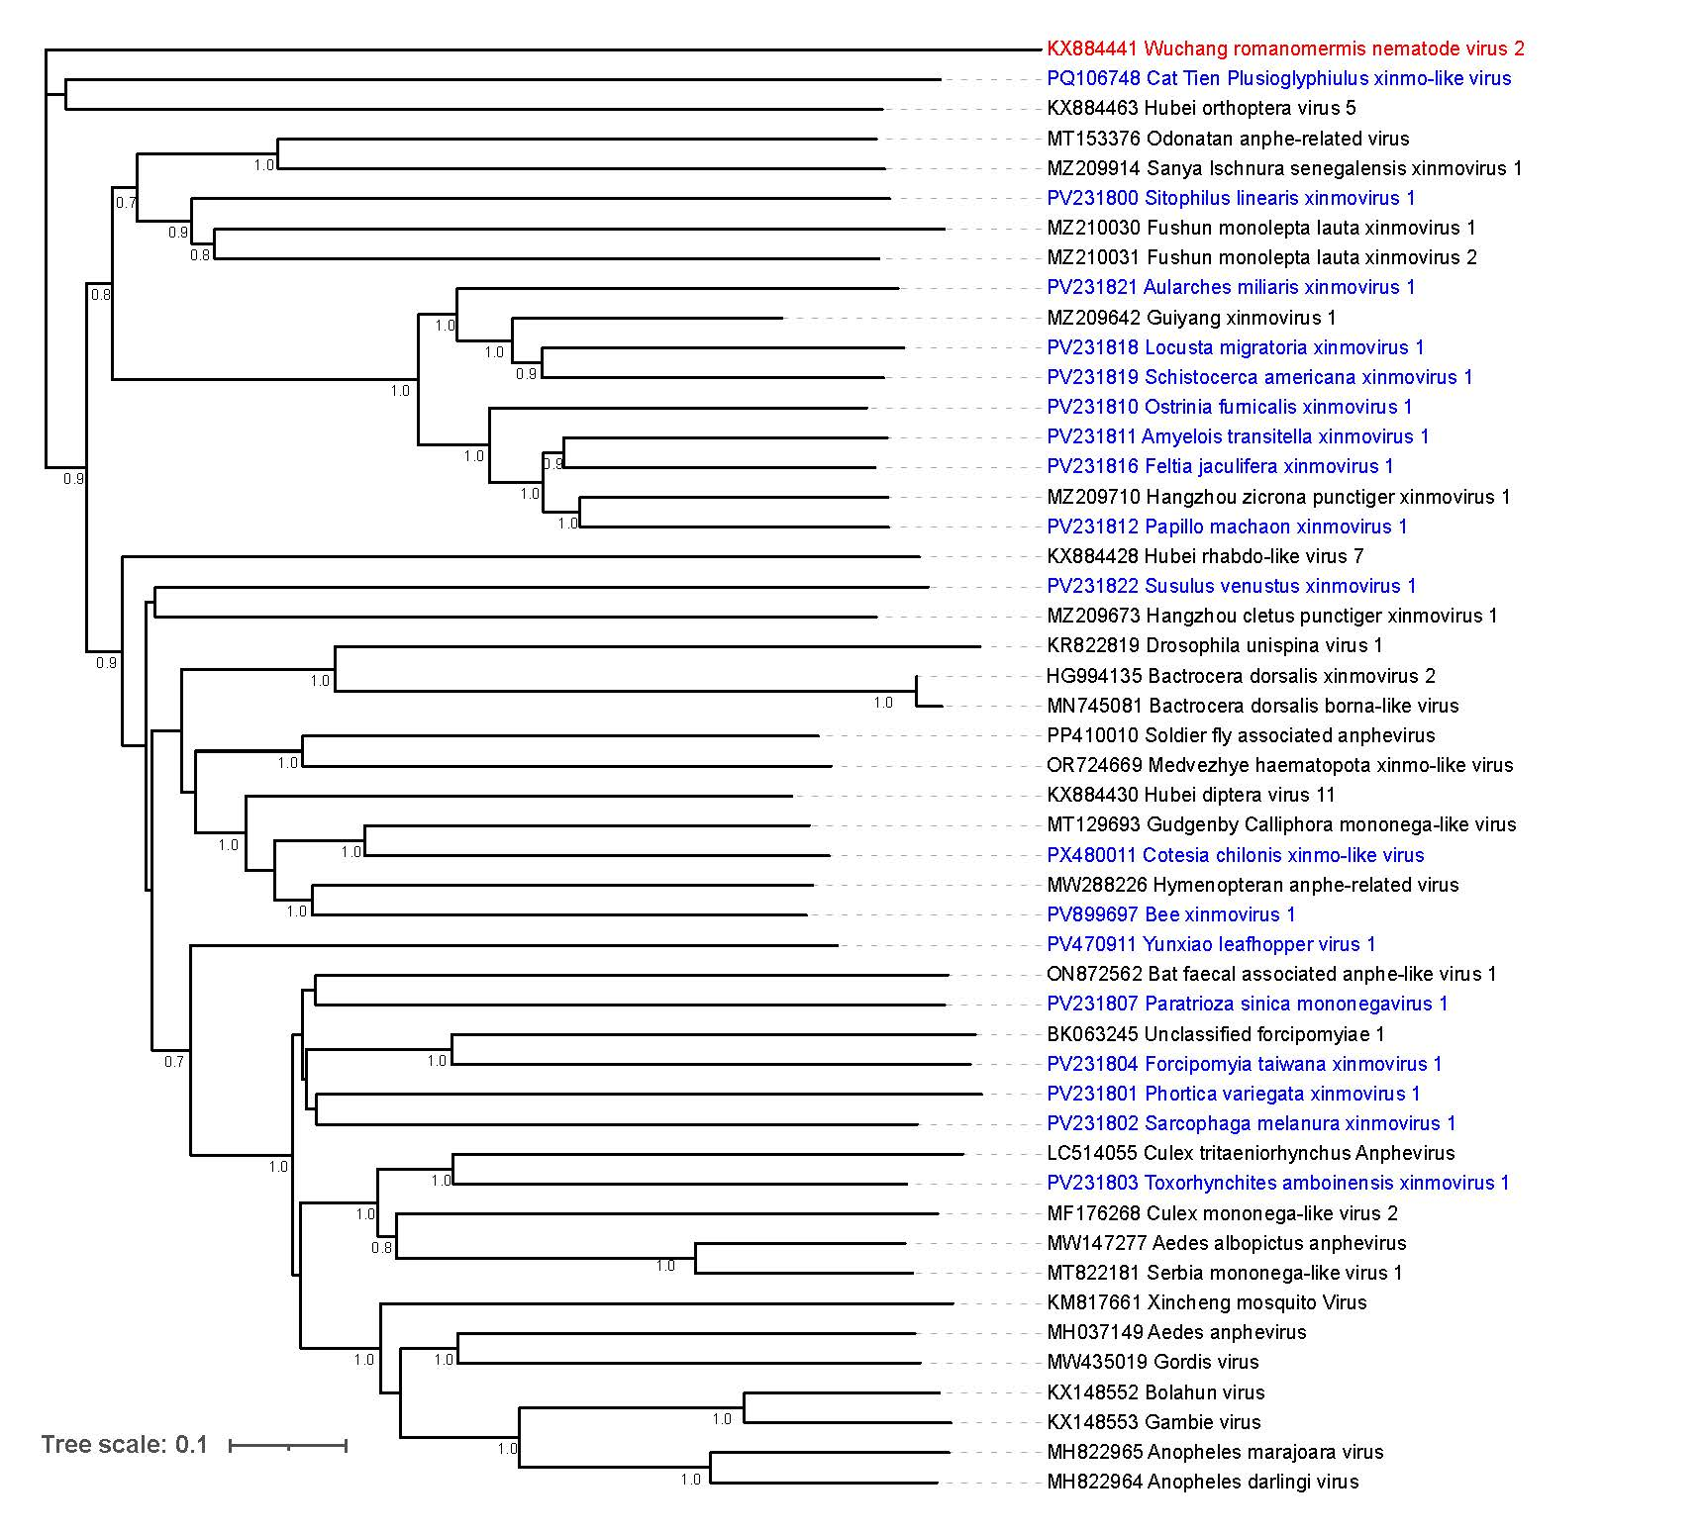
Figure 1. Phylogenetic tree of the RdRP amino acid sequences of current exemplar members of Xinmoviridae (black) with the proposed new species’ virus names (blue), the virus used as the outgroup (red) was Wǔchāng romanomermis nematode virus 2 (family Lispiviridae). Sequences were aligned using MUSCLE v5.1 (Edgar, 2022) and a neighbour-joining tree of amino acid distances was created using the Poisson correction and 1000 bootstraps within MEGA11 (Tamura et al., 2021).

Table 1.
Proposed exemplar virus name | Genbank accession | Proposed genus name | Proposed species epithet | Closest Xinmoviridae exemplar | Amino acid query cover (%) | Amino acid identity (%)
Cat Tien Plusioglyphiulus xinmo-like virus | PQ106748 | Plusiovirus | tienense | Odonatan anphe-related virus | 85 | 26.51
Yunxiao leafhopper virus 1 | PV470911 | Recsavirus | fujianense | Hymenopteran anphe-related virus | 92 | 35.15
Bee xinmovirus 1 | PV899697 | Pimvirus | israelense | Hymenopteran anphe-related virus | 95 | 45.04
Cotesia chilonis xinmo-like virus | PX480011 | Tesilovirus | hiaense | Gudgenby Calliphora mononega-like virus | 99 | 44.96
Locusta migratoria xinmovirus 1 | PV231818 | Logravirus | suwonense | Guiyang xinmovirus 1 | 69 | 56.68
Schistocerca americana xinmovirus 1 | PV231819 | Schistamvirus | arizonense | Guiyang xinmovirus 1 | 68 | 59.3
Aularches miliaris xinmovirus 1 | PV231821 | Larmilvirus | karnatakaense | Guiyang xinmovirus 1 | 70 | 52.02
Ostrinia furnicalis xinmovirus 1 | PV231810 | Osturnivirus | chinaense | Guiyang xinmovirus 1 | 71 | 50.34
Amyelois transitella xinmovirus 1 | PV231811 | Amtranvirus | kernense | Guiyang xinmovirus 1 | 71 | 50.45
Papillo machaon xinmovirus 1 | PV231812 | Papmacvirus | sichuanense | Guiyang xinmovirus 1 | 70 | 51.11
Feltia jaculifera xinmovirus 1 | PV231816 | Felticulivirus | champaignense | Guiyang xinmovirus 1 | 70 | 51.81
Paratrioza sinica mononegavirus 1 | PV231807 | Parasinivirus | qinghaiense | Bat faecal associated anphe-lke virus 1 | 98 | 34.22
Sitophilus linearis xinmovirus 1 | PV231800 | Sitolivirus | niameyense | Fushun monolepta lauta xinmovirus 2 | 76 | 36.51
Susulus venustus xinmovirus 1 | PV231822 | Susvenuvirus | tehamaense | Hubei diptera 11 | 69 | 34.6
Phortica variegata xinmovirus 1 | PV231801 | Phorvarivirus | berkeleyense | Forcipomyiae 1 vrus | 97 | 33.52
Sarcophaga melanura xinmovirus 1 | PV231802 | Sarcomelvirus | fuyangense | Gordis virus | 96 | 36.93
Toxorhynchites amboinensis xinmovirus 1 | PV231803 | Chitamvirus | juanense | Culex tritaeniorhynchus anphevirus | 96 | 43.57
Forcipomyia taiwana xinmovirus 1 | PV231804 | Fortaivirus | taichungense | Forcipomyiae 1 vrus | 96 | 41.83

