

The International Committee on Taxonomy of Viruses
Taxonomy Proposal Form, 2026
Part 1a: Details of taxonomy proposals

Title: | Creating one species in the genus Orthorubulavirus, family Paramyxoviridae
Code assigned: | 2026.013M.N.v1.Orthorubulavirus_1nsp

Author(s), affiliation and email address(es):
Given name (+middle initial(s)) | Surname | Affiliation | Email address | Corr. author(s)
Ke'an | Chen | National Key Laboratory of Intelligent Tracking and Forecasting for Infectious Diseases, National Institute for Communicable Disease Control and Prevention, Chinese Center for Disease Control and Prevention, Beijing, China | cutlerchen@outlook.com
Xuelian | Luo | National Key Laboratory of Intelligent Tracking and Forecasting for Infectious Diseases, National Institute for Communicable Disease Control and Prevention, Chinese Center for Disease Control and Prevention, Beijing, China | luoxuelian@icdc.cn | X

Part 1b: Taxonomy Proposal Submission
ICTV Subcommittee
Animal DNA Viruses and Retroviruses |  | Bacterial viruses
Animal minus-strand and dsRNA viruses | X | Fungal and protist viruses
Animal positive-strand RNA viruses |  | Plant viruses
Archaeal viruses |  | General -

List the ICTV Study Group(s) that have seen or have been involved in creating this proposal:
Optional – complete only if formally voted on by an ICTV Study Group:
Study Group | Number of members
Study Group | Votes in support | Votes against | No vote

Submission date: | 09/09/2026

Part 1c: Feedback from ICTV Executive Committee (EC) meeting
Executive Committee Meeting Decision code: | X
A – Accept
Ac – Accept subject to revision by relevant subcommittee chair. No further vote required
U – Accept without revision but with re-evaluation and email vote by the EC
Uc – Accept subject to revision and re-evaluation and email vote by the EC
Ud – Deferred to the next EC meeting, with an invitation to revise based on EC comments
J - Reject
W - Withdrawn

Comments from the Executive Committee:

Part 1d: Revised Taxonomy Proposal Submission
Response of proposer:
Revision date:

Part 3: TAXONOMIC PROPOSAL

Taxonomic changes proposed:
Establish new taxon | X | Split taxon
Abolish taxon |  | Merge taxon
Move taxon |  | Promote taxon
Rename taxon |  | Demote taxon
Move and rename

Etymology (origin) of proposed taxonomic names:
Taxon name | Etymology of the term
“Orthorubulavirus vespertilionis” | vespertilionis: from Vespertilio, the genus name of the bat host (parti-coloured bat, Vespertilio murinus); from Latin vespertilio, “bat”.

Permission for use of names derived from a living person:
Taxon name | Full name of person from whom the name is derived | Attached
NONE

Abstract of Taxonomy Proposal:

Description of current taxonomy: The genus Orthorubulavirus (subfamily Rubulavirinae, family Paramyxoviridae, order Mononegavirales) currently comprises eight species, including two for bat-borne viruses (Orthorubulavirus mapueraense and Orthorubulavirus rhinolophi). Member viruses have non-segmented, negative-sense RNA genomes with the gene order 3′-N-P/V-M-F-HN-L-5′.
Proposed taxonomic change(s): Creation of one new species, “Orthorubulavirus vespertilionis”, in the genus Orthorubulavirus, for a virus (exemplar isolate GSB2026-Q, hereafter VORV; GenBank accession PZ817176) detected in the respiratory tract of a parti-coloured bat (Vespertilio murinus) sampled in Lanzhou, Gansu Province, China, in June 2026.
Demarcation criteria for new taxon/taxa: Classification in the family Paramyxoviridae is based on comparison of complete L protein amino acid sequences (Rima et al., 2019). The complete genome of GSB2026-Q (16,356 nt) shows the canonical orthorubulavirus organisation, and phylogenetic analysis of the L protein places the virus within the genus Orthorubulavirus, as a lineage distinct from members of all eight established species (L protein amino acid p-distance to its closest relative, Human orthorubulavirus 4: 0.227; terminal branch length in the maximum-likelihood L protein tree: 0.140, exceeding the 0.03 species demarcation threshold for the genus (Rima et al., 2019); Figure 1).
Justification: GSB2026-Q represents a distinct orthorubulavirus lineage from a host species and geographic region not represented among current members of the genus. Its complete, annotated genome is publicly available (PZ817176).

Text of Taxonomy proposal:

Description of current taxonomy: The genus Orthorubulavirus currently comprises eight species (Orthorubulavirus hominis, Orthorubulavirus laryngotracheitidis, Orthorubulavirus mammalis, Orthorubulavirus mapueraense, Orthorubulavirus parotitidis, Orthorubulavirus rhinolophi, Orthorubulavirus simiae and Orthorubulavirus suis) in the subfamily Rubulavirinae, family Paramyxoviridae (ICTV Master Species List 2025, MSL41). Orthorubulaviruses have non-segmented, negative-sense, single-stranded RNA genomes of about 15–16 kb with the conserved gene order 3′-N-P/V-M-F-HN-L-5′, and infect mammals (including bats) and birds.
Proposed taxonomic change(s): We propose the creation of one new species, “Orthorubulavirus vespertilionis”, within the genus Orthorubulavirus. The exemplar virus is isolate GSB2026-Q (hereafter VORV; GenBank accession PZ817176), detected in a respiratory tract sample of a parti-coloured bat (Vespertilio murinus) collected in Lanzhou, Gansu Province, China, on 5 June 2026. The complete genome is 16,356 nt in length and encodes the six canonical transcription units N, P/V, M, F, HN and L; no small hydrophobic (SH) gene is present, consistent with most members of the genus. This taxonomic change is presented in the accompanying Excel module (Orthorubulavirus_1nsp.xlsx).
Demarcation criteria for new taxon/taxa: Taxonomic classification in the family Paramyxoviridae is based on phylogenetic analysis of complete L protein amino acid sequences, and species demarcation is based on branch lengths in the resulting tree: a terminal branch length (distance from the nearest node to the branch tip) greater than 0.03 defines a distinct species (Rima et al., 2019). Complete L protein amino acid sequences (79 taxa) were aligned with ClustalW (gap opening penalty 5 and gap extension penalty 1 for both multiple and pairwise alignments), and a maximum-likelihood tree was inferred with the JTT matrix-based model in MEGA X (Kumar et al., 2018), with branch support from 500 bootstrap replicates (Figure 1). In this tree, GSB2026-Q falls within a monophyletic genus Orthorubulavirus clade (100% bootstrap support) as a distinct, well-supported lineage (100%) sister to Human orthorubulavirus 4 (species Orthorubulavirus hominis). The terminal branch length of GSB2026-Q in this tree is 0.140, exceeding the 0.03 species demarcation threshold.
Justification: GSB2026-Q was detected in a bat species (Vespertilio murinus) and a geographic region (northwest China) not represented among current members of the genus. Its L protein amino acid p-distance to its closest relative, Human orthorubulavirus 4, is 0.227 (77.3% pairwise identity), which is comparable to distances between established species of the genus (e.g. 0.226 between Human orthorubulavirus 2 and Simian orthorubulavirus SV-41, and 0.293 between Human orthorubulavirus 4 and Wufeng Rhinolophus sinicus rubulavirus 1), supporting species-level distinctness. Its complete, annotated genome sequence is publicly available in GenBank under accession PZ817176, meeting the ICTV requirement that proposals for new species refer to publicly available, coding-complete genome sequences.
References:
Rima B, Balkema-Buschmann A, Dundon WG, Duprex P, Easton A, Fouchier R, Kurath G, Lamb R, Lee B, Rota P, Wang L-F; ICTV Report Consortium. ICTV Virus Taxonomy Profile: Paramyxoviridae. Journal of General Virology 2019; 100: 1593–1594.
International Committee on Taxonomy of Viruses (ICTV). Master Species List 2025 (MSL41). https://ictv.global/msl
Kumar S, Stecher G, Li M, Knyaz C, Tamura K. MEGA X: Molecular Evolutionary Genetics Analysis across computing platforms. Molecular Biology and Evolution 2018; 35: 1547–1549.

Accompanying files:
Filename | Description of contents
Figure1_L_protein_tree.pdf | Maximum-likelihood phylogenetic tree of complete L protein amino acid sequences of members of the genus Orthorubulavirus (to be added)

Tables, Figures:

<Start here>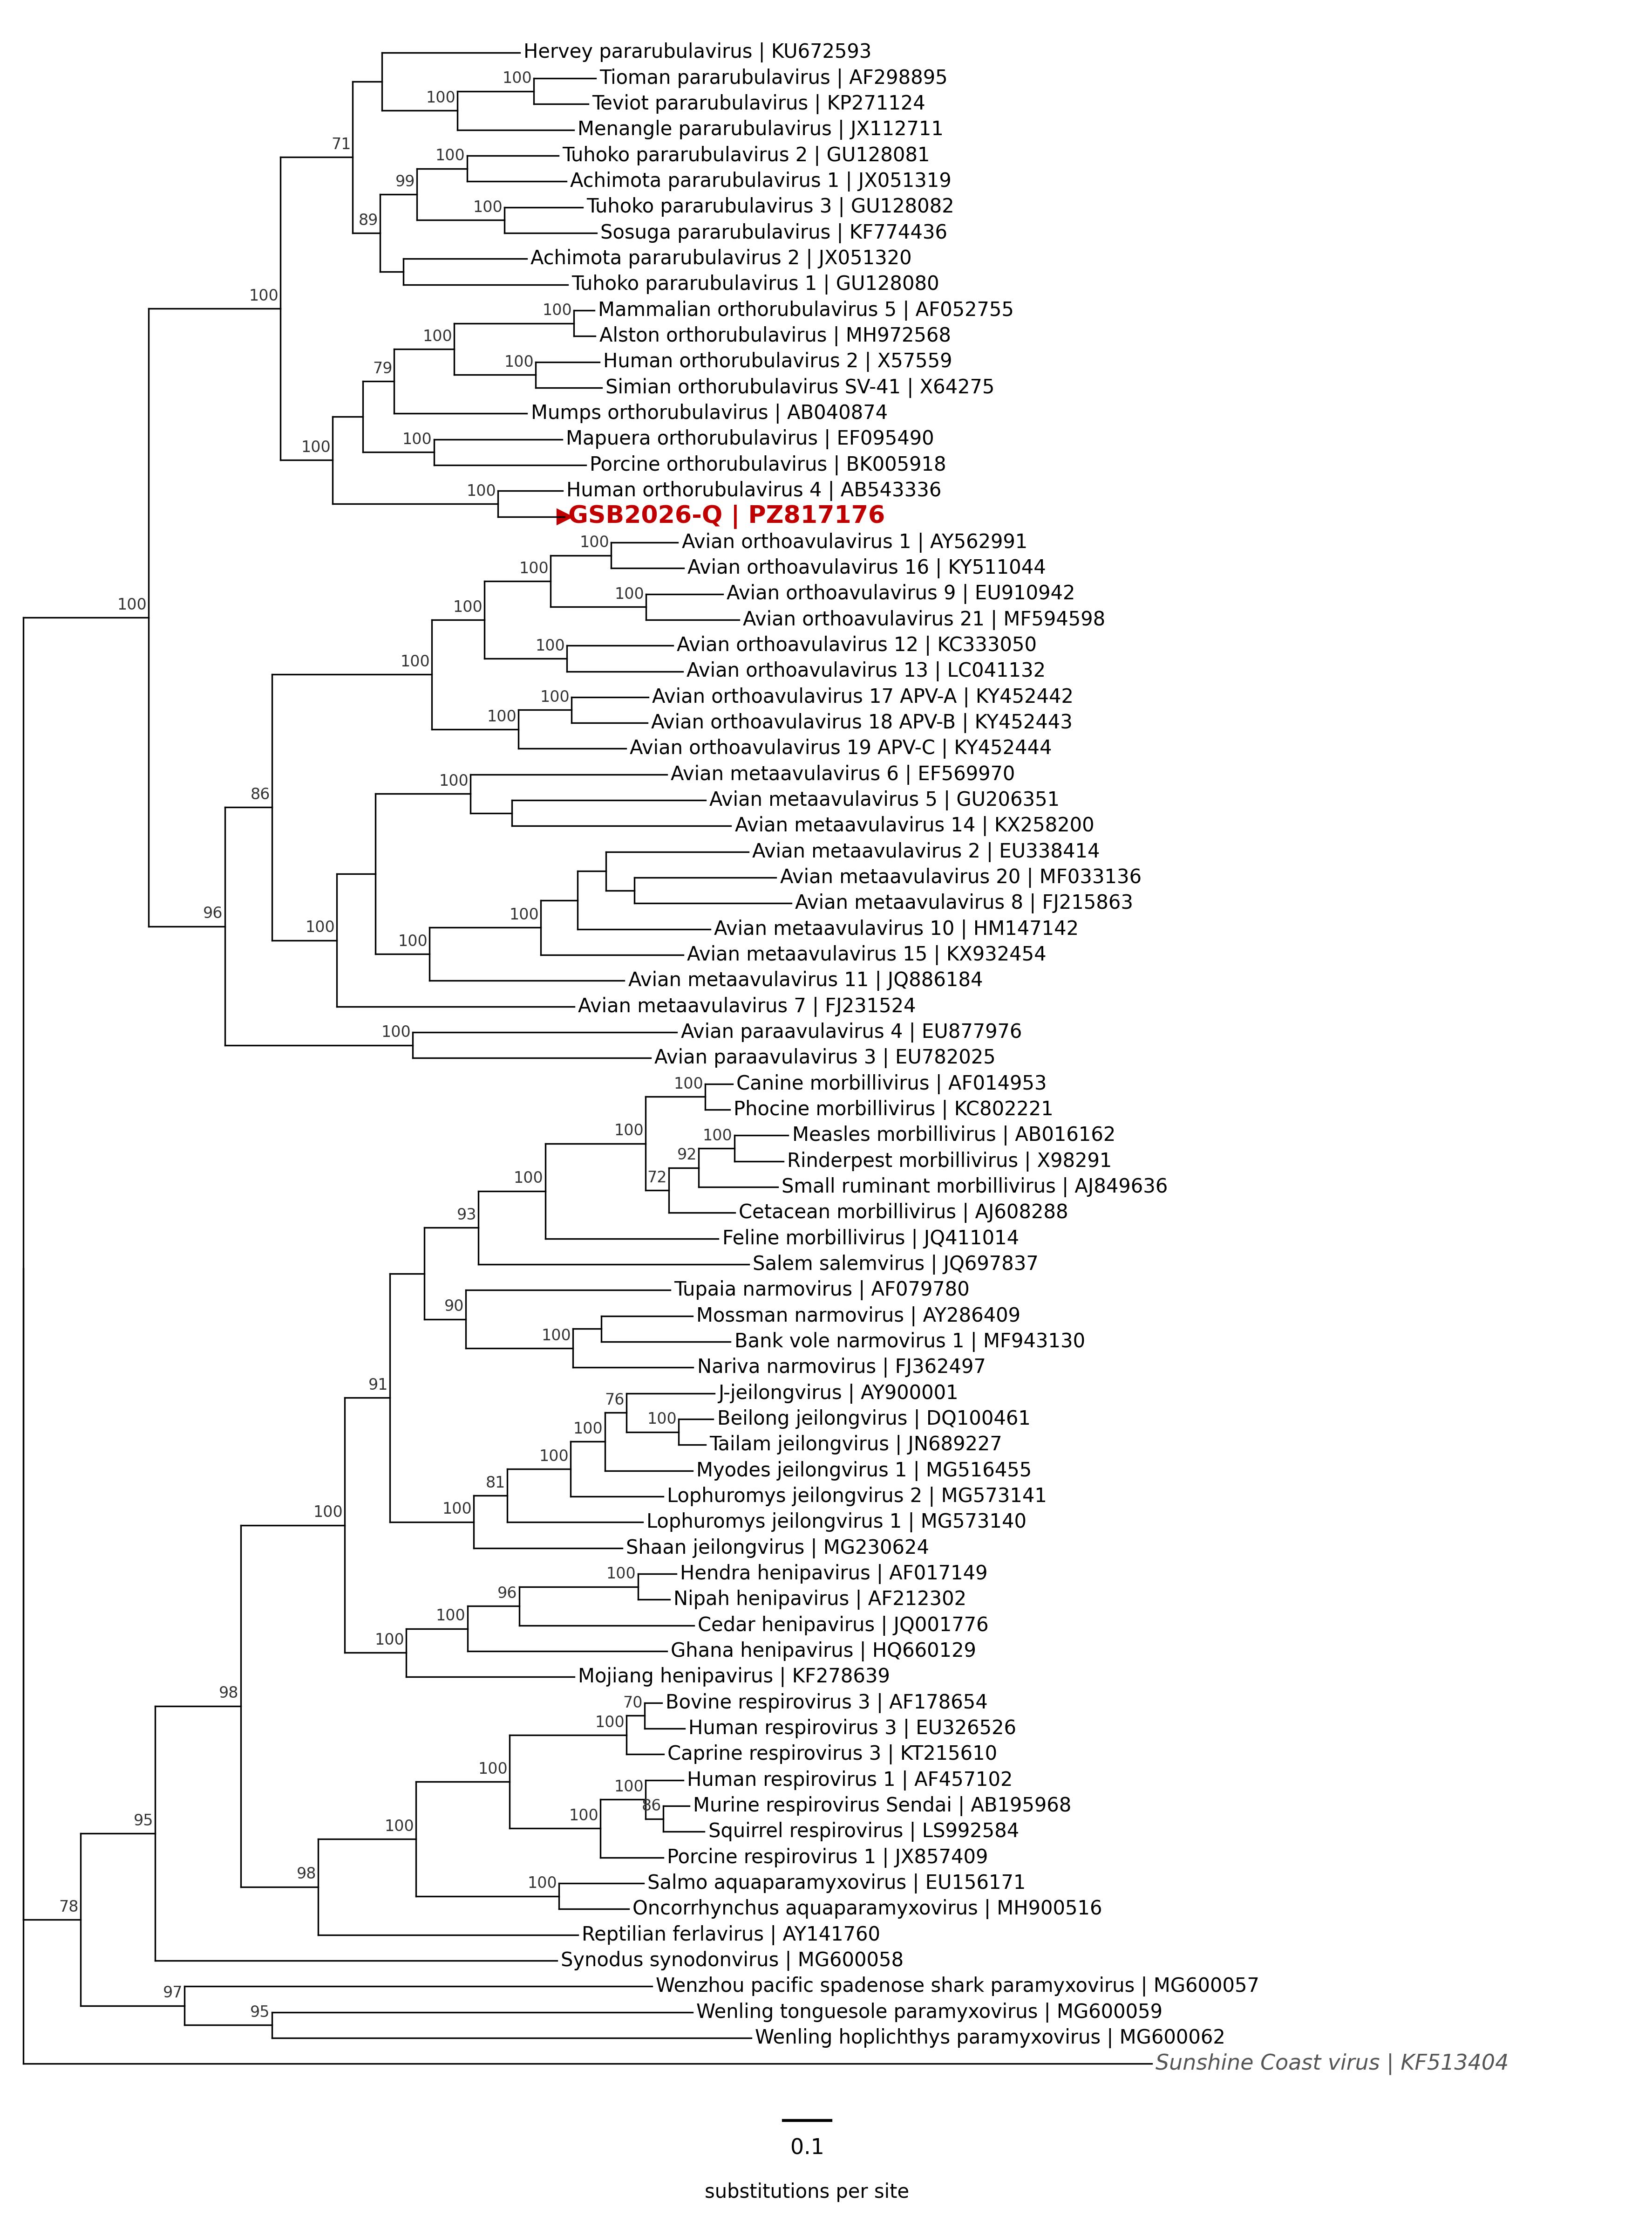
Figure 1. Maximum-likelihood phylogenetic tree of complete L protein amino acid sequences of GSB2026-Q (red triangle and bold red label) and 78 reference viruses, including members of seven of the eight established species of the genus Orthorubulavirus (subfamily Rubulavirinae) and representatives of other genera of the family Paramyxoviridae. Sequences were aligned with ClustalW (gap opening penalty 5, gap extension penalty 1 for both multiple and pairwise alignments), and the tree was inferred with the Maximum Likelihood method and JTT matrix-based model in MEGA X (Kumar et al., 2018). Numbers at nodes are the percentage of 500 bootstrap replicate trees in which the associated taxa clustered together; only values ≥70% are shown. The tree is rooted with Sunshine Coast virus (family Sunviridae) as the outgroup. Tip labels give virus names and INSDC nucleotide accession numbers. Scale bar: 0.1 amino acid substitutions per site.

