

The International Committee on Taxonomy of Viruses
Taxonomy Proposal Form, 2026

Part 1a: Details of taxonomy proposals

Title: | Creation of a genus and a species within the family Hydriviridae
Code assigned: | 2026.001F.N.v2.Hydriviridae_1ngen_1nsp

Author(s), affiliation and email address(es):
Given name (+middle initial(s)) | Surname | Affiliation | Email address | Corr. author(s)
Victória | Queiroz | Dept Biological Sciences, Virginia Tech, Blacksburg, USA | victoriafq@vt.edu | X
Gabriel | Almeida | The Arctic University of Norway, Tromso, Norway | gabriel.d.almeida@uit.no
Julien | Andréani | Aix Marseille Université, Marseille, France | julien.andreani@univ-amu.fr
Frank | Aylward | Dept Biological Sciences, Virginia Tech, Blacksburg, USA | faylward@vt.edu
Jean-Michel | Claverie | Aix Marseille Université, Marseille, France | claverie@igs.cnrs-mrs.fr
Philippe | Colson | Aix Marseille Université, Marseille, France | philippe.colson@univ-amu.fr
Gilbert | Greub | Lausanne University, Lausanne, Switzerland | Gilbert.Greub@chuv.ch
Rodrigo | Rodrigues | Universidade Federal de Minas Gerais, Belo Horizonte, Brazil | rodriguesral07@gmail.com
Masaharu | Takemura | Tokyo University of Science, Tokyo, Japan | giantvirus@rs.tus.ac.jp
Jônatas | Abrahão | Universidade Federal de Minas Gerais, Belo Horizonte, Brazil | jonatas.abrahao@gmail.com | X

Part 1b: Taxonomy Proposal Submission
ICTV Subcommittee:
Animal DNA Viruses and Retroviruses |  | Bacterial viruses
Animal minus-strand and dsRNA viruses |  | Fungal and protist viruses | x
Animal positive-strand RNA viruses |  | Plant viruses
Archaeal viruses |  | General -

List the ICTV Study Group(s) that have seen or have been involved in creating this proposal:
Pithoviridae Study Group Members
Optional – complete only if formally voted on by an ICTV Study Group:
Study Group | Number of members
Study Group | Votes in support | Votes against | No vote
Pithoviridae Study Group Members | 10 | 0 | 0

Submission date: | 17/08/2026

Part 1c: Feedback from ICTV Executive Committee (EC) meeting
Executive Committee Meeting Decision code: | X
A – Accept
Ac – Accept subject to revision by relevant subcommittee chair. No further vote required
U – Accept without revision but with re-evaluation and email vote by the EC
Uc – Accept subject to revision and re-evaluation and email vote by the EC
Ud – Deferred to the next EC meeting, with an invitation to revise based on EC comments
J – Reject
W – Withdrawn

Comments from the Executive Committee:

Part 1d: Revised Taxonomy Proposal Submission
Response of proposer:
Revision date:

Part 3: TAXONOMIC PROPOSAL
https://ictv.global/taxonomy/templates

Taxonomic changes proposed:
Establish new taxon | x | Split taxon
Abolish taxon |  | Merge taxon
Move taxon |  | Promote taxon
Rename taxon |  | Demote taxon
Move and rename

Etymology (origin) of proposed taxonomic names:
Taxon name | Etymology of the term
“Alphanaiavirus” | The proposed genus name is formed by the Greek-derived prefix “alpha”, used for genera within this suborder, combined with “naiavirus”, the name of the isolate.
“Alphanaiavirus pantanense” | The species epithet is derived from Pantanal, the Brazilian biome where the virus was isolated, with the neuter Latin suffix.

Permission for use of names derived from a living person:
Taxon name | Full name of person from whom the name is derived | Attached

Abstract of Taxonomy Proposal:
Description of current taxonomy:
Currently, the order Pimascovirales comprises six families, three of which belong to the suborder Ocovirineae. Among these, the family Hydriviridae contains a single representative, Alphahydrivirus permafrostis. These family, genus, and species were established to accommodate a complete circular metagenome-assembled genome (MAG) described in 2022. However, given the recent isolation of a new virus that clusters with this MAG, a new genus and species should be created within this family to taxonomically classify it.

Proposed taxonomic change(s):
Creation of a genus, “Alphanaiavirus”, and a species, “Alphanaiavirus pantanense”, within the family Hydriviridae.

Demarcation criteria for new taxon/taxa:
The demarcation criteria for the new genus and species should follow the standards already established for the suborder. Accordingly, viruses exhibiting similar overall genome organization and genome size, together with a pairwise ANI >80% across at least 50% of the aligned genome, are considered to belong to the same genus. Furthermore, isolates exhibiting a pairwise ANI >95% across at least 75% of their genes should be assigned to the same species. Moreover, the assignment to the same family was guided by the topology and branch distances of a phylogenetic tree built using a standard set of core genes shared among members of the order.

Justification:
A new genus and species should be created to encompass Naiavirus, a novel viral isolate that taxonomically clusters with hydrivirus, currently the only representative of the Hydriviridae family.

- Text of Taxonomy proposal:

Description of current taxonomy:
A few years ago, the description of a complete, circular metagenome-assembled genome (MAG) led to the establishment of a new species, Alphahydrivirus permafrostis, as well as a new genus, Alphahydrivirus, and family, Hydriviridae, to accommodate this representative within the order Pimascovirales [1, 2]. Consequently, the order currently comprises six families, three of which are classified within the suborder Ocovirineae. This suborder includes families that remain poorly represented, with only a few isolated viruses, or no cultured representative at all, as is the case for the Hydriviridae family [2].

Proposed taxonomic change(s):
With the recent description of the Naiavirus, we propose the creation of a second genus within the family Hydriviridae, along with a new species, to formally classify this isolate [3]. Following the naming conventions of the suborder to which the Hydriviridae family belongs, we propose the genus name “Alphanaiavirus” and the species name “Alphanaiavirus pantanense.”

Demarcation criteria for new taxon/taxa:
The demarcation criteria for the new genus and species should follow the standards established for the suborder [2024.005F.A.v2.Pimascovirales_reorg]. Accordingly, viruses exhibiting similar overall genome organization and genome size, together with a pairwise ANI >80% across at least 50% of the aligned genome, are considered to belong to the same genus. At the species level, isolates sharing a pairwise ANI >95% across at least 75% of their genes are considered to belong to the same species (Figure 1). Finally, the assignment to the same family was guided by the topology and branch lengths of a phylogenetic tree constructed using a standard set of seven core genes shared among members of the order (Figure 2).

Justification:
Phylogenetic analyses show that the Naiavirus clusters with Hydrivirus. However, it remains sufficiently distinct to warrant classification in a separate genus, as the average nucleotide identity does not reach the minimum threshold of 80% required to assign these viruses to the same genus. In addition, the overall genome size of Naiavirus is very different from that of Hydrivirus. Therefore, a new genus and a new species within the family Hydriviridae should be established.
References:
- Rigou, S., Santini, S., Abergel, C. et al. Past and present giant viruses diversity explored through permafrost metagenomics. Nat Commun 13, 5853 (2022). https://doi.org/10.1038/s41467-022-33633-x.
- Claverie, JM., Legendre, M., Rigou, S. et al. Refining the taxonomy of pithovirus-related giant DNA viruses within the order Pimascovirales. Arch Virol 170, 111 (2025). https://doi.org/10.1007/s00705-025-06297-3.
- Rodrigues, M., Queiroz, V., Arantes, T. et al. Naiavirus: an enveloped giant virus with a pleomorphic, flexible tail. Nat Commun 16, 8306 (2025). https://doi.org/10.1038/s41467-025-63463-6.
- Jain, R. et al. High throughput ANI analysis of 90K prokaryotic genomes reveals clear species boundaries. Nature Communications 9, 5114 (2018). https://doi.org/10.1038/s41467-018-07641-9.
- Aylward FO, Moniruzzaman M, Ha AD, Koonin EV (2021) A phylogenomic framework for charting the diversity and evolution of giant viruses. PLOS Biology 19(10): e3001430. https://doi.org/10.1371/journal.pbio.3001430
- Capella-Gutiérrez, S. et al. trimAl: a tool for automated alignment trimming in large-scale phylogenetic analyses. Bioinformatics 25, 1972–1973 (2009). https://doi.org/10.1093/bioinformatics/btp348.
- Minh, B. Q. et al. IQ-TREE 2: New Models and Efficient Methods for Phylogenetic Inference in the Genomic Era. Molecular Biology and Evolution 37, 1530–1534 (2020). https://doi.org/10.1093/molbev/msaa015.
- Hoang, D. T. et al. UFBoot2: Improving the Ultrafast Bootstrap Approximation. Molecular Biology and Evolution 35, 518–522 (2018). https://doi.org/10.1093/molbev/msx281.
- Letunic, I. & Bork, P. Interactive Tree of Life (iTOL) v6: recent updates to the phylogenetic tree display and annotation tool. Nucleic Acids Research 52, W78–W82 (2024). https://doi.org/10.1093/nar/gkae268.

Accompanying files:
Filename | Description of contents

Tables, Figures:

<Start here>
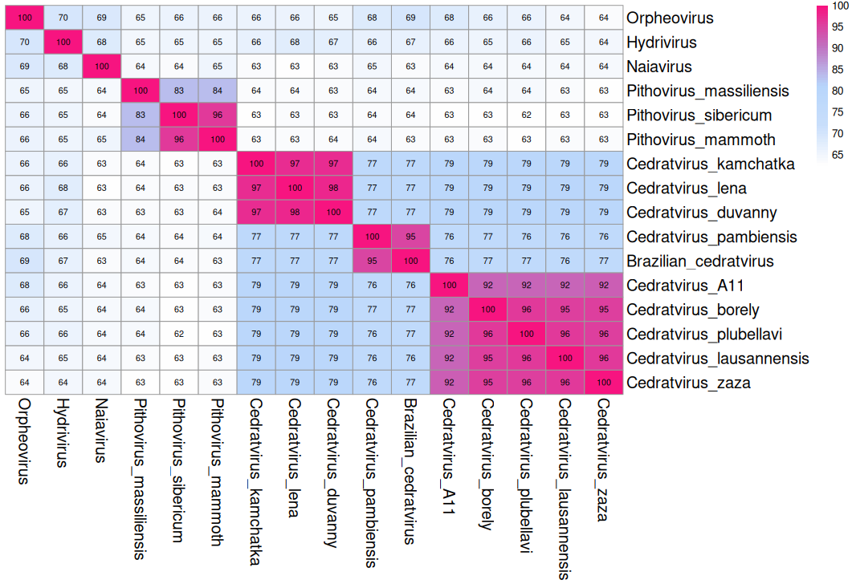Figure 1: Average nucleotide identity (ANI) analysis of the representatives of the suborder Ocovirineae used in this taxonomy proposal. ANI was calculated using the fastANI tool (https://github.com/ParBLiSS/FastANI) [4] with 1000 bp window size.
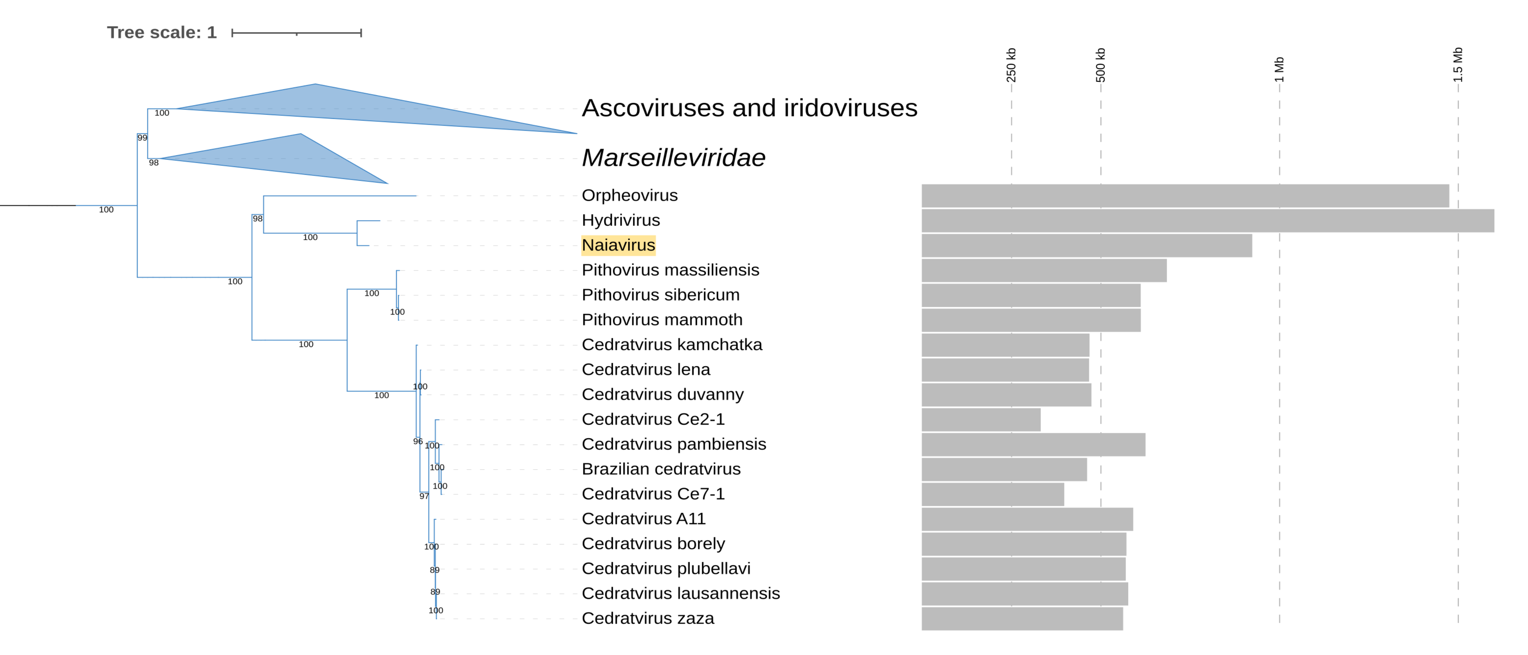
Figure 2. Phylogeny of viruses in the suborder Ocovirineae, based on a concatenated alignment of a set of seven marker genes that were previously benchmarked, namely Poxvirus Late Transcription Factor VLTF3, A32 Packaging ATPase, DNA topoisomerase II, Transcription initiation factor IIB, DNA polymerase family B, DNA-directed RNA polymerase alpha subunit (RNAPL), and DEAD/SNF2-like helicase (SFII) [5]. Gray horizontal bars correspond to the size of the genomes. The ncldv_markersearch.py utility was used to construct the alignment (https://github.com/faylward/ncldv_markersearch) before trimming with trimAl (-gt 0.1) [6] and phylogenetic reconstruction with IQ-TREE 2.4.0 using the LG+F+R10 substitution model [7]. Node support values are UltraFast bootstraps [8]. Marseilleviruses, ascoviruses and iridoviruses were included as an outgroup. Phylogenetic tree was visualized and customized using the Interactive Tree of Life (iTOL) online platform [9].

