

The International Committee on Taxonomy of Viruses
Taxonomy Proposal Form, 2026

Part 1a: Details of taxonomy proposals

Title: | Creating one new species in the genus Sputnikvirus, family Sputniviroviridae
Code assigned: | 2026.002F.N.v2.Sputnikvirus_1nsp

Author(s), affiliation and email address(es):
Given name (+middle initial(s)) | Surname | Affiliation | Email address | Corr. author(s)
Bruna L. | Azevedo | UFMG – Federal University of Minas Gerais, Brazil | azvdobruna@gmail.com
Frank O. | Aylward | Department of Biological Sciences, Virginia Tech, USA | faylward@vt.edu
Rodrigo A.L. | Rodrigues | UFMG – Federal University of Minas Gerais, Brazil | rodriguesral07@gmail.com
Jônatas S. | Abrahão | UFMG – Federal University of Minas Gerais, Brazil | jonatas.abrahao@gmail.com | x

Part 1b: Taxonomy Proposal Submission
ICTV Subcommittee:
Animal DNA Viruses and Retroviruses |  | Bacterial viruses
Animal minus-strand and dsRNA viruses |  | Fungal and protist viruses | x
Animal positive-strand RNA viruses |  | Plant viruses
Archaeal viruses |  | General -

List the ICTV Study Group(s) that have seen or have been involved in creating this proposal:
Virophage study group

Optional – complete only if formally voted on by an ICTV Study Group:
Study Group | Number of members
Study Group | Votes in support | Votes against | No vote

Submission date: | 17/08/2026

Part 1c: Feedback from ICTV Executive Committee (EC) meeting
Executive Committee Meeting Decision code: | X
A – Accept
Ac – Accept subject to revision by relevant subcommittee chair. No further vote required
U – Accept without revision but with re-evaluation and email vote by the EC
Uc – Accept subject to revision and re-evaluation and email vote by the EC
Ud – Deferred to the next EC meeting, with an invitation to revise based on EC comments
J - Reject
W - Withdrawn

Comments from the Executive Committee:

Part 1d: Revised Taxonomy Proposal Submission
Response of proposer:
Revision date:

Part 3: TAXONOMIC PROPOSAL
https://ictv.global/taxonomy/templates

Taxonomic changes proposed:
Establish new taxon | x | Split taxon
Abolish taxon |  | Merge taxon
Move taxon |  | Promote taxon
Rename taxon |  | Demote taxon
Move and rename

Etymology (origin) of proposed taxonomic names:
Taxon name | Etymology of the term
“Sputnikvirus pantanense” | The species epithet "pantanense" refers to the Pantanal, the world's largest tropical wetland, located mainly in Brazil, from which the exemplar virus (Pantanal virophage) was isolated.

Permission for use of names derived from a living person:
Taxon name | Full name of person from whom the name is derived | Attached

Abstract of Taxonomy Proposal:
Description of current taxonomy:
The genus Sputnikvirus, classified in the family Sputniviroviridae and order Mividavirales, currently comprises two recognized species, Sputnikvirus mimiviri and Sputnikvirus zamilonense. Members of this genus are virophages associated with giant viruses of the family Mimiviridae and are characterized by a conserved set of hallmark genes. Pantanal virophage was recently isolated and characterized as a member of the genus Sputnikvirus but has not yet been formally classified by the ICTV.

Proposed taxonomic change(s):
Creation of a new species, "Sputnikvirus pantanense", within the genus Sputnikvirus (family Sputniviroviridae, order Mividavirales). Pantanal virophage is designated as the exemplar virus of the proposed species.

Demarcation criteria for new taxon/taxa:
The proposed exemplar fulfills the currently accepted criteria for inclusion in the genus Sputnikvirus, including its association with a giant virus of the family Mimiviridae and the presence of the conserved hallmark genes that characterize members of the genus. Comparative genomic and phylogenetic analyses further demonstrate that Pantanal virophage represents a distinct lineage from the two currently recognized Sputnikvirus species. These analyses include whole-genome nucleotide identity, average amino acid identity, phylogenetic reconstruction of conserved marker genes, and comparative genome organization, supporting the recognition of the proposed species "Sputnikvirus pantanense".

Justification:
Pantanal virophage is an isolated and fully characterized virophage that fulfills the accepted criteria for inclusion in the genus Sputnikvirus. Based on a combination of comparative genomic and phylogenetic analyses, it represents a distinct lineage within the genus that is not accommodated by the current taxonomy. The proposed species "Sputnikvirus pantanense" accommodates this distinct lineage within the taxonomy of the genus.

- Text of Taxonomy proposal:

Description of current taxonomy:
Virophages are double-stranded DNA viruses that parasitize the replication cycle of giant viruses and are currently classified in the class Virophaviricetes. Members of the genus Sputnikvirus (family Sputniviroviridae, order Mividavirales) are associated with giant viruses of the family Mimiviridae and currently comprise two recognized species, Sputnikvirus mimiviri and Sputnikvirus zamilonense (1-5). Pantanal virophage was recently isolated in association with Moumouvirus pantanense and characterized as a member of the genus Sputnikvirus (6). Comparative genomic and phylogenetic analyses demonstrated that Pantanal virophage represents a distinct lineage from the two currently recognized Sputnikvirus species (Figures 1-3). However, Pantanal virophage has not yet been formally classified by the ICTV.

Proposed taxonomic change(s):
Creation of a new species, "Sputnikvirus pantanense", within the genus Sputnikvirus (family Sputniviroviridae, order Mividavirales, class Virophaviricetes). Pantanal virophage (GenBank accession PX975497) is designated as the exemplar virus of the proposed species.

Demarcation criteria for new taxon/taxa:
The proposed exemplar fulfills the currently accepted criteria for inclusion in the genus Sputnikvirus, as established in ICTV Taxonomy Proposal 2015.001a-kF and updated in Taxonomy Proposal 2023.009F (4,5). Pantanal virophage is associated with a giant virus of the family Mimiviridae and encodes the conserved hallmark genes of the genus, including the major and minor capsid proteins, FtsK-HerA ATPase, cysteine protease, primase-superfamily 3 helicase, and lambda-type integrase (6). Comparative genomic and phylogenetic analyses showed that Pantanal virophage shares 80–84% average nucleotide identity (ANI) and 61.8–70.7% average amino acid identity (AAI) with the two currently recognized Sputnikvirus species (Figure 3). Together with genome synteny and gene content comparisons, these data demonstrate that Pantanal virophage represents a distinct evolutionary lineage within the genus Sputnikvirus, supporting the recognition of the proposed species "Sputnikvirus pantanense" (Figures 1-3) (6).

Justification:
Pantanal virophage is an isolated and fully characterized member of the genus Sputnikvirus. Based on a combination of comparative genomic and phylogenetic analyses, it represents a distinct evolutionary lineage within the genus that is not accommodated by the current taxonomy. The proposed species "Sputnikvirus pantanense" accommodates this lineage within the taxonomy of the genus.

References:
1. La Scola B, Desnues C, Pagnier I, Robert C, Barrassi L, Fournous G, Merchat M, Suzan-Monti M, Forterre P, Koonin EV, Raoult D. The virophage as a unique parasite of the giant mimivirus. Nature. 2008;455:100–104. doi:10.1038/nature07218.

2. Fischer MG, Hackl T. Host genome integration and giant virus-induced reactivation of the virophage mavirus. Nature. 2016;540:288–291. doi:10.1038/nature20593.

3. Roux S, Fischer MG, Hackl T, Katz LA, Schulz F, Yutin N. Updated Virophage Taxonomy and Distinction from Polinton-like Viruses. Biomolecules. 2023;13:204. doi:10.3390/biom13020204.

4. International Committee on Taxonomy of Viruses (ICTV). Taxonomy Proposal 2015.001a-kF. A new family and two new genera for classification of virophages .

5. International Committee on Taxonomy of Viruses (ICTV). Taxonomy Proposal 2023.009F. Establishing formal demarcation criteria for the Maveriviricetes class (“virophages”), and creating or re-assigning 4 orders, 7 families, 7 genera, and 8 species within this class .

6. de Azevedo BL, Colquehuanca Arias NE, Machado TB, Araújo Júnior JP, Alves AKNN, Alcantara LC Jr, Aylward FO, Rosa LH, Rodrigues RAL, Abrahão JS. Pantanal virophage: a new virophage species associated with a moumouvirus and a transpoviron, expanding the genus Sputnikvirus. Journal of Virology. 2026;100(4):e01930-25. doi:10.1128/JVI.01930-25.

Accompanying files:
Filename | Description of contents

Tables, Figures:

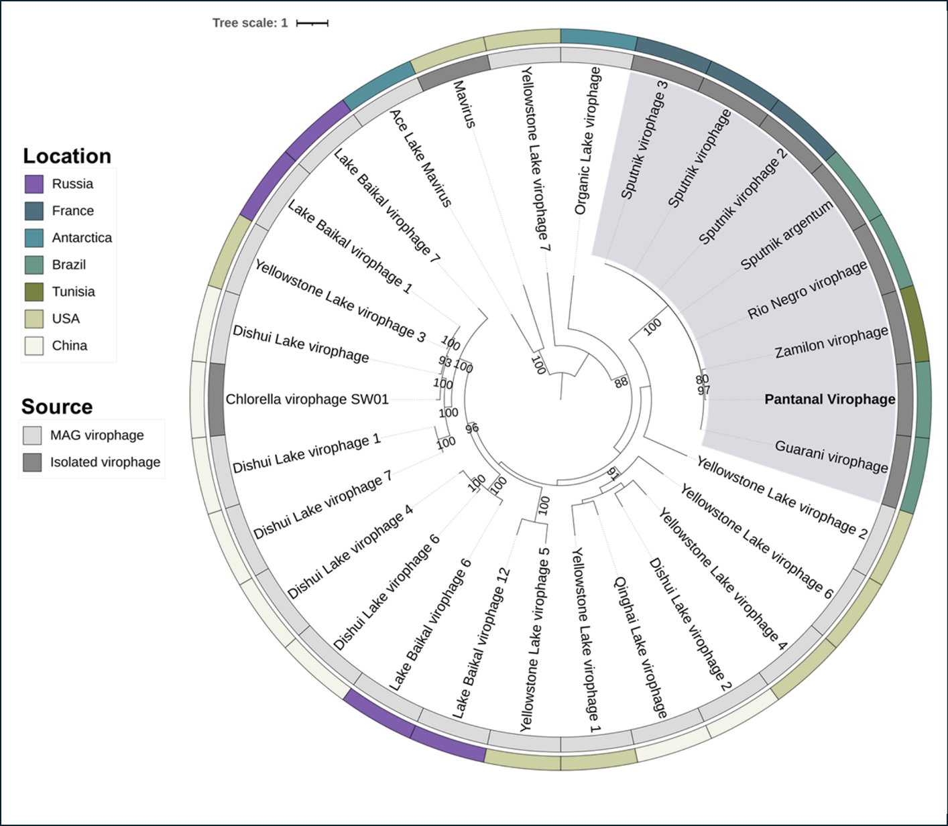

Figure 1: Major capsid protein (MCP) phylogeny based on amino acid sequences from different virophages. Pantanal virophage is labeled in bold. Sequences highlighted in purple are classified within the current genus Sputnikvirus. The inner ring indicates the source of the sequences, with isolated virophages in dark gray and MAG-related virophages in light gray. The outer ring indicates the country from where the virophages were isolated or identified with different colors for each country as indicated in the figure. This maximum likelihood phylogenetic tree was built with statistical support based on 1,000 replicates (bootstrap) and was rooted at the midpoint. The best model selected by IQ-TREE (ModelFinder) for the tree was rtREV+F+R3. The scale bar represents the number of amino acid substitutions per site.

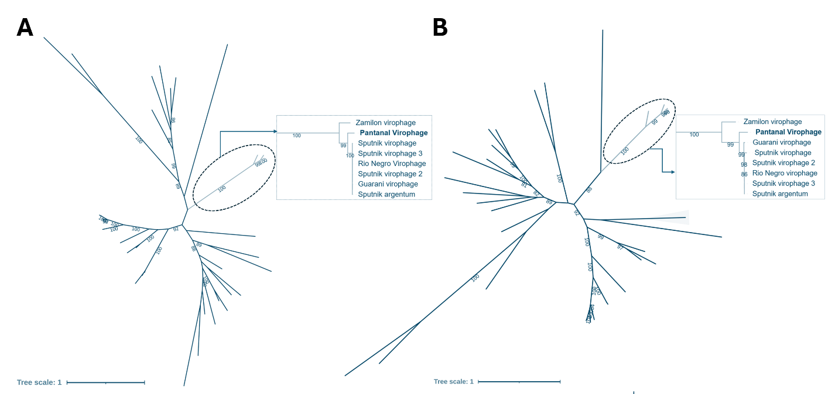Figure 2: Phylogenetic reconstructions based on virophage conserved genes. (A) Unrooted ATPase-based tree. (B) Unrooted mCP-based tree. In both trees, the clade representing the genus Sputnikvirus is labeled in green and exhibited in details with the Pantanal Virophage labeled in bold. Only bootstraps higher than 80 are shown, and the scale bars represent the number of amino acid substitutions per site. The best models, selected by IQ-TREE (ModelFinder), were rtREV+F+I+G4 for ATPase tree and Blosum62+F+I+G4 for mCP tree.

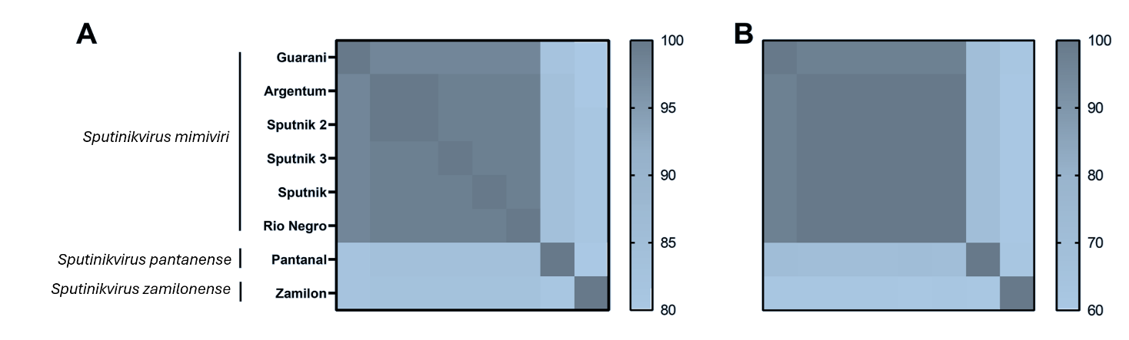

Figure 3: Average nucleotide identity (ANI) and average amino acid identity (AAI) analyses comparing different virophage sequences from genus Sputnikvirus, including Pantanal virophage. The analysis is based on a similarity matrix composed of (A) ANI and (B) AAI values. The two current species from the genus (Sputnikvirus mimiviri and Sputnikvirus zamilonense) are indicated. Pantanal virophage is indicated as a new species, Sputnikvirus pantanense. ANI values range from 80% to 100%, while AAI values range from 60% to 100%.

