

The International Committee on Taxonomy of Viruses
Taxonomy Proposal Form, 2026

Part 1a: Details of taxonomy proposals

Title: | Create a novel genus, and two species within the family Mimiviridae (Imitervirales)
Code assigned: | 2026.003F.N.v2.Mimiviridae_1ngen_2nsp

Author(s), affiliation and email address(es):
Given name (+middle initial(s)) | Surname | Affiliation | Email address | Corr. author(s)
Andor | Doszpoly | HUN-REN Veterinary Medical Research Institute, Budapest, Hungary | doszpoly.andor@vmri.hun-ren.hu | x
Sharon | Clouthier | Fisheries & Oceans Canada, Freshwater Institute, 501 University Crescent, Winnipeg, Manitoba R3T 2N6, Canada | Sharon.Clouthier@dfo-mpo.gc.ca
Gergő | Mitró | HUN-REN Veterinary Medical Research Institute, Budapest, Hungary | mitro.gergo@vmri.hun-ren.hu
Mária | Benkő | HUN-REN Veterinary Medical Research Institute, Budapest, Hungary | benko.maria@vmri.hun-ren.hu
Balázs | Harrach | HUN-REN Veterinary Medical Research Institute, Budapest, Hungary | harrach.balazs@vmri.hun-ren.hu

Part 1b: Taxonomy Proposal Submission
ICTV Subcommittee:
Animal DNA Viruses and Retroviruses | x | Bacterial viruses
Animal minus-strand and dsRNA viruses |  | Fungal and protist viruses | x
Animal positive-strand RNA viruses |  | Plant viruses
Archaeal viruses |  | General -

List the ICTV Study Group(s) that have seen or have been involved in creating this proposal:
Imitervirales SG

Optional – complete only if formally voted on by an ICTV Study Group:
Study Group | Number of members
Study Group | Votes in support | Votes against | No vote

Submission date: | 12/08/2026

Part 1c: Feedback from ICTV Executive Committee (EC) meeting
Executive Committee Meeting Decision code: | X
A – Accept
Ac – Accept subject to revision by relevant subcommittee chair. No further vote required
U – Accept without revision but with re-evaluation and email vote by the EC
Uc – Accept subject to revision and re-evaluation and email vote by the EC
Ud – Deferred to the next EC meeting, with an invitation to revise based on EC comments
J - Reject
W - Withdrawn

Comments from the Executive Committee:

Part 1d: Revised Taxonomy Proposal Submission
Response of proposer:
Revision date:

Part 3: TAXONOMIC PROPOSAL
https://ictv.global/taxonomy/templates

Taxonomic changes proposed:
Establish new taxon | x | Split taxon
Abolish taxon |  | Merge taxon
Move taxon |  | Promote taxon
Rename taxon |  | Demote taxon
Move and rename

Etymology (origin) of proposed taxonomic names:
Taxon name | Etymology of the term
Acipenservirus | Derived from the Latin acipenser, meaning "sturgeon" (referring to the host) and the word “virus” as customary in the order Imitervirales.
Acipenservirus europense | Derived from the Latinized name of Europe, referring to the distribution of the virus.
Acipenservirus namaonis | Derived from the Cree ᓇᒣ (namêw), namao, meaning "sturgeon”, referring to the host of this mimivirus and the name given to the virus.

Permission for use of names derived from a living person:
Taxon name | Full name of person from whom the name is derived | Attached

Abstract of Taxonomy Proposal:
Description of current taxonomy:
The order Imitervirales currently comprises 2 suborders, 4 families, 3 subfamilies, 18 genera and 31 species. The sturgeon nucleo-cytoplasmic large DNA viruses (sNCLDVs) have not yet been classified into any existing taxon.

Proposed taxonomic change(s):
Here, we propose to create a novel genus, and two new species, following the currently valid demarcation criteria, within the family Mimiviridae, under the suborder Orthomivirineae, in the order Imitervirales. For the “Acipenser Iridovirus-European” (AcIV-E) described in Europe from different sturgeon species (e.g. Russian sturgeon, Siberian sturgeon), we propose establishing a novel species: “Acipenservirus europense”; while for the Namao virus (NV) initially detected in lake sturgeon in central Canada, we propose the novel species named “Acipenservirus namaonis”. Both virus species should be classified into the novel genus “Acipenservirus”, within the subfamily “Aliimimivirinae” under the family Mimiviridae.

Demarcation criteria for new taxon/taxa:
Following the previously accepted criteria, representatives showing a pairwise average nucleotide identity (ANI) greater than 95% across more than 75% of their predicted genes compared to existing species were classified within the same species (2022.004F.A.Imitervirales_reorg). Comparing the genomes of NV and AcIV-E, they share no predicted genes with greater than 95% ANI.

Justification:
New knowledge generated in the past few years by sequencing the coding-complete genome of two sNCLDVs requires updates in the taxonomy of the order Imitervirales by adding new taxa that had not existed previously.

- Text of Taxonomy proposal:

Description of current taxonomy:
Sturgeon nucleo-cytoplasmic large DNA viruses (sNCLDVs) were initially identified as iridoviruses (1). The white sturgeon iridovirus was first described from a restocking facility (1), followed by other sNCLDVs: Missouri River sturgeon iridovirus, shortnose sturgeon virus, British Columbia white sturgeon virus, Namao virus (NV), and Acipenser iridovirus European (AcIV-E) (2, 3-4, 5). Besides the other recognised sturgeon viruses (Acipenserid herpesviruses, Sturgeon ichtadenovirus), the best known and most common are sNCLDVs, which comprise the largest group of viral agents causing disease in several sturgeon species (7). Based on partial genome sequences, it was concluded that the sNCLDVs likely belong to the family Mimiviridae (8). However, in the absence of sufficient sequence data, the ICTV has not yet assigned an official name to any of the sNCLDVs nor classified them into any existing or new virus family. Therefore, the exact classification of these sturgeon viruses, as well as their precise genetic relationships, awaited more sequence data (5). Ideally, the whole genomes of these viruses must be sequenced to elucidate their exact relationships, to distinguish species from variants, and to determine a suitable classification (5).

The order Imitervirales currently comprises 2 suborders, 4 families, 3 subfamilies, 18 genera and 31 species.

Proposed taxonomic change(s):
We have sequenced the coding-complete genome of AcIV-E, which proved to be 391 kbp (partial genome sequence containing the core genes is available in the GenBank: Acc. No. PZ759696). Comparing this genome to that of the NV, which has two large contigs (196 and 109 kbp) in GenBank (Acc. No.: MG745874 and MG745875), we can conclude that almost the entire coding genome of the latter virus is available. This allowed us to carry out extensive phylogenetic calculations for their classification.

Here, we propose to create a novel genus, and two new species, following the currently valid demarcation criteria, within the family Mimiviridae, under the suborder Orthomivirineae, in the order Imitervirales. For the AcIV-E described in Europe from several sturgeon species (Acipenser gueldenstaedtii, A. baerii, A. naccarii, A. stellatus, and A. ruthenus), we propose establishing a novel species: Acipenservirus europense; while for the NV initially detected in lake sturgeon (A. fulvescens) from central Canada, we propose the novel species named Acipenservirus namaonis. Both virus species should be classified into the novel genus Acipenservirus, within the subfamily Aliimimivirinae under the family Mimiviridae. In line with this classification, the AcIV-E could be re-named European sturgeon mimivirus.

Demarcation criteria for new taxon/taxa:
Following the previously accepted criteria, representatives showing a pairwise ANI greater than 95% across more than 75% of their predicted genes compared to existing species should be classified within the same species (2022.004F.A.Imitervirales_reorg). Comparing the genomes of NV and AcIV-E, they share no predicted genes with greater than 95% ANI.

Using the previously established phylogenetic approach, we constructed trees based on the concatenated deduced amino acid sequences of seven conserved marker genes: DNA polymerase family B (PolB), RNA polymerase large subunit (RNAPL), A32-like packaging enzyme (A32), topoisomerase family II (TopoII), Virus Late Transcription Factor 3 (VLTF3), Transcription Factor IIB (TFIIB), and a superfamily II helicase (SFII), which have been shown to produce high-fidelity phylogenetic trees for the order Imitervirales (9). In accordance with current taxonomic practices (2022.004F.A.Imitervirales_reorg), higher taxa are delineated based on approximately equivalent phylogenetic depths. Applying these criteria, the two sNCLDV isolates did not cluster within any previously established genera. Accordingly, we propose the creation of two novel species, a novel genus within the subfamily Aliimimivirinae (Figure 1).

Justification:
New knowledge generated in the past few years by sequencing the complete coding region of two sNCLDVs, that had not been previously classified, requires updates in the taxonomy of the order Imitervirales by adding new taxa.

References:
- Hedrick RP, Groff JM, McDowell T, Wingfield WH. 1990. An iridovirus infection of the integument of the white sturgeon Acipenser transmontanus. Dis Aquat Org 8, 39-44.

- Kurobe T, MacConnell E, Hudson C, McDowell TS, Mardones FO, Hedrick RP. 2011. Iridovirus infections among Missouri river sturgeon: initial characterization, transmission, and evidence for establishment of a carrier state. J Aquat Anim Health 23 (1), 9-18. https://doi.org/10.1080/08997659.2011.545697.

- Clouthier SC, Vanwalleghem E, Copeland S, Klassen C, Hobbs G, Nielsen O, Anderson ED. 2013. A new species of nucleo-cytoplasmic large DNA virus (NCLDV) associated with mortalities in Manitoba lake sturgeon Acipenser fulvescens. Dis Aquat Organ 102 (3), 195-209. doi: 10.3354/dao02548.

- Clouthier SC, VanWalleghem, Anderson E. 2015. Sturgeon nucleo-cytoplasmic large DNA virus phylogeny and PCR tests. Dis Aquat Organ 117, 93-106. doi: 10.3354/dao02937.

- Bigarre L, Lesne M, Lautraite NA, Chesneau V, Leroux A, Jamin N, Boitard PM, Toffan A, Prearo M, Labrut S, Daniel P. 2017. Molecular identification of iridoviruses infecting various sturgeon species in Europe. J Fish Dis 40: 105-118. doi: 10.1111/jfd.12498

- Mugetti D, Pastorino P, Menconi V, Pedron C, Prearo M. 2020. The old and the new on viral diseases in sturgeon. Pathogens 9 (2), 146. doi: 10.3390/pathogens9020146.

- Stachnik M, Matras M, Borzym E, Maj-Paluch J, Reichert M. 2021. Emerging viral pathogens in sturgeon aquaculture in Poland: Focus on herpesviruses and mimivirus detection. Viruses 13 (8), 1496. doi: 10.3390/v13081496.

- Clouthier S, Anderson E, Kurath G, Breyta R. 2018. Molecular systematics of sturgeon nucleocytoplasmic large DNA viruses. Mol Phylogenet Evol 128, 26-37. Available from: https://doi.org/ 10.1016/j.ympev.2018.07.019.

- Aylward FO, Abrahão JS, Brussaard CP et al. 2023. Taxonomic update for giant viruses in the order Imitervirales (phylum Nucleocytoviricota). Arch Virol 168, 283. doi: 10.1007/s00705-023-05906-3.

- Kuraku S, Zmasek CM, Nishimura O, Katoh K. 2013. aLeaves facilitates on-demand exploration of metazoan gene family trees on MAFFT sequence alignment server with enhanced interactivity. Nucleic Acids Research 41, W22-W28. doi: 10.1093/nar/gkt389

- Huelsenback JP, Ronquist F (2001) MrBayes: Bayesian inference of phylogeny. Bioinformatics 17, 754–755.

- Milne I, Wright F, Rowe G, Marshall DF, Husmeier D, McGuire G (2004) TOPALi: software for automatic identification of recombinant sequences within DNA multiple alignments. Bioinformatics 20, 1806–1807.

- Guindon S, Dufayard J-F, Lefort V, Anisimova M, Hordijk W, Gascuel O. 2010. New algorithms and methods to estimate maximum-likelihood phylogenies: assessing the performance of PhyML 3.0. Systematic Biology 59 (3), 307–321. doi: 10.1093/sysbio/syq010

Accompanying files:
Filename | Description of contents

Tables, Figures:
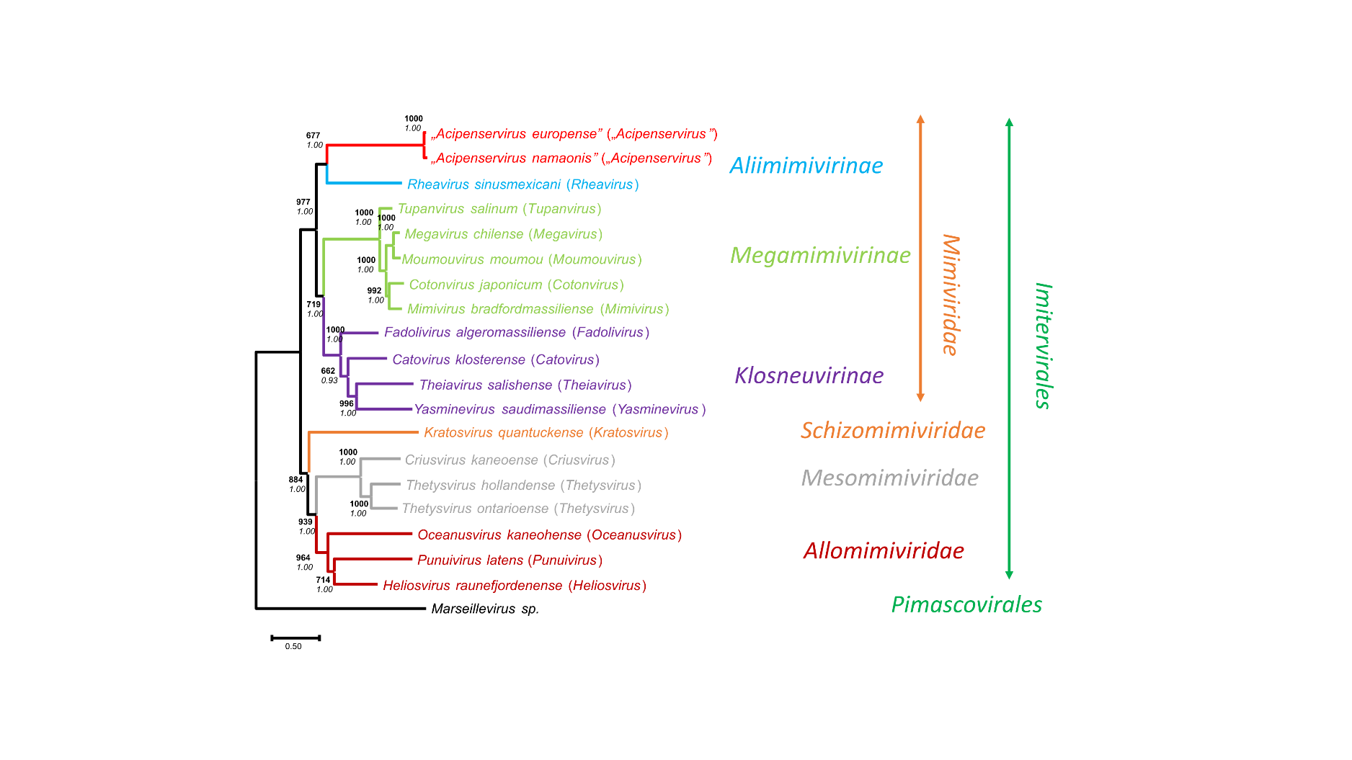
Figure 1. Phylogeny of the order Imitervirales. Marseillevirus sp (order Pimascovirales) was used as an outgroup. Analyses were based on the Bayesian analysis (WAG amino acid substitution model was found to be the best fit for the data using the model selection of TOPALI v2.5 program) and maximum likelihood (ML) method (LG substitution model) based on a concatenated alignment of seven marker genes (RNAPL, A32, VLTF3, TFIIB, SFII, TopoII, DNAPolB) (9). The deduced amino acid sequences of all genes were aligned using MAFFT v7 (10) with default parameters. After removal of gaps, Bayesian phylogenetic analyses were performed using MrBayes (11) within the TOPALi v2.5 program package and interface (12) with the following parameters: default prior probability distribution, Markov chain was run for 1 million generations, four independent analyses were conducted, each with 1 cold and 3 heated chains. Sampling occurred every 10 generations with the first 25% of Markov chain Monte Carlo samples discarded as burn-in. The maximum likelihood (PhyML) method with LG amino acid substitution model (13) (1000 samplings) were carried out on the Galaxy Pasteur server (Galaxy Version 3.3_1) (https://galaxy.pasteur.fr). Both methods resulted in the same tree topology supported by high statistical values (in bold characters: maximum-likelihood; non-highlighted characters: inference support for the Bayesian analysis).

