

The International Committee on Taxonomy of Viruses
Taxonomy Proposal Form, 2026

Part 1a: Details of taxonomy proposals

Title: | Creation of the new order ‘Pandomollivirales’ to classify pandoraviruses and molliviruses
Code assigned: | 2026.004F.N.v2.Pandomollivirales_1nord_2nfam_3ngen_12nsp

Author(s), affiliation and email address(es):
Given name (+middle initial(s)) | Surname | Affiliation | Email address | Corr. author(s)
Jean-Michel | Claverie | IGS, Aix-Marseille University, Marseille, France | Jean-Michel.Claverie@univ-amu.fr | X
Frank O. | Aylward | Department of Biological Sciences, Virginia Tech, USA | faylward@vt.edu | X
Chantal | Abergel | IGS, Aix-Marseille University, Marseille, France | Chantal.Abergel@igs.cnrs-mrs.fr
Jônatas | Abrahão | Universidade Federal de Minas Gerais, Departamento de Microbiologia, Belo Horizonte, Brazil | jonatas.abrahao@gmail.com
Bernard | La Scola | IHU Méditerranée Infection, Marseille, France | bernard.la-scola@univ-amu.fr
Hiroyuki | Ogata | Bioinformatics Center, Institute for Chemical Research, Kyoto University, Uji, Japan | ogata@kuicr.kyoto-u.ac.jp
Victoria | Queiroz | Dept Biological Sciences, Virginia Tech, Blacksburg, USA | victoriafq@vt.edu

Part 1b: Taxonomy Proposal Submission
ICTV Subcommittee:
Animal DNA Viruses and Retroviruses |  | Bacterial viruses
Animal minus-strand and dsRNA viruses |  | Fungal and protist viruses | X
Animal positive-strand RNA viruses |  | Plant viruses
Archaeal viruses |  | General -

List the ICTV Study Group(s) that have seen or have been involved in creating this proposal:
None; no study group is yet associated to pandoraviruses or molliviruses

Optional – complete only if formally voted on by an ICTV Study Group:
Study Group | Number of members
Study Group | Votes in support | Votes against | No vote

Submission date: | 07/03/2026

Part 1c: Feedback from ICTV Executive Committee (EC) meeting
Executive Committee Meeting Decision code: | X
A – Accept
Ac – Accept subject to revision by relevant subcommittee chair. No further vote required
U – Accept without revision but with re-evaluation and email vote by the EC
Uc – Accept subject to revision and re-evaluation and email vote by the EC
Ud – Deferred to the next EC meeting, with an invitation to revise based on EC comments
J - Reject
W - Withdrawn

Comments from the Executive Committee:

Part 1d: Revised Taxonomy Proposal Submission
Response of proposer:
Revision date:

Part 3: TAXONOMIC PROPOSAL
https://ictv.global/taxonomy/templates

Taxonomic changes proposed:
Establish new taxon | X | Split taxon
Abolish taxon |  | Merge taxon
Move taxon |  | Promote taxon
Rename taxon |  | Demote taxon
Move and rename

Etymology (origin) of proposed taxonomic names:
Taxon name | Etymology of the term
“Pandomollivirales” | Order clustering pandoraviruses and molliviruses, derived of a combination of both names.
“Pandoraviridae” | Family clustering the pandoraviruses, based on a name already commonly used in the literature
“Molliviridae” | Family clustering the molliviruses, based on a name already commonly used in the literature
“Alphapandoravirus” | One genus clustering some pandoraviruses, designated with Greek letter alpha as a prefix
“Betapandoravirus” | Second genus clustering other pandoraviruses, designated with the Greek letter beta as a prefix
“Alphamollivirus” | Genus clustering the molliviruses, designated with the Greek letter Alpha as a prefix in case future studies discover additional lineages
“Alphamollivirus sibericum” | Named for the geographical region of Siberia
“Alphapandoravirus talik” | Named for an area of unfrozen ground near permafrost
“Alphapandoravirus inopinatum“ | Named for something unforeseen or surprising
“Alphapandoravirus silvestre” | Named for the Latin for “tree”
“Alphapandoravirus salinum” | Named for a habitat of high salinity
“Alphapandoravirus dulce” | Named for the Latin for “sweet”, often used to denote freshwater
“Alphapandoravirus japonicum” | Named for the country of Japan
“Alphapandoravirus belohorizontense” | Named for the city of Belo Horizonte, Brazil
“Betapandoravirus mammuthis” | Named for the latinized neuter form of the extinct elephantid genus Mammuthus
“Betapandoravirus remotum” | Named for a reference to a remote area
“Betapandoravirus massiliense” | Named for the city of Marseille, France
“Betapandoravirus australe” | Named for the country of Australia

Permission for use of names derived from a living person:
Taxon name | Full name of person from whom the name is derived | Attached
NA | NA | NA

Abstract of Taxonomy Proposal:
Description of current taxonomy:
The phylum Nucleocytoviricota currently contains three classes and five orders. Although pandoraviruses and molliviruses have been known for over a decade and are generally accepted as belonging to this phylum, they have never been formally classified.

Proposed taxonomic change(s):
We propose a new order, the “Pandomollivirales” within the class Megaviricetes to accommodate the inclusion of pandoraviruses and molliviruses. We also propose two new families, three new genera, and twelve new species to further demarcate viruses within this new order.

Demarcation criteria for new taxon/taxa:
The demarcation of the new order and two new families was guided by the topology (and branch distances within) of a phylogenetic tree built from a standard core gene set conserved among members of the Megaviricetes (Figs 1 & 2). The genera and species were delineated through full genome comparisons using Average Nucleotide Identity (ANI levels). ANI>80% for genus clustering, ANI> 95% for species clustering (Fig 3).

Justification:
To include two well-characterized clades of large DNA viruses (the “Pandoraviridae” and “Molliviridae”) within the ICTV taxonomy.

Text of taxonomy proposal
Description of current taxonomy:
In the current ICTV classification, large dsDNA previously referred to as Nucleocytoplasmic Large DNA Viruses (NCLDVs) belong to the Nucleocytoviricota phylum (see [1] for review and ICTV proposal # 2019.003G.A.v1.Varidnaviria). This phylum is composed of three different classes: the Megaviricetes and the Pokkesviricetes, which contain a variety of large DNA viruses, and the Mriyaviricetes, which comprise a potentially early-branching lineage of smaller viruses that lack several hallmark genes found in the rest of the phylum [see ICTV proposal # 2024.010D.Varidnaviria_reorg]. The Megaviricetes class is presently divided into three different orders: the Algavirales, the Imitervirales, and the Pimascovirales, while the Pokkesviricetes are divided into the Chitovirales and Asfuvirales orders.

Pandoraviruses (and their distant relatives, the molliviruses), first described in 2013 and 2015 [2,3], are among the most spectacular giant viruses both in terms of genome size (> 2Mb) and particle morphology and size (> 1µm). Like many members of the phylum Nucleocytoviricota they lethally infect Acanthamoeba hosts. Many strains have been isolated, and their full characterizations published by several research groups [4,5] [Table 1]. In the literature, they have been proposed to belong to two new families, respectively the “Pandoraviridae” [6] and the “Molliviridae” [7], within the Megaviricetes class (Phylum Nucleocytoviricota, Kingdom Bamfordvirae, Realm Varidnaviria). Yet, they have remained absent from the ICTV taxonomy. The purpose of this proposal is to accommodate the pandoraviruses and molliviruses in the taxonomy by the proposed demarcation of a novel order (‘Pandomollivirales’), two new families (“Pandoraviridae” and “Molliviridae”) and several genera and species within the class Megaviricetes, so that they can be formally recognized by the ICTV.

Proposed taxonomic change(s):
In addition to the creation of the “Pandoraviridae” and “Molliviridae” families, we propose to cluster them in a new order, the “Pandomollivirales” within the existing Megaviricetes class. The various Pandoravirus isolates were distributed among the “Alphapandoravirus” and “Betapandoravirus” genera, and 4 Mollivirus isolates clustered in the “Alphamollivirus” genus. We further demarcate 12 species within these genera. The higher taxonomic ranks that we propose to establish are:

- The order “Pandomollivirales” within the class Megaviricetes.
- The two new families, “Pandoraviridae” and “Molliviridae”.
- Three new genera; “Alphapandoravirus” and “Betapandoravirus” within the family “Pandoraviridae”, and “Alphamollivirus” within the family “Molliviridae”.

The new species that we propose are:

genus: “Alphamollivirus”:
- “Alphamollivirus sibericum” (including all isolates: M. shaoxing, M. Mol-1, M. sibericum and M. kamchatka)

genus: “Alphapandoravirus”:
- “Alphapandoravirus talik” (isolate P. talik)
- “Alphapandoravirus inopinatum“ (isolate P. inopinatum)
- “Alphapandoravirus silvestre” (isolates : P. celtis and P. quercus)
- “Alphapandoravirus salinum” (isolate P. salinus)
- “Alphapandoravirus dulce (isolate P. dulcis)
- “Alphapandoravirus japonicum” (isolate P. japonicus)
- “Alphapandoravirus belohorizontense” (isolate P. belohorizontensis)

genus: “Betapandoravirus”:
- “Betapandoravirus mammuthis” (isolate P. mm38 and P. braziliensis)
- “Betapandoravirus remotum” (isolates: P.aubagnesis and P. macleodensis)
- “Betapandoravirus massiliense” (isolate P. massiliensis)
- “Betapandoravirus australe” (isolates P. neocaledonia and P. kuranda)

Demarcation criteria for new taxa:
The demarcation of the new order and two new families was guided by the topology (and branch distances within) of a phylogenetic tree built from a core gene set conserved among members of the Megaviricetes (Figs 1 & 2). This is consistent with phylogenetic approaches commonly used to examine evolutionary relationships within the Nucleocytoviricota [8] as well as recent taxonomic demarcations within this phylum [9,10]. The demarcation of families was also based on the demarcation of well-defined clades in the “Pandomollivirales” clade. The genera and species were delineated through full genome comparisons using Average Nucleotide Identity (ANI levels), with ANI>80% for genus clustering, ANI> 95% for species clustering (Fig 3).

Justification:
Phylogenetic evidence shows that the pandoraviruses and molliviruses clearly form a distinct clade that is separate from other established orders within the Nucleocytoviricota, and a new order is warranted. The clades representing the pandoraviruses and molliviruses are distinct and separated by a long branch, and distinct families to accommodate these lineages are appropriate. Within these families, established approaches using both ANI and clade demarcation can be used to establish genera and species.

References:
References:
[1] Xian Y, Xiao C. Adv Virus Res. 2020, 108:275-313. doi: 10.1016/bs.aivir.2020.09.006
[2] Philippe N, et al. Science. 2013, 341:281-6. doi: 10.1126/science.1239181.
[3] Legendre M, et al. Proc Natl Acad Sci U S A. 2015, 112:E5327-35. doi: 10.1073/pnas.1510795112.
[4] Legendre M, et al. Front Microbiol. 2019, 10:430. doi: 10.3389/fmicb.2019.00430.
[5] Xia Y, et al. Virol J. 2025, 22:216. doi: 10.1186/s12985-025-02850-3.
[6] Legendre M, et al. Nat Commun. 2018, 9:2285. doi: 10.1038/s41467-018-04698-4.
[7] Christo-Foroux E, et al.,. J Virol. 2020, 94:e01997-19. doi: 10.1128/JVI.01997-19.
[8] Aylward et al., PLOS Biology, 2021, 19(10):e3001430. doi: 10.1371/journal.pbio.3001430.
[9] Aylward et al., Arch. Virol., 2023, 168(11):283. doi: 10.1007/s00705-023-05906-3.
[10] Claverie et al., Arch. Virol., 2025, Apr 24;170(5):111. doi: 10.1007/s00705-025-06297-3.
[11] Moniruzzaman et al., Nat. Commun., 2020;11(1):1710. doi: 10.1038/s41467-020-15507-2.
[12] Sievers & Higgins, Protein Sci. 2018;27(1):135-145. doi: 10.1002/pro.3290.
[13] Capella-Gutiérrez et al., Bioinformatics. 2009;25(15):1972-3. doi: 10.1093/bioinformatics/btp348.
[14] Minh et al., Mol Biol Evol. 2020;37(5):1530-1534. doi: 10.1093/molbev/msaa015.
[15] Hoang et al., Mol Biol Evol. 2018; 35(2):518-522. doi: 10.1093/molbev/msx281.
[16] Jain et al., Nat Commun. 2018 Nov 30;9(1):5114. doi: 10.1038/s41467-018-07641-9.

TABLE 1. Complete annotated genome sequences available in Genbank.

Mollivirus Isolates used in this taxonomy proposal
Isolate name | Genbank accession# | Publication
Mollivirus sibericum | NC_027867.1 | DOI: 10.1073/pnas.1510795112
Mollivirus kamchatka | MN812837.1 | DOI: 10.1128/JVI.01997-19
Mollivirus shaoxing | PV032514.1 | DOI: 10.1186/s12985-025-02850-3
Mollivirus Mol-1 | BTJB01000001 | DOI: 10.1371/journal.pone.0301185

Pandoravirus Isolates used in this taxonomy proposal
Isolate name | accession# | Publication
Pandoravirus salinus | NC_022098.1 | DOI: 10.1126/science.1239181
Pandoravirus dulcis | NC_021858.1 | DOI: 10.1126/science.1239181
Pandoravirus inopinatum | NC_026440.1 | DOI: 10.1128/genomeA.00136-15
Pandoravirus celtis | MK174290.1 | DOI: 10.3389/fmicb.2019.00430
Pandoravirus quercus | NC_037667.1 | DOI: 10.1038/s41467-018-04698-4
Pandoravirus neocaledonia | NC_037666.1 | DOI: 10.1038/s41467-018-04698-4
Pandoravirus macleodensis | NC_037665.1 | DOI: 10.1038/s41467-018-04698-4
Pandoravirus talik | OQ413801 | DOI: 10.3390/v15020564
Pandoravirus kuranda | ON887157.1 | Direct submission
Pandoravirus japonicus | LC625835.1 | DOI: 10.1128/MRA.00365-21
Pandoravirus braziliensis | LT972217 | DOI: 10.3389/fmicb.2018.01486
Pandoravirus belohorizontensis | MZ420562 | DOI: 10.1128/mra.00131-22
Pandoravirus aubagnensis | MZ420563 | DOI: 10.1128/mra.00131-22
Pandoravirus massiliensis BZ81 | LT972215 | DOI: 10.3389/fmicb.2018.01486
Pandoravirus sp. strain Mm38 | OQ411600 | DOI: 10.3390/v15020564

Table 2. Summary of our pandoravirus/mollivirus taxonomy proposal

Order | Family | Genus | Species | Isolate | NCBI Access
Pandomollivirales | Pandoraviridae | Alphapandoravirus | Alphapandoravirus dulce | Pandoravirus dulcis | NC_021858.1
Pandomollivirales | Pandoraviridae | Alphapandoravirus | Alphapandoravirus inopinatum | Pandoravirus inopinatum | NC_026440.1
Pandomollivirales | Pandoraviridae | Alphapandoravirus | Alphapandoravirus silvestre | Pandoravirus celtis | MK174290.1
 |  |  |  | Pandoravirus quercus | NC_037667.1
Pandomollivirales | Pandoraviridae | Alphapandoravirus | Alphapandoravirus talik | Pandoravirus talik | OQ413801
Pandomollivirales | Pandoraviridae | Alphapandoravirus | Alphapandoravirus japonicum | Pandoravirus japonicus | LC625835.1
Pandomollivirales | Pandoraviridae | Alphapandoravirus | Alphapandoravirus belohorizontense | Pandoravirus belohorizontensis | MZ420562
Pandomollivirales | Pandoraviridae | Alphapandoravirus | Alphapandoravirus salinum | Pandoravirus salinus | NC_022098.1
Pandomollivirales | Pandoraviridae | Betapandoravirus | Betapandoravirus remotum | Pandoravirus aubagnensis | MZ420563
 |  |  |  | Pandoravirus macleodensis | NC_037665.1
Pandomollivirales | Pandoraviridae | Betapandoravirus | Betapandoravirus massiliense | Pandoravirus massiliensis BZ81 | LT972215
Pandomollivirales | Pandoraviridae | Betapandoravirus | Betapandoravirus mammuthis | Pandoravirus braziliensis | LT972217
 |  |  |  | Pandoravirus sp. strain Mm38 | OQ411600
Pandomollivirales | Pandoraviridae | Betapandoravirus | Betapandoravirus australe | Pandoravirus neocaledonia | NC_037666.1
 |  |  |  | Pandoravirus kuranda | ON887157.1
Pandomollivirales | Molliviridae | Alphamollivirus | Alphamollivirus sibericum | Mollivirus sibericum | NC_027867.1
 |  |  |  | Mollivirus kamchatka | MN812837.1
 |  |  |  | Mollivirus shaoxing | PV032514.1
 |  |  |  | Mollivirus Mol-1 | BTJB01000001

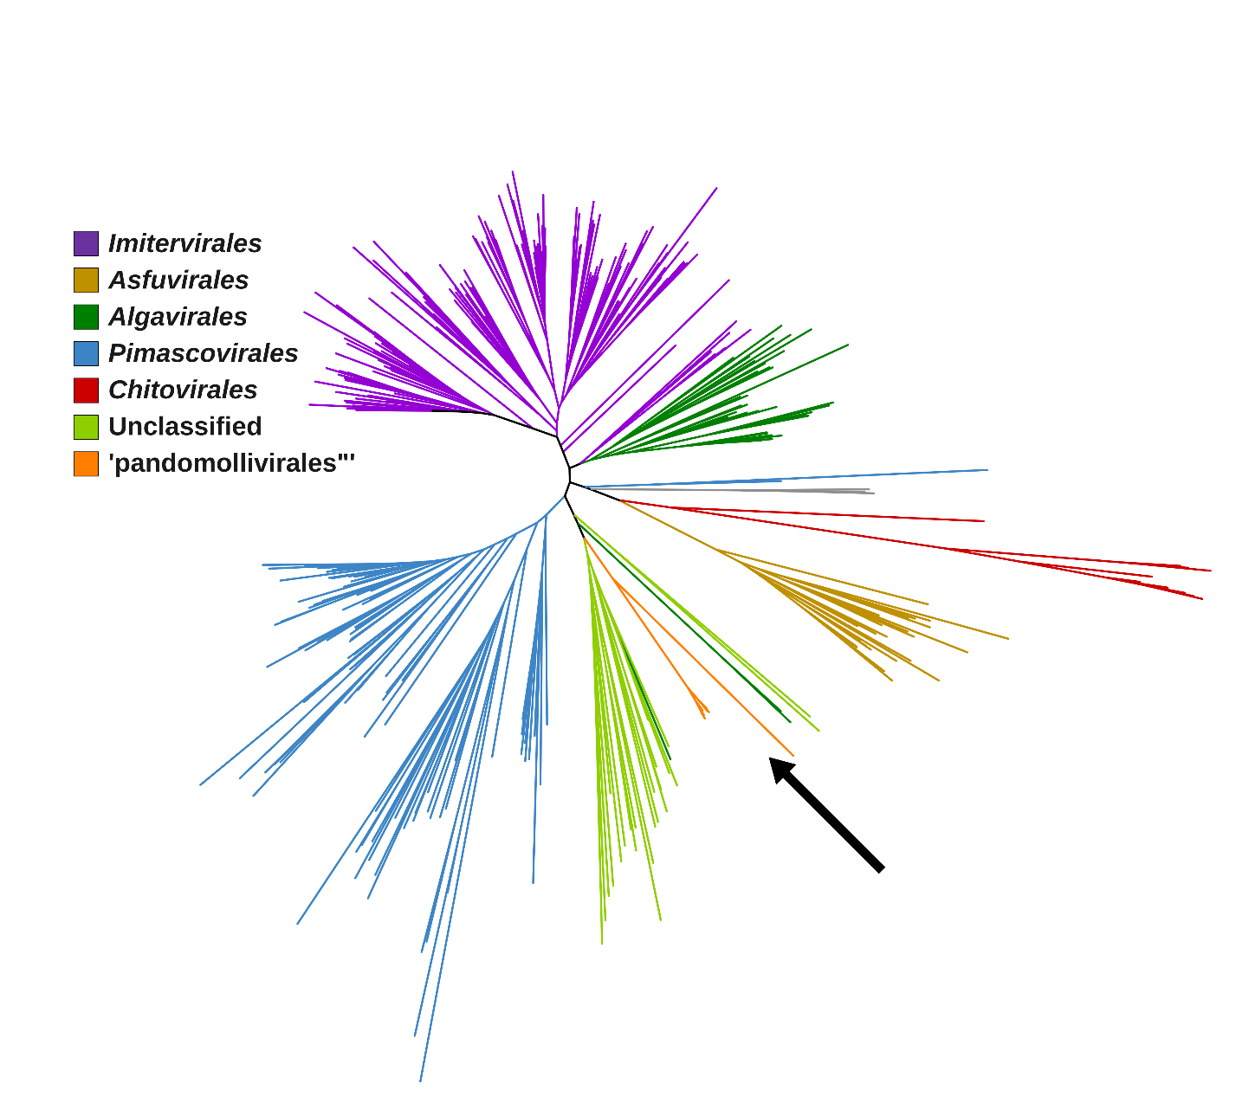

Figure 1. Phylogeny of viruses in the phylum Nucleocytoviricota, based on a concatenated alignment of DNA polymerase family B (PolB) and the two largest RNAP subunits (RNAPS and RNAPL). Pandoraviruses, molliviruses, and a subset of genomes sampled from the Giant Virus Database [8] were used, including many unclassified metagenome-assembled genomes (MAGs). Five established orders and the proposed order are shown in different colors. The node at the base of the proposed “Pandomollivirales” order has a support value of 1. The concatenated alignment was made using the ncldv_markersearch.py utility (https://github.com/faylward/ncldv_markersearch, [11]), which uses Clustal Omega for alignment (version 1.2.4, default parameters) [12] and trimAl for alignment trimming (version 1.5.rev0, parameter -gt 0.1) [13]. The final alignment contained 19,842 positions, and the tree was inferred with IQ-TREE version 2.2.2.7 [14] with the LG+F+R10 substitution model and 1000 ultrafast bootstraps [15].

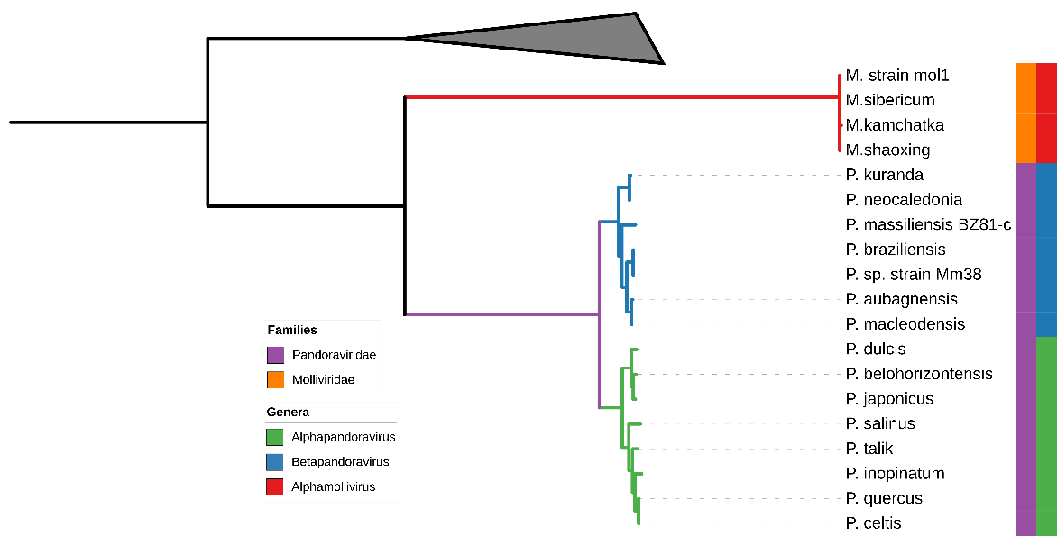
Figure 2: Phylogenetic tree showing the detailed relationships of the pandoraviruses/molliviruses, with the proposed families and genera demarcated. The tree is based on a concatenation of the family B DNA polymerase (PolB), the two largest RNA polymerase subunits (RNAPL and RNAPS), and the superfamily II helicase (SFII). The ncldv_markersearch.py utility was used to construct the alignment (https://github.com/faylward/ncldv_markersearch) before trimming with trimAl (-gt 0.1) [13] and phylogenetic reconstruction with IQ-TREE 2.4.0 using the LG+F+R10 substitution model [14]. Node support values are UltraFast bootstraps [15], with values > 95 denoted with solid circles. Genomes in the family Mimiviridae were used as an outgroup.

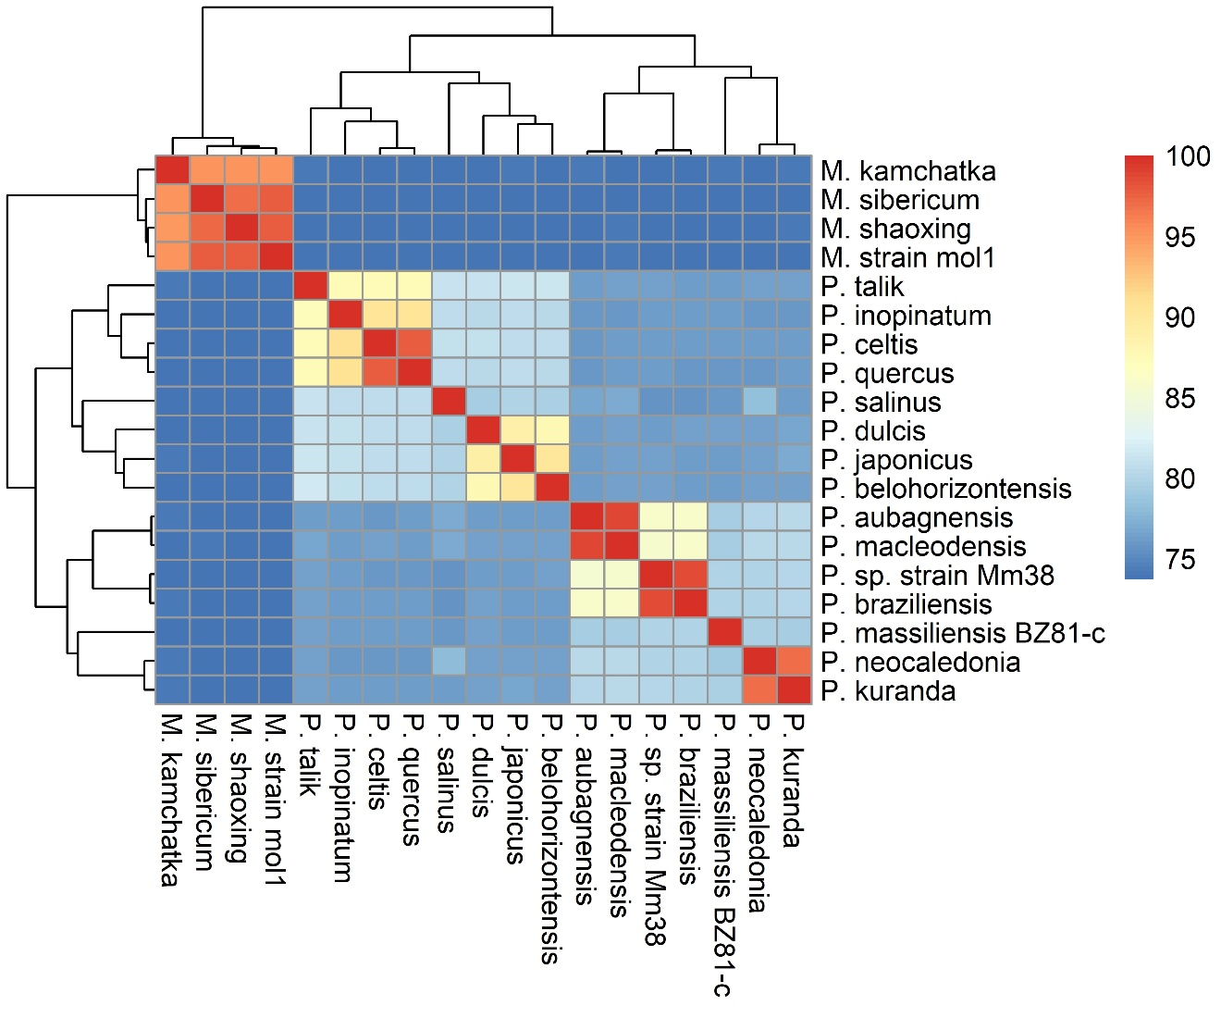

Figure 3: All genome nucleotide identity (ANI) analyses of the pandoravirus and mollivirus isolates used in this taxonomy proposal. ANI was calculated using the fastANI tool (https://github.com/ParBLiSS/FastANI) [16] with 1000 bp window size.

