

The International Committee on Taxonomy of Viruses
Taxonomy Proposal Form, 2026

Part 1a: Details of taxonomy proposals

Title: | Create a family (“Seatoskyviridae”), a genus (“Seatoskyvirus”), and a species (“Seatoskyvirus salishense”) in the order Imitervirales
Code assigned: | 2026.005F.N.v2.Imitervirales_1nfam_1ngen_1nsp

Author(s), affiliation and email address(es):
Given name (+middle initial(s)) | Surname | Affiliation | Email address | Corr. author(s)
Qi | Yang | Department of Earth, Ocean and Atmospheric Sciences, University of British Columbia, Vancouver, BC, Canada | qyang@eoas.ubc.ca
Amy M | Chan | Department of Earth, Ocean and Atmospheric Sciences, University of British Columbia, Vancouver, BC, Canada | achan@eoas.ubc.ca
Christoph M | Deeg | Department of Microbiology and Immunology, University of British Columbia, Vancouver, BC, Canada | chrdeeg@gmail.com
Curtis A | Suttle | Departments of Earth, Ocean and Atmospheric Sciences, Botany, Microbiology and Immunology, and the Institute for the Oceans and Fisheries, University of British Columbia, Vancouver, BC, Canada | suttle@science.ubc.ca | X

Part 1b: Taxonomy Proposal Submission
ICTV Subcommittee:
Animal DNA Viruses and Retroviruses |  | Bacterial viruses
Animal minus-strand and dsRNA viruses |  | Fungal and protist viruses | X
Animal positive-strand RNA viruses |  | Plant viruses
Archaeal viruses |  | General -

List the ICTV Study Group(s) that have seen or have been involved in creating this proposal:
Optional – complete only if formally voted on by an ICTV Study Group:
Study Group | Number of members
Study Group | Votes in support | Votes against | No vote

Submission date: | 09/10/2026

Part 1c: Feedback from ICTV Executive Committee (EC) meeting
Executive Committee Meeting Decision code: | X
A – Accept
Ac – Accept subject to revision by relevant subcommittee chair. No further vote required
U – Accept without revision but with re-evaluation and email vote by the EC
Uc – Accept subject to revision and re-evaluation and email vote by the EC
Ud – Deferred to the next EC meeting, with an invitation to revise based on EC comments
J - Reject
W - Withdrawn

Comments from the Executive Committee:

Part 1d: Revised Taxonomy Proposal Submission
Response of proposer:
Revision date:

Part 3: TAXONOMIC PROPOSAL
https://ictv.global/taxonomy/templates

Taxonomic changes proposed:
Establish new taxon | X | Split taxon
Abolish taxon |  | Merge taxon
Move taxon |  | Promote taxon
Rename taxon |  | Demote taxon
Move and rename

Etymology (origin) of proposed taxonomic names:
Taxon name | Etymology of the term
“Seatoskyviridae” | Prefix derived from the first isolate representative
“Seatoskyvirus” | After location: Sea-to-Sky Corridor, British Columbia, Canada
“Seatoskyvirus salishense” | After the Salish Sea where the virus and host were isolated

Permission for use of names derived from a living person:
Taxon name | Full name of person from whom the name is derived | Attached

Abstract of Taxonomy Proposal:
Description of current taxonomy:
The order Imitervirales currently comprises two suborders, four families, three subfamilies, 18 genera and 31 species (proposal 2025.011F).

Proposed taxonomic change(s):
We propose to create one new family (“Seatoskyviridae”), one new genus (“Seatoskyvirus”), and one new species (“Seatoskyvirus salishense”) in the order Imitervirales.

Demarcation criteria for new taxon/taxa:
Higher taxa in Imitervirales are delineated based on approximately equivalent phylogenetic depths inferred from phylogenetic analysis of conserved marker genes of Nucleocytoviricota. IM_14, a family-level lineage in the order Imitervirales previously known only from metagenome-assembled genomes (MAGs) but now including its first isolate representative Cunea sp. virus 1 (CspV1), does not fall into any ICTV-recognized family. Accordingly, we propose to establish IM_14 as a new family (“Seatoskyviridae”), with a new genus (“Seatoskyvirus”) containing a new species represented by CspV1 (“Seatoskyvirus salishense”).

Justification:
Cunea sp. virus 1 (CspV1), a giant virus infecting the amoeba Cunea sp., was isolated and phylogenetically placed in IM_14, a family-level lineage in the order Imitervirales not represented in ICTV taxonomy yet for comprising exclusively of MAGs. To reflect the expanded knowledge of Imitervirales diversity provided by this cultivated representative, we propose the establishment of the family “Seatoskyviridae”, the genus “Seatoskyvirus”, and the species “Seatoskyvirus salishense”.

- Text of Taxonomy proposal:

Description of current taxonomy:
The order Imitervirales currently consists of two suborders, Orthomivirineae and Paramivirineae. Orthomivirineae includes the family Mimiviridae, which consists of three subfamilies, Aliimimivirinae, Klosneuvirinae, and Megamimivirinae. Paramivirineae includes three families, Allomimiviridaei, Mesomimiviridae, and Schizomimiviridae. A total of 18 genera and 31 species are distributed in these higher taxa in Imitervirales.

Proposed taxonomic change(s):
Imitervirales is an order in the phylum Nucleocytoviricota, which encompasses all large double-stranded DNA viruses known as “giant viruses” currently, and is characterized by large genome size (typically > 500 kbp), broad taxonomic and functional diversity, and wide environmental distribution (Aylward et al., 2021; Vasquez et al., 2026). Four families with isolate representatives are currently recognized in Imitervirales by the ICTV (2025.011.F.A.v2.Imitervirales_newtaxa); however, more than ten additional family-level lineages composed of only MAGs have been identified through phylogenetics, including IM_14 (Aylward et al., 2021; Vasquez et al., 2026).

Cunea sp. virus 1 (CspV1), a virus infecting the amoeba Cunea sp., was isolated and genomically characterized. Concatenated phylogenetic analysis placed CspV1 in IM_14, making it the first isolated representative of this lineage [CspV1 ref]. We therefore propose the formal recognition of IM_14 as the new family “Seatoskyviridae”, including the new genus “Seatoskyvirus” containing the new species “Seatoskyvirus salishense” represented by CspV1.

Demarcation criteria for new taxon/taxa:
Using the previously established phylogenetic approach (Aylward et al., 2021), we constructed a maximum-likelihood tree for Imitervirales based on the concatenated alignment of seven conserved marker genes of Nucleocytoviricota, including DNA polymerase family B (DNAPolB), RNA polymerase large subunit (RNAPL), A32-like packaging enzyme (A32), topoisomerase family II (TopoII), Virus Late Transcription Factor 3 (VLTF3), Transcription Factor IIB (TFIIB), and a superfamily II helicase (SFII). Applying the criterion that higher taxa in Imitervirales are delineated based on approximately equivalent phylogenetic depths and the accepted threshold of >80% bootstrap support (2025.011.F.A.v2.Imitervirales_newtaxa), the proposed family “Seatoskyviridae” forms a distinct family-level cluster in Imitervirales, consistent with previous studies (Aylward et al., 2021; Vasquez et al., 2026). The isolate CspV1, representing the proposed species “Seatoskyvirus salishense”, falls within this cluster (Figure 1; CspV1 ref). Accordingly, we propose the creation of the family “Seatoskyviridae”, the genus “Seatoskyvirus”, and the species “Seatoskyvirus salishense”.

Justification:
The isolation and sequencing of CspV1 provides the first isolated representative of IM_14, a family-level lineage in Imitervirales previously known only from MAGs only but not yet included in ICTV taxonomy. To accurately reflect the diversity of Imitervirales, we propose to formally establish IM_14 as the family “Seatoskyviridae”, with the new genus “Seatoskyvirus” containing the species “Seatoskyvirus salishense” represented by CspV1.

References:
Aylward FO, Moniruzzaman M, Ha AD, Koonin EV. 2021. A phylogenomic framework for charting the diversity and evolution of giant viruses. PLoS Biology 19:e3001430. DOI: https://doi.org/10.1371/journal.pbio.3001430, PMID: 34705818
Letunic I, Bork P. 2024. Interactive Tree of Life (iTOL) v6: recent updates to the phylogenetic tree display and annotation tool. Nucleic Acids Research 52:W78–W82. DOI: https://doi.org/10.1093/nar/gkae268, PMID: 38613393
Moniruzzaman M, Martinez-Gutierrez CA, Weinheimer AR, Aylward FO. 2020. Dynamic genome evolution and complex virocell metabolism of globally-distributed giant viruses. Nature Communications 11:1710. DOI: https://doi.org/10.1038/s41467-020-15507-2
Nguyen L-T, Schmidt HA, Haeseler A von, Minh BQ. 2015. IQ-TREE: A Fast and Effective Stochastic Algorithm for Estimating Maximum-Likelihood Phylogenies. Molecular Biology and Evolution 32:268–274. DOI: https://doi.org/10.1093/molbev/msu300, PMID: 25371430
Vasquez YM, Nardi T, Terasaki GM, Byl P, Brůna T, Villada JC, Romero-Gutiérrez MF, Mock T, James TY, consortium Gvmag data, McMahon KD, Cavicchioli R, Hallam S, Campbell B, Crump B, Hunt D, Anantharaman K, Simon H, McKay RM, Walsh D, Slonczewski J, Konstantinidis K, Valentine DL, Tas N, Moisander P, Hatzenpichler R, Sullivan M, Crowe S, Ahlgren N, Woyke T, Schulz F. 2026. Genomic catalogue of giant viruses reveals expanded diversity and functional potential. Nature Microbiology 1–13. DOI: https://doi.org/10.1038/s41564-026-02435-y, PMID: 42595815

Accompanying files:
Filename | Description of contents

Tables, Figures:

<Start here>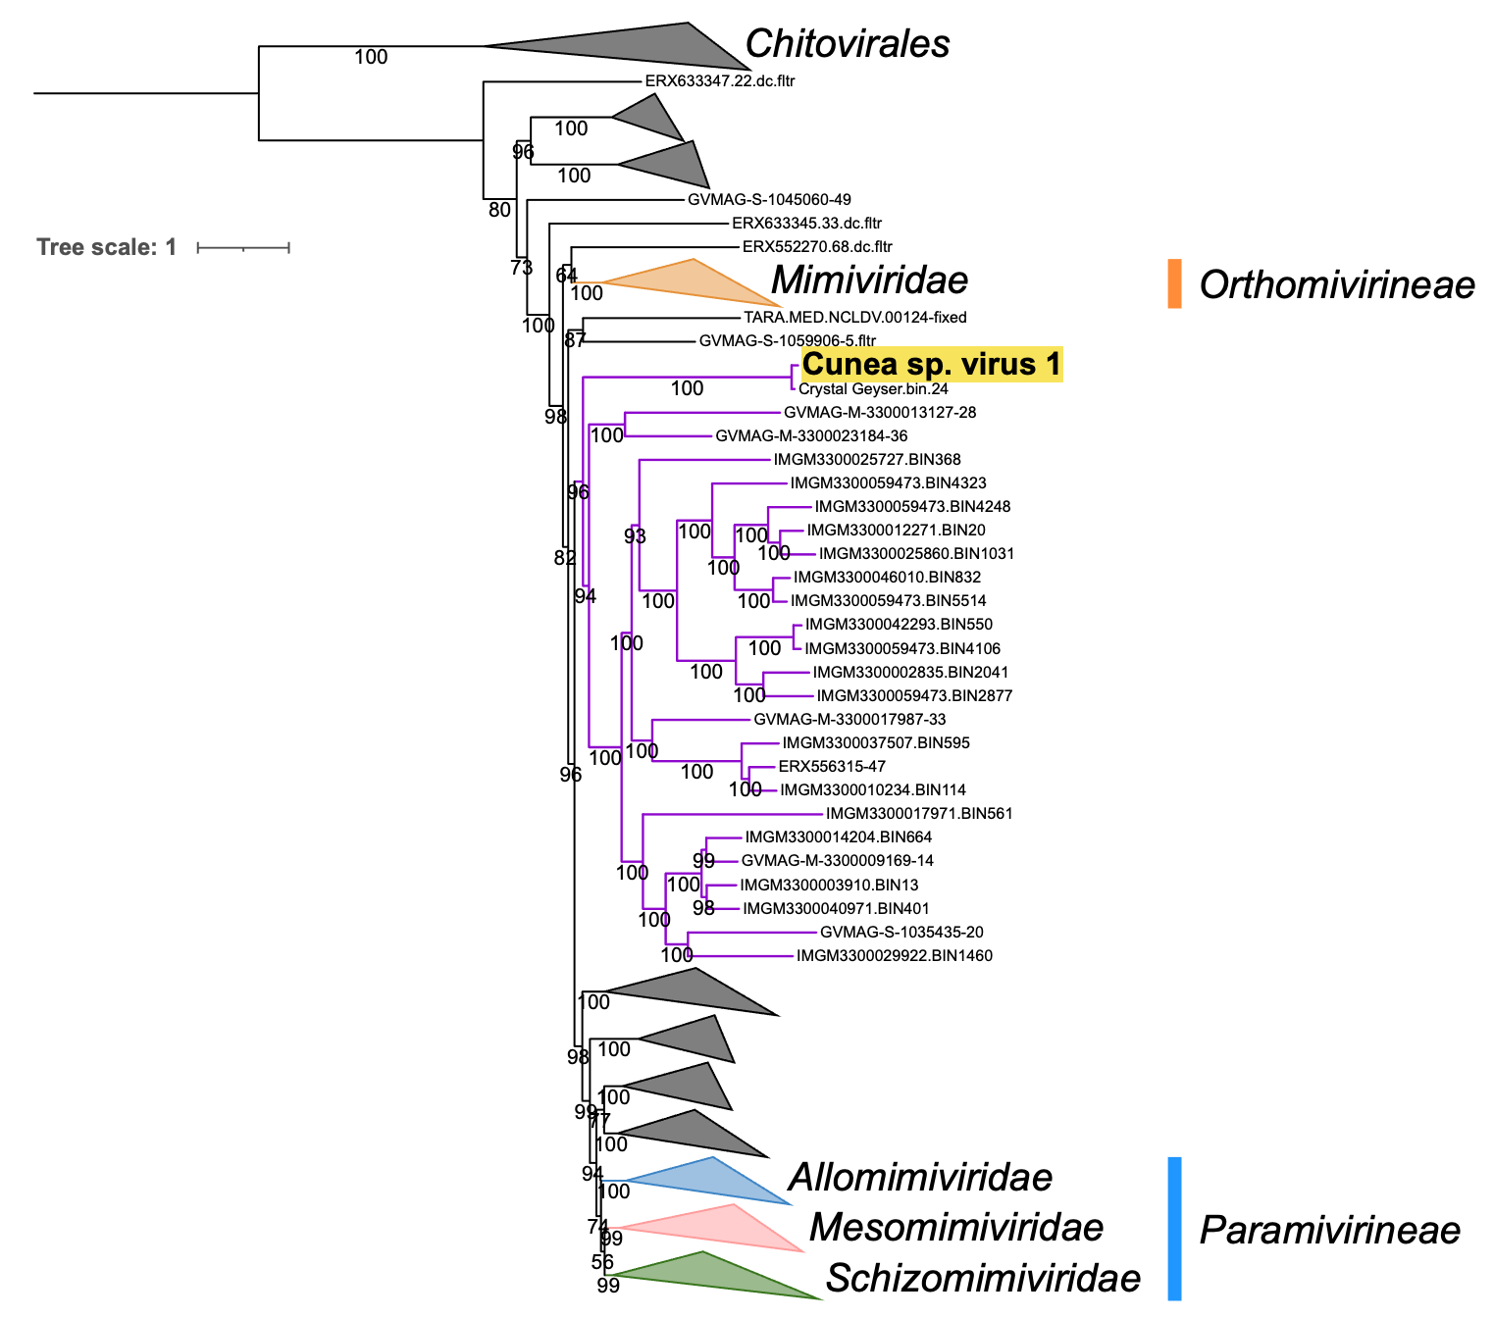Figure 1. Phylogeny of the proposed family “Seatoskyviridae”. A maximum-likelihood tree of the order Imitervirales was generated from a concatenated alignment of seven Nucleocytoviricota marker genes (DNAPolB, RNAPL, A32, TopoII, VLTF3, TFIIB, SFII) following the ncldv_markersearch workflow (https://github.com/faylward/ncldv_markersearch; Moniruzzaman et al., 2020). Sequences were obtained from the Giant Virus Database (https://faylward.github.io/GVDB/; Aylward et al., 2021), the Giant Virus Metagenome-Assembled Genomes V2 dataset (Vasquez et al., 2026), and previously assembled genomes (CspV1 ref). Chitovirales served as the outgroup. The phylogeny (LG+F+R10) was inferred using IQ-TREE v1.6.1 with branch support estimated from 1,000 ultrafast bootstrap and was visualized by iTOL (Letunic and Bork, 2024; Nguyen et al., 2015). The scale bar represents the average number of substitutions per site. The color strips adjacent to the tree indicate the currently established suborders. Branches representing the proposed family “Seatoskyviridae” are highlighted in purple and the isolate Cunea sp. virus 1 representing the proposed species “Seatoskyvirus salishense” is highlighted in yellow. Other families were collapsed, including those classified by ICTV (colored and labeled individually) and those composed exclusively of MAGs (grey).

