

The International Committee on Taxonomy of Viruses
Taxonomy Proposal Form, 2026

Part 1a: Details of taxonomy proposals

Title: | Create family “Mitodnaviridae” to classify a mitochondria-associated ssDNA virus of a marine oomycete, within the class Repensiviricetes (phylum Cressdnaviricota)
Code assigned: | 2026.006F.N.v2.Mitodnaviridae_newfam

Author(s), affiliation and email address(es):
Given name (+middle initial(s)) | Surname | Affiliation | Email address | Corr. author(s)
Leticia | Botella | Department of Forest Protection and Wildlife Management, Faculty of Forestry and Wood Technology, Mendel University in Brno, Brno, Czech Republic | qqbotell@mendelu.cz | X
Kohei | Sakuta | Department of Life Sciences, Graduate School of Arts and Sciences, The University of Tokyo, Tokyo, Japan | ksakuta3@gmail.com
Mart | Krupovic | Institut Pasteur, Université Paris Cité, Cell Biology and Virology of Archaea Unit, Paris, France | mart.krupovic@pasteur.fr

Part 1b: Taxonomy Proposal Submission
ICTV Subcommittee:
Animal DNA Viruses and Retroviruses |  | Bacterial viruses
Animal minus-strand and dsRNA viruses |  | Fungal and protist viruses | X
Animal positive-strand RNA viruses |  | Plant viruses
Archaeal viruses |  | General -

List the ICTV Study Group(s) that have seen or have been involved in creating this proposal:
Optional – complete only if formally voted on by an ICTV Study Group:
Study Group | Number of members
Study Group | Votes in support | Votes against | No vote

Submission date: | 08/19/2026

Part 1c: Feedback from ICTV Executive Committee (EC) meeting
Executive Committee Meeting Decision code: | X
A – Accept
Ac – Accept subject to revision by relevant subcommittee chair. No further vote required
U – Accept without revision but with re-evaluation and email vote by the EC
Uc – Accept subject to revision and re-evaluation and email vote by the EC
Ud – Deferred to the next EC meeting, with an invitation to revise based on EC comments
J - Reject
W - Withdrawn

Comments from the Executive Committee:

Part 1d: Revised Taxonomy Proposal Submission
Response of proposer:
Revision date:

Part 3: TAXONOMIC PROPOSAL
https://ictv.global/taxonomy/templates

Taxonomic changes proposed:
Establish new taxon | X | Split taxon
Abolish taxon |  | Merge taxon
Move taxon |  | Promote taxon
Rename taxon |  | Demote taxon
Move and rename

Etymology (origin) of proposed taxonomic names:
Taxon name | Etymology of the term
Mitodnaviridae | From mito- (Gr. mitos, referring to the mitochondrion) + dna (deoxyribonucleic acid) + -viridae (family suffix), reflecting the mitochondrial association of the exemplar virus.
Mitodnavirus | As for the family name, + -virus (genus suffix).
Mitodnavirus halophytophthorae | Species epithet derived from the host genus Halophytophthora, from which the exemplar virus (HthCRESSV1, isolate BD651) was isolated.

Permission for use of names derived from a living person:
Taxon name | Full name of person from whom the name is derived | Attached

Abstract of Taxonomy Proposal:
Description of current taxonomy:
Phylum Cressdnaviricota comprises two classes, Arfiviricetes and Repensiviricetes, which accommodate 13 orders and 24 families of eukaryote-infecting viruses with small circular ssDNA genomes encoding a two-domain rolling-circle replication initiation endonuclease (Rep) of the HUH superfamily.

Proposed taxonomic change(s):
Create a new family, “Mitodnaviridae”, within class Repensiviricetes, which will include one new genus “Mitodnavirus” with one species “Mitodnavirus halophytophthorae”, exemplified by Halophytophthora thermoambigua CRESS virus 1 (HthCRESSV1), isolate BD651 (GenBank PV883009).

Demarcation criteria for new taxon/taxa:
As the sole characterized member of the proposed family, genus/species demarcation criteria based on Rep pairwise identity cannot yet be derived from data; we recommend these be established once additional relatives are formally characterized. Membership in the family will depend on the phylogenetic analysis of the Rep protein sequences.

Justification:
HthCRESSV1 (i) falls outside of all 24 currently recognized Cressdnaviricota families in Rep phylogeny; (ii) lacks the jelly-roll capsid protein gene, which has been thus far universal to classified cressdnaviricots, encoding instead a multi-pass membrane protein; (iii) is the first cressdnaviricot shown to localize to host mitochondria.

+Text of Taxonomy proposal:
Description of current taxonomy:
Phylum Cressdnaviricota includes viruses with small, circular single-stranded DNA (ssDNA) genomes that encode a two-domain rolling-circle replication initiator (Rep) with the N-terminal HUH superfamily endonuclease and C-terminal superfamily 3 helicase domains (Krupovic et al., 2020, 2026). Cressdnaviricota comprises two classes, Arfiviricetes and Repensiviricetes, which accommodate 13 orders and 24 families of viruses associated with plants, fungi, animals and various protists. However, no DNA virus infecting an oomycete had previously been isolated, although endogenous viral elements (EVEs) bearing Rep- and capsid protein (CP)-like sequences have been described through metagenomics in several Phytophthora spp. and other oomycetes (Sabanadzovic et al. 2025).

Proposed taxonomic change(s):
Recently, a tentative member of Cressdnaviricota, Halophytophthora thermoambigua CRESS virus 1 (HthCRESSV1; 2,793-nt circular ssDNA genome; GenBank PV883009; Figure 1), has been discovered in a marine oomycete, BD651 (ex-type strain of H. thermoambigua), isolated from brackish water on the Algarve coast of Portugal (Sakuta et al., 2026). Cellular fractionation, mitochondrial marker (cytochrome c oxidase) co-enrichment and comparative genomics indicated that HthCRESSV1 replicates in oomycete mitochondria. Here we propose classifying HthCRESSV1 into a new family “Mitodnaviridae” within class Repensiviricetes. The new family will include one genus “Mitodnavirus”, with one species “Mitodnavirus halophytophthorae”.

Order-level placement is not proposed at this time. Rep sequences of HthCRESSV1-like viruses cluster near order Geplafuvirales in our phylogeny, and we recommend the Cressdnaviricota Study Group evaluate formal order assignment using the full multi-family Rep alignment.
Distinguishing features of the proposed family: (i) the genome encodes only Rep (ORF1, 380 aa) and a divergent, non-capsid membrane protein (ORF2/HP, 363 aa, five transmembrane domains + C-terminal coiled-coil, no jelly-roll fold, no homology to any known viral or cellular protein); (ii) mitochondrial subcellular localisation, supported by cytochrome c oxidase co-enrichment and BLASTn matches restricted to oomycete mitochondrial genome assemblies; (iii) a large intergenic region with tandem 72-nt repeats, a TATA-like promoter motif and a candidate replication-origin nonanucleotide (TGGCAGTGT) divergent from those of geminiviruses, genomoviruses, smacoviruses and circoviruses (Figure 1).

Demarcation criteria for new taxon/taxa:
Species demarcation: HthCRESSV1 is presently the only complete, autonomously replicating genome recovered for this lineage; no within-genus or within-family pairwise-identity threshold can yet be derived. We propose that a Rep amino acid pairwise-identity threshold be established once further complete genomes of this lineage are characterized, following the precedent of related cressdnaviricot families (e.g. Genomoviridae, <78% Rep aa identity for species demarcation; Varsani and Krupovic, 2021).
Genus/family demarcation: the new family is demarcated from its closest classified relative, Geplanaviridae, by Rep phylogenetic divergence at family level, together with the absence of a jelly-roll CP gene and the presence of the characteristic membrane protein (HP; Sakuta et al., 2026), a gene complement not found in any classified Cressdnaviricota family. Notably, related Rep/HP-like sequences were detected as apparent endogenized elements in the mitochondrial genomes of Lagenidium giganteum, Phytophthora sojae, P. palmivora, P. colocasiae, P. botryosa, Peronospora tabacina and Pseudoperonospora cubensis (Table 1). These elements may represent additional members of the proposed “Mitodnaviridae” family but were not recovered as complete autonomous genomes and are therefore not included as separate species in this proposal.

Justification:
HthCRESSV1 encodes a two-domain Rep protein, typical of members of the phylum Cressdnaviricota (Figure 2). Phylogenetic analysis of Rep sequences and comparative genomics analysis suggested that HthCRESSV1 and related endogenous sequences in oomycete mitochondrial genomes form a distinct family-level lineage within class Repensiviricetes (Figure 3). The new family is a sister to, but clearly distinct from, family Geplanaviridae, and more distant from Genomoviridae and Geminiviridae. Unlike all other cressdnaviricots, HthCRESSV1 does not encode a homolog of the single jelly-roll-fold CP. Instead, ORF2 uniquely encodes a multi-pass membrane protein, which is predicted to be part of the pleomorphic enveloped virions (Sakuta et al., 2026). The combination of unique biological features (mitochondrial association, lack of typical CP and presence of the gene encoding a membrane protein) and phylogenetic analysis of the Rep, justify creation of a new family.

References:
Kazlauskas D, Varsani A, Koonin EV, Krupovic M. (2019) Multiple origins of prokaryotic and eukaryotic single-stranded DNA viruses from bacterial and archaeal plasmids. Nat Commun 10, 3425. doi: 10.1038/s41467-019-11433-0

Krupovic M, Varsani A, Kazlauskas D, Breitbart M, Delwart E, Rosario K, Yutin N, Wolf YI, Harrach B, Zerbini FM, Dolja VV, Kuhn JH, Koonin EV. Cressdnaviricota: a virus phylum unifying even families of Rep-Encoding viruses with single-stranded, circular DNA genomes. J Virol. 2020; 94. doi: 10.1128/JVI.00582-20

Krupovic M, Varsani A, Roux S, Zerbini FM, Kuhn JH, Koonin EV. Efunaviria, Floreoviria, Pleomoviria, and Volvereviria: four realms of viruses with small DNA genomes to replace realm Monodnaviria. J Virol. 2026; in press. doi: 10.1128/jvi.01019-26. PMID: 42584058

Sabanadzovic S, Abergel C, Ayllón MA, Botella L, Canuti M, Chiba Y, Claverie J, Coutts RHA, Daghino S, Donaire L, Forgia M, Hejna O, Jia J, Jiang D, Kotta-Loizou I, Krupovic M, Lang AS, Legendre M, Lee Marzano SY, Mu F, Neri U, Nerva L, Pénzes J, Poimala A, Rigou S, Sato Y, Shamsi W, Sutela S, Suzuki N, Turina M, Urayama SI, Vainio EJ, Xie J, ICTV Taxonomy Summary Consortium. Summary of taxonomy changes ratified by the International Committee on Taxonomy of Viruses (ICTV) from the Fungal and Protist Viruses Subcommittee. J Gen Virol. 2025; 106:002115. doi: 10.1099/jgv.0.002115. PMID: 40711811

Sakuta K, Krupovic M, Hejna O, Maia C, Horta Jung M, Komatsu K, Moriyama H, Jung T, Botella L. A single-stranded DNA virus replicates in the mitochondria of a marine oomycete, Virus Evol 2026; veag047, doi: 10.1093/ve/veag047

Varsani A, Krupovic M. Family Genomoviridae: 2021 taxonomy update. Arch Virol. 2021; 166:2911-2926. doi: 10.1007/s00705-021-05183-y. PMID: 34331585

Accompanying files:
Filename | Description of contents

Tables, Figures:

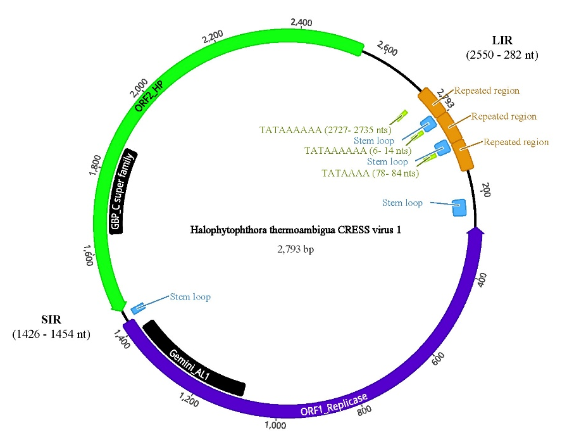

Figure 1. Schematic representation of the circular genome of HthCRESSV1 showing the two major ORFs encoding the replication-associated protein (Rep) and the hypothetical protein (HP), as well as the large (LIR) and small (SIR) intergenic regions. Predicted stem–loop structures and repeated elements are indicated. From Sakuta et al. 2026.

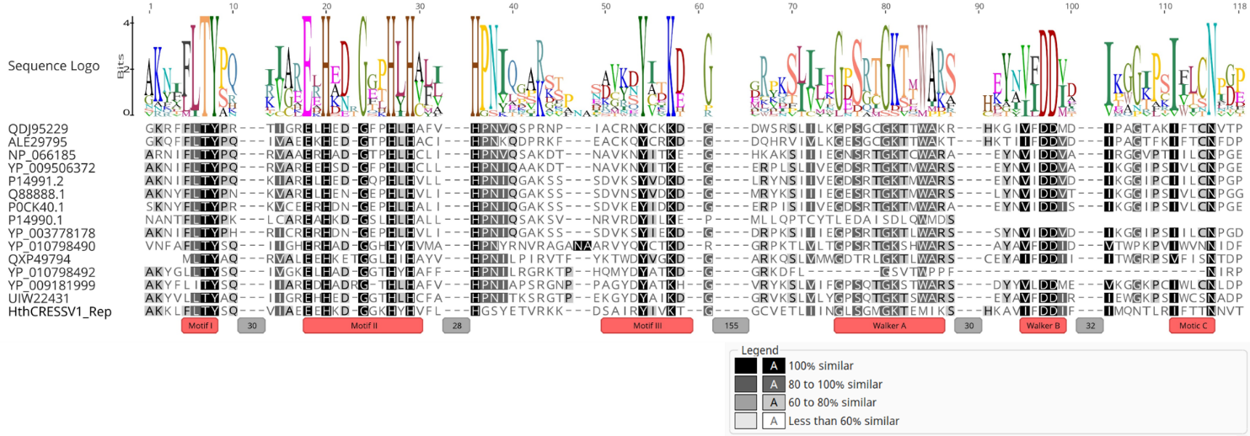

Figure 2. Comparison of Rep motifs across representative members within the order Geplafuvirales and HthCRESSV1, including rolling-circle replication motifs (I–III) and helicase motifs (Walker A, Walker B and motif C). Geplanaviridae: QDJ95229 (Capybara virus 11), NP_066185 (Horseradish curly top virus); Geminiviridae: ALE29795 (Lake Sarah-associated circular virus 45); YP_009506372 (Abutilon golden mosaic Yucatan virus), P14991.2 (Beet curly top virus), Q88888.1 (Tomato pseudo-curly top virus), P0CK40.1 (Bean golden yellow mosaic virus), YP_003778178 (Turnip curly top virus); Genomoviridae: YP_010798490 (Zizania latifolia genomoviridae), YP_010798492 (Artemisia carvifolia genomoviridae), YP_009181999 (Soybeanassociated gemycircularvirus 1), UIW22431 (Sclerotinia sclerotiorum hypovirulence associated DNA
virus 1), QXP49794 (Botrytis gemydayirivirus 2). Numbers in grey boxes represent number of nucleotides omitted in the alignment. From Sakuta et al. 2026.
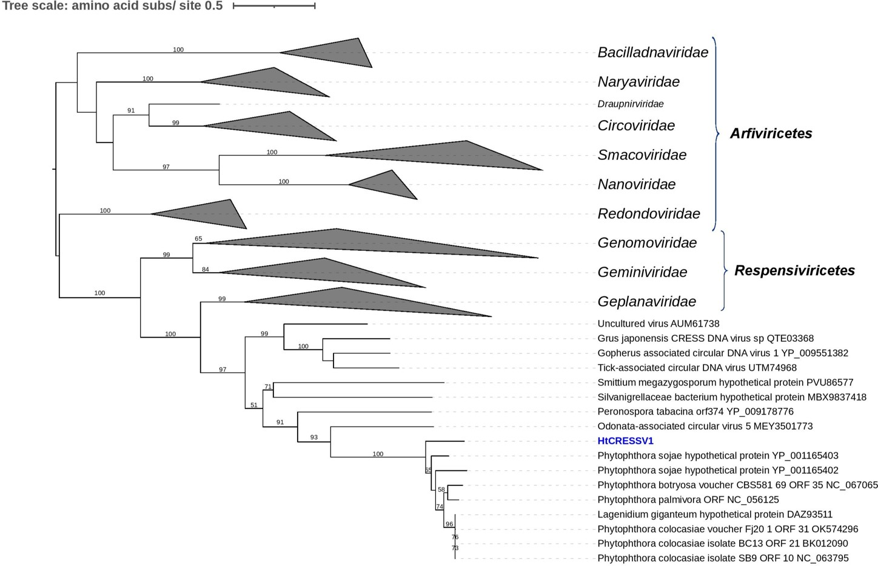

Figure 3. Phylogenetic tree (From Sakuta et al. 2026). RAxML tree depicting the phylogenetic relationships of the predicted Replicase. Nodes are labelled with bootstrap support values ≥50%. Branch lengths are scaled to the expected underlying number of substitutions per site. Some of the classified families and genera were collapsed to simplify the tree. Family classification and the corresponding GenBank accession numbers are shown next to the virus names.

Table 1. Summary of homologous sequences identified in the mitochondrial genomes of various oomycete species, based on GenBank data.
Organism/isolate | mtDNA accession number | mtDNA size (pb) | REP | ORF nt interval | Gemini_AL1 domain | Acc. Number | HP | ORF nt interval | domain | Acc. Number
Phytophthora capsici isolate TaiwanPc377 | BK012088 | 38,418 | N | N | N | N | Y | 6,514 - 7,627 | SMC_N super family | not annotated
Phytophthora capsici isolate TaiwanPc33e | NC_063804 | 38,427 | N | N | N | N | Y | 6,514 - 7,627 | SMC_N super family | not annotated
Pseudoperonospora humuli | MH923236 | 39,087 | N | N | N | N | orf168 | 8,382 - 7,303 | N | QLD32048.1
Pseudoperonospora cubensis | NC_027859 | 38,995 | N | N | N | N | orf306 gene | 8,779 - 7,859 | N | YP_009164875.1
Phytophthora umbellatus (Phytophthora sp. ML-2023a) | OQ735416 | 39,675 | N | N | N | N | Y | 19,330 -18,332 | N | not annotated
Paralagenidium karlingii | NC080886 | 46,638 | N | N | N | N | ORF22 | 27,753 - 29,075 | N | YP_010886810
Paralagenidium karlingii | NC080886 | 46,638 | N | N | N | N | ORF16 | 21,979 - 23,055 | Zinc finger-containing protein; pfam10146 | YP_010886807
Peronospora tabacina | NC_028331 | 43,225 | orf374 | 9,988 - 11,208 | Walker A and B motifs | YP_009178776 | N | N | N | N
Phytophthora botryosa voucher CBS581_69_ORF 35_NC_067065 | NC_067065 | 39,743 | Y, | 18,882 - 17,707 | Y | not annotated | N | N | N | N
Phytophthora colocasiae voucher_Fj20_1 | OK574296 | 41,838 | Y | 19,604 - 18,456 | Y | not annotated | Y, shorter | 20,649 - 19,918 | N | not annotated
Phytophthora colocasiae isolate BC13 | BK012090 | 41,367 | Y | 8,451 -9,599 | Y | not annotated | N | N | N | N
Phytophthora colocasiae isolate SB9 | NC_063795 | 41,297 | Y | 8,381 - 9,529 | Y | not annotated | N | N | N | N
Phytophthora palmivora | NC_056125 | 40,799 | Y | 8,338 - 9,549 | Y | not annotated | Y | 7,200 - 8,363 | SMC_prok_B super family | not annotated
Lagenidium giganteum strain ARSEF 373 | DAKRPA010000311 * | 80,403* | Y | 45,029 - 45,667 | Y | DAZ93511 | Y | 46,469 - 47,064 | Coiled-coil domain-containing protein 158; CCDC158 | DAZ93512
Phytophthora sojae | NC_009385 | 42,977 | orf98 | 29,048 - 29,344 | Y | YP_001165402 | N | N | N | N
Phytophthora sojae | NC_009385 | 42,977 | orf112a | 29,328 - 29,666 | N | YP_001165403 | N | N | N | N

Y, Yes, Present; N, No, absent; *Lagenidium giganteum strain ARSEF 373 scaffold_527 mitochondrial, whole genome shotgun sequence

