

The International Committee on Taxonomy of Viruses
Taxonomy Proposal Form, 2026

Part 1a: Details of taxonomy proposals

Title: | Establish a new order “Orplavirales” (four new families, four genera, 19 new species) in the Amabiliviricetes to classify orfanplasmoviruses
Code assigned: | 2026.008F.N.v2.Orplavirales_neword

Author(s), affiliation and email address(es):
Given name (+middle initial(s)) | Surname | Affiliation | Email address | Corr. author(s)
Massimo Turina | Turina | Institute for sustainable Plant Protection, CNR, Torino, Italy | massimo.turina@cnr.it | x
María A. | Ayllón | Centro de Biotecnología y Genómica de Plantas (CBGP), Universidad Politécnica de Madrid (UPM), Madrid, Spain | mariaangeles.ayllon@upm.es
Daohong | Jiang | College of Plant Science and Technology, Huazhong Agricultural University, Wuhan, China | daohongjiang@mail.hzau.edu.cn
Jiatao | Xie | College of Plant Science and Technology, Huazhong Agricultural University, Wuhan, China | jiataoxie@mail.hzau.edu.cn
Eeva J. | Vainio | Natural Resources Institute Finland, Helsinki, Finland | eeva.vainio@luke.fi
Nobuhiro | Suzuki | Innovation Center for Future Agricultural Production and Food Industry, Graduate School of Agricultural Science, Tohoku University, Sendai, Japan | nobuhiro.suzuki.e6@tohoku.ac.jp
Marco | Forgia | Institute for sustainable Plant Protection, CNR, Torino, Italy | marco.forgia@cnr.it
Stefania | Daghino | Institute for sustainable Plant Protection, CNR, Torino, Italy | stefania.daghino@cnr.it

Part 1b: Taxonomy Proposal Submission
ICTV Subcommittee:
Animal DNA Viruses and Retroviruses |  | Bacterial viruses
Animal minus-strand and dsRNA viruses |  | Fungal and protist viruses | X
Animal positive-strand RNA viruses |  | Plant viruses
Archaeal viruses |  | General -

List the ICTV Study Group(s) that have seen or have been involved in creating this proposal:
Optional – complete only if formally voted on by an ICTV Study Group:
Study Group | Number of members
Study Group | Votes in support | Votes against | No vote

Submission date: | 20/08/2026

Part 1c: Feedback from ICTV Executive Committee (EC) meeting
Executive Committee Meeting Decision code: | X
A – Accept
Ac – Accept subject to revision by relevant subcommittee chair. No further vote required
U – Accept without revision but with re-evaluation and email vote by the EC
Uc – Accept subject to revision and re-evaluation and email vote by the EC
Ud – Deferred to the next EC meeting, with an invitation to revise based on EC comments
J - Reject
W - Withdrawn

Comments from the Executive Committee:

Part 1d: Revised Taxonomy Proposal Submission
Response of proposer:
Revision date:

Part 3: TAXONOMIC PROPOSAL
https://ictv.global/taxonomy/templates

Taxonomic changes proposed:
Establish new taxon | X | Split taxon
Abolish taxon |  | Merge taxon
Move taxon |  | Promote taxon
Rename taxon |  | Demote taxon
Move and rename

Etymology (origin) of proposed taxonomic names:
Taxon name | Etymology of the term
“Orplavirales” | From the original group of viruses defined orfanplasmovirus based on term orfan and plasmo (from Plasmopara viticola, the initially presumed host).
“Orplaalphaviridae” | Orpla plus Alpha
“Orplabetaviridae” | Orpla plus Beta
“Orplagammaviridae” | Orpla plus Gamma
“Orpladeltaviridae” | Orpla plus Delta
“Unorplavirus” | Un plus Orpla
“Duorplavirus” | Du plus Orpla
“Triorplavirus” | Tri plus Orpla
“Quaorplavirus” | Qua plus Orpla

Permission for use of names derived from a living person:
Taxon name | Full name of person from whom the name is derived | Attached

Abstract of Taxonomy Proposal:
Description of current taxonomy:
Currently the class Amabiliviricetes in the Lenarviricota phylum comprises one order (Wolframvirales) and two families, Narnaviridae and Splipalmiviridae, which encompass one (Narnavirus) and three genera (Delepalmivirus, Divipalmivirus and Jakapalmivirus), respectively. The monogeneric family Narnaviridae accommodates two species, while the family Splipalmiviridae contains16 species.

Proposed taxonomic change(s):
A number of bipartite virus sequences described in numerous studies, distinct from members of currently recognized taxa, were initially labelled “orfanplasmovirus” and are present in public databases. There is now sufficient molecular information to establish 19 new species, in four genera in four families in a newly established order named “Orplavirales” in the class Amabiliviricetes.

Demarcation criteria for new taxon/taxa:
Viruses representing two distinct species should share less than 90% amino acid (aa) identity in the RdRP. Each family and genus is monophyletic and distinguished phylogenetically from the others. Members of each genus share similar genomic segment lengths that are different from those of members of other genera.

Justification:
All the studies reporting orfanplasmovirus-like sequences uniformly classify them in a well- supported distinct clade in the Amabiliviricetes. This class will need to accommodate hundreds of viral sequences, only a small portion of which have so far been taxonomically classified in two families in the Wolframvirales order. A new order is required to distinguish this specific cluster of bipartite viruses from the rest of the viruses in the Amabiliviricetes. The existing wide diversity present in this order warrants also the creation of four families each represented by one genus.

- Text of Taxonomy proposal:

Description of current taxonomy:
Hundreds of potential member of the Amabiliviricetes class in the phylum Lenarviricota have been described in many metaviromic studies (1–4) and are present in public databases. Some of these viruses have been well characterized both molecularly and biologically (5,6); nevertheless, their taxonomic placement is very limited. Currently only one order is established, the Wolframvirales, with only two families, the Narnaviridae (7) with the single genus Narnavirus and two species of yeast-infecting narnaviruses, and the recently established family Splipalmiviridae, that includes three genera Delepalmivirus, Divipalmivirus, and Jakapalmivirus and 16 species (8).

Proposed taxonomic change(s):
We classify 19 exemplary bi-segmented viral sequences (coding-complete or complete) in 19 species, organized in four monogeneric families inside the newly established order “Orplavirales” in the existing class Amabiliviricetes. The four newly created families (Aalphaorplaviridae, Betaorplaviridae, Gammaorplaviridae, and Deltaorplaviridae) each encompass single genera, Unorplavirus, Duorplavirus, Triorplavirus, and Quaorplavirus, respectively. Some of these sequences are from a plant phytobiome study with grapevine downy mildew lesions (see Justification below) and therefore they have no assigned host. Others were characterized in collection of fungal isolates and their confirmed host are Sclerotinia sclerotiorum (9,10) Botrytis cinerea (11), the genus Heterobasidion (12,13), Fusarium asiaticum (14), Fusarium culmorum (15), Alternaria alternata (16), and Exserohilum rostratum (17). A unique source was associated with thrips population metasamples (18). Two exemplary sequences infecting Torula fici and Trichothecium roseum are present in the databases without an associated publication. A list of the newly established species with the corresponding exemplary sequences are detailed in Table 1.

Demarcation criteria for new taxon/taxa:

Viruses representing two different species should have less than 90% identity in the pairwise comparison of the RdRPs (Figure 2). Each family and genus is monophyletic and distinguished phylogenetically from the others (Figure 1). Members of the same genus share similar lengths of the corresponding genomic segments that differ from those of members of other genera (Table 2).

Justification:
Originally, the family Narnaviridae was characterized as a group of viruses containing monopartite genomes of positive-strand RNA segments encoding only the RdRP (7,8). Multiple studies have now shown that a number of virus sequences distantly related to members of the Narnaviridae possess multipartite segmented genomes or non-segmented ambisense genomes (19–22). Among them were numerous viruses with bisegmented genomes, of which the larger RNA encoding the RdRP, and the smaller RNA encoding a partially structurally conserved protein of an unknown function. These sequences were initially identified in the microbiologically complex metasample of downy mildew lesions, caused by Plasmopara viticola (23). Recently the virome of these metasamples was re-evaluated allowing completion of the coding sequences of the two genomic RNAs of a number of exemplar isolates (24).
A phylogenetic tree that includes diverse representatives of the phylum Lenarviricota shows that the “orfanplasmovirus” clade is constantly associated to, but distinct from, members of other orders in the class Amabiliviricetes (Figure 1). The considerable diversity of sequences in this clade, that potentially will be further expanded in the future by the additional data, suggest establishing a new order (“Orplavirales”) comprised of four families, four genera and 19 species to classify “orfanplasmaviruses” with currently available coding complete or complete genomes. The four families are supported by a single statistically well-supported node. Distinct size of the hypothetical proteins encoded by ORF2 (expressed in aa lengths) distinguishes different genera (Table 2). The identity percentages of pairwise comparisons of these hypothetical proteins encoded by RNA2 further support taxonomic distinction of these viruses (Figure 4).

References:
1. Neri U, Wolf Y, Roux S, Camargo A, Lee B, Kazlauskas D, et al. Expansion of the global RNA virome reveals diverse clades of bacteriophages. Cell. 2022 Sep 1. doi:10.1016/j.cell.2022.08.023
2. Starr E, Nuccio E, Pett‐Ridge J, Banfield J, Firestone M. Metatranscriptomic reconstruction reveals RNA viruses with the potential to shape carbon cycling in soil. Proc Natl Acad Sci U S A. 2019 Apr 4;116:25900–8. doi:10.1073/pnas.1908291116
3. Wolf Y, Silas S, Wang Y, Wu SYin, Bocek M, Kazlauskas D, et al. Doubling of the known set of RNA viruses by metagenomic analysis of an aquatic virome. Nat Microbiol. 2020 Jul 20;5:1262–70. doi:10.1038/s41564-020-0755-4
4. Edgar R, Taylor J, Lin V, Altman T, Barbera P, Meleshko D, et al. Petabase-scale sequence alignment catalyses viral discovery. Nature. 2020 Aug 10;602:142–7. doi:10.1038/s41586-021-04332-2
5. Cai G, Myers K, Fry WE, Hillman BI. A member of the virus family Narnaviridae from the plant pathogenic oomycete Phytophthora infestans. Arch Virol. 2012 Jan 1;157(1):165–9. doi:10.1007/s00705-011-1126-5
6. Richaud A, Frézal L, Tahan S, Jiang H, Blatter JA, Zhao G, et al. Vertical transmission in Caenorhabditis nematodes of RNA molecules encoding a viral RNA-dependent RNA polymerase. Proc Natl Acad Sci. 2019 Dec 3;116(49):24738–47. doi:10.1073/pnas.1903903116
7. Hillman BI, Cai G. The Family Narnaviridae. In: Ghabrial SA, editor. Mycoviruses [Internet]. Academic Press; 2013 [cited 2026 Aug 15]. p. 149–76. (Advances in Virus Research). Available from: https://www.sciencedirect.com/science/article/pii/B9780123943156000064 doi:10.1016/B978-0-12-394315-6.00006-4
8. Sabanadzovic S, Abergel C, Ayllón M, Botella L, Canuti M, Chiba Y, et al. Summary of taxonomy changes ratified by the International Committee on Taxonomy of Viruses (ICTV) from the Fungal and Protist Viruses Subcommittee, 2025. J Gen Virol. 2025 Jul 1;106. doi:10.1099/jgv.0.002115
9. Gao L, Li W, Jia J, Cheng J, Fu Y, Xiao X, et al. Exploration of mycovirus composition in a hypovirulent strain of Sclerotinia sclerotiorum potentially uncovers mycovirus cross-taxa transmission. Virus Res. 2025 Apr 1;354:199552. doi:10.1016/j.virusres.2025.199552
10. Jia J, Fu Y, Jiang D, Mu F, Cheng J, Lin Y, et al. Interannual dynamics, diversity and evolution of the virome in Sclerotinia sclerotiorum from a single crop field. Virus Evol. 2021 Jan 1;7(1):veab032. doi:10.1093/ve/veab032
11. Muñoz-Suárez H, Ruiz-Padilla A, Donaire L, Benito EP, Ayllón MA. Reexamining the Mycovirome of Botrytis spp. Viruses. 2024 Oct;16(10):1640. doi:10.3390/v16101640
12. Dálya LB, Černý M, de la Peña M, Poimala A, Vainio EJ, Hantula J, et al. Diversity and impact of single-stranded RNA viruses in Czech Heterobasidion populations. mSystems. 2024 Sep 17;9(10):e00506-24. doi:10.1128/msystems.00506-24
13. Sutela S, Piri T, Vainio EJ. Discovery and Community Dynamics of Novel ssRNA Mycoviruses in the Conifer Pathogen Heterobasidion parviporum. Front Microbiol. 2021 Nov 24;12. doi:10.3389/fmicb.2021.770787
14. Huang H, Hua X, Pang X, Zhang Z, Ren J, Cheng J, et al. Discovery and Characterization of Putative Glycoprotein-Encoding Mycoviruses in the Bunyavirales. J Virol. 2023 Jan 10;97(1):e01381-22. doi:10.1128/jvi.01381-22
15. Buivydaitė Ž, Winding A, Jørgensen LN, Zervas A, Sapkota R. New insights into RNA mycoviruses of fungal pathogens causing Fusarium head blight. Virus Res. 2024 Nov 1;349:199462. doi:10.1016/j.virusres.2024.199462
16. Liang H, Xia J, Wang J, Zhang B, Jia J, Mu F. Complete genomic characterization of a novel orfanplasmovirus from Alternaria alternata f. sp. mali. Arch Virol. 2026 Jan 15;171(2):52. doi:10.1007/s00705-025-06501-4
17. Chiapello M, Bosco L, Ciuffo M, Ottati S, Salem N, Rosa C, et al. Complexity and Local Specificity of the Virome Associated with Tospovirus-Transmitting Thrips Species. J Virol. 2021 Nov;95(21). Located at: WOS:000708640200003. doi:10.1128/JVI.00597-21
18. Kondō H, Botella L, Suzuki N. Mycovirus Diversity and Evolution Revealed/Inferred from Recent Studies. Annu Rev Phytopathol. 2022 May 24. doi:10.1146/annurev-phyto-021621-122122
19. Chiba Y, Oiki S, Zhao YJ, Nagano Y, Urayama SI, Hagiwara D. Splitting of RNA-dependent RNA polymerase is common in Narnaviridae: Identification of a type II divided RdRp from deep-sea fungal isolates. Virus Evol. 2021 Nov 8;7. doi:10.1093/ve/veab095
20. Derisi J, Huber G, Kistler A, Retallack H, Wilkinson M, Yllanes D. An exploration of ambigrammatic sequences in narnaviruses. Sci Rep. 2019 Sep 9;9. doi:10.1038/s41598-019-54181-3
21. Lye L, Akopyants N, Dobson D, Beverley S. A Narnavirus-Like Element from the Trypanosomatid Protozoan Parasite Leptomonas seymouri. Genome Announc. 2016 Aug 4;4. doi:10.1128/genomea.00713-16
22. Chiapello M, Rodríguez-Romero J, Ayllón MA, Turina M. Analysis of the virome associated to grapevine downy mildew lesions reveals new mycovirus lineages. Virus Evol. 2020 Jul 1;6(2):veaa058. doi:10.1093/ve/veaa058
23. Daghino S, Forgia M, Di Serio F, de la Peña M, Ayllón MA, Navarro B, et al. Expanded virome analysis of metatranscriptomes from grapevine downy mildew lesions reveals novel viral segments, novel viruses and viroid-like RNAs. Virus Res. 2026 Sep 1;371:199780. doi:10.1016/j.virusres.2026.199780

Accompanying files:
Filename | Description of contents
all_RdRPs_lenarviricota_withsplip_orplavirales.fasta | RdRP sequences used for phylogenetic analysis (representative of Phylum Lenarviricota plus some partitivirus as outgroup)
mafft-includingsplipalmi80perc.fasta | MAFFT alignment used for IQ-Tree
mafft-includingsplipalmi80perc.nwk | Newick consensus tree
IdentityMatrixClustalOalign | Identity matrix all sequences

Tables, Figures:

<Start here>

Table 1: List of species in the new order “Orplavirales”, with representative exemplar virus names and their main features

Species name | Exemplar GenBank  Accession Number | Exemplar  virus name | Acronym | Isolate | Genome coverage | Host/Source | Literature
Unorplavirus fusari | PQ000864.1 PQ000865.1 | Fusarium culmorum narnavirus 1 | FcNV1 | AU2 | CG | fungi | https://doi.org/10.1016/j.virusres.2024.199462
Unorplavirus trichotheci | PX620831.1 PX620832.1 | Trichothecium roseum orfanplasmovirus 1 | TrOPV1 | DN7892 | CCG | fungi | unpublished
Unorplavirus hispanicus | MT338028.1 OR044910.1 | Downy mildew lesion associated orfanplasmovirus 5 | DMLaOPV1 | DMS4_DN34671 | CCG | phytobiome (S) | https://doi.org/10.1016/j.virusres.2026.199780
Unorplavirus ibericus | OR044913.1 OR044914.1 | Downy mildew lesion associated orfanplasmovirus 7 | DMLaOPV7 | DMS10 | CCG | phytobiome (S) | https://doi.org/10.1016/j.virusres.2026.199780
Unorplavirus italicus | MT338026.1 OR044909.1 | Downy mildew lesion associated orfanplasmovirus 3 | DMLaOPV3 | DMG-C_DN31001 | CCG | phytobiome (S) | https://doi.org/10.1016/j.virusres.2026.199780
Unorplavirus fusariasiatici | MZ969061.1 MZ969062.1 | Fusarium asiaticum narnavirus 1 | FaNV1 | NJ-37 | CCG | fungi | http://dx.doi.org/10.1128/jvi.01381-22
Unorplavirus sclerotiniae | PQ328751.1 PQ328752.1 | Sclerotinia sclerotiorum narnavirus 4 | SsNV4 | XZ69 | CCG | fungi | https://doi.org/10.1016/j.virusres.2025.199552
Unorplavirus vitisitalicus | OR044911.1 OR044912.1 | Downy mildew lesion associated orfanplasmovirus 6 | DMLaOPV6 | DMG-D | CCG | phytobiome (S) | https://doi.org/10.1016/j.virusres.2026.199780
Unorplavirus hexserohili | PP350703.1 PP350704.1 | Exserohilum rostratum orfanplasmovirus 1 | ErOPV1 | JZ1 | CG | fungi | https://doi.org/10.3389/fmicb.2024.1409677
Unorplavirus vitisibericus | MT338025.1 OR044908.1 | Downy mildew lesion associated orfanplasmovirus 2 | DMLaOPV2 | DMS3_DN24671 | CCG | phytobiome (S) | https://doi.org/10.1016/j.virusres.2026.199780
Unorplavirus orfanplasmi | MT338024.1 OR044907.1 | Downy mildew lesion associated orfanplasmovirus 1 | DMLaOPV1 | DMG-A | CCG | phytobiome (S) | https://doi.org/10.1016/j.virusres.2026.199780
Unorplavirus alternariae | PX399416.1 PX399417.1 | Alternaria alternata orfanplasmovirus 1 | AaOPV1 | TG155-3 | CG | fungi | https://doi.org/10.1007/s00705-025-06501-4
Unorplavirus torulae | PX620833.1 PX620834.1 | Torula fici orfanplasmovirus 1 | TfOPV1 | DN353305 | CCG | fungi | unpublished
Duorplavirus botritidis | PP776567.1 PP776566.1 | Botrytis narnavirus 1 | BNV1 | V446 | CG | fungi | http://dx.doi.org/10.3390/v16101640
Duorplavirus sclerotiniae | MW442873.1 MW442874.1 | Sclerotinia sclerotiorum narnavirus 3 | SsNV3 | WuXue | CG | fungi | https://www.ncbi.nlm.nih.gov/pubmed/33927888
Duorplavirus botriticinerinus | PP776568.1 PP776569.1 | Botrytis cinerea narnavirus 1 | BcNV1 | V448 | CG | fungi | http://dx.doi.org/10.3390/v16101640
Triorplavirus heterobasidii | MZ502381.1 MZ502382.1 | Heterobasidion narna-like virus 1 | HNlV1 | RKU172 | CG | fungi | https://www.ncbi.nlm.nih.gov/pubmed/34899655
Triorplavirus boemicus | ON014536.1 ON985234.1 | Heterobasidion narna-like virus 4 | HNlV4 | CZ1987 | CCG | fungi | https://doi.org/10.1128/msystems.00506-24
Quaorplavirus insecti | MN764145.1 MW297845.1 | Insect narna-like virus 1 | INlV1 | THR-D_DN17285 | CCG | invertebrates (S) | https://doi.org/10.1128/jvi.00597-21

Table 2: Lengths of the hypothetical protein encoded by the RNA2 (expressed in aa) of members of the order “Orplavirales”

Accession | Full Virus Name | Length (aa)
UNG44323.1 | Fusarium asiaticum narnavirus 1 | 760
QZE12025.1 | Sclerotinia sclerotiorum narnavirus 4 | 760
WMV69888.1 | Downy mildew lesion associated orfanplasmovirus 5 | 760
YCG58075.1 | Torula fici orfanplasmovirus 1 | 760
XXP61158.1 | Diaphorina citri associated narnavirus | 760
WMV69890.1 | Downy mildew lesion associated orfanplasmovirus 7 | 760
YBB96901.1 | Alternaria alternata orfanplasmovirus 1 | 760
WMV69887.1 | Downy mildew lesion associated orfanplasmovirus 3 | 760
WMV69886.1 | Downy mildew lesion associated orfanplasmovirus 2 | 760
WWE42868.1 | Exserohilum rostratum orfanplasmovirus 1 | 761
WYM66966.1 | Exserohilum turcicum orfanplasmovirus 1 | 761
WMV69889.1 | Downy mildew lesion associated orfanplasmovirus 6 | 740
YCG58073.1 | Trichothecium roseum orfanplasmovirus 1 | 760
XCO56019.1 | Fusarium culmorum narnavirus 1 | 791
YDH72982.1 | Narnavirus sp. | 820
WMV69885.1 | Downy mildew lesion associated orfanplasmovirus 1 | 658
UHK02570.1 | Heterobasidion narna-like virus 1 | 1201
XHA28149.1 | Heterobasidion narna-like virus 1 | 1201
UOX39319.1 | Heterobasidion narna-like virus 4 | 1201
XBY87740.1 | Botrytis cinerea narnavirus 1 | 862
XBY87738.1 | Botrytis narnavirus 1 | 852
QZE12023.1 | Sclerotinia sclerotiorum narnavirus 3 | 862
XPU89919.1 | Insect narna-like virus 1 | 563
QXP45024.1 | Insect narna-like virus 1 | 563

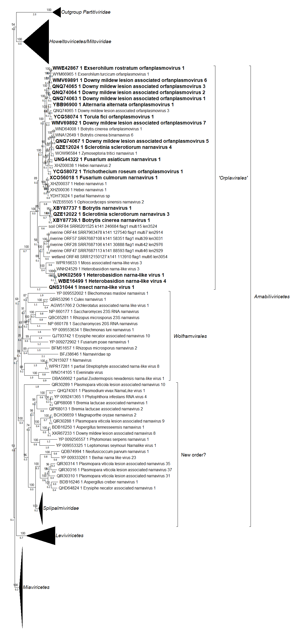
Figure 1: Maximum likelihood phylogenetic tree of 162 amino acid RdRP sequences encoded by RNA1 of “orfanplasmoviruses” and representatives of the four classes of the Lenarviricota: partitivirid RdRP sequences are included as the outgroup. The alignment was performed with MAFFT, and only sites with 80% coverage were retained. IQ-TREE version 3.1.2 for Linux x86 64-bit was used to generate the consensus tree. The best-fit substitution model Q.PFAM+F+I+R7 was chosen according to BIC. Branch testing was performed using SH-like aLRT with 1000 replicates. Accession numbers are shown next to the respective virus or are in the attached list of sequences used to generate the alignment for the collapsed clades; some RdRP sequences from the Lucaprot database were also included (no accession number). For members of the Splipalmiviridae, an artificial complete RdRP was assembled for each viral sequence (normally split into two distinct proteins) and used in the alignment.

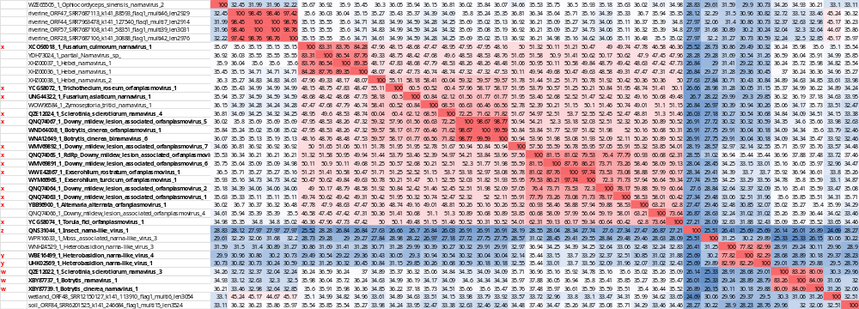

Figure 2: Identity matrix for RdRPs present in NCBI that can be included in the “Orplavirales” order: In bold, coding complete or complete genomic sequences. In the first column, X, Y,W and Z represent the 4 distinct genera and families corresponding to the 19 newly established species.

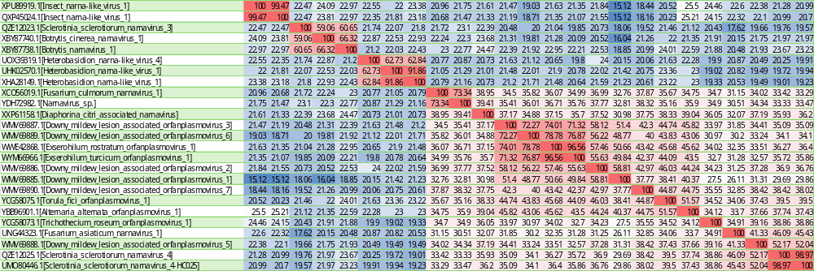

Figure 3: Identity matrix for hypothetical proteins encoded by RNA2 of orfanplasmoviruses classified in the “Orplavirales” order (those with complete or coding-complete sequences available in GenBank).

