

The International Committee on Taxonomy of Viruses
Taxonomy Proposal Form, 2026

Part 1a: Details of taxonomy proposals

Title: | Reorganization of the Marseilleviridae family
Code assigned: | 2026.009F.N.v2.Marseilleviridae_reorg

Author(s), affiliation and email address(es):
Given name (+middle initial(s)) | Surname | Affiliation | Email address | Corr. author(s)
Victória | Queiroz | Dept Biological Sciences, Virginia Tech, Blacksburg, USA | victoriafq@vt.edu | X
Gabriel | Almeida | The Arctic University of Norway, Tromso, Norway | gabriel.d.almeida@uit.no
Julien | Andréani | Aix Marseille Université, Marseille, France | julien.andreani@univ-amu.fr’
Frank | Aylward | Dept Biological Sciences, Virginia Tech, Blacksburg, USA | faylward@vt.edu
Jean-Michel | Claverie | Aix Marseille Université, Marseille, France | claverie@igs.cnrs-mrs.fr
Philippe | Colson | Aix Marseille Université, Marseille, France | philippe.colson@univ-amu.fr
Gilbert | Greub | Lausanne University, Lausanne, Switzerland | Gilbert.Greub@chuv.ch
Rodrigo | Rodrigues | Universidade Federal de Minas Gerais, Belo Horizonte, Brazil | rodriguesral07@gmail.com
Masaharu | Takemura | Tokyo University of Science, Tokyo, Japan | giantvirus@rs.tus.ac.jp
Jônatas | Abrahão | Universidade Federal de Minas Gerais, Belo Horizonte, Brazil | jonatas.abrahao@gmail.com | X

Part 1b: Taxonomy Proposal Submission
ICTV Subcommittee:
Animal DNA Viruses and Retroviruses |  | Bacterial viruses
Animal minus-strand and dsRNA viruses |  | Fungal and protist viruses | X
Animal positive-strand RNA viruses |  | Plant viruses
Archaeal viruses |  | General -

List the ICTV Study Group(s) that have seen or have been involved in creating this proposal:
Pithovirales
Optional – complete only if formally voted on by an ICTV Study Group:
Study Group | Number of members
Study Group | Votes in support | Votes against | No vote
Pithovirales | 10 | 0

Submission date: | 30/09/2026

Part 1c: Feedback from ICTV Executive Committee (EC) meeting
Executive Committee Meeting Decision code: | X
A – Accept
Ac – Accept subject to revision by relevant subcommittee chair. No further vote required
U – Accept without revision but with re-evaluation and email vote by the EC
Uc – Accept subject to revision and re-evaluation and email vote by the EC
Ud – Deferred to the next EC meeting, with an invitation to revise based on EC comments
J – Reject
W – Withdrawn

Comments from the Executive Committee:

Part 1d: Revised Taxonomy Proposal Submission
Response of proposer:
Revision date:

Part 3: TAXONOMIC PROPOSAL
Taxonomic changes proposed:
Establish new taxon | X | Split taxon | x
Abolish taxon | X | Merge taxon | x
Move taxon | X | Promote taxon
Rename taxon | X | Demote taxon
Move and rename | X

Etymology (origin) of proposed taxonomic names:
Taxon name | Etymology of the term
“Alphamarseillevirus” | Prefix derived from the Romanized name of the first letter of the Greek alphabet, alpha, combined with the family name and the standardized suffix for the genus level
“Betamarseillevirus” | Prefix derived from the Romanized name of the second letter of the Greek alphabet, beta, combined with the family name and the standardized suffix for the genus level
“Gammamarseillevirus” | Prefix derived from the Romanized name of the third letter of the Greek alphabet, gamma, combined with the family name and the standardized suffix for the genus level
“Deltamarseillevirus” | Prefix derived from the Romanized name of the fourth letter of the Greek alphabet, delta, combined with the family name and the standardized suffix for the genus level
“Epsilonmarseillevirus” | Prefix derived from the Romanized name of the fifth letter of the Greek alphabet, epsilon, combined with the family name and the standardized suffix for the genus level
“Zetamarseillevirus” | Prefix derived from the Romanized name of the sixth letter of the Greek alphabet, zeta, combined with the family name and the standardized suffix for the genus level
“Etamarseillevirus” | Prefix derived from the Romanized name of the seventh letter of the Greek alphabet, eta, combined with the family name and the standardized suffix for the genus level
“Alphamarseillevirus massiliense” | Renamed name of the current species Marseillevirus massiliense, keeping the epithet and updating the genus
“Gammamarseillevirus zhujiangense” | After location of isolation: Zhūjiāng River, China
“Gammamarseillevirus bayiense” | After location of isolation: Bayi Reservoir II, China
“Gammamarseillevirus tunisense” | Renamed name of the current species Losannavirus tunisense, keeping the epithet and updating the genus
“Gammamarseillevirus zhongguoense” | Romanized Chinese name for China: Zhōngguó, country of isolation
“Deltamarseillevirus brasiliense” | Isolate name modified to Latinized singular form
“Deltamarseillevirus norgense” | Norwegian name for Norway: Norge, country of isolation
“Betamarseillevirus lausannense” | Renamed name of the current species Losannavirus lausannense, keeping the epithet and updating the genus
“Betamarseillevirus xiwanense” | Isolate name modified to Latinized singular form
“Betamarseillevirus noumeaense” | First isolate name modified to Latinized singular form
“Epsilonmarseillevirus guaibense” | After location of isolation: Guaíba Lake, Brazil
“Zetamarseillevirus nipponense” | Romanized Japanese name for Japan: Nippon, country of isolation
“Zetamarseillevirus shenzhense” | After location of isolation of the first representative: Shenzhen, China
“Etamarseillevirus futianense” | Isolate name modified to Latinized singular form
“Etamarseillevirus cajuinense” | First isolate name modified to Latinized singular form

Permission for use of names derived from a living person:
Taxon name | Full name of person from whom the name is derived | Attached

Abstract of Taxonomy Proposal:
Description of current taxonomy:
Currently, the family Marseilleviridae comprises two genera, Marseillevirus and Losannavirus, with two species each: Marseillevirus massiliense and Marseillevirus senegalense in the former, and Losannavirus lausannense and Losannavirus tunisense in the latter. However, to accommodate new isolates and apply the demarcation criteria and nomenclatural rules already established for other representatives of the order to which this family belongs, a reorganization of the family is necessary.

Proposed taxonomic change(s):
Splitting of one genus, establishment of five genera, and renaming of the two existing genera. Creation of 12 species, moving one species, renaming three existing species, and abolition of the species Marseillevirus senegalense.

Demarcation criteria for new taxon/taxa:
The demarcation criteria for the new genera and species should follow standards similar to those already established for other taxa within the order. Accordingly, viruses forming a monophyletic clade and exhibiting a pairwise ANI >80% across at least 50% of the aligned genome are considered to belong to the same genus. Furthermore, isolates exhibiting a pairwise ANI >95% across at least 75% of their genes should be assigned to the same species.

Justification:
The creation of five genera and 12 species is necessary to encompass all marseilleviruses isolated to date. The renaming of existing taxa is necessary to maintain nomenclatural consistency. The abolition of the species Marseillevirus senegalense is necessary because the isolate to which this species refers does not meet the criteria for recognition as a distinct species.

Text of Taxonomy proposal:
Description of current taxonomy:
The family Marseilleviridae was named after Marseille, the French city where Marseillevirus, the first described isolate and representative of the family, was discovered [1]. Currently, the family Marseilleviridae comprises two genera, each containing two species (from 2012.002a-hF.A.v5.Marseilleviridae). The genus Marseillevirus comprises the species Marseillevirus massiliense, represented by the virus Marseillevirus marseillevirus strain T19, and the species Marseillevirus senegalense, represented by the virus Senegalvirus marseillevirus SSV-A. The second genus, Losannavirus, comprises the species Losannavirus lausannense and Losannavirus tunisense, represented by the Lausannevirus isolate 7715 and Tunisvirus fontaine 2 strain U484 viruses, respectively. However, over 40 Marseillevirus isolates have been documented to date, making a reorganization of the family necessary [2-19]

Proposed taxonomic change(s):
To formally incorporate additional fully sequenced representatives into the existing taxonomy, while applying the established demarcation criteria and standardizing the nomenclature of the taxa, we propose:

- Renaming of the two existing genera
Genus Marseillevirus:
In order to distinguish the collective name 'marseillevirus' at the family or genus level we propose renaming the first described genus Marseillevirus to "Alphamarseillevirus". The use of prefixes derived from letters of the Greek alphabet is also established at the genus level within the suborder Ocovirineae.
Genus Losannavirus:
To maintain consistency, we propose renaming the genus Losannavirus to "Betamarseillevirus".

- Establishment of five new genera
To accommodate additional representatives, we propose the establishment of five new genera. Following the same nomenclatural logic, we propose the creation of the genera “Gammamarseillevirus”, “Deltamarseillevirus”, “Epsilonmarseillevirus”, “Zetamarseillevirus”, and “Etamarseillevirus”.

- Split of existing genus
Currently, the genus Losannavirus comprises both Losannavirus lausannense and Losannavirus tunisense. However, our analyses show that representatives of these two species do not meet the reciprocal ANI threshold of >80%. Therefore, under the proposed classification, these species should no longer be assigned to the same genus. Therefore, this genus should be separated.

- Moving existing species
The species Losannavirus tunisense should then be moved to the new proposed genus “Gammamarseillevirus”.

- Renaming of the three existing species
Following the renaming of the genera, the binomial nomenclature of species already recognized by the ICTV should be updated to reflect the new genus names while retaining the existing species epithets. Therefore, we propose that the species Marseillevirus massiliense be renamed "Alphamarseillevirus massiliense", the species Losannavirus lausannense be renamed “Betamarseillevirus lausannense”, and the species Losannavirus tunisense be renamed "Gammamarseillevirus tunisense".

- Abolition of existing species
According to the demarcation criteria used in this proposal, the Senegalvirus strain SSV-A, currently the only representative of the species Marseillevirus senegalense, shares an ANI >95% with several other Marseillevirus isolates, including the founder isolate, Marseillevirus T19. Therefore, these isolates should be assigned to a single species. In accordance with chronological precedence, we propose retaining the proposed species name “Alphamarseillevirus massiliense” and abolishing the species Marseillevirus senegalense.

- Establishment of 12 new species
Withing the proposed genus “Betamarseillevirus”:
We propose the creation of the species “Betamarseillevirus xiwanense” and “Betamarseillevirus noumeaense”
Withing the proposed genus “Gammamarseillevirus”:
We propose the creation of the species “Gammamarseillevirus zhujiangense”, “Gammamarseillevirus bayiense”, and “Gammamarseillevirus zhongguoense”.
Withing the proposed genus “Deltamarseillevirus”:
We propose the creation of the species “Deltamarseillevirus brasiliense” and “Deltamarseillevirus norgense”.
Withing the proposed genus “Epsilonmarseillevirus”:
We propose the creation of the species “Epsilonmarseillevirus guaibense”.
Withing the proposed genus “Zetamarseillevirus”:
We propose the creation of the species “Zetamarseillevirus nipponense” and “Zetamarseillevirus shenzhense”.
Withing the proposed genus “Etamarseillevirus”:
We propose the creation of the species “Etamarseillevirus futianense” and “Etamarseillevirus cajuinense”.

When multiple isolates were assigned to the same species, the nomenclature was selected based on the earliest isolate to prioritize chronological precedence. The assignment of isolates to species is presented in Table 1.

Demarcation criteria for new taxon/taxa:
The demarcation criteria for new genera and species follow standards similar to those established for the suborder Ocovirineae (from 2024.005F.A.v2.Pimascovirales_reorg), which belongs to the same order as the family Marseilleviridae. Accordingly, viruses forming a monophyletic clade and exhibiting a pairwise ANI >80% across at least 50% of the aligned genome are considered to belong to the same genus (Figures 1 and 2). At the species level, isolates sharing a pairwise ANI >95% across at least 75% of their genes should be assigned to the same species (Figure 3).

Justification:
This update of the taxonomy of the family Marseilleviridae includes incorporating new isolates and representatives that have not been previously classified. The establishment of new taxa is necessary to accommodate these isolates. The split of the genus Losannavirus is necessary to meet the genus delimitation criteria, with the species Losannavirus tunisense subsequently transferred to a newly proposed genus. The abolition of the species Marseillevirus senegalense is necessary because the isolate to which this species refers does not meet the criteria for recognition as a distinct species. Finally, the renaming of existing taxa is necessary to maintain nomenclatural consistency.

References:
- Boyer, M., Yutin, N., Pagnier, I. et al. Giant Marseillevirus highlights the role of amoebae as a melting pot in emergence of chimeric microorganisms. Proceedings of the National Academy of Sciences of the United States of America 106, 21848–21853 (2009). https://doi.org/10.1073/pnas.0911354106.
- Thomas, V., Bertelli, C., Collyn, F. et al. Lausannevirus, a giant amoebal virus encoding histone doublets. Environmental Microbiology 13, 1454–1466 (2011). https://doi.org/10.1111/j.1462-2920.2011.02446.x.
- Lagier, J.-C., Armougom, F., Million, M. et al. Microbial culturomics: paradigm shift in the human gut microbiome study. Clinical Microbiology and Infection 18, 1185–1193 (2012). https://doi.org/10.1111/1469-0691.12023.
- Doutre, G., Philippe, N., Abergel, C. & Claverie, J.-M. Genome analysis of the first Marseilleviridae representative from Australia indicates that most of its genes contribute to virus fitness. Journal of Virology 88, 14340–14349 (2014). https://doi.org/10.1128/JVI.02414-14.
- Boughalmi, M., Pagnier, I., Aherfi, S. et al. First isolation of a Marseillevirus in the Diptera Syrphidae Eristalis tenax. Intervirology 56, 386–394 (2013). https://doi.org/10.1159/000354560.
- Aherfi, S., Pagnier, I., Fournous, G. et al. Complete genome sequence of Cannes 8 virus, a new member of the proposed family "Marseilleviridae". Virus Genes 47, 550–555 (2013). https://doi.org/10.1007/s11262-013-0965-4.
- Fabre, E., Jeudy, S., Santini, S. et al. Noumeavirus replication relies on a transient remote control of the host nucleus. Nature Communications 8, 15087 (2017). https://doi.org/10.1038/ncomms15087.
- Doutre, G., Arfib, B., Rochette, P. et al. Complete genome sequence of a new member of the Marseilleviridae recovered from the brackish submarine spring in the Cassis Port-Miou Calanque, France. Genome Announcements 3, e01148-15 (2015). https://doi.org/10.1128/genomeA.01148-15.
- Dornas, F. P., Assis, F. L., Aherfi, S. et al. A Brazilian Marseillevirus is the founding member of a lineage in family Marseilleviridae. Viruses 8, 76 (2016). https://doi.org/10.3390/v8030076.
- Dos Santos, R. N., Campos, F. S., Medeiros de Albuquerque, N. R. et al. A new marseillevirus isolated in Southern Brazil from Limnoperna fortunei. Scientific Reports 6, 35237 (2016). https://doi.org/10.1038/srep35237.
- Aherfi, S., Boughalmi, M., Pagnier, I. et al. Complete genome sequence of Tunisvirus, a new member of the proposed family Marseilleviridae. Archives of Virology 159, 2349–2358 (2014). https://doi.org/10.1007/s00705-014-2023-5.
- Takemura, M. Draft genome sequence of Tokyovirus, a member of the family Marseilleviridae isolated from the Arakawa River of Tokyo, Japan. Genome Announcements 4, e00429-16 (2016). https://doi.org/10.1128/genomeA.00429-16.
- Arthofer, P., Delafont, V., Willemsen, A. et al. Defensive symbiosis against giant viruses in amoebae. Proceedings of the National Academy of Sciences of the United States of America 119, e2205856119 (2022). https://doi.org/10.1073/pnas.2205856119.
- Chatterjee, A. & Kondabagil, K. Complete genome sequence of Kurlavirus, a novel member of the family Marseilleviridae isolated in Mumbai, India. Archives of Virology 162, 3243–3245 (2017). https://doi.org/10.1007/s00705-017-3469-z.
- de Azevedo, B. L., Queiroz, V. F., de Aquino, I. L. M. et al. The genomic and phylogenetic analysis of Marseillevirus cajuinensis raises questions about the evolution of Marseilleviridae lineages and their taxonomical organization. Journal of Virology 98, e00513-24 (2024). https://doi.org/10.1128/jvi.00513-24.
- Almeida, G. M. F., Arriaga, I., de Azevedo, B. L. et al. Genomic and structural insights into Jyvaskylavirus, the first giant virus isolated from Finland. eLife 13, RP103492 (2025). https://doi.org/10.7554/eLife.103492.3.
- Rodrigues, M. F. D. R., Arias, N. E. C., Machado, T. B. et al. A Marseillevirus isolate from the Brazilian wetlands. Archives of Virology 171, 2 (2026). https://doi.org/10.1007/s00705-025-06456-6.
- Xia, Y., Su, B., Ren, H. et al. Conserved marseilleviruses harboring diverse antibiotic resistance genes isolated from the Yangtze River Delta and the Pearl River Delta, China. Scientific Reports 15, 10663 (2025). https://doi.org/10.1038/s41598-025-94967-2.
- Aoki, K., Hagiwara, R., Akashi, M. et al. Fifteen Marseilleviruses newly isolated from three water samples in Japan reveal local diversity of Marseilleviridae. Frontiers in Microbiology 10, 1152 (2019). https://doi.org/10.3389/fmicb.2019.01152.
- Jain, R. et al. High throughput ANI analysis of 90K prokaryotic genomes reveals clear species boundaries. Nature Communications 9, 5114 (2018). https://doi.org/10.1038/s41467-018-07641-9.
- Aylward, F. O., Moniruzzaman, M., Ha, A. D. & Koonin, E. V. A phylogenomic framework for charting the diversity and evolution of giant viruses. PLOS Biology 19, e3001430 (2021). https://doi.org/10.1371/journal.pbio.3001430.
- Capella-Gutiérrez, S. et al. trimAl: a tool for automated alignment trimming in large-scale phylogenetic analyses. Bioinformatics 25, 1972–1973 (2009). https://doi.org/10.1093/bioinformatics/btp348.
- Minh, B. Q. et al. IQ-TREE 2: new models and efficient methods for phylogenetic inference in the genomic era. Molecular Biology and Evolution 37, 1530–1534 (2020). https://doi.org/10.1093/molbev/msaa015.
- Hoang, D. T. et al. UFBoot2: improving the ultrafast bootstrap approximation. Molecular Biology and Evolution 35, 518–522 (2018). https://doi.org/10.1093/molbev/msx281.
- Letunic, I. & Bork, P. Interactive Tree of Life (iTOL) v6: recent updates to the phylogenetic tree display and annotation tool. Nucleic Acids Research 52, W78–W82 (2024). https://doi.org/10.1093/nar/gkae268.

Accompanying files:
Filename | Description of contents

Tables, Figures:

Table 1. Proposed taxonomy
Family | Genus | Species | Virus Isolate | NCBI Access.
Marseilleviridae | “Etamarseillevirus” | “Etamarseillevirus futianense” | Marseillevirus futianmevirus | OR157982
Marseilleviridae | “Etamarseillevirus” | “Etamarseillevirus cajuinense” | Marseillevirus pantanense isolate Pantanal | PV939247
Marseilleviridae | “Etamarseillevirus” | “Etamarseillevirus cajuinense” | Marseillevirus cajuinensis isolate 1 | OR991738
Marseilleviridae | “Zetamarseillevirus” | “Zetamarseillevirus nipponense” | Tokyovirus A1 | AP017398
Marseilleviridae | “Zetamarseillevirus” | “Zetamarseillevirus shenzhense” | Marseillevirus strain f | OR343188
Marseilleviridae | “Zetamarseillevirus” | “Zetamarseillevirus shenzhense” | Marseillevirus strain R2024HHW | PX691297
Marseilleviridae | “Alphamarseillevirus” | “Alphamarseillevirus massiliense” | Melbournevirus isolate 1 | KM275475
Marseilleviridae | “Alphamarseillevirus” | “Alphamarseillevirus massiliense” | Cannes 8 virus | KF261120
Marseilleviridae | “Alphamarseillevirus” | “Alphamarseillevirus massiliense” | Senegalvirus strain SSV-A | NC_043225; NC_043226; NC_043224; NC_043227; NC_043228; NC_043223
Marseilleviridae | “Alphamarseillevirus” | “Alphamarseillevirus massiliense” | Tromsoevirus isolate AC41 | PZ055819
Marseilleviridae | “Alphamarseillevirus” | “Alphamarseillevirus massiliense” | Lofotenvirus isolate AC140 | PZ157483
Marseilleviridae | “Alphamarseillevirus” | “Alphamarseillevirus massiliense” | Marseillevirus Shanghai isolate 1 | MG827395
Marseilleviridae | “Alphamarseillevirus” | “Alphamarseillevirus massiliense” | Marseillevirus strain Vienna | PP736097
Marseilleviridae | “Alphamarseillevirus” | “Alphamarseillevirus massiliense” | Marseillevirus marseillevirus strain T19 | GU071086
Marseilleviridae | “Gammamarseillevirus” | “Gammamarseillevirus zhujiangense” | Marseillevirus strain R2025LXD | PX691298
Marseilleviridae | “Gammamarseillevirus” | “Gammamarseillevirus bayiense” | Marseillevirus strain BY2 | PV637151
Marseilleviridae | “Gammamarseillevirus” | “Gammamarseillevirus tunisense” | Insectomime virus strain V478 | KF527888
Marseilleviridae | “Gammamarseillevirus” | “Gammamarseillevirus tunisense” | Tunisvirus fontaine 2 strain U484 | KF483846
Marseilleviridae | “Gammamarseillevirus” | “Gammamarseillevirus zhongguoense” | Marseillevirus strain HYL | PV637149
Marseilleviridae | “Gammamarseillevirus” | “Gammamarseillevirus zhongguoense” | Marseillevirus strain YJ2 | PV637154
Marseilleviridae | “Gammamarseillevirus” | “Gammamarseillevirus zhongguoense” | Marseillevirus strain BY6 | PV637152
Marseilleviridae | “Gammamarseillevirus” | “Gammamarseillevirus zhongguoense” | Marseillevirus strain CWP | PV637150
Marseilleviridae | “Gammamarseillevirus” | “Gammamarseillevirus zhongguoense” | Marseillevirus strain MGH | PV637153
Marseilleviridae | “Deltamarseillevirus” | “Deltamarseillevirus brasiliense” | Brazilian marseillevirus strain BH2014 | KT752522
Marseilleviridae | “Deltamarseillevirus” | “Deltamarseillevirus norgense” | Breivikavirus strain A isolate AC266 | PZ157485
Marseilleviridae | “Deltamarseillevirus” | “Deltamarseillevirus norgense” | Finnkrokenvirus isolate AC359 | PZ157482
Marseilleviridae | “Deltamarseillevirus” | “Deltamarseillevirus norgense” | Breivikavirus strain B isolate AC269 | PZ157484
Marseilleviridae | “Betamarseillevirus” | “Betamarseillevirus lausannense” | Jyvaskylavirus isolate fiAc85 | PQ284187
Marseilleviridae | “Betamarseillevirus” | “Betamarseillevirus lausannense” | Port-miou virus | KT428292
Marseilleviridae | “Betamarseillevirus” | “Betamarseillevirus lausannense” | Lausannevirus isolate 7715 | HQ113105
Marseilleviridae | “Betamarseillevirus” | “Betamarseillevirus xiwanense” | Xiwanvirus strain YHH | PQ561596
Marseilleviridae | “Betamarseillevirus” | “Betamarseillevirus xiwanense” | Xiwanvirus isolate 2312 | PQ010612
Marseilleviridae | “Betamarseillevirus” | “Betamarseillevirus noumeaense” | Marseillevirus strain R2025SJC | PX691299
Marseilleviridae | “Betamarseillevirus” | “Betamarseillevirus noumeaense” | Marseillevirus strain e | OR343189
Marseilleviridae | “Betamarseillevirus” | “Betamarseillevirus noumeaense” | Marseillevirus strain qu | MT663336
Marseilleviridae | “Betamarseillevirus” | “Betamarseillevirus noumeaense” | Marseillevirus isolate jzz1 | PQ010614
Marseilleviridae | “Betamarseillevirus” | “Betamarseillevirus noumeaense” | Noumeavirus isolate NMV1 | KX066233
Marseilleviridae | “Betamarseillevirus” | “Betamarseillevirus noumeaense” | Kurlavirus BKC-1 | KY073338
Marseilleviridae | “Betamarseillevirus” | “Betamarseillevirus noumeaense” | Dashavirus isolate PK2311 | PQ220252
Marseilleviridae | “Betamarseillevirus” | “Betamarseillevirus noumeaense” | Dongchongvirus isolate DC2310 | PQ220253
Marseilleviridae | “Epsilonmarseillevirus” | “Epsilonmarseillevirus guaibense” | Golden marseillevirus | KT835053

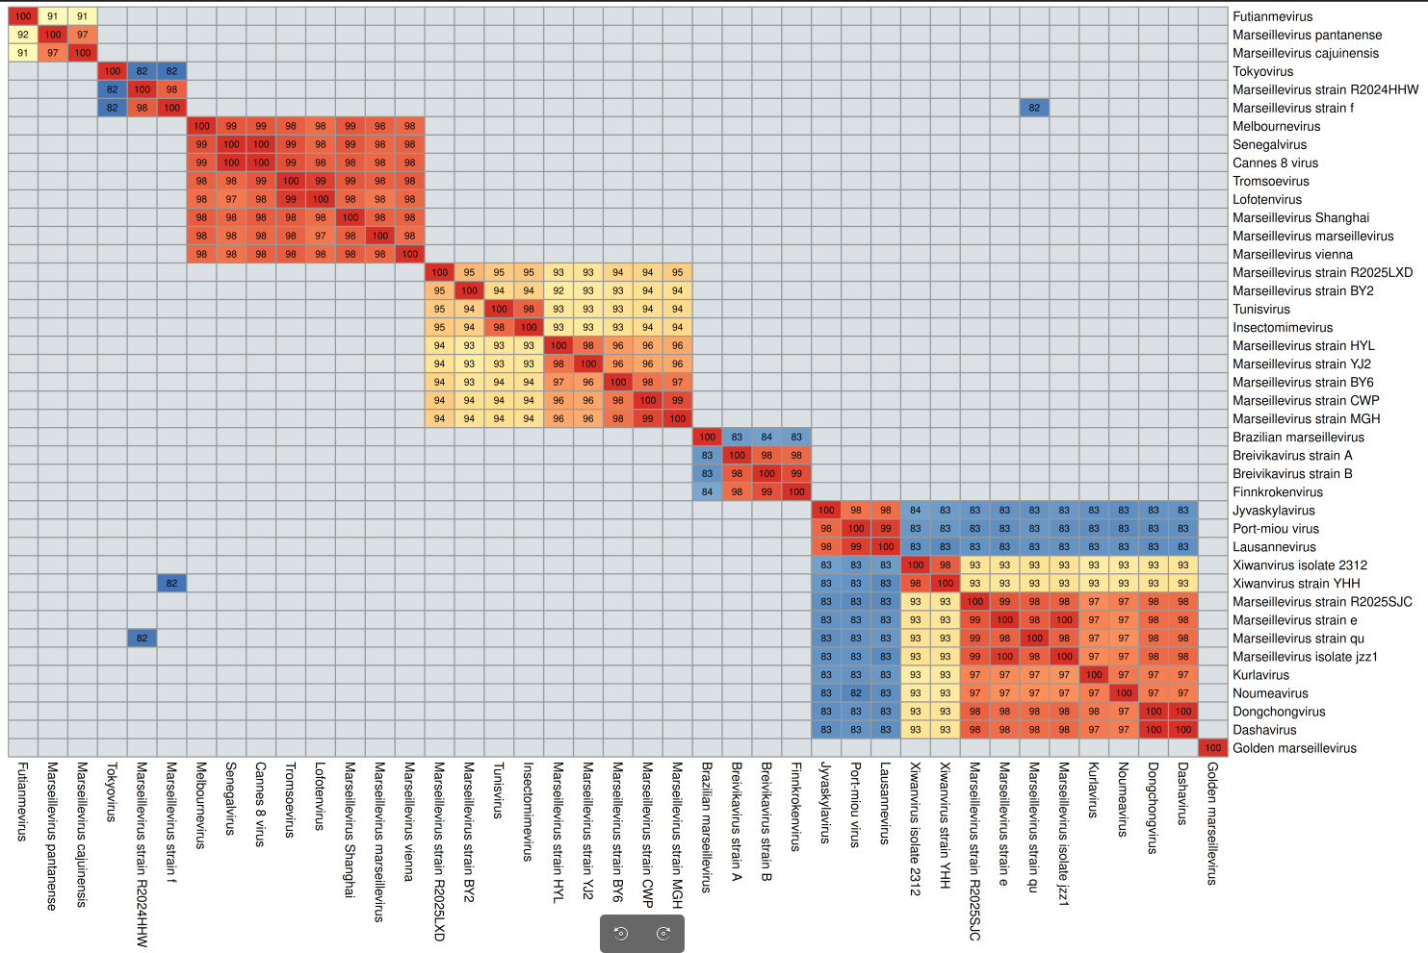Figure 1: Complete genome ANI among viral isolates in the family Marseilleviridae. ANI was calculated using the fastANI tool (https://github.com/ParBLiSS/FastANI) [20] with 1000 bp window size and --minFraction 0. Values below 81.58% were excluded from the matrix.

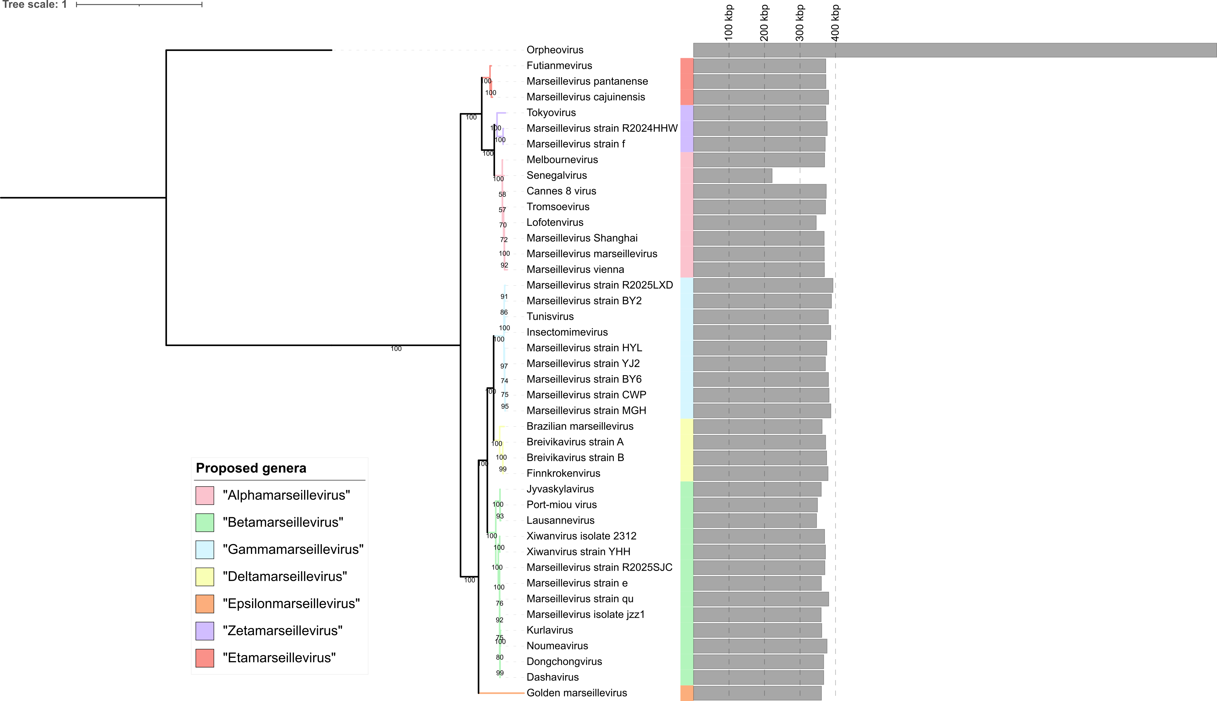Figure 2. Phylogeny of viruses in the family Marseilleviridae, based on a concatenated alignment of a set of seven marker genes that were previously benchmarked, namely Poxvirus Late Transcription Factor VLTF3, A32 Packaging ATPase, DNA topoisomerase II, Transcription initiation factor IIB, DNA polymerase family B, DNA-directed RNA polymerase alpha subunit (RNAPL), and DEAD/SNF2-like helicase (SFII) [21]. Gray horizontal bars correspond to the size of the genomes. The ncldv_markersearch.py utility was used to construct the alignment (https://github.com/faylward/ncldv_markersearch) before trimming with trimAl (-gt 0.5) [22] and phylogenetic reconstruction with IQ-TREE 2.4.0 using the LG+F+R10 substitution model [23]. Node support values are UltraFast bootstraps [24]. Orpheovirus was included as an outgroup. Phylogenetic tree was visualized and customized using the Interactive Tree of Life (iTOL) online platform [25].

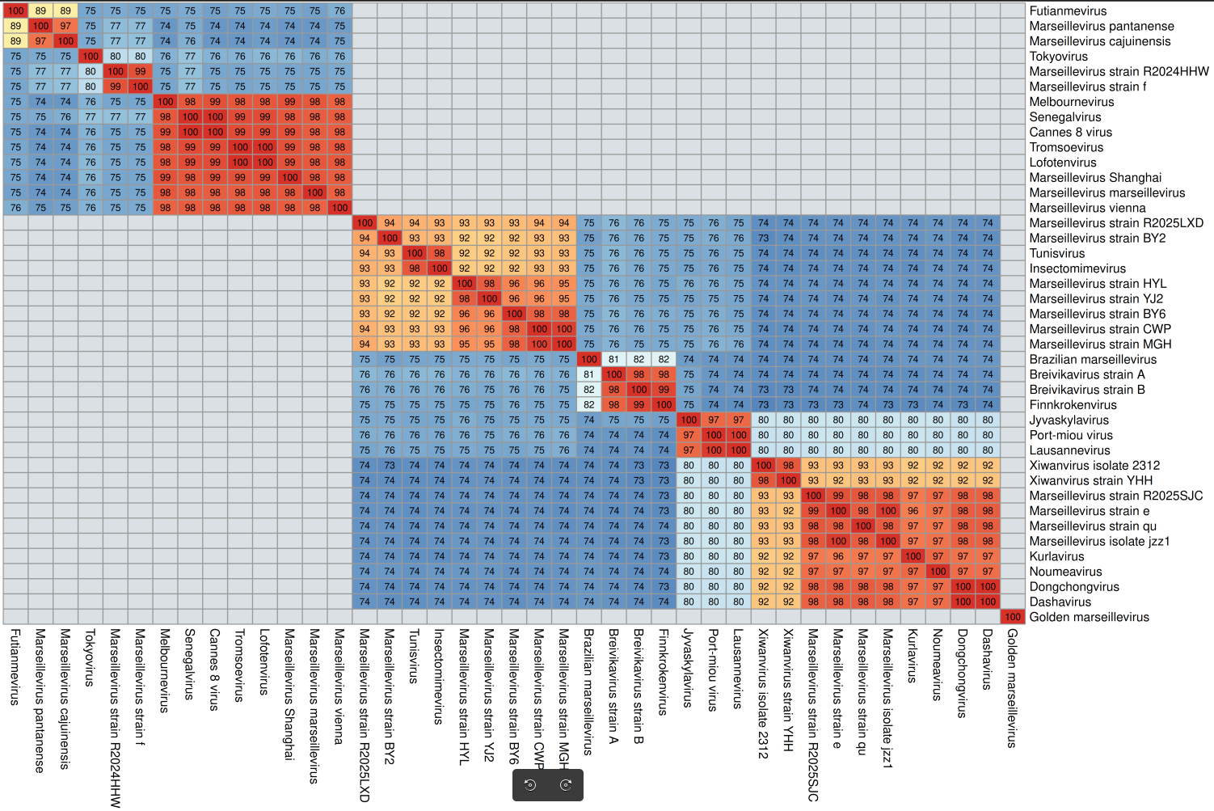Figure 3. Genes ANI among viral isolates in the family Marseilleviridae. Ceiling rounding was applied to all values. Values below 71% were excluded from the matrix.

