

The International Committee on Taxonomy of Viruses
Taxonomy Proposal Form, 2026

Part 1a: Details of taxonomy proposals

Title: | Create three (3) new species in the family Alphaflexiviridae
Code assigned: | 2026.002P.N.v1.Alphaflexiviridae_3nsp

Author(s), affiliation and email address(es):
Given name (+middle initial(s)) | Surname | Affiliation | Email address | Corr. author(s)
Peter | Abrahamian | USDA ARS National Germplasm Resources Laboratory, Beltsville, Maryland 20705, USA | peter.abrahamian@usda.gov
Miguel A. | Aranda | Centro de Edafología y Biología Aplicada del Segura-CSIC, 30100 Murcia, Spain | m.aranda@cebas.csic.es | X
Thierry | Candresse | UMR 1332 Biologie du Fruit et Pathologie  INRAE & Université de Bordeaux  33882 Villenave d'Ornon Cedex  France | thierry.candresse@inrae.fr
Livia | Donaire | Centro de Edafología y Biología Aplicada del Segura-CSIC, 30100 Murcia, Spain | ldonaire@cebas.csic.es
John | Hammond | USDA-ARS, USNA, Floral and Nursery Plants Research Unit  Beltsville, MD 20705, USA | john.hammond@usda.gov
Wulf | Menzel | Leibniz Institute  DSMZ-German Collection of Microorganisms and Cell Cultures GmbH,  Braunschweig-Süd  Germany | wulf.menzel@dsmz.de
Luisa | Rubino | National Research Council, Institute for Sustainable Plant Protection, Bari, Italy | luisa.rubino@cnr.it
Anna Maria | Vaira | National Research Council, Institute for Sustainable Plant Protection, Torino, Italy | annamaria.vaira@cnr.it
Part 1b: Taxonomy Proposal Submission
ICTV Subcommittee:
Animal DNA Viruses and Retroviruses |  | Bacterial viruses
Animal minus-strand and dsRNA viruses |  | Fungal and protist viruses
Animal positive-strand RNA viruses |  | Plant viruses | x
Archaeal viruses |  | General

List the ICTV Study Group(s) that have seen or have been involved in creating this proposal:
Alphaflexiviridae SG

Optional – complete only if formally voted on by an ICTV Study Group:
Study Group | Number of members
Study Group | Votes in support | Votes against | No vote
Alphaflexiviridae SG | 9 | 0 | 6

Submission date: | 14/08/2026

Part 1c: Feedback from ICTV Executive Committee (EC) meeting <To be completed by the subcommittee chair after EC evaluation>
Executive Committee Meeting Decision code: | X
A – Accept
Ac – Accept subject to revision by relevant subcommittee chair. No further vote required
U – Accept without revision but with re-evaluation and email vote by the EC
Uc – Accept subject to revision and re-evaluation and email vote by the EC
Ud – Deferred to the next EC meeting, with an invitation to revise based on EC comments
J – Reject
W – Withdrawn

Comments from the Executive Committee:

Part 1d: Revised Taxonomy Proposal Submission <To be completed for the revised version>
Response of proposer: Please describe in detail how you have responded to the EC meeting feedback
Revision date:

Enter date of the revised version (DD/MM/YYYY).

Part 3: TAXONOMIC PROPOSAL

Taxonomic changes proposed:
Establish new taxon | x | Split taxon
Abolish taxon |  | Merge taxon
Move taxon |  | Promote taxon
Rename taxon |  | Demote taxon
Move and rename

Etymology (origin) of proposed taxonomic names:
Taxon name | Etymology of the term
“Allexivirus rubicalicari” | The species epithet combines rubi-, derived from the Latin generic name Rubus (blackberry), with calicari, a Latinized form derived from calico, referring to the characteristic calico-like symptom observed in the host. We avoided calici, probably a more appropriate form after Latinization of calico to calicum, because of its similarity to calicis, the genitive of calix.
“Potexvirus plantagotessellati” | The species epithet combines Plantago, the Latin generic name of the host plant, with tessellati meaning tessellated, mosaic-like, or marked with small square or mosaic-like areas.
“Potexvirus petroselini” | The species epithet is derived from the host genus ‘Petroselinum’. We avoided referring to the numeral in the English name of the virus because of the construction of a too long and difficult to pronounce word (quinquepetroselini), and the absence of other potexviruses whose species names refer to Petroselinum.

Permission for use of names derived from a living person:
Taxon name | Full name of person from whom the name is derived | Attached

Abstract of Taxonomy Proposal:

Description of current taxonomy:
The family Alphaflexiviridae currently includes 73 virus species in genera Allexivirus (15), Botrexvirus (3), Lolavirus (1), Platypuvirus (1), Potexvirus (52) and Sclerodarnavirus (1). Genera Allexivirus and Potexvirus include subgenera Acarallexivirus and Mandarivirus, respectively.

Proposed taxonomic change(s):
This taxonomic proposal considers the recognition of 3 new virus species belonging to genera Allexivirus (1) and Potexvirus (2) within the family Alphaflexiviridae.

Demarcation criteria for new taxon/taxa:
Throughout the family, isolates of different species should have less than 72% nucleotide identity (or 80% amino acid identity) between their respective coat protein or polymerase genes (or proteins). Members of different genera are distinguished by various features of genome organization and host; viruses from different genera usually have less than 45% nucleotide identity in the CP or polymerase genes.

Justification:
The nucleotide and amino acid sequences of the three viruses belonging to the newly proposed species fit well within these demarcation criteria.

Text of Taxonomy proposal:

Description of current taxonomy:
The family Alphaflexiviridae currently includes 73 virus species in genera Allexivirus (15), Botrexvirus (3), Lolavirus (1), Platypuvirus (1), Potexvirus (52) and Sclerodarnavirus (1). Genera Allexivirus and Potexvirus include subgenera Acarallexivirus and Mandarivirus, respectively.

Proposed taxonomic changes:
This taxonomic proposal considers the recognition of 3 new virus species belonging to genera Allexivirus (1) and Potexvirus (2) within the family Alphaflexiviridae.

Demarcation criteria for new taxon/taxa:
Throughout the family, isolates of different species should have less than 72% nucleotide identity (or 80% amino acid identity) between their respective coat protein or polymerase genes (or proteins). Members of different genera are distinguished by various features of genome organization and host; viruses from different genera usually have less than 45% nucleotide identity in the CP or polymerase genes.

Justification:

Creation of a novel species in the genus Allexivirus of the family Alphaflexiviridae.
The complete genomic sequence of blackberry calico virus (BCV) was determined separately from leaf extracts of nine different Rubus species and hybrid cultivars by high-throughput sequencing, followed by 5′/3′ RACE [1]. The exemplar BCV genome is 7790 nt long (accession number OR026033) excluding the poly(A) tail, and contains untranslated regions (UTRs) of 97 nt and 107 nt at the 5′ and 3′ ends, respectively. The genome is organized into six ORFs: ORF 1 encodes the replicase; ORFs 2-4 triple gene block-like proteins TGB1, TGB2, and TGB3 respectively, with ORF 4 having an AUG initiation codon and the CX4TGHX6C motif conserved in allexiviruses. ORF 5 encodes protein SR-P40 characteristic of pfam05549 in allexiviruses, while ORF 6 encodes the CP. A BLASTN search showed 72.8% nt identity, with 69% coverage, to blackberry virus E (BVE) (genus Allexivirus) isolate BVW-16 genome. Phylogenetic analyses based on the amino acid sequences of the replicase (Figure 1) and CP (Figure 2), the regions used for genus and species demarcation within the Alphaflexiviridae, showed that BCV clustered together with members of the genus Allexivirus, and was related most closely to BVE, and distinct from members of the subgenus Acarallexivirus. The highest amino acid identities of the replicase and CP to BVE were 74% with 99% coverage, and 72% with 93% coverage, respectively, clearly below the established 80% amino acid identity species discrimination level for allexiviruses [1].

Proposed new species name – “Allexivirus rubicalicari”; the species epithet combines rubi-, derived from the Latin generic name Rubus (blackberry), with calicari, a Latinized form derived from calico, referring to the characteristic calico-like symptom observed in the host. We avoided calici, probably a more appropriate form after Latinization of calico to calicum, because of its similarity to calicis, the genitive of calix.
Creation of a novel species in the genus Potexvirus of the family Alphaflexiviridae.
Following mechanical inoculation of leaf tissue from a mosaic displaying broadleaf plantain (Plantago major) to Nicotiana benthamiana, the Plantago mosaic associated virus (PlMaV) genome sequence was determined by Illumina high-throughput sequencing [2]. The complete genome (accession number PV167217) encodes five ORFs in an arrangement typical of potexviruses: a replication-associated protein (ORF1, nt 100–4707), three triple gene block proteins (ORFs 2–4, nt 4691-5814) and a capsid protein (ORF5, nt 5840–6487) enclosed by untranslated regions at the 3’ (99 nt) and 5’ ends (117 nt). The taxonomically relevant replicase and coat protein sequences showed the highest amino acid sequence identities to isolates of papaya mosaic virus (74.4%, QHA79264) and Alternanthera mosaic virus (79.7%, AAX86015), respectively. The presence of the virus in the original Plantago sample was confirmed by specific RT-PCR and direct amplicon sequencing. In addition, electron microscopic examinations of the original material showed only the presence of filamentous virions. Phylogenetic analyses based on the PlMaV replicase (Figure 1) and CP (Figure 2) amino acid sequences placed the virus within the genus Potexvirus of the family Alphaflexiviridae.

Proposed new species name – “Potexvirus plantagotessellati”; the species epithet combines Plantago, the Latin generic name of the host plant, with tessellati, meaning tessellated, mosaic-like, or marked with small square or mosaic-like areas.

Creation of a second novel species in the genus Potexvirus of the family Alphaflexiviridae.
The complete genome sequence of parsley virus 5 (PaV5) was determined using high-throughput sequencing of dsRNA extracted from parsley leaves, followed by 5′/3′ RACE [3]. The PaV5 genome is 5900 nt long (accession number PX021648), excluding the poly(A) tail, and contains untranslated regions (UTRs) of 73 nt and 126 nt at the 5′ and 3′ ends, respectively. The genome is organized into five ORFs: ORF 1 encodes the replicase, ORFs 2–4 encode TGB proteins 1, 2, and 3, respectively, and ORF 5 encodes the CP. The PaV5 proteins share the highest amino acid sequence identity with Cnidium virus X (CnVX; species Potexvirus ecscnidii) for both the replicase (79.5%) and CP (71.6%). Phylogenetic analyses based on the PaV5 replicase (Figure 1) and CP (Figure 2) amino acid sequences placed the virus within the genus Potexvirus of the family Alphaflexiviridae.

Proposed new species name – “Potexvirus petroselini”; the species epithet is derived from the host genus ‘Petroselinum’. We avoided referring to the numeral in the English name of the virus because of the construction of a too long and difficult to pronounce word (quinquepetroselini), and the absence of other potexviruses whose species names refer to Petroselinum.

References:
[1] Fager D, Stockwell V, Grinstead S, Mollov D. Genomic and Biological Characterization of Blackberry Calico Virus. Plant Dis 2026; 110:2259-2266
https://doi.org/10.1094/PDIS-06-25-1232-RE

[2] Menzel W, Knierim D, Margaria P, Krenz B. Characterization of a new potexvirus associated with mosaic symptoms in Plantago major. J Plant Pathol 2026; 108: 1307–1310 https://doi.org/10.1007/s42161-026-02114-1

[3] Gaafar YZA, Zia A, Schmidt I, Ziebell H. Rediscovering parsley virus 5: characterizing a known virus with an unknown genome. J Plant Pathol 2026; 108:1333–1338
https://doi.org/10.1007/s42161-026-02153-8

[4] Edgar RC. MUSCLE: multiple sequence alignment with high accuracy and high throughput. Nucleic Acids Res 2004; 32:1792-7. doi: 10.1093/nar/gkh340.

[5] Tamura K, Stecher G, Kumar S. MEGA11: Molecular Evolutionary Genetics Analysis Version 11. Mol Biol Evol 2021: 38: 3022–3027.

[6] Kozlov AM, Darriba D, Flouri T, Morel B, Stamatakis A. RAxML-NG: a fast, scalable and user-friendly tool for maximum likelihood phylogenetic inference. Bioinformatics 2019; 35:4453-4455. doi: 10.1093/bioinformatics/btz305.

Accompanying files:

Filename | Description of contents

Tables, Figures:

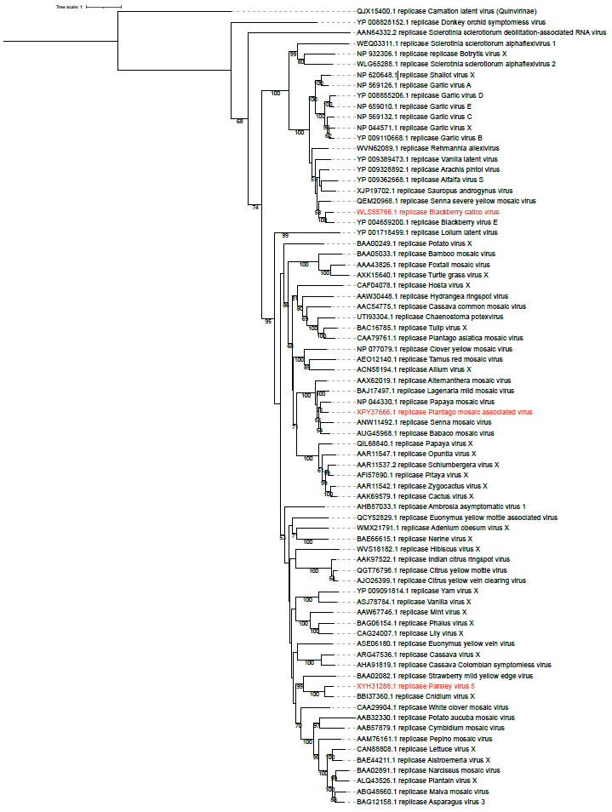

Figure 1. Phylogenetic analysis of viruses in the family Alphaflexiviridae inferred using replicase amino acid sequences. Multiple sequence alignment of 76 replicase sequences was done using MUSCLE [4]. Best amino acid substitution method was inferred using MEGA 11 [5]. Maximum likelihood trees were inferred using RAxML-NG software [6] using the LG method considering the proportion of invariable sites (+I) and the variation of the substitution rate among sites according to a gamma distribution (+G). Best ML tree with bootstrap support values (1000 replicates) is shown. Only bootstrap values higher than 50% are displayed. Carnation latent virus (QJX15400.1) (genus Carlavirus, family Betaflexiviridae) was used as an outgroup. The sequences from BCV, PlMaV and PaV5 are marked in red.

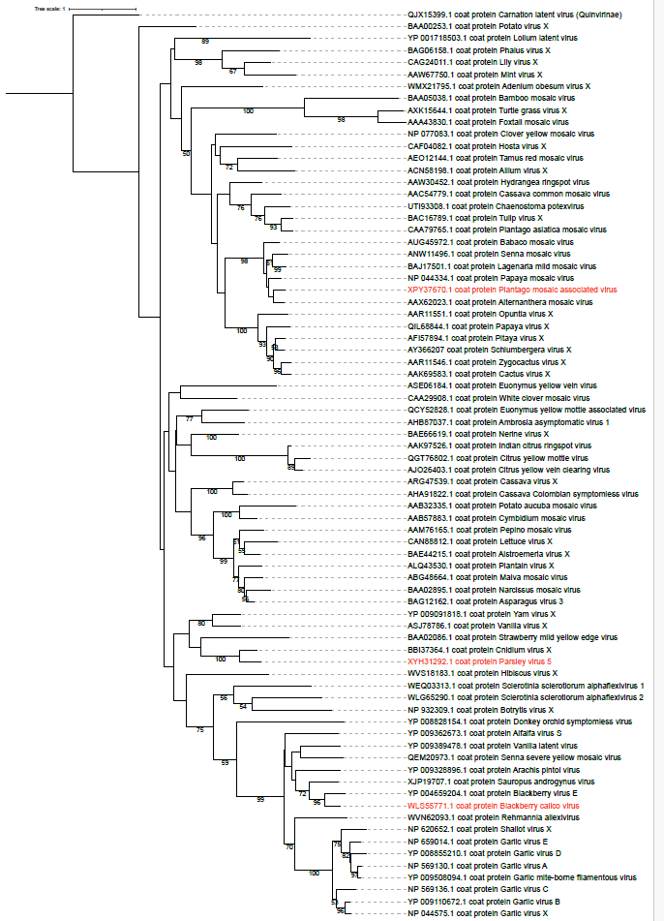

Figure 2. Phylogenetic analysis of viruses in the family Alphaflexiviridae inferred using coat protein (CP) amino acid sequences. Multiple sequence alignment of 76 CP sequences was done using MUSCLE [4]. Best amino acid substitution method was inferred using MEGA 11 [5]. Maximum likelihood trees were inferred using RAxML-NG software [6] using the LG method considering the variation of the substitution rate among sites according to a gamma distribution (+G). Best ML tree with bootstrap support values (1000 replicates) is shown. Only bootstrap values higher than 50% are displayed. Carnation latent virus (QJX153999.1) (genus Carlavirus, family Betaflexiviridae) was used as an outgroup. The sequences from BCV, PlMaV and PaV5 are marked in red.

