

The International Committee on Taxonomy of Viruses
Taxonomy Proposal Form, 2026

Part 1a: Details of taxonomy proposals

Title: | Create two [2] new species in the genus Orthotospovirus (Elliovirales: Tospoviridae)
Code assigned: | 2026.003P.N.v1.Tospoviridae_2nsp

Author(s), affiliation and email address(es):
Given name (+middle initial(s)) | Surname | Affiliation | Email address | Corr. author(s)
Marcel | Westenberg | Netherlands Food and Consumer Product Safety Authority, Wageningen, The Netherlands | m.westenberg@nvwa.nl
Marleen | Botermans | Netherlands Food and Consumer Product Safety Authority, Wageningen, The Netherlands | m.botermans@nvwa.nl
Scott | Adkins | United States Department of Agriculture, Fort Pierce, USA | scott.adkins@usda.gov
Ozgur | Batuman | Plant Pathology Department, University of Florida, Immokalee, Florida, USA | obatuman@ufl.edu
Amalendu | Ghosh | ICAR-Indian Agricultural Research Institute, New Delhi, India | Amalendu.Ghosh@icar.gov.in
Holly R. | Hughes | Centers for Disease Control and Prevention, Fort Collins, USA | ltr8@cdc.gov
Naidu | Rayapati | Washington State University, Prosser, USA | naidu.rayapati@wsu.edu
Massimo | Turina | Institute for Sustainable Plant Protection, Turin, Italy | massimo.turina@cnr.it
Anna | Whitfield | North Carolina State University, Raleigh, USA | awhitfi@ncsu.edu
Paolo | Margaria | Leibniz Institute DSMZ, Braunschweig, Germany | paolo.margaria@dsmz.de | X

Part 1b: Taxonomy Proposal Submission
ICTV Subcommittee:
Animal DNA Viruses and Retroviruses |  | Bacterial viruses
Animal minus-strand and dsRNA viruses |  | Fungal and protist viruses
Animal positive-strand RNA viruses |  | Plant viruses | X
Archaeal viruses |  | General

List the ICTV Study Group(s) that have seen or have been involved in creating this proposal:
Tospoviridae Study Group

Optional – complete only if formally voted on by an ICTV Study Group:
Study Group | Number of members
Study Group | Votes in support | Votes against | No vote
Tospoviridae | 8

Submission date: | 14/08/2026

Part 1c: Feedback from ICTV Executive Committee (EC) meeting <To be completed by the subcommittee chair after EC evaluation>
Executive Committee Meeting Decision code: | X
A – Accept
Ac – Accept subject to revision by relevant subcommittee chair. No further vote required
U – Accept without revision but with re-evaluation and email vote by the EC
Uc – Accept subject to revision and re-evaluation and email vote by the EC
Ud – Deferred to the next EC meeting, with an invitation to revise based on EC comments
J - Reject
W - Withdrawn

Comments from the Executive Committee:

Part 1d: Revised Taxonomy Proposal Submission <To be completed for the revised version>
Response of proposer: Please describe in detail how you have responded to the EC meeting feedback
Revision date:

Enter date of the revised version (DD/MM/YYYY).

Part 3: TAXONOMIC PROPOSAL

Taxonomic changes proposed:
Establish new taxon | X | Split taxon
Abolish taxon |  | Merge taxon
Move taxon |  | Promote taxon
Rename taxon |  | Demote taxon
Move and rename

Etymology (origin) of proposed taxonomic names:
Taxon name | Etymology of the term
“Orthotospovirus capsici” | Genus of the host plant where it was first described
“Orthotospovirus ipomoeae” | Genus of the host plant where it was first described

Permission for use of names derived from a living person
Taxon name | Full name of person from whom the name is derived | Attached

Abstract of Taxonomy Proposal:

Description of current taxonomy:
Negarnaviricota, Polyploviricotina, Bunyaviricetes, Elliovirales, Tospoviridae, Orthotospovirus.
The genus Orthotospovirus is the only genus in the family Tospoviridae. It currently includes 36 virus species.

Proposed taxonomic change(s):
Create two (2) new species in the genus Orthotospovirus to classify two (2) novel orthotospoviruses.

Demarcation criteria for new taxon/taxa:
On the basis of the % amino acid sequence identity (<90%) of the nucleocapsid protein (N).

Justification:
The identity value of the nucleocapsid (N) protein sequence of the two novel orthotospoviruses to other established orthotospoviruses and between themselves, is below 90%, satisfying the criterion for novel species demarcation in the genus Orthotospovirus based on identity of the amino acid sequence of the N protein.

Text of Taxonomy proposal:

Description of current taxonomy:
The genus Orthotospovirus in the family Tospoviridae currently includes 36 species: Orthotospovirus alstroemeriflavi, Orthotospovirus alstroemerinecrosis, Orthotospovirus arachianuli, Orthotospovirus arachiflavamaculae, Orthotospovirus arachiflavi, Orthotospovirus arachinecrosis, Orthotospovirus callaflavi, Orthotospovirus capsiciflavi, Orthotospovirus capsicimaculaflavi, Orthotospovirus chrysanthinecrocaulis, Orthotospovirus citrullomaculosi, Orthotospovirus citrullonecrosis, Orthotospovirus cucurbichlorosis, Orthotospovirus eustomae, Orthotospovirus fatsiae, Orthotospovirus glycininecrovenae, Orthotospovirus hippeflavi, Orthotospovirus impatiensnecromaculae, Orthotospovirus iridimaculaflavi, Orthotospovirus meloflavi, Orthotospovirus melotessellati, Orthotospovirus morivenae, Orthotospovirus phaseolinecrotessellati, Orthotospovirus polygonianuli, Orthotospovirus tomatanuli, Orthotospovirus tomatoflavi, Orthotospovirus tomatomaculae, Orthotospovirus tomatozonae, Orthotospovirus tomatonecroanuli, Orthotospovirus limonii, Orthotospovirus barlerichlorosis, Orthotospovirus scadoxiflavianuli, Orthotospovirus macadamianuli, Orthotospovirus mercurialis, Orthotospovirus capsiciflavianuli, Orthotospovirus tomatonecromaculae.

Proposed taxonomic change(s):
Following examination of the literature and NCBI GenBank sequence repository, we here propose the classification of two novel orthotospoviruses recently reported from Capsicum sp. and Ipomoea batatas, respectively, as members of two new species in the genus Orthotospovirus.

Demarcation criteria for new taxon/taxa:
<90% amino acid sequence identity of the nucleocapsid protein (N).

Justification:
Creation of a first novel species in the genus Orthotospovirus
The complete genome sequence of Capsicum orthotospovirus 1 (CaV1) was determined from Capsicum sp. from South Africa using high-throughput sequencing [1], and is available in NCBI GenBank under accession numbers PV423510, PV423511, PV423512. The highest identity value of the N protein sequence to other orthotospoviruses is below the species demarcation criterion of the genus Orthotospovirus (Table 1). In the phylogenetic tree (Fig.1), CaV1 groups closest to Macadamia ringspot-associated virus (species Orthotospovirus macadamianuli), also described from South Africa. According to the current criterion based on the diversity of the N sequence, we propose to classify CaV1 as a member of a novel species, named “Orthotospovirus capsici”, from the genus of the host plant where it was first described, adopting the name proposed by the authors in the original publication [1].

Creation of a second novel species in the genus Orthotospovirus
The complete genome sequence of Ipomoea orthotospovirus 1(IpOV1) was determined from Ipomoea batatas from Honduras using high-throughput sequencing, and is publicly available in NCBI GenBank under accession numbers PZ196873, PZ196874, PZ196875. The highest identity value of the N protein sequence to other orthotospoviruses is below the species demarcation criterion of the genus Orthotospovirus (Table 1). In the phylogenetic tree (Fig.1), Ipomoea orthotospovirus 1 groups together with other members assigned to the American clade 2 [2]. According to the current criterion, we propose to classify IpOV1 as a member of a novel species, named “Orthotospovirus ipomoeae”, from the genus of the host plant where it was first described.

References:
[1] Westenberg M, de Krom C, Oplaat C, van Gemert J, Roenhorst A, Schoen R, de Koning P, Botermans M (2025). Complete genome sequence of a putative novel orthotospovirus species identified in Capsicum fruits from South Africa. Microbiology Resource Announcements, 14(10), e00561-25.

[2] Hassani-Mehraban A, Westenberg M, Verhoeven JTJ, Van de Vossenberg BTLH, Kormelink R, Roenhorst JW (2016). Generic RT-PCR tests for detection and identification of tospoviruses. Journal of Virological Methods, 233, 89-96.

[3] Le SQ, Gascuel O (2008). An improved general amino acid replacement matrix. Molecular Biology and Evolution, 25(7),1307-1320.

[4] Tamura K, Stecher G, Kumar S (2021) MEGA11: Molecular Evolutionary Genetics Analysis Version 11. Molecular Biology and Evolution, 38(7), 3022–3027.

Accompanying files:

Filename | Description of contents

Tables, Figures:

Table 1. Amino acid identity (%) matrix generated from the nucleocapsid protein sequences of representative members of accepted and proposed new species in the genus Orthotospovirus. Representative members of proposed new species in this proposal are highlighted in bold.

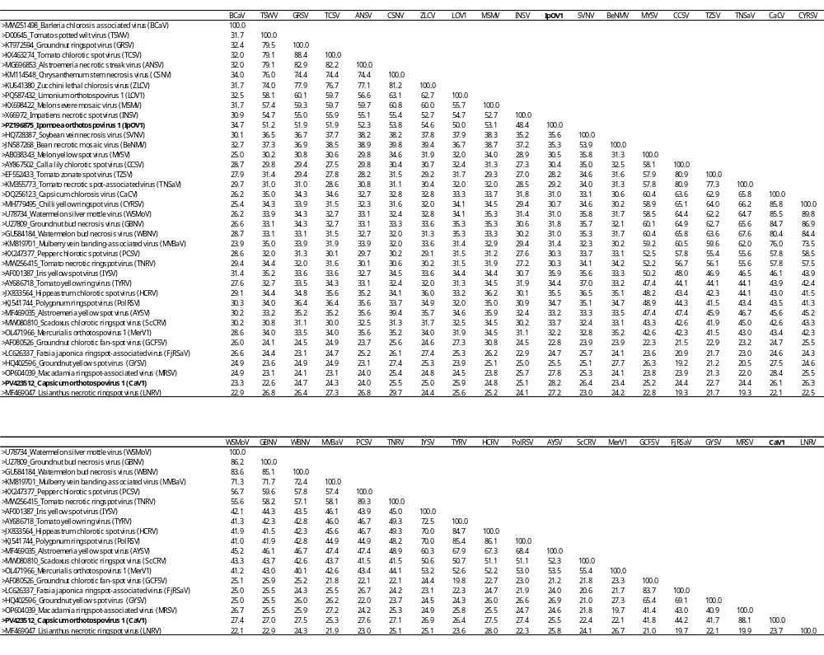

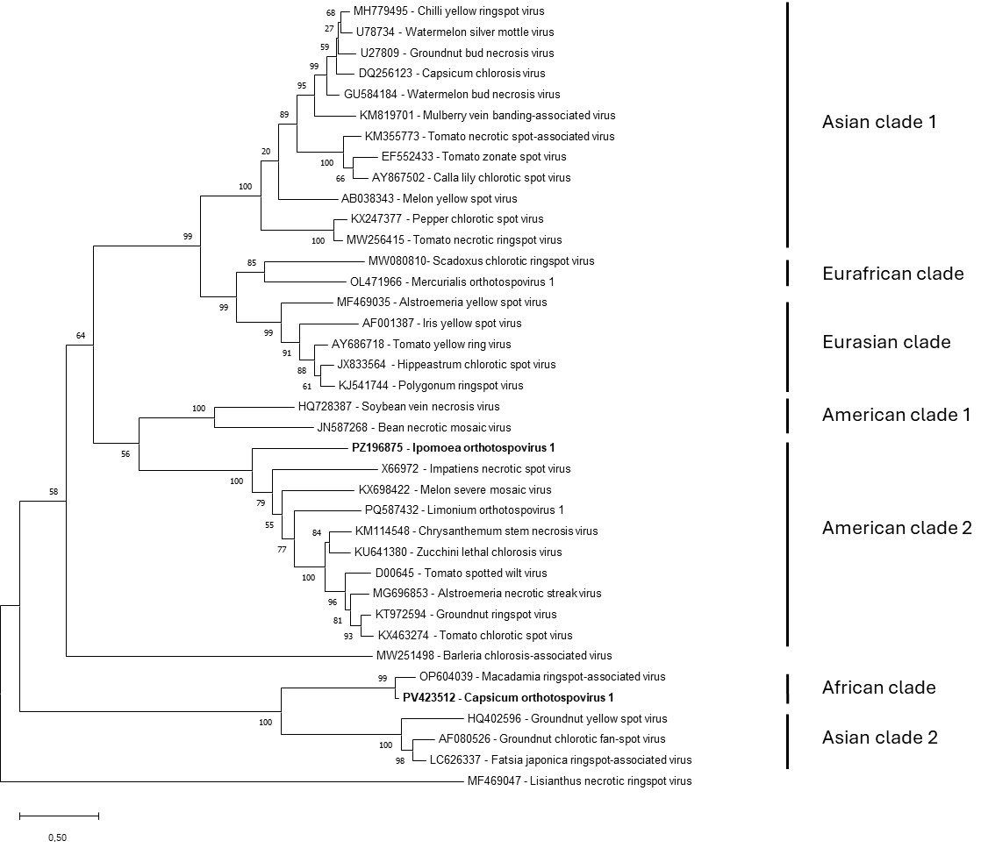

Fig.1 Phylogenetic tree constructed on the amino acid sequence of the nucleocapsid protein of members of all accepted species in the genus Orthotospovirus, and of the two novel orthotospoviruses considered in this proposal. The evolutionary history was inferred by using the Maximum Likelihood method and Le-Gascuel model [3]. The percentage of trees in which the associated taxa clustered together is shown next to the branches. Initial tree(s) for the heuristic search were obtained automatically by applying Neighbor-Join and BioNJ algorithms to a matrix of pairwise distances estimated using the JTT model, and then selecting the topology with superior log likelihood value. A discrete Gamma distribution was used to model evolutionary rate differences among sites (4 categories (+G, parameter = 1,3674)). The rate variation model allowed for some sites to be evolutionarily invariable ([+I], 1,81% sites). The tree is drawn to scale, with branch lengths measured in the number of substitutions per site. This analysis involved 38 amino acid sequences. Evolutionary analyses were conducted in MEGA11 [4]. Representative members of proposed new species are highlighted in bold.

