

The International Committee on Taxonomy of Viruses
Taxonomy Proposal Form, 2026

Part 1a: Details of taxonomy proposals

Title: | Create one new species (“Emaravirus citri”) in the genus Emaravirus, family Fimoviridae
Code assigned: | 2026.004P.N.v1.Fimoviridae_1nsp

Author(s), affiliation and email address(es):
Given name (+middle initial(s)) | Surname | Affiliation | Email address | Corr. author(s)
Michele | Digiaro | CIHEAM, Istituto Agronomico Mediterraneo of Bari, Valenzano (BA), Italy | michele.digiaro@bari.ciheam.org | X
Toufic | Elbeaino | CIHEAM, Istituto Agronomico Mediterraneo of Bari, Valenzano (BA), Italy | toufic.elbeaino@bari.ciheam.org
Kenji | Kubota | Institute for Plant Protection, NARO, Tsukuba, Japan | kubota.kenji813@naro.go.jp
Francisco M. | Ochoa Corona | Oklahoma State University, Institute for Biosecurity & Microbial Forensics, Stillwater, OK, USA | ochoaco@okstate.edu
Susanne | von Bargen | Humboldt-Universität zu Berlin, Berlin, Germany | susanne.von.bargen@agrar.hu-berlin.de
Rachelle | Bester | Department of Genetics, Stellenbosch University, South Africa | rachelle@sun.ac.za
Casey | Gill | Citrus Research International, Matieland, South Africa | casey@cri.co.za
Johannes HJ | Breytenbach | Citrus Research International Nelspruit, South Africa | kobus@cri.co.za
Chanel | Steyn | Citrus Research International, Nelspruit, South Africa | chanel@cri.co.za
Hans J | Maree | Department of Genetics, Stellenbosch University, South Africa | hjmaree@sun.ac.za
Glynnis | Cook | Citrus Research International, Nelspruit, South Africa | glynnis@cri.co.za

Part 1b: Taxonomy Proposal Submission
ICTV Subcommittee:
Animal DNA Viruses and Retroviruses |  | Bacterial viruses
Animal minus-strand and dsRNA viruses |  | Fungal and protist viruses
Animal positive-strand RNA viruses |  | Plant viruses | X
Archaeal viruses |  | General

List the ICTV Study Group(s) that have seen or have been involved in creating this proposal:
Family Fimoviridae Study Group

Optional – complete only if formally voted on by an ICTV Study Group:
Study Group | Number of members
Study Group | Votes in support | Votes against | No vote
Fimoviridae Study Group | 5

Submission date: | 29/07/2026

Part 1c: Feedback from ICTV Executive Committee (EC) meeting <To be completed by the subcommittee chair after EC evaluation>
Executive Committee Meeting Decision code: | X
A – Accept
Ac – Accept subject to revision by relevant subcommittee chair. No further vote required
U – Accept without revision but with re-evaluation and email vote by the EC
Uc – Accept subject to revision and re-evaluation and email vote by the EC
Ud – Deferred to the next EC meeting, with an invitation to revise based on EC comments
J - Reject
W - Withdrawn

Comments from the Executive Committee:

Part 1d: Revised Taxonomy Proposal Submission <To be completed for the revised version>
Response of proposer: Please describe in detail how you have responded to the EC meeting feedback
Revision date:

Enter date of the revised version (DD/MM/YYYY).

Part 3: TAXONOMIC PROPOSAL

Taxonomic changes proposed:
Establish new taxon | X | Split taxon
Abolish taxon |  | Merge taxon
Move taxon |  | Promote taxon
Rename taxon |  | Demote taxon
Move and rename

Etymology (origin) of proposed taxonomic names:
Taxon name | Etymology of the term
“Emaravirus citri” | Named using the singular genitive of the genus name Citrus, the genus to which the species Citrus limon is assigned.

Permission for use of names derived from a living person
Taxon name | Full name of person from whom the name is derived | Attached

Abstract of Taxonomy Proposal:
Description of current taxonomy:
Emaraviruses comprise a group of plant-infecting viruses with segmented, single-stranded (ss), negative-sense (-) RNA genomes. The family Fimoviridae, in the order Elliovirales, consists of a single genus, currently including 33 officially recognized species. Several members of this genus are transmitted by eriophyid mites.

Proposed taxonomic change(s):
Create one new species in the genus Emaravirus in the family Fimoviridae, order Elliovirales.

Demarcation criteria for new taxon/taxa:
Deduced amino acid sequences of citrus emaravirus 1 (CiEV1) show less than 20% amino acid sequence identity for at least two of the relevant gene products of RNA1 (RdRP), RNA2 (GP), RNA3 (NP), and RNA4 (MP) with those of other viruses in the genus Emaravirus.

Justification:
The creation of the new species “Emaravirus citri” in the genus Emaravirus, family Fimoviridae, is proposed to accommodate citrus emaravirus 1 (CiEV1) as its exemplar virus isolate. This virus possesses a genome comprising four, linear, single-stranded, negative-sense RNA segments, as in other Emaravirus species. The fully sequenced RNA segments display features common to those of other recognized Emaravirus species, while showing significant differences in nucleotide and amino acid sequence identities.

Text of Taxonomy proposal:
Description of current taxonomy:
Emaraviruses comprise a group of plant-infecting viruses with segmented, single-stranded (ss), negative-sense (-) RNA genomes. The family Fimoviridae, in the order Elliovirales, consists of a single genus, currently including the following 33 officially recognized species: Actinidia chlorotic ringspot-associated virus (AcCRaV), Actinidia virus 2 (AcV2), Ailanthus crinkle leaf-associated virus (ACrLaV), Arceuthobium sichuanense-associated virus 1 (ArSaV1), Artemisia fimovirus 1 (ArtV1), ash shoestring-associated virus (ASaV), aspen mosaic-associated virus (AsMaV), blackberry leaf mottle associated virus (BLMaV), Camellia japonica-associated virus 1 (CjaV1), Camellia japonica-associated virus 2 (CjaV2), chrysanthemum mosaic-associated virus (ChMaV), Clematis yellow mottle-associated virus (CYMaV), common oak ringspot-associated virus (CORaV), European mountain ash ringspot-associated virus (EMARaV), fig mosaic virus (FMV), High Plains wheat mosaic virus (HPWMoV), Japanese star anise ringspot-associated virus (JSARaV), jujube yellow mottle-associated virus (JYMaV), karaka Okahu purepure emaravirus (KOPV), lilac chlorotic ringspot-associated virus (LiCRaV), maple mottle-associated virus (MaMaV), palo verde broom virus (PVBV), pear chlorotic leaf spot-associated virus (PCLSaV), perilla mosaic virus (PerMV), pigeonpea sterility mosaic virus 1 (PPSMV1), pigeonpea sterility mosaic virus 2 (PPSMV2), Pistacia virus B (PiVB), Pueraria lobata-associated emaravirus (PloaEV), raspberry leaf blotch virus (RLBV), redbud yellow ringspot-associated virus (RYRaV), rose rosette virus (RRV), ti ringspot-associated virus (TiRSaV), and Vitis emaravirus (VEV) [1, 2]. The RNA-dependent RNA polymerase (RdRP), glycoprotein precursor (GP), nucleocapsid (NC) and movement protein (MP) exhibit varying levels of amino acid sequence identity with the corresponding proteins of other emaraviruses. Several members of this genus are transmitted by eriophyid mites.

Proposed taxonomic change(s):
The creation of the species “Emaravirus citri” within the genus Emaravirus, with citrus emaravirus 1 (CiEV1) isolate ER1S designated as the exemplar virus isolate, is proposed.

Demarcation criteria for new taxon/taxa:
Citrus emaravirus 1 (CiEV1) fulfils the species demarcation criteria established for the genus Emaravirus, namely amino acid sequence identities differing by more than 20% for at least two of the proteins encoded by RNA1 (RdRP), RNA2 (GP), RNA3 (NP), and RNA4 (MP) (https://ictv.global/report/chapter/fimoviridae/fimoviridae). Together with its typical emaravirus genome organization, these characteristics clearly indicate that CiEV1 represents a distinct species within the genus Emaravirus.

Justification:
The establishment of the new species “Emaravirus citri” within the genus Emaravirus, family Fimoviridae, is proposed to accommodate citrus emaravirus 1 (CiEV1), recently identified in lemon trees (Citrus limon) in South Africa, as the exemplar virus isolate. The complete genome sequence of CiEV1 has been determined, and the genomic RNA segments display the structural and molecular features characteristic of members of the genus Emaravirus. At the same time, they differ significantly from all currently recognized species in both nucleotide and amino acid sequence identities.
CiEV1 has the following properties:
- Genome: resembles those of members of the genus Emaravirus and consists of four linear, single-stranded, negative-sense RNA segments. RNA1: 7,175 nt, RNA2: 1,595 nt, RNA3: 1,291 nt, and RNA4: 1,408 nt (Figure1) (in order from RNA1 to RNA4, accession numbers are: PV823284– PV823287) [3]. Each segment is monocistronic, encoding a single protein translated from the complementary strand (Figure 1). The 3’ and 5’ untranslated regions (UTRs) range from 48 to 90 nt and from 113 to 277 nt, respectively.
- Virus-encoded proteins: RNA-dependent RNA polymerase (P1): 275 kDa; putative glycoprotein precursor (P2): 54.3 kDa; putative nucleocapsid protein (P3): 34.1 kDa; putative movement protein (P4): 40.4 kDa (Figure 1).
- Phylogenetic relationships: the RdRP protein of CiEV1 clustered with those of CjaV1 and CjaV2 and formed a clade with the emaraviruses CjaV1, CjaV2, PerMV, ArtV1, and JSARaV (Figure 2). The aa identities between the CiEV1 proteins and those of CjaV1 were 42%, 24%, 29%, and 58% to the RdRP, GP, NP, and MP, respectively.
- Transmission: No vector transmission studies have been conducted.
Natural host range: Lemon (Citrus limon).
References:
[1] Digiaro M, Elbeaino T., Kubota K, Ochoa FM, von Bargen S (2024) ICTV Virus Taxonomy Profile: Fimoviridae 2024, J Gen Virol 105, 001943 https://doi.org/10.1099/jgv.0.001943
[2] Mielke N, Muehlbach HP (2007) A novel, multipartite, negative-strand RNA virus is associated with the ringspot disease of European mountain ash (Sorbus aucuparia L.). J Gen Virol 88:1337–1346. https://doi.org/10.1099/vir.0.82715-0
[3] Bester R, Gill C. Breytenbach JHJ, Steyn C, Maree HJ, Cook G (2025) Molecular characterisation of a novel citrus-infecting emaravirus, citrus emaravirus 1. Arch Virol 179; 219 https://doi.org/10.1007/s00705-025-06424-0

Accompanying files:

Filename | Description of contents

Tables, Figures:

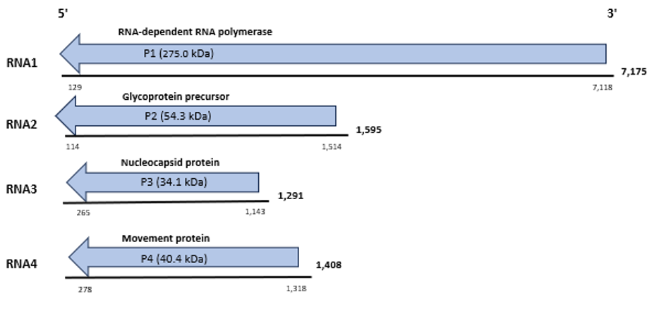< Figure 1. Genome organization of citrus emaravirus 1 (CiEV1). Colored boxes represent the protein-encoding region (ORF) for each RNA. The length of RNAs, the putative protein product for each ORF, function (if known), and estimated molecular mass are provided. The genomic RNAs are not drawn to scale.

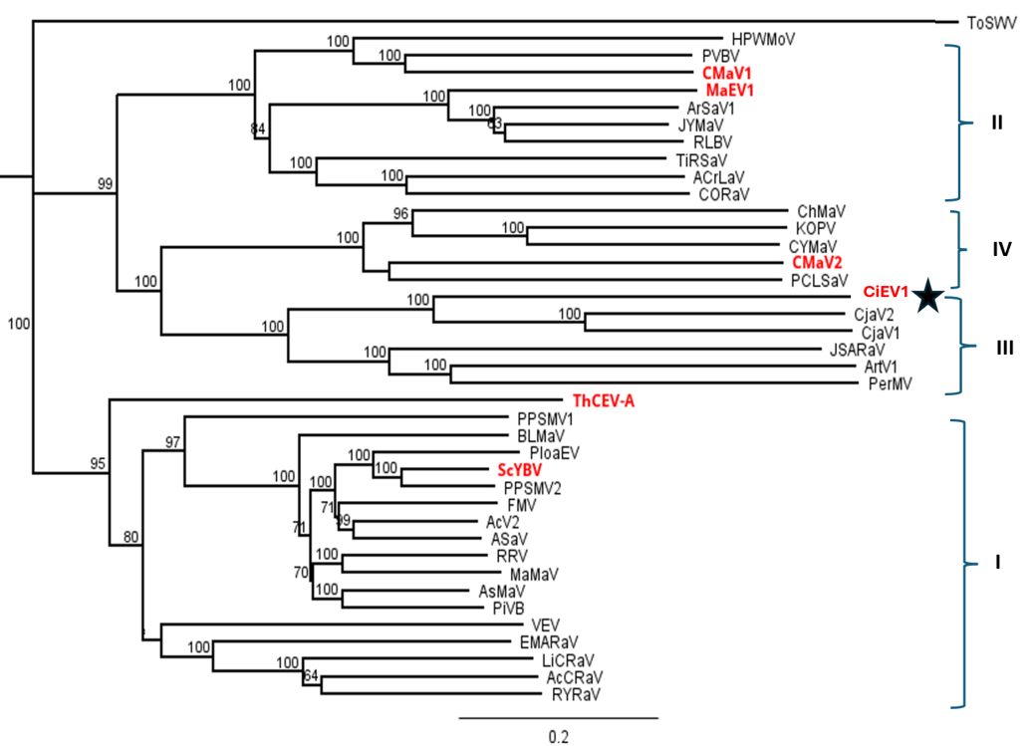

Figure 2. A phylogenetic tree is constructed with amino acid sequences encoded by RNA1 (RdRP) of recognized emaraviruses and corresponding tentative species, which are indicated in bold red text. Alignment was obtained using ClustalW and analyzed using the Neighbor-Joining method, with 1000 bootstrap replicates. The percentage of replicate trees where the associated taxa clustered together in the bootstrap is shown next to the branches (when >80%). Tomato spotted wilt virus (ToSWV, AIY28466), an orthotospovirus of the family Tospoviridae, was used as an outgroup species. Actinidia chlorotic ringspot-associated virus (AcCRaV, YP_009507925), Actinidia virus 2 (AcV2, YP_010088071), ailanthus crinkle leaf-associated virus (ACrLaV, WCL16047), Arceuthobium sichuanense virus 1 (ArSV1, YP_010840857), Artemisia virus 1 (ArtV1, USL90372), ash shoestring-associated virus (ASaV, CAG9003603), aspen mosaic-associated virus (AsMaV, YP_010840587), blackberry leaf mottle associated virus (BLMaV, YP_010839677), Callicarpa mosaic-associated virus 1 (CMaV1, WGG93561), Callicarpa mosaic-associated virus 2 (CMaV2, WGG93565), Camellia japonica-associated virus 1 (CjaV1, YP_010840109), Camellia japonica-associated virus 2 (CjaV2, YP_010840122), chrysanthemum mosaic-associated virus (ChMaV, YP_010840376), citrus emaravirus 1 (CiEV1, PV823284) (indicated by a star), Clematis yellow mottle-associated virus (CYMaV, WIM36821), common oak ringspot-associated virus (CORaV, YP_010840591), European mountain ash ringspot-associated virus (EMARaV, YP_003104764), fig mosaic virus (FMV, YP_009237269), High Plains wheat mosaic virus (HPWMoV, YP_009237277), Japanese star anise ringspot-associated virus (JSARaV, YP_010840873), jujube yellow mottle-associated virus (JYMaV, YP_010840071), karaka Õkahu purepure emaravirus (KOPV, YP_010840842), lilac chlorotic ringspot-associated virus (LiCRaV, YP_010840135), malva-associated emaravirus 1 (MaV1, PP848144), maple mottle-associated virus (MaMaV, YP_010840395), palo verde broom virus (PVBV, YP_010840059), pear chlorotic leaf spot-associated virus (PCLSaV, YP_010840088), Perilla mosaic virus (PerMV, YP_010840051), pigeonpea sterility mosaic virus 1 (PPSMV1, YP_009237282), pigeonpea sterility mosaic virus 2 (PPSMV2, YP_009268863), Pistacia virus B (PiVB, YP_010839662), Pueraria lobata-associated emaravirus (PloaEV, UQV97405), raspberry leaf blotch virus (RLBV, YP_009237274 ), redbud yellow ringspot-associated virus (RYRSaV, YP_009508083), rose rosette virus (RRV, YP_004327589), Scaevola yellow blotch virus (ScYBV, PQ868494), Theobroma cacao emaravirus A (ThCEV-A, PX114415), ti ringspot-associated virus (TiRSaV, YP_010088065), and Vitis emaravirus (VEV, LC604727).

