

The International Committee on Taxonomy of Viruses
Taxonomy Proposal Form, 2026

Part 1a: Details of taxonomy proposals

Title: | Create three new species in the genus Badnavirus (family Caulimoviridae)
Code assigned: | 2026.009P.N.v1.Caulimoviridae_Badnavirus_3nsp

Author(s), affiliation and email address(es):
Given name (+middle initial(s)) | Surname | Affiliation | Email address | Corr. author(s)
Marie | Umber | INRAE, UR ASTRO, Petit Bourg, Guadeloupe, France | marie.umber@inrae.fr
Indranil | Dasgupta | University of Delhi South Campus, New Delhi, India | indranil57@hotmail.com
Andrew D.W. | Geering | QAAFI, The University of Queensland, St Lucia, Australia | a.geering@uq.edu.au
Anders | Hafrén | Swedish University of Agriculture, Uppsala, Sweden | anders.hafren@slu.se
Roger | Hull | Retired from John Innes Centre | rogerhull@btinternet.com
Jan | Kreuze | International Potato Center (CIP), Lima, Peru | j.kreuze@cgiar.org
Scott M. | Leisner | University of Toledo, Department of Biological Sciences, Toledo, OH, USA | scott.leisner@utoledo.edu
Emmanuelle | Muller | CIRAD, UMR AGAP Institut, Montpellier, France | emmanuelle.muller@cirad.fr
Hanu | Pappu | Department of Plant Pathology, Washington State University, Pullman, WA, U.S.A | hrp@wsu.edu
Mikhail | Pooggin | PHIM Plant Health Institute, Univ Montpellier, INRAE, CIRAD, IRD, Institute Agro, Montpellier, France | mikhail.pooggin@inrae.fr
Katja | Richert-Poeggeler | Julius Kühn-Institut, Braunschweig, Germany | katja.richert-poeggeler@julius-kuehn.de
Susan | Seal | Natural Resources Institute, University of Greenwich, Chatham Maritime, Kent, UK | S.E.Seal@greenwich.ac.uk
Livia | Stavolone | Institute for Sustainable Plant Protection, National Research Council, Bari, Italy | livia.stavolone@cnr.it
Pierre Yves | Teycheney | CIRAD, UMR PVBMT, Saint Pierre, La Réunion, France | teycheney@cirad.fr | x

Part 1b: Taxonomy Proposal Submission
ICTV Subcommittee:
Animal DNA Viruses and Retroviruses |  | Bacterial viruses
Animal minus-strand and dsRNA viruses |  | Fungal and protist viruses
Animal positive-strand RNA viruses |  | Plant viruses | X
Archaeal viruses |  | General

List the ICTV Study Group(s) that have seen or have been involved in creating this proposal:
Caulimoviridae

Optional – complete only if formally voted on by an ICTV Study Group:
Study Group | Number of members
Study Group | Votes in support | Votes against | No vote
Caulimoviridae | 9 | 0 | 5

Submission date: | 06/08/2026

Part 1c: Feedback from ICTV Executive Committee (EC) meeting <To be completed by the subcommittee chair after EC evaluation>
Executive Committee Meeting Decision code: | X
A – Accept
Ac – Accept subject to revision by relevant subcommittee chair. No further vote required
U – Accept without revision but with re-evaluation and email vote by the EC
Uc – Accept subject to revision and re-evaluation and email vote by the EC
Ud – Deferred to the next EC meeting, with an invitation to revise based on EC comments
J - Reject
W - Withdrawn

Comments from the Executive Committee:

Part 1d: Revised Taxonomy Proposal Submission <To be completed for the revised version>
Response of proposer: Please describe in detail how you have responded to the EC meeting feedback
Revision date:

Enter date of the revised version (DD/MM/YYYY).

Part 3: TAXONOMIC PROPOSAL

Taxonomic changes proposed:
Establish new taxon | X | Split taxon
Abolish taxon |  | Merge taxon
Move taxon |  | Promote taxon
Rename taxon |  | Demote taxon
Move and rename

Etymology (origin) of proposed taxonomic names:.
Taxon name | Etymology of the term
“Badnavirus lepidothamni” | Epithet derived from Lepidothamnus intermedius (yellow silver pine)
“Badnavirus pelargoniivenafascians” | Epithet derived from pelargonii (of Pelargonium), vena (vein) and fascians (banding)
“Badnavirus prunigummocorticis” | Epithet based on pruni- (from Prunus), gummo- (from gummosis) and corticis (from cortex, corticis, meaning bark)

Permission for use of names derived from a living person:
Taxon name | Full name of person from whom the name is derived | Attached

Abstract of Taxonomy Proposal:

Description of current taxonomy:
The family Caulimoviridae [1] currently comprises 11 genera whose members share similar genome organization. Genus Badnavirus [2] currently includes 76 species and is the largest genus within the family Caulimoviridae.

Proposed taxonomic change(s):
We propose the creation of three new species in the genus Badnavirus: “Badnavirus lepidothamni”, “Badnavirus pelargoniivenafascians” and “Badnavirus prunigummocorticis”.

Demarcation criteria for new taxon/taxa:
The molecular species demarcation criterion is <80% identity of nucleotide sequences in the reverse transcriptase (RT) / ribonuclease H (RNase H) region of the polymerase.

Justification:
The complete genomes of yellow silver pine badnavirus 2 (YSPV2), Pelargonium vein banding virus (PVBV) and Prunus gummosis bark splitting virus (PGBSV) were sequenced and published recently. Their genome organizations are similar to those of other members of genus Badnavirus. Phylogenetic analyses place YSPV2, PVBV and PGBSV in this genus as representatives of three distinct novel species.

Text of Taxonomy proposal:

Description of current taxonomy:
The family Caulimoviridae [1] currently comprises 11 genera whose members share similar genome organization. Genus Badnavirus [2] currently includes 76 species and is the largest genus within the family Caulimoviridae.

Proposed taxonomic change(s):
We propose the creation of three new species in the genus Badnavirus: “Badnavirus lepidothamni”, “Badnavirus pelargoniivenafascians” and “Badnavirus prunigummocorticis”.

Demarcation criteria for new taxon/taxa:
The molecular species demarcation criterion is <80% identity of nucleotide sequences in the reverse transcriptase (RT) / ribonuclease H (RNase H) region of the polymerase.

Justification:
“Badnavirus lepidothamni” can be considered a new species in the genus Badnavirus for the following reasons:
- Its exemplar virus isolate, yellow silver pine badnavirus 2 (YSPV2, [3]), has a 7,847-bp dsDNA-RT genome with an organization typical of members of the genus Badnavirus, with 3 putative open reading frames (ORF1 to ORF3). ORF3 encodes a large putative polyprotein with the conserved domains of a zinc finger, an aspartate protease, a reverse transcriptase and a ribonuclease H.
- YSPV2 complete genome sequence was assembled from RNAseq data. The assembled sequence is perfect, with no sign of junction with a plant genome.
- The genome of YSPV2 harbors a putative tRNA^{Met} primer binding site.
- The genome of YSPV2 has all the hallmark features of badnaviruses: 3 ORFs, with ORF3 displaying Zn finger, aspartate protease and RT/RH domains.
- Phylogenetic analyses using the pol gene sequence place YSPV2 in genus Badnavirus. YSPV is most closely related to Epiphyllum mottle-associated virus (EpMoaV) with 66.5% nucleotide identity, well below the species demarcation threshold of 80%.
- Species name complies with the binomial nomenclature, with the free epithet derived from Lepidothamnus intermedius (yellow silver pine).

“Badnavirus pelargoniivenafascians” can be considered a new species in the genus Badnavirus for the following reasons:
- The dsDNA-RT genome of its exemplar isolate, Pelargonium vein banding virus (PVBV, [4]), is 7,586 bp long and has all the hallmark features of badnaviruses: a tRNA^{Met} binding site, 3 ORFs, with ORF3 displaying Zn finger, aspartate protease and RT/RH domains.
- The complete genome sequence of PVBV was obtained from viral genomic DNA that was extracted from purified viral particles, digested by restriction enzymes, cloned into a vector and Sanger sequenced. Restriction junctions amplified by PCR were Sanger sequenced.
- Phylogenetic analyses based on RT/RH sequence comparisons place PVBV in genus Badnavirus. PVBV is most closely related to Dracaena mottle virus (DrMV) with 68.8% nt identity, below the 80% species demarcation threshold.
- Agroinfection of P. × hortorum using a 1.2 copies construct of the PVBV genome resulted in mosaic symptoms and chlorosis, and the release of badnavirus-like bacilliform virions approximately 30 nm in diameter and 144 nm in length.
- P. × hortorum hybrids and its parents P. zonale and P. inquinans host infectious endogenous PVBV sequences (ePVBVs).

“Badnavirus prunigummocorticis” can be considered a new species in the genus Badnavirus for the following reasons:
- Its exemplar virus isolate, Prunus gummosis bark splitting virus (PGBSV, [5]), has a 7,741 bp DNA-RT genome with an organization typical of members of the genus Badnavirus, with 3 putative open reading frames (ORF1 to ORF3). ORF3 encodes a large putative polyprotein with conserved domains of a coat protein, an aspartate protease, a reverse transcriptase and a ribonuclease H.
- The genome of PGBSV harbors a putative tRNA^{Met} primer binding site and a TATATAA promoter-like motif located in the 3' UTR.
- The full-length genome was assembled from HTS data generated by Illumina from dsRNA extracted from Prunus avium following graft from P. salicina plants showing pronounced gummosis, dieback and/or bark splitting symptoms. Symptoms are graft-transmissible to Prunus domestica, P. serrulate and P. avium.
- Phylogenetic analyses using the RT/RH sequence place PGBSV in genus Badnavirus. PGBSV is most closely related to green Sichuan pepper vein clearing-associated virus (GSPVCaV) with 73.3% nt identity, below the 80% species demarcation threshold.
There is no evidence for PGBSV endogenous sequences in the genome of Prunus avium in BlastN analyses using the PGBSV genome as query.

References:
[1] Teycheney PY, Geering ADW, Dasgupta I, Hull R, Kreuze JF, Lockhart B, Muller E, Olszewski N, Pappu H, Pooggin MM, Richert-Pöggeler KR, Schoelz JE, Seal S, Stavolone L, Umber M (2020) ICTV Virus Taxonomy Profile: Caulimoviridae. J Gen Virol. 101(10):1025-1026. https://doi.org/10.1099/jgv.0.001497
[2] Geering, A.D.W. (2021) Badnaviruses (Caulimoviridae). In: Bamford, D.H. and Zuckerman, M. (eds.)
Encyclopedia of Virology, 4th Edition, vol. 3, pp. 158–168. Oxford: Academic Press. http://dx.doi.org/10.1016/B978-0-12-814515-9.00147-8
[3] French, R.K., Anderson, S.H., Cain, K.E. et al. Host phylogeny shapes viral transmission networks in an island ecosystem. Nat Ecol Evol 7, 1834–1843 (2023). https://doi.org/10.1038/s41559-023-02192-9
[4] Paudel S, Olszewski N, Mason S, Lockhart B, Mollov D, Arenz B, Alvarez-Quinto R (2026). Elucidation of the nature of Pelargonium vein banding virus sequences present in Pelargonium × hortorum. Phytopathology. 116(2):327-335. https://doi.org/10.1094/PHYTO-12-24-0389-R
[5] Rott M, Boyes I, Hoffmann R, Gratz A, Phelan J (2026). A novel double-stranded DNA Badnavirus, prunus gummosis bark splitting virus infecting plum. Plant Dis. https://doi.org/10.1094/PDIS-02-26-0353-RE

Accompanying files:

Filename | Description of contents

Tables, Figures:
Figure 1: Phylogenetic tree showing placement of yellow silver pine badnavirus 2 (YSPV2; exemplar virus of species “Badnavirus lepidothamni”), Pelargonium vein banding virus (PVBV; exemplar virus of species “Badnavirus pelargoniivenafascians”) and Prunus gummosis bark splitting virus (PGBSV, exemplar virus of species “Badnavirus prunigummocorticis”).
Maximum likelihood phylogenetic tree showing the relationships between sequences of viruses from the different genera in the family Caulimoviridae. Phylogenetic analyses were performed on the coding part of polymerase gene sequences of exemplar virus isolates of each viral species, corresponding to nucleotide positions 4449–5648 in the genome of cauliflower mosaic virus (V00141). Nucleotide sequence alignment was generated using MAFFT and phylogenetic analyses was done using IQ-Tree v. 3.1.3 with GTR+F+I+G4 model. Support values above 95% from UltraFast bootstrap method with 10,000 replicates are shown above branches. Saccharomyces cerevisiae Ty3 virus (genus Metavirus, family Metaviridae) was used as an outgroup. Colored dots indicate genera. Type members of the proposed new species are shown with open circles and in red boxes. The phylogenetic placement of YSPV1, PVBV and PGBSV are shown in red boxes.

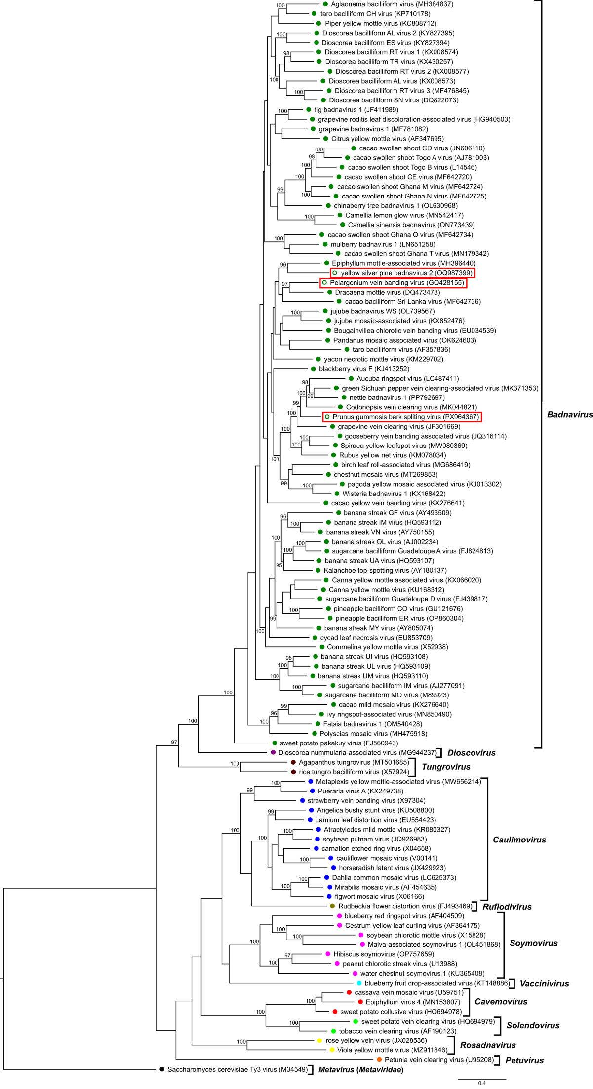

Table 1: Similarity matrix showing percent nucleotide identities for the Caulimoviridae in pol gene nucleotide sequences.
Figures corresponding to YSPV2, PVBV and PGBSV are highlighted in red.


Thomas K.F. Wong, Nhan Ly-Trong, Huaiyan Ren, Piyumal Demotte, Hector Banos, Andrew J. Roger, Edward Susko, Chris Bielow, Nicola De Maio, Nick Goldman, Matthew W. Hahn, Mario dos Reis, Le Sy Vinh, Gavin Huttley, Robert Lanfear, Bui Quang Minh (2026). IQ-TREE 3: Phylogenomic Inference Software using Complex Evolutionary Models. Molecular Biology and Evolution, msag117.https://doi.org/10.1093/molbev/msag117

