

The International Committee on Taxonomy of Viruses
Taxonomy Proposal Form, 2026

Part 1a: Details of taxonomy proposals

Title: | Establish two new species in the genus Mastrevirus (family Geminiviridae)
Code assigned: | 2026.010P.N.v1.Geminiviridae_Mastrevirus_2nsp

Author(s), affiliation and email address(es):
Given name (+middle initial(s)) | Surname | Affiliation | Email address | Corr. author(s)
Arvind | Varsani | The Biodesign Center for Fundamental and Applied Microbiomics, Center for Evolution and Medicine, School of Life Sciences, Arizona State University, Tempe, USA | Arvind.varsani@asu.edu | x
Jean-Michel | Lett | CIRAD, UMR PVBMT, Saint Pierre de la Réunion, France | lett@cirad.fr
Darren | Martin | Institute of Infectious Disease and Molecular Medicine, University of Cape Town, Cape Town, South Africa | darrenpatrickmartin@gmail.com
José T | Ascencio-Ibáñez | North Carolina State University, Raleigh, USA | jtascenc@ncsu.edu
Jesús | Navas-Castillo | Instituto de Hortofruticultura Subtropical y Mediterránea “La Mayora” (IHSM-UMA-CSIC), Málaga, Spain | jnavas@eelm.csic.es
Paola M | López-Lambertini | INTA-CIAP-IPAVE, Universidad Nacional de Córdoba, Córdoba, Argentina | plopezlambertini@gmail.com
Simone | Ribeiro | Embrapa Recursos Genéticos e Biotecnologia, Brasília, Brazil | simone.ribeiro@embrapa.br
Cica | Urbino | CIRAD, UMR PHIM, Montpellier, France | cica.urbino@cirad.fr
F Murilo | Zerbini | Dep. de Fitopatologia/BIOAGRO, Universidade Federal de Viçosa, Viçosa, Brazil | zerbini@ufv.br
Philippe | Roumagnac | CIRAD, UMR PHIM, Montpellier, Fr | philippe.roumagnac@cirad.fr

Part 1b: Taxonomy Proposal Submission
ICTV Subcommittee:
Animal DNA Viruses and Retroviruses |  | Bacterial viruses
Animal minus-strand and dsRNA viruses |  | Fungal and protist viruses
Animal positive-strand RNA viruses |  | Plant viruses | x
Archaeal viruses |  | General

List the ICTV Study Group(s) that have seen or have been involved in creating this proposal:
Geminiviridae and Tolecusatellitidae study group

Optional – complete only if formally voted on by an ICTV Study Group
Study Group | Number of members
Study Group | Votes in support | Votes against | No vote
Geminiviridae and Tolecusatellitidae

Submission date: | 14/08/2026

Part 1c: Feedback from ICTV Executive Committee (EC) meeting <To be completed by the subcommittee chair after EC evaluation>
Executive Committee Meeting Decision code: | X
A – Accept
Ac – Accept subject to revision by relevant subcommittee chair. No further vote required
U – Accept without revision but with re-evaluation and email vote by the EC
Uc – Accept subject to revision and re-evaluation and email vote by the EC
Ud – Deferred to the next EC meeting, with an invitation to revise based on EC comments
J - Reject
W - Withdrawn

Comments from the Executive Committee:

Part 1d: Revised Taxonomy Proposal Submission <To be completed for the revised version>
Response of proposer: Please describe in detail how you have responded to the EC meeting feedback
Revision date:

Enter date of the revised version (DD/MM/YYYY).

Part 3: TAXONOMIC PROPOSAL

Taxonomic changes proposed:
Establish new taxon | x | Split taxon
Abolish taxon |  | Merge taxon
Move taxon |  | Promote taxon
Rename taxon |  | Demote taxon
Move and rename

Etymology (origin) of proposed taxonomic names:
Taxon name | Etymology of the term
“Mastrevirus irapuatoense” | Epithet is the latinized location (Irapuato. Mexico) name – irapuatoense
“Mastrevirus glycinis” | Plant host genus (Glycine) + genitive suffix (-e → -is)

Permission for use of names derived from a living person:
Taxon name | Full name of person from whom the name is derived | Attached

Abstract of Taxonomy Proposal:

Description of current taxonomy:
Floreoviria; Shotokuvirae; Cressdnaviricota; Repensiviricetes; Geplafuvirales; Geminiviridae; Mastrevirus

Proposed taxonomic change(s):
Establish two new species in the genus Mastrevirus

Demarcation criteria for new taxon/taxa:
New species in the genus Mastrevirus are based on a 78% pairwise identity threshold coupled with phylogenetic support.

Justification:
In the last year two new genomes of mastreviruses have been identified that do not fall within the currently established species based on the species demarcation criteria of 78% [1]. These two mastrevirus genomes represent two new species.

Text of Taxonomy proposal:

Description of current taxonomy:
Floreoviria; Shotokuvirae; Cressdnaviricota; Repensiviricetes; Geplafuvirales; Geminiviridae; Mastrevirus

Proposed taxonomic change(s):
There are currently 55 established species in the genus Mastrevirus. We provide support for establishing two new species to classify two recently identified mastreviruses.

Demarcation criteria for new taxon/taxa:
78% genome-wide pairwise identity threshold coupled with phylogenetic support [1]. Thus, genomes sequences that share <78% pairwise identity to any classified mastrevirus genomes represent a new species.

Justification:
The genome sequences of the two new mastreviruses represent two new species since they share <78% genome-wide pairwise identity with all classified mastreviruses as determined using Sequence Demarcation Tool (SDT) v1.2 [2] (Figure 1). The classification of these into two new species is supported by maximum likelihood phylogenetic tree inferred using PHYML [3] from the aligned genomes using MAFFT [4] with GTR+I+G4 chosen as the best fit determined using jModelTest [5] (Figure 2).

References:
- Muhire B, Martin DP, Brown JK, Navas-Castillo J, Moriones E, Zerbini FM, Rivera-Bustamante R, Malathi VG, Briddon RW, Varsani A. 2013. A genome-wide pairwise-identity-based proposal for the classification of viruses in the genus Mastrevirus (family Geminiviridae). Archives of Virology. 158(6):1411-24. doi: 10.1007/s00705-012-1601-7. Epub 2013 Jan 23. PMID: 23340592.
- Muhire BM, Varsani A, Martin DP. 2014. SDT: a virus classification tool based on pairwise sequence alignment and identity calculation. PLoS One. 26;9(9):e108277. doi: 10.1371/journal.pone.0108277. PMID: 25259891; PMCID: PMC4178126.
- Guindon S, Dufayard JF, Lefort V, Anisimova M, Hordijk W, Gascuel O. 2010. New algorithms and methods to estimate maximum-likelihood phylogenies: assessing the performance of PhyML 3.0. Systems Biology 59(3):307-21. doi: 10.1093/sysbio/syq010. Epub 2010 Mar 29. PMID: 20525638.
- Katoh K, Rozewicki J, Yamada KD. 2019. MAFFT online service: multiple sequence alignment, interactive sequence choice and visualization. Brief Bioinformatics. 19;20(4):1160-1166. doi: 10.1093/bib/bbx108. PMID: 28968734; PMCID: PMC6781576.
- Darriba D, Taboada GL, Doallo R, Posada D. 2010. jModelTest 2: more models, new heuristics and parallel computing. Nature Methods. 30;9(8):772. doi: 10.1038/nmeth.2109. PMID: 22847109; PMCID: PMC4594756.
- Choi H, Jo Y, Hong J, Chung H, Choi S, Kim S, Lee J, Moh S, Lee B, Cho WK. Complete Genome Sequence of a Novel Monopartite Mastrevirus, Soybean Geminivirus B, Isolated from Soybean (Glycine max (L.) Merrill). Plants (Basel). 2022 Jul 3;11(13):1768. doi: 10.3390/plants11131768. PMID: 35807721; PMCID: PMC9269612.
- Lappe RR, Elmore MG, Lozier ZR, Jander G, Miller WA, Whitham SA. Metagenomic identification of novel viruses of maize and teosinte in North America. BMC Genomics. 2022 Nov 23;23(1):767. doi: 10.1186/s12864-022-09001-w. PMID: 36418948; PMCID: PMC9685911.

Accompanying files:

Filename | Description of contents

Tables, Figures:

Table 1: Members of the two new species in the genus Mastrevirus.

Species name | Accession no. | Virus name | Isolate name | Country | Host/source | Ref
“Mastrevirus glycinis” | MH428830 | soybean geminivirus B | Kong | Korea | Glycine max | [6]
“Mastrevirus irapuatoense” | MZ852895 | North American maize-associated mastrevirus | P2E2S76 | Mexico | Zea mays | [7]

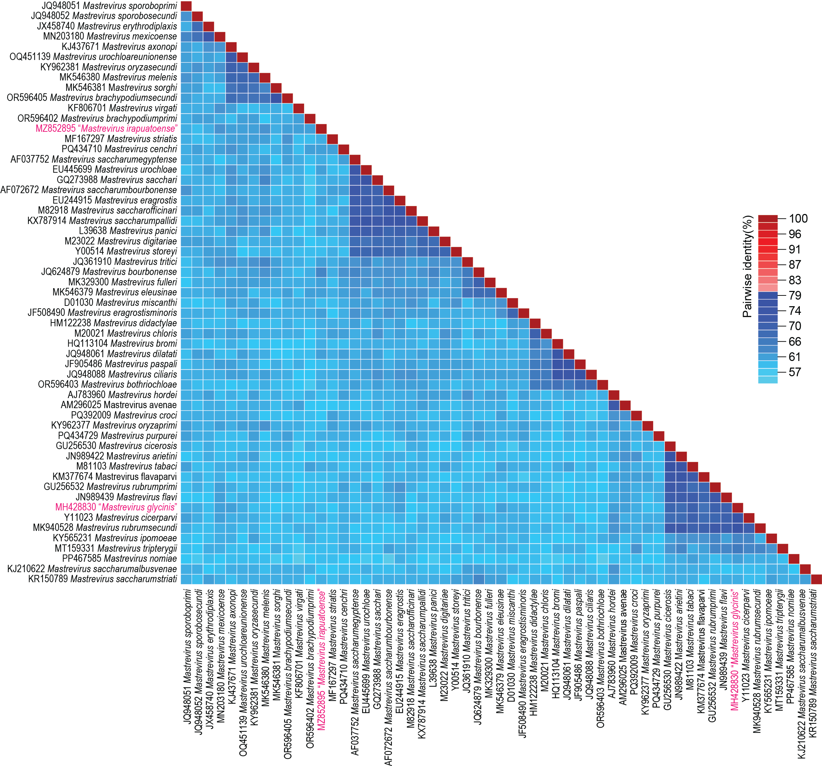

Figure 1: Genome-wide pairwise identity matrix of representative members of the genus Mastrevirus together with those of the two new species inferred using SDT v1.2 [2].

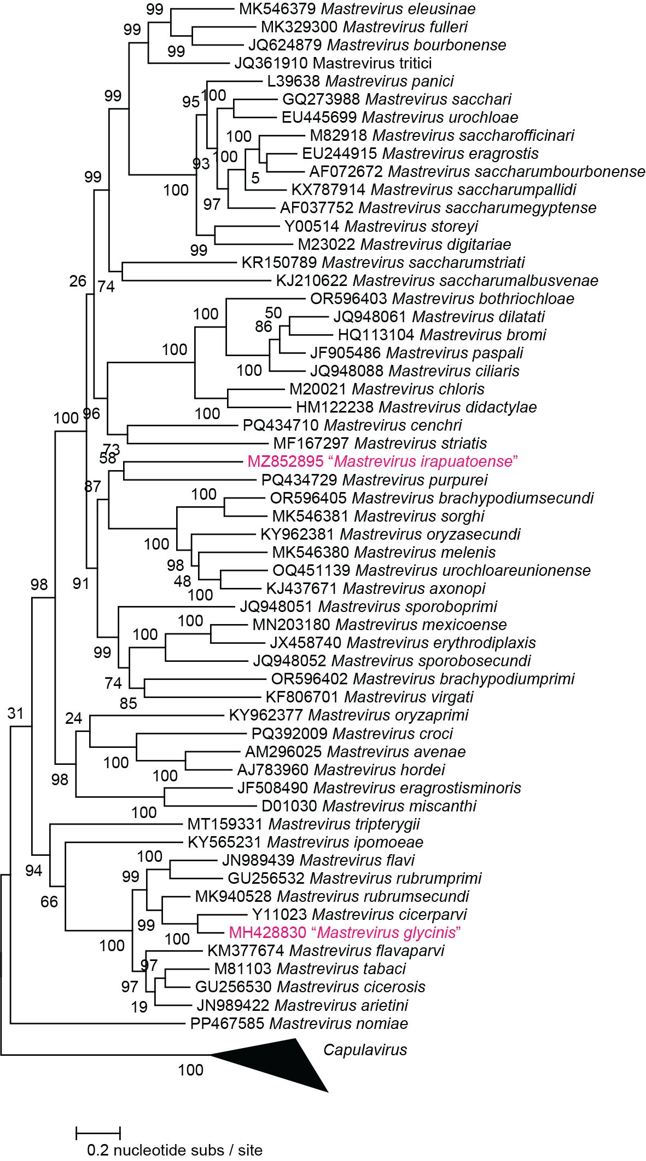

Figure 2: Maximum likelihood phylogenetic tree of representative genomes from each Mastrevirus species together with those that are members of the two new species. The phylogenetic tree is rooted with capulavirus genome sequences.

