

The International Committee on Taxonomy of Viruses
Taxonomy Proposal Form, 2026

Part 1a: Details of taxonomy proposals

Title: | Establish nine new species in the subfamily Geminialphasatellitinae (family Alphasatellitidae)
Code assigned: | 2026.011P

Author(s), affiliation and email address(es):
Given name (+middle initial(s)) | Surname | Affiliation | Email address | Corr. author(s)
Arvind | Varsani | The Biodesign Center for Fundamental and Applied Microbiomics, Center for Evolution and Medicine, School of Life Sciences, Arizona State University, Tempe, USA | Arvind.varsani@asu.edu | x
Jean-Michel | Lett | CIRAD, UMR PVBMT, Saint Pierre de la Réunion, France | lett@cirad.fr
Darren | Martin | Institute of Infectious Disease and Molecular Medicine, University of Cape Town, Cape Town, South Africa | darrenpatrickmartin@gmail.com
José T | Ascencio-Ibáñez | North Carolina State University, Raleigh, USA | jtascenc@ncsu.edu
Jesús | Navas-Castillo | Instituto de Hortofruticultura Subtropical y Mediterránea “La Mayora” (IHSM-UMA-CSIC), Málaga, Spain | jnavas@eelm.csic.es
Paola M | López-Lambertini | INTA-CIAP-IPAVE, Universidad Nacional de Córdoba, Córdoba, Argentina | plopezlambertini@gmail.com
Simone | Ribeiro | Embrapa Recursos Genéticos e Biotecnologia, Brasília, Brazil | simone.ribeiro@embrapa.br
Cica | Urbino | CIRAD, UMR PHIM, Montpellier, France | cica.urbino@cirad.fr
F Murilo | Zerbini | Dep. de Fitopatologia/BIOAGRO, Universidade Federal de Viçosa, Viçosa, Brazil | zerbini@ufv.br
Philippe | Roumagnac | CIRAD, UMR PHIM, Montpellier, France | philippe.roumagnac@cirad.fr

Part 1b: Taxonomy Proposal Submission
ICTV Subcommittee:
Animal DNA Viruses and Retroviruses |  | Bacterial viruses
Animal minus-strand and dsRNA viruses |  | Fungal and protist viruses
Animal positive-strand RNA viruses |  | Plant viruses | x
Archaeal viruses |  | General -

List the ICTV Study Group(s) that have seen or have been involved in creating this proposal:
Geminiviridae and Tolecusatellitidae study group

Optional – complete only if formally voted on by an ICTV Study Group:
Study Group | Number of members
Study Group | Votes in support | Votes against | No vote
Geminiviridae and Tolecusatellitidae

Submission date: | 14/08/2026

Part 1c: Feedback from ICTV Executive Committee (EC) meeting <To be completed by the subcommittee chair after EC evaluation>
Executive Committee Meeting Decision code: | X
A – Accept
Ac – Accept subject to revision by relevant subcommittee chair. No further vote required
U – Accept without revision but with re-evaluation and email vote by the EC
Uc – Accept subject to revision and re-evaluation and email vote by the EC
Ud – Deferred to the next EC meeting, with an invitation to revise based on EC comments
J - Reject
W - Withdrawn

Comments from the Executive Committee:

Part 1d: Revised Taxonomy Proposal Submission <To be completed for the revised version>
Response of proposer: Please describe in detail how you have responded to the EC meeting feedback
Revision date:

Enter date of the revised version (DD/MM/YYYY).

Part 3: TAXONOMIC PROPOSAL

Taxonomic changes proposed:
Establish new taxon | x | Split taxon
Abolish taxon |  | Merge taxon
Move taxon |  | Promote taxon
Rename taxon |  | Demote taxon
Move and rename

Etymology (origin) of proposed taxonomic names:
Taxon name | Etymology of the term
“Colecusatellite pongamiae” | Latinized host genus (Pongamia) name
“Colecusatellite caricae” | Latinized host genus (Carica) name
“Colecusatellite solanumkrishnagiriense” | Latinized concatenation of host host genus (Solanum) name and + geolocation (Krishnagiri)
“Colecusatellite amaranthi” | Latinized host genus (Amaranthus) name
“Colecusatellite solanummaduraiense” | Latinized concatenation of host genus (Solanum) name and + geolocation (Madurai)
“Colecusatellite capsicumjorhatense” | Latinized concatenation of host genus (Capsicum) name and geolocation (Jorhat)
“Colecusatellite codonopsis” | Latinized host genus (Codonopsis) name
“Gosmusatellite capsici” | Latinized host genus (Capsicum) name
“Gosmusatellite glycinis” | Latinized host genus (Glycine) name

Permission for use of names derived from a living person:
Taxon name | Full name of person from whom the name is derived | Attached

Abstract of Taxonomy Proposal:

Description of current taxonomy:

The family Alphasatellitidae is divided into three subfamilies: Geminialphasatellitinae, Nanoalphasatellitinae, and Petromoalphasatellitinae.

Proposed taxonomic change(s):
Establish seven new species in the genus Colecusatellite and two in Gosmusatellite, both genera being in the subfamily Geminialphasatellitinae

Demarcation criteria for new taxon/taxa:
The species demarcation threshold for members of Geminialphasatellitinae is 88%. Thus, genome sequences that share <88% pairwise identity with any classified member of Geminialphasatellitinae represent a new species if they have an intact Rep open reading frame and the species classification is phylogenetically supported [1].

Justification:
Over the last year or so a few new alphasatellites have been identified that cannot be assigned to currently established species in the Geminialphasatellitinae, in the genera Colecusatellite and Gosmusatellite.

Text of Taxonomy proposal:

Description of current taxonomy:
The family Alphasatellitidae is divided into three subfamilies: Geminialphasatellitinae, Nanoalphasatellitinae, and Petromoalphasatellitinae.

Proposed taxonomic change(s):
Establish seven new species in the genus Colecusatellite and two in Gosmusatellite, both genera being in the subfamily Geminialphasatellitinae).

Demarcation criteria for new taxon/taxa:
The species demarcation threshold for members of Geminialphasatellitinae is 88%. Thus, genome sequences that share <88% pairwise identity with any classified member of Geminialphasatellitinae represent a new species if they have an intact Rep open reading frame and the species classification is phylogenetically supported [1].

Justification:
Over the last year a number of new alphasatellites have been identified that cannot be assigned to currently established species in the Geminialphasatellitinae, in the genera Colecusatellite and Gosmusatellite.

The genome sequences of the seven new colecusatellites and two new gosmusatellites represent nine new species, as they share <88% genome-wide pairwise identity with all classified members of Geminialphasatellitinae as determined using Sequence Demarcation Tool (SDT) v1.2 [2] (Figure 1). The classification of these into nine new species is supported by maximum likelihood phylogenetic tree inferred using PHYML [3] from the aligned genomes using MAFFT [4] with GTR+G4 chosen as the best fit determined using jModelTest [5] (Figure 2).

References:
- Varsani A, Martin DP, Randles JW, Vetten HJ, Thomas JE, Fiallo-Olivé E, Navas-Castillo J, Lett JM, Zerbini FM, Roumagnac P, Gronenborn B. Taxonomy update for the family Alphasatellitidae: new subfamily, genera, and species. Arch Virol. 2021 Dec;166(12):3503-3511. doi: 10.1007/s00705-021-05232-6. PMID: 34550466.
- Muhire BM, Varsani A, Martin DP. 2014. SDT: a virus classification tool based on pairwise sequence alignment and identity calculation. PLoS One. 26;9(9):e108277. doi: 10.1371/journal.pone.0108277. PMID: 25259891; PMCID: PMC4178126.
- Guindon S, Dufayard JF, Lefort V, Anisimova M, Hordijk W, Gascuel O. 2010. New algorithms and methods to estimate maximum-likelihood phylogenies: assessing the performance of PhyML 3.0. Systems Biology 59(3):307-21. doi: 10.1093/sysbio/syq010. Epub 2010 Mar 29. PMID: 20525638.
- Katoh K, Rozewicki J, Yamada KD. 2019. MAFFT online service: multiple sequence alignment, interactive sequence choice and visualization. Brief Bioinformatics. 19;20(4):1160-1166. doi: 10.1093/bib/bbx108. PMID: 28968734; PMCID: PMC6781576.
- Darriba D, Taboada GL, Doallo R, Posada D. 2010. jModelTest 2: more models, new heuristics and parallel computing. Nature Methods. 30;9(8):772. doi: 10.1038/nmeth.2109. PMID: 22847109; PMCID: PMC4594756.
- Santosa AI. Molecular diversity of begomoviruses in Bugel Beach. Unpublished. GenBank: PX648381 (Ageratum yellow vein alphasatellite isolate AYVA-6-Bugel).
- Mate KT. Long-term survey of Begomoviruses and satellites in symptomatic plants in Delhi-NCR, India. GenBank: PP210055 (Tomato leaf curl alphasatellite isolate PNr18-2023).
- Saikia NK., Hiremath S, Debnath D, Talukdar A, Mech S. Meta-transcriptome analysis of field-collected chilli samples and development of rapid diagnostics.. GenBank: PX893797 (Tomato leaf curl alphasatellite isolate ToLCA:IN:AS:JRH:Chi:25_S4).
- Mahmod MA, Ahmed N, Amin I, Mansoor S. Diversity of Begomovirus and associated satellites in Pakistan.. GenBank: MZ057254 (Ageratum conyzoides symptomless alphasatellite isolate AV39).
- Naveen, M., Shanmugam P, S., Srinivasan, R., Shanthi, M., Murugan, M., Angappan, K., Oliva, R., Manikanda Boopathi, N., Karthikeyan, G., Sivagnanapazham, K. Direct Submission. GenBank: PQ587366 (Cotton leaf curl Multan alphasatellite isolate KGI-01).
- Mohana Pradeep RK, Karthikeyan G, Kavi Sidharthan V, Nagendran K, Sivagnanapazham K, Vignesh P, Boopathi N, Raveendran M, Senthilraja G, Kumar KK, Varanavasiappan S. Chilli leaf curl India alphasatellite_Complete genome_TMD isolate. GenBank: PX893707 (Chilli leaf curl India alphasatellite isolate TMD segment Alphasatellite).
- Wu X, Zhao L, Zhong J, Li ., Zhang S, Ding M. Direct Submission. GenBank: PZ168566 (Tobacco curly shoot alphasatellite isolate 24YN1374 clone 34).
- Ahmed N, Mahmood MA, Hussain S, Zaidi SSEA, Rahman SU, Amin I, Mansoor S. Circular DNA enrichment sequencing explores the genetic diversity of begomoviruses and associated satellites causing chilli leaf curl disease in Pakistan. GenBank: MW615597 (Chilli leaf curl Pakistan alphasatellite isolate).
- Ahale S, Sirar, A, Dhkal M. Direct Submission. GenBank: PP856047 (Bhendi yellow vein mosaic virus-associated alphasatellite isolate Jabalpur AlphaJ7, rep gene).

Accompanying files:

Filename | Description of contents

Tables, Figures:

Table 1: Summary of the members of the new species in the genera Colecusatellite and Gosmusatellite.

Accession | Species | Virus | Isolate | Country | host | Reference
PX648381 | “Colecusatellite amaranthi” | Ageratum yellow vein alphasatellite | AYVA-6-Bugel | Indonesia | Amaranthus spinosus | [6]
PP210055 | “Colecusatellite caricae” | tomato leaf curl alphasatellite PNr18-2023 | PNr18-2023 | India | Carica papaya | [7]
PX893797 | “Colecusatellite capsicumjorhatense” | tomato leaf curl alphasatellite IN:AS:JRH:Chi:25_S4 | ToLCA:IN:AS:JRH:Chi:25_S4 | India | Capsicum sp. | [8]
MZ057254 | “Colecusatellite pongamiae” | Ageratum conyzoides symptomless alphasatellite | AV39 | Pakistan | Pongamia pinnata | [9]
PQ587366 | “Colecusatellite solanumkrishnagiriense” | cotton leaf curl Multan alphasatellite | KGI-01 | India | Solanum lycopersicum | [10]
PX893707 | “Colecusatellite solanummaduraiense” | chilli leaf curl India alphasatellite | TMD | India | Solanum lycopersicum | [11]
PZ168566 | “Colecusatellite codonopsis” | tobacco curly shoot alphasatellite | 24YN1374 | China | Codonopsis pilosula (Franch.) Nannf. | [12]
MW615597 | “Gosmusatellite capsici” | chilli leaf curl Pakistan alphasatellite | m54073_190913_  041431_58917631_ccs | Pakistan | Capsicum annuum | [13]
PP856047 | “Gosmusatellite glycinis” | bhendi yellow vein mosaic virus-associated alphasatellite | Jabalpur AlphaJ7 | India: | Glycine max; cultivar: NRC-165 | [14]

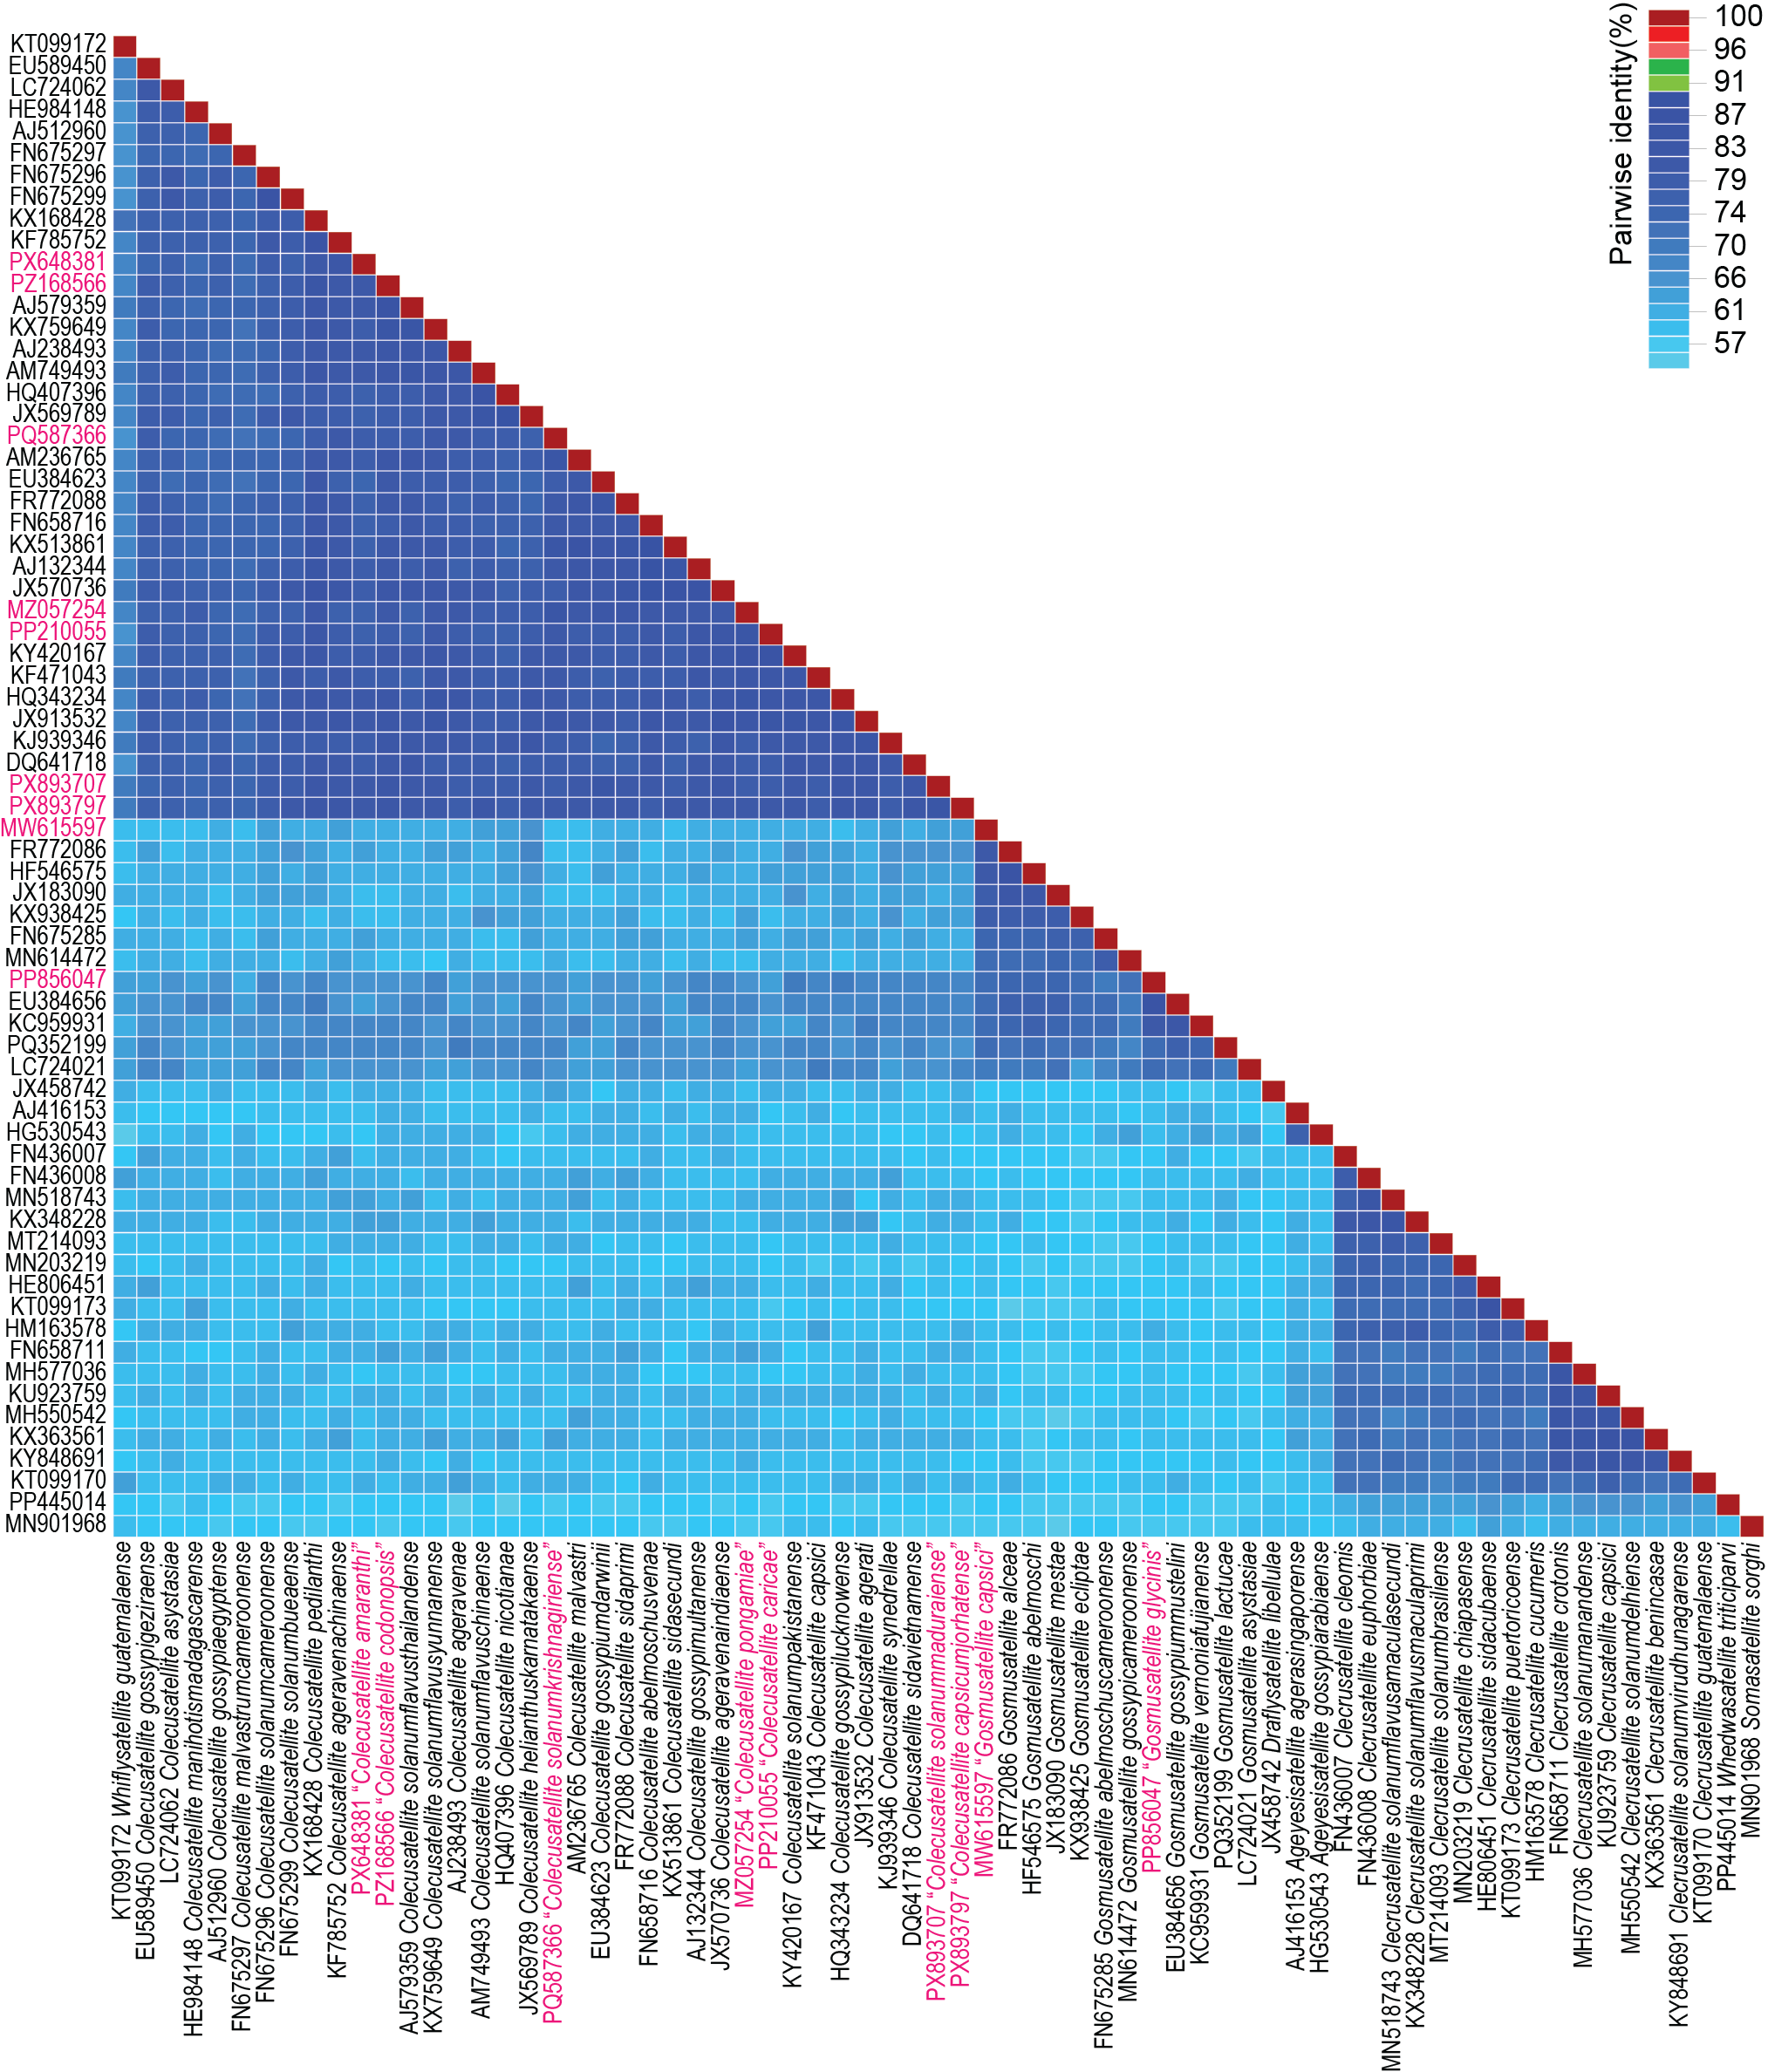
Figure 1: Genome-wide pairwise identity matrix of representative members of Geminialphasatellitinae together with those of the nine new species. The pairwise identity matrix was generated using SDT v1.2 [2].

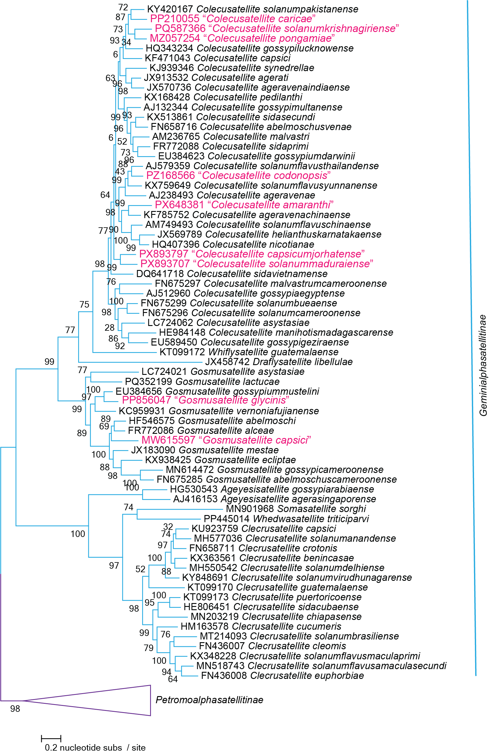
Figure 2: Maximum likelihood phylogenetic tree of representative genomes of Geminialphasatellitinae together with those of the nine new species. The phylogenetic tree is rooted with representative sequence of Petromoalphasatellitinae.

