

The International Committee on Taxonomy of Viruses
Taxonomy Proposal Form, 2026

Part 1a: Details of taxonomy proposals

Title: | Create 8 new species in the genus Begomovirus
Code assigned: | 2026.012P.N.v1.Geminiviridae_Begomovirus_8nsp

Author(s), affiliation and email address(es):
Given name (+middle initial(s)) | Surname | Affiliation | Email address | Corr. author(s)
F Murilo | Zerbini | Dep. de Fitopatologia/BIOAGRO, Universidade Federal de Viçosa, Viçosa, Brazil | zerbini@ufv.br | X
José T | Ascencio-Ibañez | North Carolina State University, Raleigh, USA | jtascenc@ncsu.edu | X
Cica | Urbino | CIRAD, UMR PHIM, Montpellier, France | cica.urbino@cirad.fr | X
Jean-Michel | Lett | CIRAD, UMR PVBMT, Saint Pierre de la Réunion, France | lett@cirad.fr | X
Paola | López-Lambertini | INTA-CIAP-IPAVE, Universidad Nacional de Córdoba, Córdoba, Argentina | plopezlambertini@gmail.com
Jesús | Navas-Castillo | Instituto de Hortofruticultura Subtropical y Mediterránea “La Mayora” (IHSM-UMA-CSIC), Málaga, Spain | jnavas@eelm.csic.es | X
Darren P | Martin | Institute of Infectious Disease and Molecular Medicine, University of Cape Town, Cape Town, South Africa | darrenpatrickmartin@gmail.com
Simone G | Ribeiro | Embrapa Recursos Genéticos e Biotecnologia, Brasília, Brazil | simone.ribeiro@embrapa.br
Philippe | Roumagnac | CIRAD, UMR PHIM, Montpellier, France | philippe.roumagnac@cirad.fr
Arvind | Varsani | The Biodesign Center for Fundamental and Applied Microbiomics, Center for Evolution and Medicine, School of Life Sciences, Arizona State University, Tempe, USA | Arvind.varsani@asu.edu

Part 1b: Taxonomy Proposal Submission
ICTV Subcommittee:
Animal DNA Viruses and Retroviruses |  | Bacterial viruses
Animal minus-strand and dsRNA viruses |  | Fungal and protist viruses
Animal positive-strand RNA viruses |  | Plant viruses | X
Archaeal viruses |  | General

List the ICTV Study Group(s) that have seen or have been involved in creating this proposal:
Geminiviridae and Tolecusatellitidae

Optional – complete only if formally voted on by an ICTV Study Group
Study Group | Number of members
Study Group | Votes in support | Votes against | No vote

Submission date: | 28/08/2026

Part 1c: Feedback from ICTV Executive Committee (EC) meeting <To be completed by the subcommittee chair after EC evaluation>
Executive Committee Meeting Decision code: | X
A – Accept
Ac – Accept subject to revision by relevant subcommittee chair. No further vote required
U – Accept without revision but with re-evaluation and email vote by the EC
Uc – Accept subject to revision and re-evaluation and email vote by the EC
Ud – Deferred to the next EC meeting, with an invitation to revise based on EC comments
J - Reject
W - Withdrawn

Comments from the Executive Committee:

Part 1d: Revised Taxonomy Proposal Submission <To be completed for the revised version>
Response of proposer: Please describe in detail how you have responded to the EC meeting feedback
Revision date:

Enter date of the revised version (DD/MM/YYYY).

Part 3: TAXONOMIC PROPOSAL

Taxonomic changes proposed:
Establish new taxon | X | Split taxon
Abolish taxon |  | Merge taxon
Move taxon |  | Promote taxon
Rename taxon |  | Demote taxon
Move and rename

Etymology (origin) of proposed taxonomic names:
Taxon name | Etymology of the term
"Begomovirus emiliaflavi" | Host (Emilia coccinea) + symptom (yellow mosaic)
"Begomovirus melongenaflavi" | Host (Solanum melongena) + symptom (yellow mosaic)
"Begomovirus millingtoniae" | From the host, Millingtonia hortensis
"Begomovirus achyranthis" | From the host, Achyranthes bidentata
"Begomovirus solanumflavusreunionense" | Host (Solanum lycopersicum) + symptom (yellow leaf curl) + location (Reunion Islands)
"Begomovirus crepidiastri" | From the host, Crepidiastrum denticulatum
"Begomovirus senecioflavi" | Host (Senecio scandens) + symptom (yellow mosaic)
"Begomovirus lagenariae" | From the host, Lagenaria siceraria

Permission for use of names derived from a living person:
Taxon name | Full name of person from whom the name is derived | Attached

Abstract of Taxonomy Proposal:

Description of current taxonomy: Floreoviria -> Shotokuvirae -> Cressdnaviricota -> Repensiviricetes -> Geplafuvirales -> Geminiviridae -> Begomovirus

Proposed taxonomic changes: Establishment of 8 new species to classify new begomoviruses that have been identified and described in the literature over the past 18 months.

Demarcation criteria for new taxon/taxa: 91% genome-wide (or DNA-A in the case of bipartite begomoviruses) pairwise nucleotide sequence identity [1].

Justification: Members of all 8 proposed new species share <91% genome-wide (or DNA-A in the case of bipartite viruses) pairwise identity with sequences of members of currently established begomovirus species.

Text of Taxonomy proposal:

Description of current taxonomy: Floreoviria -> Shotokuvirae -> Cressdnaviricota -> Repensiviricetes -> Geplafuvirales -> Geminiviridae -> Begomovirus

Proposed taxonomic changes: Establish 8 new species in the genus Begomovirus.

Demarcation criteria for new taxon/taxa: 91% genome-wide (or DNA-A in the case of bipartite begomoviruses) pairwise nucleotide (nt) sequence identity [1].

Justification: The 8 begomoviruses summarized in Table 1 can be classified into new species that share <91% genome-wide (or DNA-A in the case of bipartite begomoviruses) pairwise identity with all classified begomoviruses. This is supported by maximum likelihood phylogenetic analysis.

We provide a brief description of each proposed new species below:

"Begomovirus emiliaflavi" [2]
- Begomovirus-like symptoms of yellow mosaic were observed on fiery tasselflower (Emilia coccinea) plants in Iguowan, Nigeria.
- Total DNA was extracted and used as a template for rolling circle amplification (RCA); RCA products were digested with restriction enzymes and a band of 2802 nt was cloned for the complete monopartite begomovirus genome and Sanger sequenced.
- Two complete monopartite begomovirus genome sequences (PX273383 and PX273384) were 99.86% identical to each other and shared the highest sequence identity (83.6–84.3%) with tomato leaf curl Nigeria virus (FJ685621), which is far below the begomovirus species demarcation threshold (< 91%).
- The authors propose to classify the new begomovirus, named tasselflower yellow mosaic virus (TFYMV), into a new species for which they proposed the name "Begomovirus emiliaflavi".
"Begomovirus melongenaflavi" [3]
- Two eggplants exhibiting yellow mosaic symptoms were sampled from Iguowan, Edo State, Nigeria.
-Total DNA was extracted from each sample and used as a template for rolling circle amplification (RCA); RCA products were used as PCR templates with begomovirus core coat protein generic primers.
-The two 600-base pair (bp) amplicons were sequenced and the BLASTn analysis of their nt sequences revealed that they were identical and shared 76–87% identity with those of members of the genus Begomovirus.
-No B component nor DNA satellites were detected with generic primers.
- Abbutting primers were designed from the coat protein sequence to amplify the complete genome which was cloned and sequenced with the Sanger method.
- The complete genome sequence (PV394619) shared the highest (86%) complete genome identity with tomato leaf curl Cameroon virus isolate GH Tou-12 (KT382327) which is below the begomovirus species demarcation threshold (< 91%).
The authors propose to classify the new begomovirus as a new species, with the virus name eggplant yellow mosaic virus (EYMV) and the species name "Begomovirus melongenaflavi".

"Begomovirus millingtoniae" [4]
- Mosaic symptoms restricted to the interveinal areas of the leaves and sometimes leaf distortion were observed on the leaves of Millingtonia hortensis at Kamalanagar, Medchal, Telangana, India.
-Total DNA was isolated from one sample and the presence of a begomovirus was confirmed with begomovirus-specific primers. No DNA-B, alphasatellites or betasatellites were detected with group-specific primers.
-RCA products were digested with restriction enzymes and a band of ca. 2.7 kbp was cloned and sequenced using a primer-walking approach.
-The complete sequence (GenBank accession no. PV610740) is 2,743 nt in length. Sequence identity matrix showed that the begomoviral genome from the current study shared the most nt sequence similarity (89.2% identity) with that of chilli leaf curl India virus (ChiLCINV).
- The authors propose to classify the new begomovirus, called Millingtonia mosaic virus (MilMV), as a new species, but do not propose a species name. The SG proposes the name "Begomovirus millingtoniae".

"Begomovirus achyranthis" [5]
- Two Achyranthes bidentata plants exhibiting yellowing and leaf curling symptoms were collected in Zhoukou, Henan province, China.
- Total DNA was isolated from the two samples; RCA products were obtained and digested with restriction enzymes.
- The bands of ca. 2.7 kbp were cloned and sequenced using a primer-walking approach.
- The sequencing results indicated that the two complete genome sequences are identical and consist of 2,751 nt (GenBank accession no. PX055574 and PX069020, respectively)
- Sequence identity matrix showed that the begomoviral genome shared the highest identity (85.88%) with tobacco curly shoot virus (GenBank accession no. MN481156).
- PCR using DNA-B, alphasatellite and betasatellite-specific primers did not yield positive results.
- According to the current ICTV species demarcation the authors propose this virus as a new species of the genus Begomovirus, and propose the tentative name "Achyranthes yellow leaf curl virus" (AYLCV); the SG proposes the species name "Begomovirus achyranthis".

"Begomovirus solanumflavusreunionense" [6]
- Two tomato leaf samples showing severe curling symptoms with or without interveinal yellowing were collected at St. Louis and Le Tampon, respectively, in the south of Reunion Island
- Total DNA was isolated from the two samples; PCR products of the expected sizes were obtained with core coat protein generic primers suggesting the presence of a begomovirus species; no DNA-B or betasatellite molecules were detected by PCR with group-specific primers.
- RCA products were obtained and digested with restriction enzymes; the bands of ca. 2.7 kbp were cloned and sequenced using a primer-walking approach.
- The sequencing results indicated that the two complete genome sequences (PV126637 and PV126638) were very similar to each other (99.7%) and shared the highest nt sequence identity (88.8 and 89.0%, respectively) with that of a TYLCV-Mld isolate from Reunion (AJ865337).
- Using RDP4, two recombinant fragments inherited from ToLCMGV (in the coat protein gene) and ToLCDiaV (in the C1/C4 genes) and representing 48% of the complete genome were detected in a TYLCV-Mild background
- According to the current ICTV species demarcation the authors propose this genome as a new species of the genus Begomovirus, and propose the virus name called tomato yellow leaf curl Reunion virus (TYLCREV) and the species name "Begomovirus solanumflavusreunionense"

"Begomovirus crepidiastri" [7]
- Crepidiastrum denticulatum leaf samples with symptoms were collected, total RNA was extracted and used for high-throughput sequencing (HTS).
- A 2,742 nt contig was obtained, with <91% identity with known begomoviruses.
- The complete (monopartite) genome was amplified by PCR with specific primers, cloned and sequenced.
- An infectious clone was obtained and the virus infected N. benthamiana, tomato and pepper.
- The authors named the new virus as Crepidiastrum yellow vein virus, but did not propose a species name; the SG suggests "Begomovirus crepidiastri".

"Begomovirus senecioflavi" [8]
- Groundsel (Senecio scandens) leaf samples with symptoms were collected, total RNA was extracted and used for HTS.
- Two contigs, with 2,712 and 2,642 nt, were obtained, with high similarities with DNA-A and DNA-B of begomoviruses, respectively; no satellites were detected.
- The complete (bipartite) genome was amplified by PCR with DNA-A and DNA-B specific primers, cloned and sequenced; the DNA-B clone had 2,658 nt.
- Genome annotation shows that is a typical OW bipartite begomovirus, with the AV2 gene in the DNA-A.
- The complete DNA-A nt sequence has <75% identity with known begomoviruses.
- The virus was named groundsel yellow mosaic virus (GYMV), but a species name was not proposed; the SG suggests "Begomovirus senecioflavi".

"Begomovirus lagenariae" [9]
- Four bottle gourd (Lagenaria siceraria) leaf samples with symptoms were collected; total DNA was extracted and used as template for PCR amplification with universal DNA-A, DNA-B and betasatellite primers.
- Only DNA-A fragments were detected from samples L4 and L5, and sequence analysis indicated that they corresponded to two different viruses.
- Specific primers were designed and the full-length components were amplified, cloned and Sanger-sequenced.
- The virus from sample L5 is an isolate of a known begomovirus.
- The virus from sample L4 (2,658 nt) is a typical OW monopartite begomovrius, with the AV2 gene in the DNA-A; a recombination event encompasses part of the C1 gene.
- The complete genomic sequence has <88% identity with known begomoviruses.
- An infectious clone was constructed and used to inoculate bottle gourd, N. benthamiana, tomato, and cucumber; all plants were infected.
- The virus was named bottle gourd leaf mottling virus (BGLMV), and the authors propose the species name "Begomovirus lagenariae".
References:
[1] Brown JK, Zerbini FM, Navas-Castillo J, Moriones E, Ramos-Sobrinho R, Silva JC, et al. Revision of Begomovirus taxonomy based on pairwise sequence comparisons. Arch Virol. 2015;160:1593-619.
[2] Oladokun JO, Arogundade O, Kumar PL, Attanda ML, Alabi OJ. Molecular characterization of a novel begomovirus-satellite complex infecting fiery tasselflower (Emilia coccinea) in Nigeria. Arch Virol. 2026;171:5.
[3] Arogundade O, Oladokun JO, Kumar PL, Alabi OJ. Molecular identification of a new monopartite begomovirus isolated from eggplant (Solanum melongena L.) with yellow mosaic symptoms in Nigeria. Arch Virol. 2025;170:198.
[4] Diksha D, Sidharthan VK, Baranwal VK. A novel begomovirus associated with mosaic disease of Millingtonia hortensis in India. Archi Virol. 2025;170:241.
[5] Du J, Liu Y, Zhou Q et al. Identification and characterization of the complete genome sequence of a novel monopartite begomovirus infecting Achyranthes bidentata in China. Eur J Plant Pathol.2026;174:1235-1241.
[6] Leclair P, Hoareau M, Parvedy E et al. Tomato yellow leaf curl Reunion virus: A novel tomato-infecting monopartite begomovirus from Reunion Island. Arch Virol. 2025;170:173.
[7] Peng R, Zhou W, Chen Y, Chen Y, Lu Y, Peng J, Lin L, Chen J, Yan F, Zheng H (2026) First report of a new begomovirus infecting Crepidiastrum denticulatum in China. Plant Dis. 2026;110:1497.
[8] Yang J, Jiang W, Kong W. Identification and molecular characterization of a novel bipartite begomovirus infecting groundsel (Senecio scandens) in China. Eur J Plant Pathol. 2025;172: 1–6.
[9] Ringeera KH, Neriya Y, Natsuaki T et al. Characterization of a novel recombinant begomovirus and tomato leaf curl Kunene virus infecting bottle gourd in Kenya. Mol Biol Rep. 2025;52:901.
[10] Muhire BM, Varsani A, Martin DP. SDT: A virus classification tool based on pairwise sequence alignment and identity calculation. PLOS One 2014;9:e108277.
[11] Katoh K, Standley DM. MAFFT multiple sequence alignment software version 7: Improvements in performance and usability. Mol Biol Evol. 2013;30:772.
[12] Nguyen LT, Schmidt HA, von Haeseler A, Minh BQ. IQ-TREE: A fast and effective stochastic algorithm for estimating maximum likelihood phylogenies. Mol Biol Evol. 2015;32:268.
[13] Kalyaanamoorthy S, Minh BQ, Wong TKF, von Haeseler A, Jermiin LS. ModelFinder: Fast model selection for accurate phylogenetic estimates. Nature Methods. 2017;14:587.
[14] Hoang DT, Chernomor O, von Haeseler A, Minh BQ, Vinh LS. UFBoot2: Improving the ultrafast bootstrap approximation. Mol Biol Evol. 2018;35:518.

Accompanying files:

Filename | Description of contents

Tables, Figures:

Table 1. Summary of the 9 new species in the genus Begomovirus and their members.
Species name | Accession no. | Virus name | Isolate name | Country | Host/source | Ref.
"Begomovirus emiliaflavi" | PX273383 | tasselflower yellow mosaic virus | Ec21 | Nigeria | Emilia coccinae | 2
"Begomovirus melongenaflavi" | PV394619 | eggplant yellow mosaic virus | ED_Sol25.391.1 | Nigeria | Solanum melongena | 3
"Begomovirus millingtoniae" | PV610740 | Millingtonia mosaic virus | Hyderabad | India | Millingtonia hortensis | 4
"Begomovirus achyranthis" | PX055574 | Achyranthes yellow leaf curl virus | ZK1 | China | Achyranthes bidentata | 5
"Begomovirus solanumflavusreunionense" | PV126637 | tomato yellow leaf curl Reunion virus | Reunion-558EC-2024 | Reunion Island | Sonalum lycopersicum | 6
"Begomovirus crepidiastri" | PX310655 | Crepidiastrum yellow vein virus | Cre | China | Crepidiastrum denticulatum | 7
"Begomovirus senecioflavi" | DNA-A: OR340560  DNA-B: OR340561 | groundsel yellow mosaic virus | sxak | China | Senecio scandens | 8
"Begomovirus lagenariae" | LC865743 | bottle gourd leaf mottling virus | bottle gourd/Kenya/L4/2023 | Kenya | Lagenaria siceraria | 9

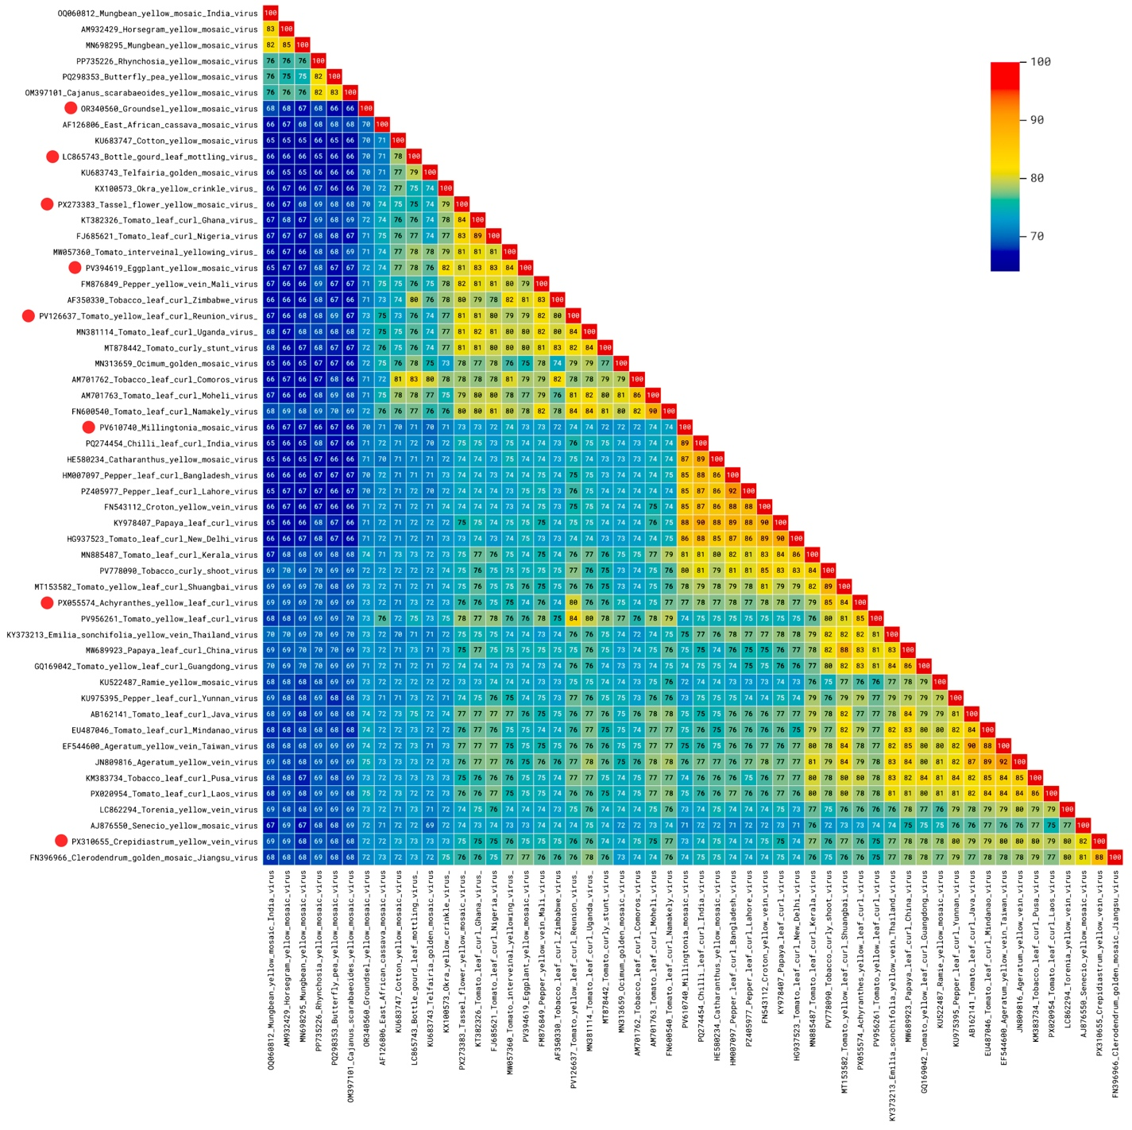
Figure 1. Pairwise nucleotide sequence identities (%) for the full-length genomes of begomoviruses (or the full-length DNA-A segment, in the case of bipartite begomoviruses), including the members of the 9 new species being proposed (indicated by the red circles). Identities were calculated with SDT [10] v. 2 (github.com/SDT-org/SDT2/releases/tag/v2.0.0.beta4.20250302.2).

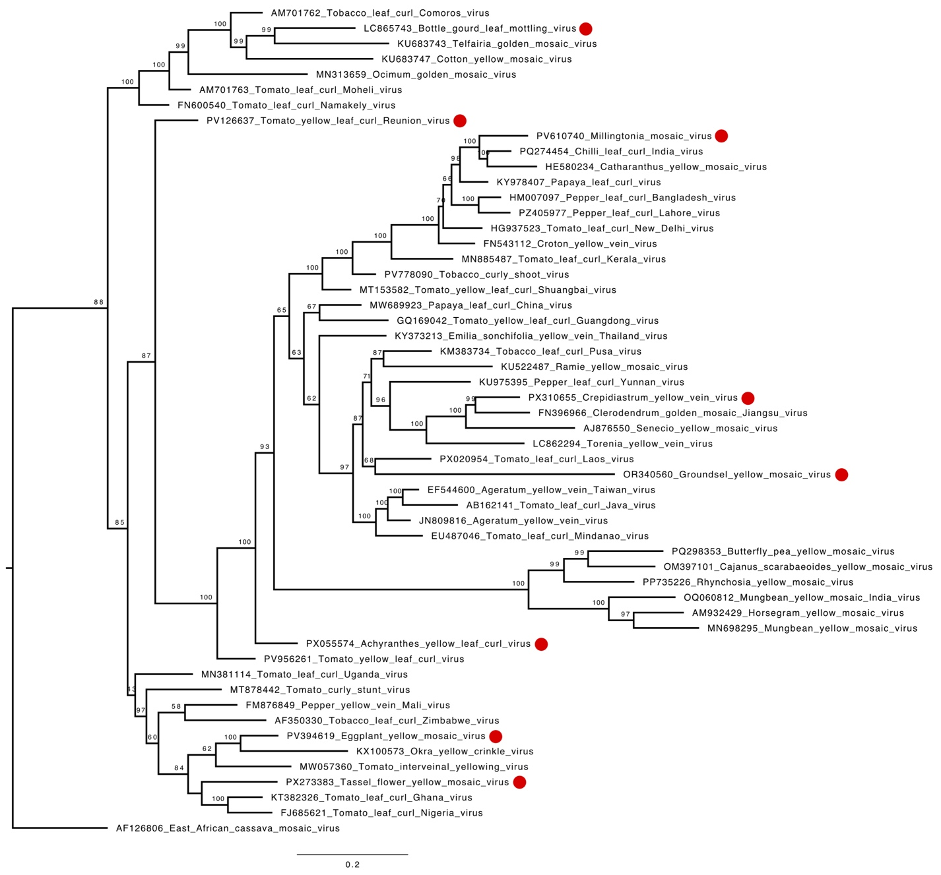
Figure 2. Maximum-likelihood phylogenetic tree based on the complete genomes of begomoviruses (or the complete DNA-A segment, in the case of bipartitie begomoviruses), including the members of the 9 new species being proposed (indicated by the red circles). East African cassava mosaic virus (AF126806) was used as an outgroup. Number at the branches are bootstrap values (1,000 replications). The scale bar indicates nucleotide substitutions per site. Sequences were aligned with MAFFT [11] and the tree was constructed with IQ-TREE [12] using the TIM3+F+R5 nucleotide substitution model (determined by ModelFinder [13]) and the ultrafast bootstrap option [14]. The tree was edited in FigTree (tree.bio.ed.ac.uk/software/figtree).

