

The International Committee on Taxonomy of Viruses
Taxonomy Proposal Form, 2026

Part 1a: Details of taxonomy proposals

Title: | Create seven new species and rename one species in the genus Betacytorhabdovirus, subfamily Betarhabdovirinae (Mononegavirales: Rhabdoviridae)
Code assigned: | 2026.017P.N.v1.Rhabdoviridae_Betacytorhabdovirus_7nsp_1rensp

Author(s), affiliation and email address(es):
Given name (+middle initial(s)) | Surname | Affiliation | Email address | Corr. author(s)
Nicolas | Bejerman | UFyMA INTA-CONICET, Argentina | bejerman.nicolas@inta.gob.ar | X
Humberto | Debat | UFyMA INTA-CONICET, Argentina | debat.humberto@inta.gob.ar
Ralf G | Dietzgen | QAAFI, UQ, Australia | r.dietzgen@hotmail.com
Juliana | Freitas-Astua | EMBRAPA Mandioca e Fruticultura, Brazil | juliana.astua@embrapa.br
Hideki | Kondo | Okayama University, Japan | hkondo@rib.okayama-u.ac.jp
Pedro Luis | Ramos-Gonzalez | Instituto Biológico de São Paulo, Brazil | pedro.gonzalez@sp.gov.br
Anna E | Whitfield | NC State University, USA | awhitfi@ncsu.edu
Peter J | Walker | School of Chemistry and Molecular Biosciences, The University of Queensland, St Lucia, Australia | peter.walker@uq.edu.au

Part 1b: Taxonomy Proposal Submission
ICTV Subcommittee:
Animal DNA Viruses and Retroviruses |  | Bacterial viruses
Animal minus-strand and dsRNA viruses |  | Fungal and protist viruses
Animal positive-strand RNA viruses |  | Plant viruses | X
Archaeal viruses |  | General

List the ICTV Study Group(s) that have seen or have been involved in creating this proposal:
Rhabdoviridae study group

Optional – complete only if formally voted on by an ICTV Study Group:
Study Group | Number of members
Study Group | Votes in support | Votes against | No vote
Rhabdoviridae | 12 |  | 2

Submission date: | 12/08/2026

Part 1c: Feedback from ICTV Executive Committee (EC) meeting
Executive Committee Meeting Decision code: | X
A – Accept
Ac – Accept subject to revision by relevant subcommittee chair. No further vote required
U – Accept without revision but with re-evaluation and email vote by the EC
Uc – Accept subject to revision and re-evaluation and email vote by the EC
Ud – Deferred to the next EC meeting, with an invitation to revise based on EC comments
J - Reject
W - Withdrawn

Comments from the Executive Committee:

Part 1d: Revised Taxonomy Proposal Submission
Response of proposer:
Revision date:

Part 3: TAXONOMIC PROPOSAL

Taxonomic changes proposed:
Establish new taxon | X | Split taxon
Abolish taxon |  | Merge taxon
Move taxon |  | Promote taxon
Rename taxon | X | Demote taxon
Move and rename

Etymology (origin) of proposed taxonomic names:
Taxon name | Etymology of the term
“Betacytorhabdovirus achilleae” | The species epithet is derived from Achillea, the scientific name of the plant host genus from which the sequence of the virus was obtained.
“Betacytorhabdovirus citri” | The species epithet is derived from Citrus, the scientific name of the plant host genus from which the sequence of the virus was obtained.
“Betacytorhabdovirus geranii” | The species epithet is derived from Geranium, the scientific name of the plant host genus from which the sequence of the virus was obtained.
“Betacytorhabdovirus rubi” | The species epithet is derived from Rubus, the scientific name of the plant host genus from which the sequence of the virus was obtained.
“Betacytorhabdovirus alphastachysis” | The species epithet is derived from Stachys, the scientific name of the plant host genus from which the sequence of the virus was obtained, and from the first letter of the Greek alphabet.
“Betacytorhabdovirus betastachysis” | The species epithet is derived from Stachys, the scientific name of the plant host genus from which the sequence of the virus was obtained, and from the second letter of the Greek alphabet.
“Betacytorhabdovirus betatrifolii” | The species epithet is derived from Trifolium, the scientific name of the plant host genus from which the sequence of the virus was obtained, and from the second letter of the Greek alphabet.

Permission for use of names derived from a living person:
Taxon name | Full name of person from whom the name is derived | Attached

Abstract of Taxonomy Proposal:

Description of current taxonomy:
Genus Betacytorhabdovirus belongs to the subfamily Betarhabdovirinae, family Rhabdoviridae, and consists of sixty-two species. Viruses classified into species in the genus Betacytorhabdovirus infect a wide range of plants, and the assignment of viruses to this genus is based on the placement of the viruses on Maximum Likelihood trees inferred from complete L protein sequences.

Proposed taxonomic change(s):
Create seven new species in the genus Betacytorhabdovirus, subfamily Betarhabdovirinae, family Rhabdoviridae. These species are proposed to be named “Betacytorhabdovirus achilleae”, “Betacytorhabdovirus citri”,” Betacytorhabdovirus geranii”, “Betacytorhabdovirus rubi”, “Betacytorhabdovirus alphastachysis”, “Betacytorhabdovirus betastachysis”, and “Betacytorhabdovirus betatrifolii”. The species Betacytorhabdovirus trifolii is proposed to be renamed “Betacytorhabdovirus alphatrifolii”.

"
Demarcation criteria for new taxon/taxa:
Viruses assigned to different species within the genus Betacytorhabdovirus should have several of the following characteristics:
A) nucleotide identity values less than 75% for the coding-complete genome sequence
B) amino acid identity values less than 86% in proteins encoded by all the cognate open reading frames
C) occupy different ecological niches as evidenced by differences in hosts and/or biological vectors

Justification:
Seven novel rhabdovirids were identified in several hosts [1, 2, and Ghorbani et al., unpublished (PX657362)]. The characterization of these seven viruses showed that they should be classified into novel species within the genus Betacytorhabdovirus.

Text of Taxonomy proposal:
Description of current taxonomy:
Genus Betacytorhabdovirus belongs to the subfamily Betarhabdovirinae, family Rhabdoviridae and consists of sixty-two species. Viruses classified into species in the genus Betacytorhabdovirus infect a wide range of plants, and the assignment of viruses to this genus is based on the placement of the viruses on Maximum Likelihood trees inferred from complete L protein sequences.

Proposed taxonomic change(s):
Create seven new species in the genus Betacytorhabdovirus, subfamily Betarhabdovirinae, family Rhabdoviridae. Rename species Betacytorhabdovirus trifolii as “Betacytorhabdovirus alphatrifolii”.

Demarcation criteria for new taxon/taxa:
Viruses assigned to different species within the genus Betacytorhabdovirus should have several of the following characteristics:
A) nucleotide identity values less than 75% for the coding-complete genome sequence
B) amino acid identity values less than 86% in proteins encoded by all the cognate open reading frames
C) occupy different ecological niches as evidenced by differences in hosts and/or biological vectors

Justification:
Seven novel rhabdovirids were identified in several hosts [1, 2, and Ghorbani et al., unpublished (PX657362)]. The characterization of these seven viruses showed that they should be classified into novel species within the genus Betacytorhabdovirus based on the sequence divergence from previously reported betacytorhabdoviruses and phylogenetic placement (see below).

- Achillea betacytorhabdovirus 1 (AchBCRV1) was identified from yarrow (Achillea millefolium) samples collected in the Netherlands. The coding-complete genome (CCG) sequence of AchBCRV1 consists of 12,628 nucleotides (PX121435) and contains seven ORFs in the order 3’-N-P- P3-M-G-P6-L-5’ [1] representing the five canonical rhabdovirid structural protein genes as well as the putative cell-to-cell movement protein gene P3 in the conserved location between the P and M genes, and the accessory protein gene P6 between the G and L genes (Figure 1). The CCG nucleotide sequence of AchBCRV1 has the highest identity values with that of Chrysanthemum betacytorhabdovirus 1 (ChrBCRV1; 58.4%), while the AchBCRV1 encoded proteins have the highest identity values with those of ChrBCRV1 (59.37%). Based on ML trees generated from complete L protein sequences, AchBCRV1 forms a well-supported clade within betacytorhabdoviruses with ChrBCRV1 and Artemisia betacytorhabdovirus 1 (Figure 2).
- quick decline associated citrus cytorhabdovirus (QDaCCRV) was identified from Citrus sp. samples collected in Iran. The coding-complete genome (CCG) sequence of QDaCCRV consists of 14,201 nucleotides (PX657362) and contains six ORFs in the order 3’-N-P- P3-M-G- L-5’ [Ghorbani et al., unpublished] representing the five canonical rhabdovirid structural protein genes as well as the putative cell-to-cell movement protein gene P3 in the conserved location between the P and M genes. Interestingly, QDaCCRV has a shorter G-like gene, which also was reported for several betacytorhabdoviruses [3] (Figure 1). The CCG nucleotide sequence of QDaCCRV has the highest identity values with that of Glycyrrhiza betacytorhabdovirus 1 (GlyBCRV1; 70.9%), while the QDaCCRV encoded proteins have the highest identity values with those of GlyBCRV1 (73.21%). Based on ML trees generated from complete L protein sequences, QDaCCRV forms a well-supported clade within those betacytorhabdoviruses that have the shorter G-like gene with GlyBCRV1 (Figure 2).
- cranesbill betacytorhabdovirus 1 (CraBCRV1) was identified from cranesbill (Geranium sp.) samples collected in the Netherlands. The coding-complete genome (CCG) sequence of CraBCRV1 consists of 12,531 nucleotides (PX121453) and contains seven ORFs in the order 3’-N-P- P3-M-G-P6-L-5’ [1] representing the five canonical rhabdovirid structural protein genes as well as the putative cell-to-cell movement protein gene P3 in the conserved location between the P and M genes, and the accessory protein gene P6 between the G and L genes (Figure 1). The CCG nucleotide sequence of CraBCRV1 has the highest identity values with that of Stachys betacytorhabdovirus 2 (StaBCRV2; 60.7%), while the CraBCRV1 encoded proteins have the highest identity values with those of StaBCRV2 (63.85%). Based on ML trees generated from complete L protein sequences, CraBCRV1 forms a well-supported clade within betacytorhabdoviruses with StaBCRV2 and Stachys betacytorhabdovirus 1 (Figure 2).
- Rubus betacytorhabdovirus 1 (RubBCRV1) was identified from Rubus sp. samples collected in Belgium. The coding-complete genome (CCG) sequence of RubBCRV1 consists of 16,202 nucleotides (PX121465) and contains eight ORFs in the order 3’-N-P- P3-P4-M-G-P7-L-5’ [1] representing the five canonical rhabdovirid structural protein genes as well as the putative cell-to-cell movement protein gene P3 between the P and P4 genes, the accessory protein P4 between the P3 and M genes, and the accessory protein gene P7 between the G and L genes (Figure 1). The CCG nucleotide sequence of RubBCRV1 has the highest identity values with that of rose associated cytorhabdovirus (RaCV; 74.2%), while the RubBCRV1 encoded proteins have the highest identity values with those of RaCV (77.72%). Based on ML trees generated from complete L protein sequences, RubBCRV1 forms a well-supported clade within betacytorhabdoviruses with RaCV (Figure 2).
- Stachys betacytorhabdovirus 1 (StaBCRV1) was identified from marsh woundwort (Stachys palustris) samples collected in the Netherlands. The coding-complete genome (CCG) sequence of StaBCRV1 consists of 12,996 nucleotides (PX550110) and contains seven ORFs in the order 3’-N-P- P3-M-G-P6-L-5’ [1] representing the five canonical rhabdovirid structural protein genes as well as the putative cell-to-cell movement protein gene P3 in the conserved location between the P and M genes, and the accessory protein gene P6 between the G and L genes (Figure 1). The CCG nucleotide sequence of StaBCRV1 has the highest identity values with that of Stachys betacytorhabdovirus 2 (StaBCRV2; 74.9%), while the StaBCRV1 encoded proteins have the highest identity values with those of StaBCRV2 (85.93%). Based on ML trees generated from complete L protein sequences, StaBCRV1 forms a well-supported clade within betacytorhabdoviruses with StaBCRV2 (Figure 2).
- Stachys betacytorhabdovirus 2 (StaBCRV2) was identified from marsh woundwort (Stachys palustris) samples collected in the Netherlands. The coding-complete genome (CCG) sequence of StaBCRV2 consists of 13.124 nucleotides (PX550111) and contains seven ORFs in the order 3’-N-P- P3-M-G-P6-L-5’ [1] representing the five canonical rhabdovirid structural protein genes as well as the putative cell-to-cell movement protein gene P3 in the conserved location between the P and M genes, and the accessory protein gene P6 between the G and L genes (Figure 1). The CCG nucleotide sequence of StaBCRV2 has the highest identity values with that of Stachys betacytorhabdovirus 1 (StaBCRV1; 74.9%), while the StaBCRV2 encoded proteins have the highest identity values with those of StaBCRV1 (85.93%). Based on ML trees generated from complete L protein sequences, StaBCRV2 forms a well-supported clade within betacytorhabdoviruses with StaBCRV1 (Figure 2).
- Trifolium betacytorhabdovirus 2 (TriBCRV2) was identified from red clover (Trifolium pratense) samples collected in Russia. The coding-complete genome (CCG) sequence of TriBCRV2 consists of 10,977 nucleotides (PX672756) and contains five ORFs in the order 3’-N-P- P3-M-L-5’ [2] representing the canonical nucleocapsid (N), phosphoprotein (P), matrix protein (M) and polymerase (L) rhabdovirid structural proteins genes as well as the putative cell-to-cell movement protein gene P3 in the conserved location between the P and M genes. Interestingly, this virus genome lacked the G gene (Figure 1), which was also described for Vicia betacytorhabdovirus 1 [3]. The CCG nucleotide sequence of TriBCRV2 has the highest identity values with that of Vicia betacytorhabdovirus 1 (VicBCRV1; 56.3%), while the TriBCRV2 encoded proteins have the highest identity values with those of VicBCRV1 (57.69%). Based on ML trees generated from complete L protein sequences, TriBCRV2 forms a well-supported clade within betacytorhabdoviruses with VicBCRV1 (Figure 2).

AchBCRV1, QDaCCRV, CraBCRV1, RubBCRV1, StaBCRV1, StaBCRV2, and TriBCRV2 meet the demarcation criteria A, B and C. Thus, we propose to classify AchBCRV1, QDaCCRV, CraBCRV1, RubBCRV1, StaBCRV1, StaBCRV2, and TriBCRV2 into the new species “Betacytorhabdovirus achilleae”, “Betacytorhabdovirus citri”, “Betacytorhabdovirus geranii”, “Betacytorhabdovirus rubi”, “Betacytorhabdovirus alphastachysis”, “Betacytorhabdovirus betastachysis”, and “Betacytorhabdovirus betatrifolii”, subfamily Betarhabdovirinae, family Rhabdoviridae.

Moreover, species Betacytorhabdovirus trifolii was renamed as “Betacytorhabdovirus alphatrifolii”, because a second betacytorhabdovirus was discovered in Trifolium.
References:
[1] Botermans M, de Koning P, Westenberg M, Adams I, Ben Mansour K, et al. (2026). Expanding insights into plant rhabdovirus diversity through the discovery of viruses representing 32 putative novel species. Arch Virol 171:156. PMID: 41951987. DOI: 10.1007/s00705-026-06609-1.
[2] Lazareva E, Lezzhov A, Chergintzev D, Tolstiko E, Selifonov I, et al. (2025). Red clover RNA virus 1: functional analysis of ORF2 protein, associations with co-infecting viruses, and seed transmission. Arch Virol 171:148 PMID: 41906034. DOI: 10.1007/s00705-026-06598-1.
[3] Bejerman N, Dietzgen R, Debat H (2023). Novel Tri-Segmented Rhabdoviruses: A Data Mining Expedition Unveils the Cryptic Diversity of Cytorhabdoviruses. Viruses 15:2402, PMID:38140643, DOI: 10.3390/v15122402.

Accompanying files:

Filename | Description of contents
2026.0xxP.betacytorhabdovirus_7nsp_1rensp | excel sheet

Tables, Figures:

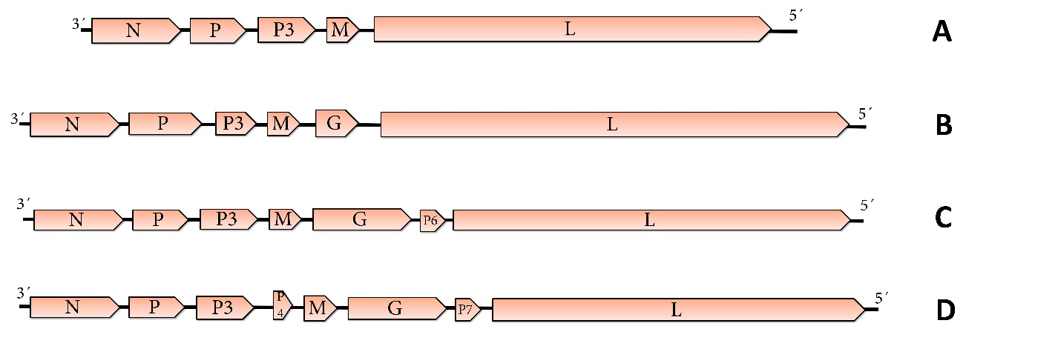
Figure 1. Genome diagrams depicting the architecture and gene products of the seven viruses proposed to be included in species within the genus Betacytorhabdovirus. Abbreviations: N: nucleoprotein; P´: P overlapping protein; P: phosphoprotein; P3: putative cell-to-cell movement protein; M: matrix protein; G: glycoprotein; P6: protein 6; L: RNA-dependent RNA polymerase. A: TriBCRV2 B: QDaCCRV C: AchBCRV1, CraBCRV1, StaBCVR1 and StaBCRV2 D: RubBCRV1. Acronyms of each virus are described in the proposal justification.

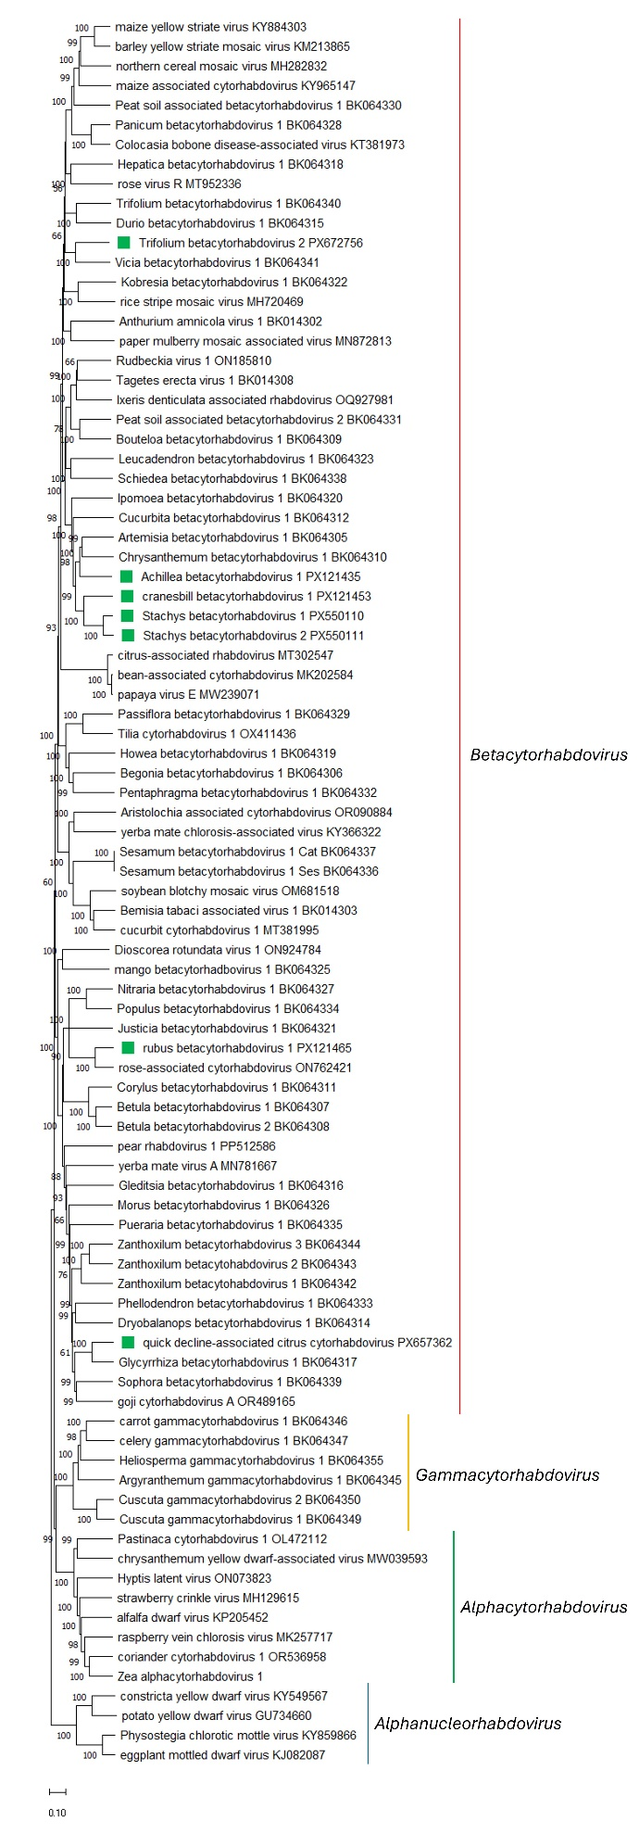
Figure 2. Maximum Likelihood (ML) phylogenetic tree of plant-infecting rhabdovirid L polymerase protein sequences. Amino acid sequences were aligned using MUSCLE. The resulting alignment was used to generate a phylogenetic tree using Mega11 with the best-fit model LG + G + I +F. Seven viruses potentially belonging to the new species are indicated with green squares. Numbers at the nodes indicate bootstrap support (1000 replicates).

