
w

The International Committee on Taxonomy of Viruses
Taxonomy Proposal Form, 2026

Part 1a: Details of taxonomy proposals

Title: | Create three new species in the genus Gammacytorhabdovirus, subfamily Betarhabdovirinae (Mononegavirales: Rhabdoviridae)
Code assigned: | 2026.019P.N.v1.Rhabdoviridae_Gammacytorhabdovirus_3nsp

Author(s), affiliation and email address(es):
Given name (+middle initial(s)) | Surname | Affiliation | Email address | Corr. author(s)
Nicolas | Bejerman | UFyMA INTA-CONICET, Argentina | bejerman.nicolas@inta.gob.ar | X
Humberto | Debat | UFyMA INTA-CONICET, Argentina | debat.humberto@inta.gob.ar
Ralf G | Dietzgen | QAAFI, UQ, Australia | r.dietzgen@hotmail.com
Juliana | Freitas-Astua | EMBRAPA Mandioca e Fruticultura, Brazil | juliana.astua@embrapa.br
Hideki | Kondo | Okayama University, Japan | hkondo@rib.okayama-u.ac.jp
Pedro Luis | Ramos-Gonzalez | Instituto Biológico de São Paulo, Brazil | pedro.gonzalez@sp.gov.br
Anna E | Whitfield | NC State University, USA | awhitfi@ncsu.edu
Peter J | Walker | School of Chemistry and Molecular Biosciences, The University of Queensland, St Lucia, Australia | peter.walker@uq.edu.au

Part 1b: Taxonomy Proposal Submission
ICTV Subcommittee:
Animal DNA Viruses and Retroviruses |  | Bacterial viruses
Animal minus-strand and dsRNA viruses |  | Fungal and protist viruses
Animal positive-strand RNA viruses |  | Plant viruses | X
Archaeal viruses |  | General

List the ICTV Study Group(s) that have seen or have been involved in creating this proposal:
Rhabdoviridae study group

Optional – complete only if formally voted on by an ICTV Study Group:
Study Group | Number of members
Study Group | Votes in support | Votes against | No vote
Rhabdoviridae | 12 |  | 2

Submission date: | 12/08/2026

Part 1c: Feedback from ICTV Executive Committee (EC) meeting
Executive Committee Meeting Decision code: | X
A – Accept
Ac – Accept subject to revision by relevant subcommittee chair. No further vote required
U – Accept without revision but with re-evaluation and email vote by the EC
Uc – Accept subject to revision and re-evaluation and email vote by the EC
Ud – Deferred to the next EC meeting, with an invitation to revise based on EC comments
J - Reject
W - Withdrawn

Comments from the Executive Committee:

Part 1d: Revised Taxonomy Proposal Submission
Response of proposer:
Revision date:

Part 3: TAXONOMIC PROPOSAL

Taxonomic changes proposed:
Establish new taxon | X | Split taxon
Abolish taxon |  | Merge taxon
Move taxon |  | Promote taxon
Rename taxon |  | Demote taxon
Move and rename

Etymology (origin) of proposed taxonomic names:
Taxon name | Etymology of the term
“Gammacytorhabdovirus bergerdensis” | The species epithet is derived from Bergerden, the name of the location from which the sequence of the virus was obtained
“Gammacytorhabdovirus mali” | The species epithet is derived from Malus, the scientific name of the plant host genus from which the sequence of the virus was obtained.
“Gammacytorhabdovirus passiflorae” | The species epithet is derived from Passiflora, the scientific name of the plant host genus from which the sequence of the virus was obtained.

Permission for use of names derived from a living person:
Taxon name | Full name of person from whom the name is derived | Attached X

Abstract of Taxonomy Proposal:

Description of current taxonomy:
Eighteen virus species are currently classified in the genus Gammacytorhabdovirus. The assignment of viruses to this genus is based on the placement of the viruses on a Maximum Likelihood tree inferred from complete L protein sequences.

Proposed taxonomic change(s):
Create three new species in the genus Gammacytorhabdovirus, subfamily Betarhabdovirinae, family Rhabdoviridae. These species are proposed to be named “Gammacytorhabdovirus bergerdensis”, “Gammacytorhabdovirus mali”, and “Gammacytorhabdovirus passiflorae”.

Demarcation criteria for new taxon/taxa:
Viruses assigned to different species within the genus Gammacytorhabdovirus should have several of the following characteristics:
A) nucleotide sequence identity less than 75% for the coding-complete genome sequence
B) amino acid sequence identity less than 86% in proteins encoded by all the cognate open reading frames
C) occupy different ecological niches as evidenced by differences in hosts and/or biological vectors

Justification:
Three novel rhabdovirids were identified in several hosts collected in Bergerden, in apple [1], and passion fruit [2]. The characterization of these three viruses showed that they should be classified into novel species within the genus Gammacytorhabdovirus.

Text of Taxonomy proposal:
Description of current taxonomy:
Eighteen virus species are currently classified in the genus Gammacytorhabdovirus. The assignment of viruses to this genus is based on the placement of the viruses on a Maximum Likelihood tree inferred from complete L protein sequences.

Proposed taxonomic change(s):
Create three new species in the genus Gammacytorhabdovirus, subfamily Betarhabdovirinae, family Rhabdoviridae.

Demarcation criteria for new taxon/taxa:
Viruses assigned to different species within the genus Gammacytorhabdovirus should have several of the following characteristics:
A) nucleotide sequence identity less than 75% for the coding-complete genome sequence
B) amino acid sequence identity less than 86% in proteins encoded by all the cognate open reading frames
C) occupy different ecological niches as evidenced by differences in hosts and/or biological vectors

Justification:
Three novel rhabdoviruses were identified in several hosts collected in Bergerden, in apple [1], and passion fruit [2]. The characterization of these three viruses showed that they should be classified into novel species within the genus Gammacytorhabdovirus, based on the sequence divergence from previously reported gammacytorhabdoviruses and phylogenetic placement (see below).

- Bergerden gammacytorhabdovirus 1 (BerGCRV1) was identified from samples of four distinct hosts (Medicago lupulina, Heracleum sphondylium, Pastinaca sativa and Phalaenopsis 'White World') collected in Bergerden, Netherlands. The coding-complete genome (CCG) sequence of BerGCRV1 consists of 15,185 nucleotides (PX121446) and contains seven ORFs in the order 3’-N-P- P3-M-G-P6-L-5’ [1] representing the five canonical rhabdovirid structural protein genes as well as the putative cell-to-cell movement protein gene P3 in the conserved location between the P and M genes, and the accessory protein gene P6 between the G and L genes (Figure 1). The CCG nucleotide sequence of BerGCRV1 has the highest identity values with that of Fraxinus gammacytorhabdovirus 2 (FraGCRV2, 46.9%), while the BerGCRV1-encoded proteins have the highest identity values with those of FraGCRV2 (58.25%). Based on ML trees generated from complete L protein sequences, BerGCRV1 forms a well-supported clade with other gammacytorhabdoviruses (Figure 2).
- apple gammacytorhabdovirus 1 (ApGCRV1) was identified from apple (Malus sp.) samples collected in Zagora, Greece. The coding-complete genome (CCG) sequence of ApGCRV1 is 12,988 nucleotides (PV979719) in size and contains nine ORFs in the order 3’-N-P-P3-P4-P5-P6-G-L-P9-5’ [1] representing four canonical rhabdovirid structural protein genes as well as the putative cell-to-cell movement protein gene P3 in the conserved location after the P gene, as well as four accessory proteins, three located between the P3 and G genes, and the other one is located after the L gene. Interestingly, ApGCRV1 lacks a recognizable M gene and has a shorter G-like gene (Figure 1). The CCG nucleotide sequence of ApGCRV1 has the highest identity values with that of Coptis gammacytorhabdovirus 1 (CopGCRV1; 47.7%); while the ApGCRV1 encoded proteins have the highest identity values with those of CopGCRV1 (47.53%). Based on ML trees generated from complete L protein sequences, ApGCRV1 forms a well-supported clade with other gammacytorhabdoviruses (Figure 2).
- Passiflora cytorhabdovirus (PFCV) was identified from passion fruit (Passiflora edulis) samples collected in Rio de Janeiro, Brazil. The coding-complete genome (CCG) sequence of PFCV consists of 13,323 nucleotides (PV460965) and contains eight ORFs in the order 3’-N-P-P3-P4-M-G-P7-L-5’ [2] representing the five canonical rhabdovirid structural protein genes as well as the putative cell-to-cell movement protein gene P3 in the conserved location between P and M genes, the accessory protein P7 gene between the G and L genes, and another accessory protein with an unknown function located between the P3 and M genes (Figure 1). The CG nucleotide sequence of PFCV has the highest identity values with that of Cuscuta gammacytorhabdovirus 2 (CusGCRV2; 40.2%); while the PFCV encoded proteins have the highest identity values with those of CusGCRV2 (51.5%) [2]. Based on ML trees generated from complete L protein sequences, PFCV forms a well-supported clade with other gammacytorhabdoviruses (Figure 2).

BerGCRV1, ApGCRV1 and PFCV meet the demarcation criteria A, B and C. Thus, we propose to classify BerGCRV1, ApGCRV1 and PFCV into the new species “Gammacytorhabdovirus bergerdensis”, “Gammacytorhabdovirus mali”, and “Gammacytorhabdovirus passiflorae”, subfamily Betarhabdovirinae, family Rhabdoviridae.
References:
[1] Botermans M, de Koning P, Westenberg M, Adams I, Ben Mansour K, et al. (2026). Expanding insights into plant rhabdovirus diversity through the discovery of viruses representing 32 putative novel species. Arch Virol 171:156. PMID: 41951987. DOI: 10.1007/s00705-026-06609-1.
[2] Vidal A, Rodrigues Abreu A, Sousa Dantas-Filho J, Vianna M, Lacorte C, et al., (2025). Discovery and Genome Characterization of Three New Rhabdoviruses Infecting Passiflora spp. in Brazil. Viruses 17:725. PMID: 40431736. DOI: 10.3390/v17050725

Accompanying files:

Filename | Description of contents
2026.0xxP.gammacytorhabdovirus_3nsp | excel sheet

Tables, Figures:

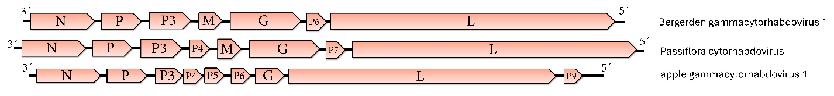
Figure 1. Genome diagrams depicting the architecture and gene products of the three viruses proposed to be included in species within the genus Gammacytorhabdovirus. Abbreviations: N: nucleoprotein; P: phosphoprotein; P3: putative cell-to-cell movement protein; P4: protein 4; P5: protein 5; M: matrix protein; G: glycoprotein; P6: protein 6; P7: protein 7; L: RNA-dependent RNA polymerase; P9: protein 9.

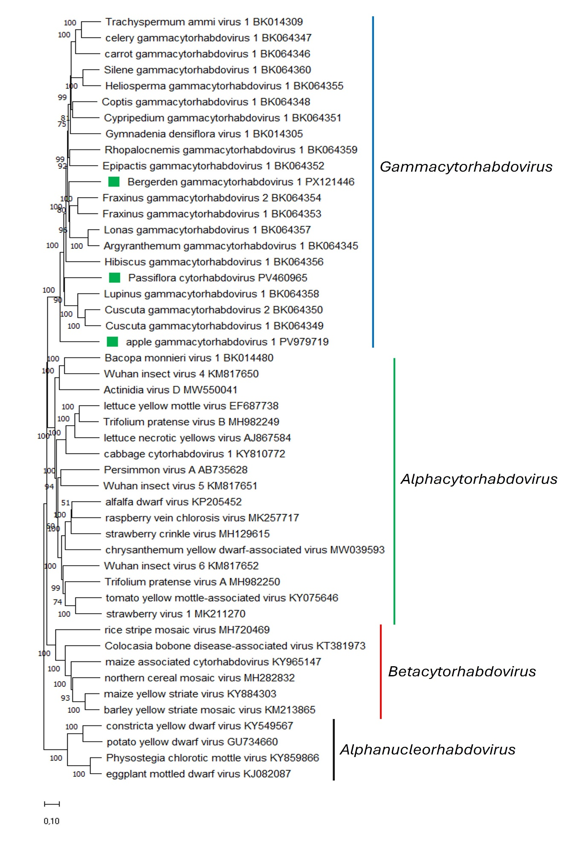
Figure 2. Maximum Likelihood (ML) phylogenetic tree of plant-infecting rhabdovirid L polymerase protein sequences. Amino acid sequences were aligned using MUSCLE. The resulting alignment was used to generate a phylogenetic tree using Mega11 with the best-fit model LG + G + I +F. Three viruses potentially belonging to the new species are indicated with green squares. Numbers at the nodes indicate bootstrap support (1000 replicates).

