

The International Committee on Taxonomy of Viruses
Taxonomy Proposal Form, 2026

Part 1a: Details of taxonomy proposals

Title: | Create four new species in the genus Gammanucleorhabdovirus, subfamily Betarhabdovirinae (Mononegavirales: Rhabdoviridae)
Code assigned: | 2026.020P.N.v1.Rhabdoviridae_Gammanucleorhabdovirus_4nsp

Author(s), affiliation and email address(es):
Given name (+middle initial(s)) | Surname | Affiliation | Email address | Corr. author(s)
Nicolas | Bejerman | UFyMA INTA-CONICET, Argentina | bejerman.nicolas@inta.gob.ar | X
Humberto | Debat | UFyMA INTA-CONICET, Argentina | debat.humberto@inta.gob.ar
Ralf G | Dietzgen | QAAFI, UQ, Australia | r.dietzgen@hotmail.com
Juliana | Freitas-Astua | EMBRAPA Mandioca e Fruticultura, Brazil | juliana.astua@embrapa.br
Hideki | Kondo | Okayama University, Japan | hkondo@rib.okayama-u.ac.jp
Pedro Luis | Ramos-Gonzalez | Instituto Biológico de São Paulo, Brazil | pedro.gonzalez@sp.gov.br
Anna E | Whitfield | NC State University, USA | awhitfi@ncsu.edu
Peter J | Walker | School of Chemistry and Molecular Biosciences, The University of Queensland, St Lucia, Australia | peter.walker@uq.edu.au

Part 1b: Taxonomy Proposal Submission
ICTV Subcommittee:
Animal DNA Viruses and Retroviruses |  | Bacterial viruses
Animal minus-strand and dsRNA viruses |  | Fungal and protist viruses
Animal positive-strand RNA viruses |  | Plant viruses | X
Archaeal viruses |  | General

List the ICTV Study Group(s) that have seen or have been involved in creating this proposal:
Rhabdoviridae study group

Optional – complete only if formally voted on by an ICTV Study Group:
Study Group | Number of members
Study Group | Votes in support | Votes against | No vote
Rhabdoviridae | 12 |  | 2

Submission date: | 12/08/2026

Part 1c: Feedback from ICTV Executive Committee (EC) meeting
Executive Committee Meeting Decision code: | X
A – Accept
Ac – Accept subject to revision by relevant subcommittee chair. No further vote required
U – Accept without revision but with re-evaluation and email vote by the EC
Uc – Accept subject to revision and re-evaluation and email vote by the EC
Ud – Deferred to the next EC meeting, with an invitation to revise based on EC comments
J - Reject
W - Withdrawn

Comments from the Executive Committee:

Part 1d: Revised Taxonomy Proposal Submission
Response of proposer:
Revision date:

Part 3: TAXONOMIC PROPOSAL

Taxonomic changes proposed:
Establish new taxon | X | Split taxon
Abolish taxon |  | Merge taxon
Move taxon |  | Promote taxon
Rename taxon |  | Demote taxon
Move and rename

Etymology (origin) of proposed taxonomic names:
Taxon name | Etymology of the term
“Gammanucleorhabdovirus bruguierae” | The species epithet is derived from Bruguiera, the scientific name of the plant host genus from which the sequence of the virus was obtained
“Gammanucleorhabdovirus myricae” | The species epithet is derived from Myrica, the scientific name of the plant host genus from which the sequence of the virus was obtained.
“Gammanucleorhabdovirus populi” | The species epithet is derived from Populus, the scientific name of the plant host genus from which the sequence of the virus was obtained.
“Gammanucleorhabdovirus tamaricis” | The species epithet is derived from Tamarix, the scientific name of the plant host genus from which the sequence of the virus was obtained.

Permission for use of names derived from a living person:
Taxon name | Full name of person from whom the name is derived | Attached

Abstract of Taxonomy Proposal:

Description of current taxonomy:
Two virus species are currently classified in the genus Gammanucleorhabdovirus. The assignment of viruses to this genus is based on the placement of the viruses on a Maximum Likelihood tree inferred from complete L protein sequences.

Proposed taxonomic change(s):
Create four new species in the genus Gammanucleorhabdovirus, subfamily Betarhabdovirinae, family Rhabdoviridae. These species are proposed to be named “Gammanucleorhabdovirus bruguierae”, “Gammanucleorhabdovirus myricae”, “Gammanucleorhabdovirus populi” and “Gammanucleorhabdovirus tamaricis”.

Demarcation criteria for new taxon/taxa:
Viruses assigned to different species within the genus Gammanucleorhabdovirus should have several of the following characteristics:
A) nucleotide identity values less than 75% for the coding-complete genome sequence
B) amino acid identity values less than 86% in proteins encoded by all the cognate open reading frames
C) occupy different ecological niches as evidenced by differences in hosts and/or biological vectors

Justification:
Four novel rhabdovirids were identified in the oriental mangrove, Myrica rubra, Populus trichocarpa, and tamarisk [1]. The characterization of these four viruses showed that they should be classified into novel species within the genus Gammanucleorhabdovirus.

Text of Taxonomy proposal:
Description of current taxonomy:
Two virus species are currently classified in the genus Gammanucleorhabdovirus. The assignment of viruses to this genus is based on the placement of the viruses on a Maximum Likelihood tree inferred from complete L protein sequences.

Proposed taxonomic change(s):
Create four new species in the genus Gammanucleorhabdovirus, subfamily Betarhabdovirinae, family Rhabdoviridae.

Demarcation criteria for new taxon/taxa:
Viruses assigned to different species within the genus Gammanucleorhabdovirus should have several of the following characteristics:
A) nucleotide identity values less than 75% for the coding-complete genome sequence
B) amino acid identity values less than 86% in proteins encoded by all the cognate open reading frames
C) occupy different ecological niches as evidenced by differences in hosts and/or biological vectors

Justification:
Four novel rhabdovirids were identified in the oriental mangrove, Myrica rubra, Populus trichocarpa, and tamarisk [1]. The characterization of these four viruses showed that they should be classified into novel species within the genus Gammanucleorhabdovirus based on the sequence divergence from previously reported gammanucleorhabdoviruses and phylogenetic placement (see below).

- Bruguiera gammanucleorhabdovirus 1 (BruGNRV1) was identified from an in silico analysis of transcriptome data of oriental mangrove (Bruguiera gymnorhiza) from China. The coding-complete genome (CCG) sequence of BruGNRV1 consists of 13,259 nucleotides (BK070517) and contains six ORFs in the order 3’-N-P-P3-M-G-L-5’ [1], representing the five canonical rhabdovirid structural protein genes and the putative cell-to-cell movement protein gene P3 in the conserved location between the P and M genes (Figure 1). The CCG nucleotide sequence of BruGNRV1 has the highest identity values with that of Populus gammanucleorhabdovirus 1 (PopGNRV1; 61.9%), while the BruGNRV1 encoded proteins have the highest identity values with those of PopGNRV1 (49.43%) [1]. Based on ML trees generated from complete L protein sequences, BruGNRV1 forms a well-supported clade within gammanucleorhabdoviruses with PopGNRV1 (Figure 2).
- Myrica gammanucleorhabdovirus 1 (MyrGNRV1) was identified from an in silico analysis of transcriptome data of Chinese bayberry (Myrica rubra) from Zhejiang, China. The coding-complete genome (CCG) sequence of MyrGNRV1 consists of 14,282 nucleotides (BK070518) and contains six ORFs in the order 3’-N-P-P3-M-G-L-5’ [1], representing the five canonical rhabdovirid structural protein genes and the putative cell-to-cell movement protein gene P3 in the conserved location between the P and M genes (Figure 1). The CCG nucleotide sequence of MyrGNRV1 has the highest identity values with that of Populus gammanucleorhabdovirus 1 (PopGNRV1; 60.7%), while the MyrGNRV1 encoded proteins have the highest identity values with those of PopGNRV1 (48.02%) [1]. Based on ML trees generated from complete L protein sequences, MyrGNRV1 forms a well-supported clade within gammanucleorhabdoviruses with PopGNRV1 and Bruguiera gammanucleorhabdovirus 1 (Figure 2).
- Populus gammanucleorhabdovirus 1 (PopGNRV1) was identified from an in silico analysis of transcriptome data of black cottonwood (Populus trichocarpa) from Oregon, USA. The coding-complete genome (CCG) sequence of PopGNRV1 consists of 14,326 nucleotides (BK070519) and contains six ORFs in the order 3’-N-P-P3-M-G-L-5’ [1], representing the five canonical rhabdovirid structural protein genes and the putative cell-to-cell movement protein gene P3 in the conserved location between the P and M genes (Figure 1). The CCG nucleotide sequence of PopGNRV1 has the highest identity values with that of Bruguiera gammanucleorhabdovirus 1 (BruGNRV1; 61.9%), while the PopGNRV1 encoded proteins have the highest identity values with those of BruGNRV1 (49.43%) [1]. Based on ML trees generated from complete L protein sequences, PopGNRV1 forms a well-supported clade within gammanucleorhabdoviruses with BruGNRV1 (Figure 2).
- Tamarix gammanucleorhabdovirus 1 (TamGNRV1) was identified from an in silico analysis of transcriptome data of tamarisk (Tamarix ramosissima) from Nanjing, China. The coding-complete genome (CCG) sequence of TamGNRV1 consists of 13,791 nucleotides (BK070520) and contains six ORFs in the order 3’-N-P-P3-M-G-L-5’ [1], representing the five canonical rhabdovirid structural protein genes and the putative cell-to-cell movement protein gene P3 in the conserved location between the P and M genes (Figure 1). The CCG nucleotide sequence of TamGNRV1 has the highest identity values with that of maize fine streak virus (MFSV; 59.7%), while the TamGNRV1 encoded proteins have the highest identity values with those of MFSV (46.18%) [1]. Based on ML trees generated from complete L protein sequences, TamGNRV1 forms a well-supported clade within gammanucleorhabdoviruses with MFSV and cereal chlorotic mottle virus (Figure 2).

BruGNRV1, MyrGNRV1, PopGNRV1 and TamGNRV1 meet the demarcation criteria A, B and C. Thus, we propose to classify BruGNRV1, MyrGNRV1, PopGNRV1 and TamGNRV1 into the new species “Gammanucleorhabdovirus bruguierae”, “Gammanucleorhabdovirus myricae”, “Gammanucleorhabdovirus populi” and “Gammanucleorhabdovirus tamaricis”, subfamily Betarhabdovirinae, family Rhabdoviridae.
References:
[1] Bejerman N, Dietzgen R, Debat H (2026). Expanding the known nucleorhabdovirus world: the final chapter in a trilogy exploring the hidden diversity of plant-associated rhabdoviruses. Virology 613:110699. PMID: 41033042. DOI: 10.1016/j.virol.2025.110699

Accompanying files:

Filename | Description of contents

Tables, Figures:

Figure 1. Genome diagram depicting the architecture and gene products of the four viruses proposed to be included in species within the genus Gammanucleorhabdovirus. Abbreviations: N: nucleoprotein; P: phosphoprotein; P3: putative cell-to-cell movement protein; M: matrix protein; G: glycoprotein; L: RNA-dependent RNA polymerase.

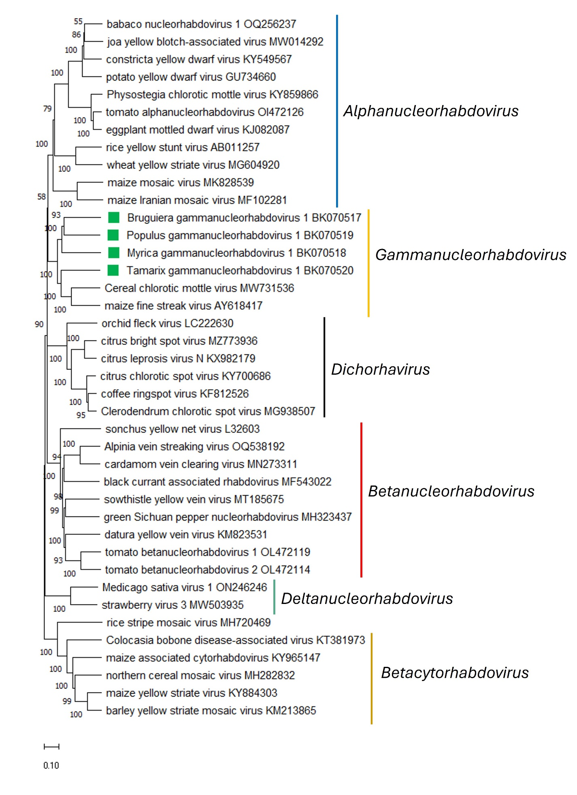
Figure 2. Maximum Likelihood (ML) phylogenetic tree of plant-infecting rhabdovirid L polymerase protein sequences. Amino acid sequences were aligned using MUSCLE. The resulting alignment was used to generate a phylogenetic tree using Mega11 with the best-fit model LG + G + I +F. Four viruses potentially belonging to the new species are indicated with green squares. Numbers at the nodes indicate bootstrap support (1000 replicates).

