

The International Committee on Taxonomy of Viruses
Taxonomy Proposal Form, 2026

Part 1a: Details of taxonomy proposals

Title: | Create ten new species in the genus Deltanucleorhabdovirus, subfamily Betarhabdovirinae (Mononegavirales: Rhabdoviridae)
Code assigned: | 2026.021P.N.v1.Rhabdoviridae_Deltanucleorhabdovirus_10nsp

Author(s), affiliation and email address(es):
Given name (+middle initial(s)) | Surname | Affiliation | Email address | Corr. author(s)
Nicolas | Bejerman | UFyMA INTA-CONICET, Argentina | bejerman.nicolas@inta.gob.ar | X
Humberto | Debat | UFyMA INTA-CONICET, Argentina | debat.humberto@inta.gob.ar
Ralf G | Dietzgen | QAAFI, UQ, Australia | r.dietzgen@hotmail.com
Juliana | Freitas-Astua | EMBRAPA Mandioca e Fruticultura, Brazil | juliana.astua@embrapa.br
Hideki | Kondo | Okayama University, Japan | hkondo@rib.okayama-u.ac.jp
Pedro Luis | Ramos-Gonzalez | Instituto Biológico de São Paulo, Brazil | pedro.gonzalez@sp.gov.br
Anna E | Whitfield | NC State University, USA | awhitfi@ncsu.edu
Peter J | Walker | School of Chemistry and Molecular Biosciences, The University of Queensland, St Lucia, Australia | peter.walker@uq.edu.au

Part 1b: Taxonomy Proposal Submission
ICTV Subcommittee:
Animal DNA Viruses and Retroviruses |  | Bacterial viruses
Animal minus-strand and dsRNA viruses |  | Fungal and protist viruses
Animal positive-strand RNA viruses |  | Plant viruses | X
Archaeal viruses |  | General

List the ICTV Study Group(s) that have seen or have been involved in creating this proposal:
Rhabdoviridae study group

Optional – complete only if formally voted on by an ICTV Study Group:
Study Group | Number of members
Study Group | Votes in support | Votes against | No vote
Rhabdoviridae | 12 |  | 2

Submission date: | 12/08/2026

Part 1c: Feedback from ICTV Executive Committee (EC) meeting
Executive Committee Meeting Decision code: | X
A – Accept
Ac – Accept subject to revision by relevant subcommittee chair. No further vote required
U – Accept without revision but with re-evaluation and email vote by the EC
Uc – Accept subject to revision and re-evaluation and email vote by the EC
Ud – Deferred to the next EC meeting, with an invitation to revise based on EC comments
J - Reject
W - Withdrawn

Comments from the Executive Committee:

Part 1d: Revised Taxonomy Proposal Submission
Response of proposer:
Revision date:

Part 3: TAXONOMIC PROPOSAL

Taxonomic changes proposed:
Establish new taxon | X | Split taxon
Abolish taxon |  | Merge taxon
Move taxon |  | Promote taxon
Rename taxon |  | Demote taxon
Move and rename

Etymology (origin) of proposed taxonomic names:
Taxon name | Etymology of the term
“Deltanucleorhabdovirus artemisiae” | From Artemisia, the scientific name of the plant host genus from which the sequence of the virus was obtained
“Deltanucleorhabdovirus chrysanthemi” | From Chrysanthemum, the scientific name of the plant host genus from which the sequence of the virus was obtained.
“Deltanucleorhabdovirus gei” | From Geum, the scientific name of the plant host genus from which the sequence of the virus was obtained.
“Deltanucleorhabdovirus laburni” | From Laburnum, the scientific name of the plant host genus from which the sequence of the virus was obtained
“Deltanucleorhabdovirus lamii” | From Lamium, the scientific name of the plant host genus from which the sequence of the virus was obtained.
“Deltanucleorhabdovirus menthae” | From Mentha, the scientific name of the plant host genus from which the sequence of the virus was obtained
“Deltanucleorhabdovirus thymi” | From Thymus, the scientific name of the plant host genus from which the sequence of the virus was obtained.
“Deltanucleorhabdovirus tolmieae” | From Tolmiea, the scientific name of the plant host genus from which the sequence of the virus was obtained.
“Deltanucleorhabdovirus lycopersici” | From Lycopersicum, the scientific name of the plant host species from which the sequence of the virus was obtained.
“Deltanucleorhabdovirus vaccinii” | From Vaccinium, the scientific name of the plant host genus from which the sequence of the virus was obtained.

Permission for use of names derived from a living person:
Taxon name | Full name of person from whom the name is derived | Attached X

Abstract of Taxonomy Proposal:

Description of current taxonomy:
Two virus species are currently classified in the genus Deltanucleorhabdovirus. The assignment of viruses to this genus is based on the placement of the viruses on a Maximum Likelihood tree inferred from complete L protein sequences.

Proposed taxonomic change(s):
Create ten new species in the genus Deltanucleorhabdovirus, subfamily Betarhabdovirinae, family Rhabdoviridae. These species are proposed to be named “Deltanucleorhabdovirus artemisiae”, “Deltanucleorhabdovirus chrysanthemi”, “Deltanucleorhabdovirus gei”, “Deltanucleorhabdovirus laburni, “Deltanucleorhabdovirus lamii”, “Deltanucleorhabdovirus menthae”, “Deltanucleorhabdovirus thymi”, “Deltanucleorhabdovirus tolmieae”, “Deltanucleorhabdovirus lycopersici” and “Deltanucleorhabdovirus vaccinii”.

Demarcation criteria for new taxon/taxa:
Viruses assigned to different species within the genus Deltanucleorhabdovirus should have several of the following characteristics:
A) nucleotide identity values less than 75% for the coding-complete genome sequence
B) amino acid identity values less than 86% in proteins encoded by all the cognate open reading frames
C) occupy different ecological niches as evidenced by differences in hosts and/or biological vectors

Justification:
Ten new rhabdovirids were identified in Artemisia annua, Chrysanthemum crassum, Geum urbanum, Mentha spicata, Thymus quinquecostatus, Tolmiea menziesii, tomato (Solanum lycopersicum), American cranberry (Vaccinium macrocarpon) [1], Laburnum x watereri and Lamium album [2]. The characterization of these ten viruses showed that they should be classified into new species within the genus Deltanucleorhabdovirus.

Text of Taxonomy proposal:
Description of current taxonomy:
Two virus species are currently classified in the genus Deltanucleorhabdovirus. The assignment of viruses to this genus is based on the placement of the viruses on a Maximum Likelihood tree inferred from complete L protein sequences.

Proposed taxonomic change(s):
Create ten new species in the genus Deltanucleorhabdovirus, subfamily Betarhabdovirinae, family Rhabdoviridae.

Demarcation criteria for new taxon/taxa:
Viruses assigned to different species within the genus Deltanucleorhabdovirus should have several of the following characteristics:
A) nucleotide identity values less than 75% for the coding-complete genome sequence
B) amino acid identity values less than 86% in proteins encoded by all the cognate open reading frames
C) occupy different ecological niches as evidenced by differences in hosts and/or biological vectors

Justification:
Ten new rhabdovirids were identified in Artemisia annua, Chrysanthemum crassum, Geum urbanum, Mentha spicata, Thymus quinquecostatus, Tolmiea menziessi, tomato (Solanum lycopersicum), American cranberry (Vaccinium macrocarpon) [1] Laburnum x watereri and Lamium album [2]. The characterization of these ten viruses showed that they should be classified into new species within the genus Deltanucleorhabdovirus based on the sequence divergence from previously reported deltanucleorhabdoviruses and phylogenetic placement (see below).

- Artemisia deltanucleorhabdovirus 1 (ArtDNRV1) was identified from an in silico analysis of transcriptome data of sweet wormwood (Artemisia annua) from Guangxi, China. The coding-complete genome (CCG) sequence of ArtDNRV1 consists of 15,227 nucleotides (BK070508) and contains six ORFs in the order 3’-N-P-P3-M-G-L-5’ [1], representing the five canonical rhabdovirid structural protein genes and the putative cell-to-cell movement protein gene P3 in the conserved location between the P and M genes (Figure 1). The CCG nucleotide sequence of ArtDNRV1 has the highest identity value with that of Chrysanthemum deltanucleorhabdovirus 1 (ChrDNRV1; 66.9%), while the ArtDNRV1 encoded proteins have the highest identity values with those of ChrDNRV1 (72.22%) [1]. Based on ML trees generated from complete L protein sequences, ArtDNRV1 forms a well-supported clade within deltanucleorhabdoviruses with ChrDNRV1 (Figure 2).
- Chrysanthemum deltanucleorhabdovirus 1 (ChrDNRV1) was identified from an in silico analysis of transcriptome data of thick-leaved mum (Chrysanthemum crassum) from Jiangsu, China. The coding-complete genome (CCG) sequence of ChrDNRV1 consists of 14,830 nucleotides (BK070510) and contains six ORFs in the order 3’-N-P-P3-M-G-L-5’ [1], representing the five canonical rhabdovirid structural protein genes and the putative cell-to-cell movement protein gene P3 in the conserved location between the P and M genes (Figure 1). The CCG nucleotide sequence of ChrDNRV1 has the highest identity value with that of Artemisia deltanucleorhabdovirus 1 (ArtDNRV1; 66.9%), while the ChrDNRV1 encoded proteins have the highest identity values with those of ArtDNRV1 (72.22%) [1]. Based on ML trees generated from complete L protein sequences, ChrDNRV1 forms a well-supported clade within deltanucleorhabdoviruses with ArtDNRV1 (Figure 2).
- Geum deltanucleorhabdovirus 1 (GeuDNRV1) was identified from an in silico analysis of transcriptome data of herb bennet (Geum urbanum) from the United Kingdom. The coding-complete genome (CCG) sequence of GeuDNRV1 consists of 14,140 nucleotides (BK070511) and contains six ORFs in the order 3’-N-P-P3-M-G-L-5’ [1], representing the five canonical rhabdovirid structural protein genes and the putative cell-to-cell movement protein gene P3 in the conserved location between the P and M genes (Figure 1). The CCG nucleotide sequence of GeuDNRV1 has the highest identity value with that of Artemisia deltanucleorhabdovirus 1 (ArtDNRV1; 59.9%), while the GeuDNRV1 encoded proteins have the highest identity values with those of Mentha deltanucleorhabdovirus 1 (MenDNRV1; 43.62%) [1]. Based on ML trees generated from complete L protein sequences, GeuDNRV1 a well-supported clade with other deltanucleorhabdoviruses (Figure 2).
- Laburnum deltanucleorhabdovirus 1 (LabDNRV1) was identified from golden chain tree (Laburnum x watereri) samples collected in the Netherlands. The coding-complete genome (CCG) sequence of LabDNRV1 consists of 15,506 nucleotides (PX121458) and contains seven ORFs in the order 3’-N-P-P3-M-P5-G-L-5’ [2], representing the five canonical rhabdovirid structural protein genes, the putative cell-to-cell movement protein gene P3 in the conserved location between the P and M genes, as well as an additional ORF encoding a P5 between the M and G genes (Figure 1). The CCG nucleotide sequence of LabDNRV1 has the highest identity value with that of Lamium deltanucleorhabdovirus 1 (LamDNRV1; 70.7%), while the LabDNRV1 encoded proteins have the highest identity values with those of LamDNRV1 (71.95%). Based on ML trees generated from complete L protein sequences, LabDNRV1 forms a well-supported clade within deltanucleorhabdoviruses with LamDNRV1 (Figure 2).
- Lamium deltanucleorhabdovirus 1 (LamDNRV1) was identified from white dead-nettle (Lamium album) samples collected in the Czech Republic. The coding-complete genome (CCG) sequence of LamDNRV1 consists of 14,086 nucleotides (PX121460) and contains six ORFs in the order 3’-N-P-P3-M-G-L-5’ [2], representing the five canonical rhabdovirid structural protein genes and the putative cell-to-cell movement protein gene P3 in the conserved location between the P and M genes (Figure 1). The CCG nucleotide sequence of LamDNRV1 has the highest identity value with that of Laburnum deltanucleorhabdovirus 1 (LabDNRV1; 70.7%), while the LamDNRV1 encoded proteins have the highest identity values with those of LabDNRV1 (71.95%). Based on ML trees generated from complete L protein sequences, LamDNRV1 forms a well-supported clade within deltanucleorhabdoviruses with LabDNRV1 (Figure 2).
- Mentha deltanucleorhabdovirus 1 (MenDNRV1) was identified from an in silico analysis of transcriptome data of spearmint (Mentha spicata) from Singapore. The coding-complete genome (CCG) sequence of MenDNRV1 consists of 14,557 nucleotides (BK070512) and contains six ORFs in the order 3’-N-P-P3-M-G-L-5’ [1], representing the five canonical rhabdovirid structural protein genes and the putative cell-to-cell movement protein gene P3 in the conserved location between the P and M genes (Figure 1). The CCG nucleotide sequence of MenDNRV1 has the highest identity value with that of strawberry virus 3 (StrV3; 65.8%), while the MenDNRV1 encoded proteins have the highest identity values with those of StrV3 (66.03%) [1]. Based on ML trees generated from complete L protein sequences, MenDNRV1 forms a well-supported clade within deltanucleorhabdoviruses with StrV3, Thymus deltanucleorhabdovirus 1 and Vaccinium deltanucleorhabdovirus 1 (Figure 2).
- Thymus deltanucleorhabdovirus 1 (ThyDNRV1) was identified from an in silico analysis of transcriptome data of five-ribbed thyme (Thymus quinquecostatus) from Hebei, China. The coding-complete genome (CCG) sequence of ThyDNRV1 consists of 13,988 nucleotides (BK070513) and contains six ORFs in the order 3’-N-P-P3-M-G-L-5’ [1], representing the five canonical rhabdovirid structural protein genes and the putative cell-to-cell movement protein gene P3 in the conserved location between the P and M genes (Figure 1). The CCG nucleotide sequence of ThyDNRV1 has the highest identity value with that of strawberry virus 3 (StrV3; 68.5%), while the ThyDNRV1 encoded proteins have the highest identity values with those of StrV3 (72.85%) [1]. Based on ML trees generated from complete L protein sequences, ThyDNRV1 forms a well-supported clade within deltanucleorhabdoviruses with StrV3 and Vaccinium deltanucleorhabdovirus 1 (Figure 2).
- Tolmiea deltanucleorhabdovirus 1 (TolDNRV1) was identified from an in silico analysis of transcriptome data of piggyback plant (Tolmiea menziesii) from Washington, USA. The coding-complete genome (CCG) sequence of TolDNRV1 consists of 14,165 nucleotides (BK070514) and contains six ORFs in the order 3’-N-P-P3-M-G-L-5’ [1], representing the five canonical rhabdovirid structural protein genes and the putative cell-to-cell movement protein gene P3 in the conserved location between the P and M genes (Figure 1). The CCG nucleotide sequence of TolDNRV1 has the highest identity value with that of Thymus deltanucleorhabdovirus 1 (ThyDNRV1; 62.8%), while the TolDNRV1 encoded proteins have the highest identity values with those of ThyDNRV1 (58.7%) [1]. Based on ML trees generated from complete L protein sequences, TolDNRV1 forms a well-supported clade with other deltanucleorhabdoviruses (Figure 2).
- Tomato deltanucleorhabdovirus 1 (TomDNRV1) was identified from an in silico analysis of transcriptome data of tomato (Solanum lycopersicum) from the USA. The coding-complete genome (CCG) sequence of TomDNRV1 consists of 14,175 nucleotides (BK070515) and contains six ORFs in the order 3’-N-P-P3-M-G-L-5’ [1], representing the five canonical rhabdovirid structural protein genes and the putative cell-to-cell movement protein gene P3 in the conserved location between the P and M genes (Figure 1). The CCG nucleotide sequence of TomDNRV1 has the highest identity value with that of Lamium deltanucleorhabdovirus 1 (LamDNRV1; 60.3%), while the TomDNRV1 encoded proteins have the highest identity values with those of LamDNRV1 (69.09%) [1]. Based on ML trees generated from complete L protein sequences, TomDNRV1 forms a well-supported clade within deltanucleorhabdoviruses with LamDNRV1 (Figure 2).
- Vaccinium deltanucleorhabdovirus 1 (VacDNRV1) was identified from an in silico analysis of transcriptome data of American cranberry (Vaccinium macrocarpon) from Jilin, China. The coding-complete genome (CCG) sequence of VacDNRV1 consists of 14,415 nucleotides (BK070516) and contains six ORFs in the order 3’-N-P-P3-M-G-L-5’ [1], representing the five canonical rhabdovirid structural protein genes and the putative cell-to-cell movement protein gene P3 in the conserved location between the P and M genes (Figure 1). The CCG nucleotide sequence of VacDNRV1 has the highest identity value with that of strawberry virus 3 (StrV3; 70.7%), while the VacDNRV1 encoded proteins have the highest identity values with those of StrV3 (79.51%) [1]. Based on ML trees generated from complete L protein sequences, VacDNRV1 forms a well-supported clade within deltanucleorhabdoviruses with StrV3 (Figure 2).

ArtDNRV1, ChrDNRV1, GeuDNRV1, LabDNRV1, LamDNRV1, MenDNRV1, ThyDNRV1, TolDNRV1, TomDNRV1 and VacDNRV1 meet the demarcation criteria A, B and C. Thus, we propose to classify ArtDNRV1, ChrDNRV1, GeuDNRV1, LabDNRV1, LamDNRV1, MenDNRV1, ThyDNRV1, TolDNRV1, TomDNRV1 and VacDNRV1 into the new species “Deltanucleorhabdovirus artemisiae”, “Deltanucleorhabdovirus chrysanthemi”, “Deltanucleorhabdovirus gei”, “Deltanucleorhabdovirus laburni, Deltanucleorhabdovirus lamii, Deltanucleorhabdovirus menthae, Deltanucleorhabdovirus thymi”, “Deltanucleorhabdovirus tolmieae”, “Deltanucleorhabdovirus lycopersici” and “Deltanucleorhabdovirus vaccinii”, subfamily Betarhabdovirinae, family Rhabdoviridae.
References:
[1] Bejerman N, Dietzgen R, Debat H (2026). Expanding the known nucleorhabdovirus world: the final chapter in a trilogy exploring the hidden diversity of plant-associated rhabdoviruses. Virol 613:110699. PMID: 41033042. DOI: 10.1016/j.virol.2025.110699
[2] Botermans M, de Koning P, Westenberg M, Adams I, Ben Mansour K, et al. (2026). Expanding insights into plant rhabdovirus diversity through the discovery of viruses representing 32 putative novel species. Arch Virol 171:156. PMID: 41951987. DOI: 10.1007/s00705-026-06609-1.

Accompanying files:

Filename | Description of contents

Tables, Figures:

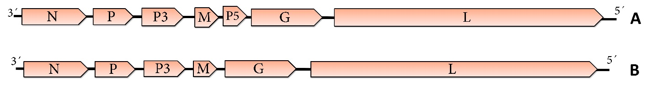
Figure 1. Genome diagrams depicting the architecture and gene products of the ten viruses proposed to be included as new species within the genus Deltanucleorhabdovirus. Abbreviations: N: nucleoprotein; P: phosphoprotein; P3: putative cell-to-cell movement protein; M: matrix protein; P5: protein 5; G: glycoprotein; L: RNA-dependent RNA polymerase. A: LabDNRV1 B: ArtDNRV1, ChrDNRV1, GeuDNRV1, LamDNRV1, MenDNRV1, ThyDNRV1, TolDNRV1, TomDNRV1 and VacDNRV1. Acronyms of each virus are described in the proposal justification.

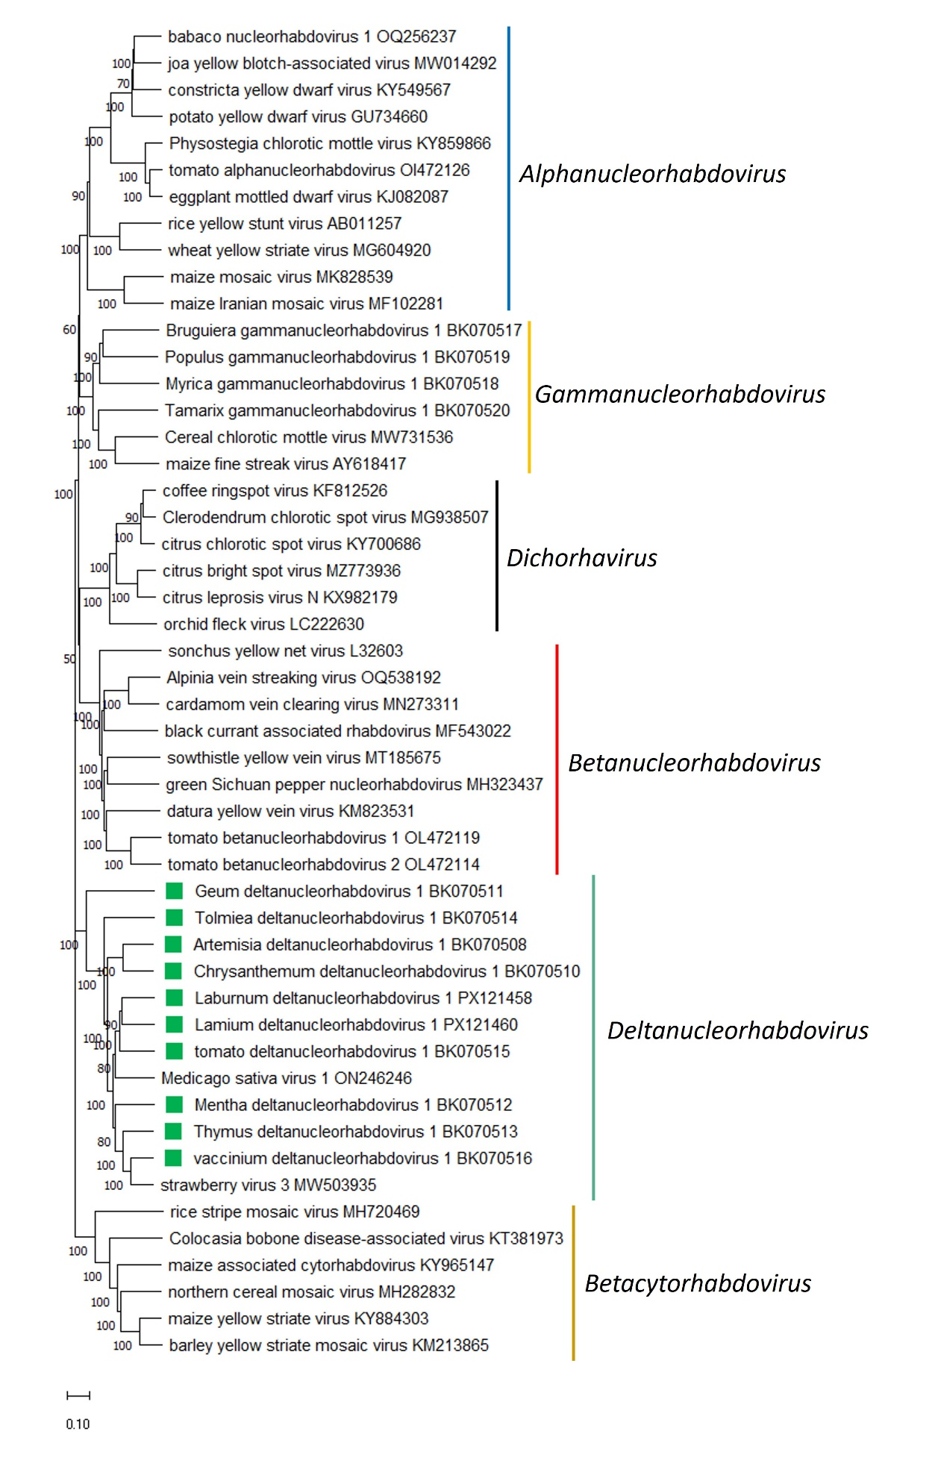

Figure 2. Maximum Likelihood (ML) phylogenetic tree of plant-infecting rhabdovirid L polymerase protein sequences. Amino acid sequences were aligned using MUSCLE. The resulting alignment was used to generate a phylogenetic tree using Mega11 with the best-fit model LG + G + I +F. Ten viruses potentially belonging to the new species are indicated with green squares. Numbers at the nodes indicate bootstrap support (1000 replicates).

