

The International Committee on Taxonomy of Viruses
Taxonomy Proposal Form, 2026

Part 1a: Details of taxonomy proposals

Title: | Create three new species in the genus Trirhavirus, subfamily Betarhabdovirinae (Mononegavirales: Rhabdoviridae)
Code assigned: | 2026.022P.N.v1.Rhabdoviridae_Trirhavirus_3nsp

Author(s), affiliation and email address(es):
Given name (+middle initial(s)) | Surname | Affiliation | Email address | Corr. author(s)
Nicolas | Bejerman | UFyMA INTA-CONICET, Argentina | bejerman.nicolas@inta.gob.ar | X
Humberto | Debat | UFyMA INTA-CONICET, Argentina | debat.humberto@inta.gob.ar
Ralf G | Dietzgen | QAAFI, UQ, Australia | r.dietzgen@hotmail.com
Juliana | Freitas-Astua | EMBRAPA Mandioca e Fruticultura, Brazil | juliana.astua@embrapa.br
Hideki | Kondo | Okayama University, Japan | hkondo@rib.okayama-u.ac.jp
Pedro Luis | Ramos-Gonzalez | Instituto Biológico de São Paulo, Brazil | pedro.gonzalez@sp.gov.br
Anna E | Whitfield | NC State University, USA | awhitfi@ncsu.edu
Peter J | Walker | School of Chemistry and Molecular Biosciences, The University of Queensland, St Lucia, Australia | peter.walker@uq.edu.au

Part 1b: Taxonomy Proposal Submission
ICTV Subcommittee:
Animal DNA Viruses and Retroviruses |  | Bacterial viruses
Animal minus-strand and dsRNA viruses |  | Fungal and protist viruses
Animal positive-strand RNA viruses |  | Plant viruses | X
Archaeal viruses |  | General

List the ICTV Study Group(s) that have seen or have been involved in creating this proposal:
Rhabdoviridae study group

Optional – complete only if formally voted on by an ICTV Study Group:
Study Group | Number of members
Study Group | Votes in support | Votes against | No vote
Rhabdoviridae | 12 |  | 2

Submission date: | 12/08/2026

Part 1c: Feedback from ICTV Executive Committee (EC) meeting
Executive Committee Meeting Decision code: | X
A – Accept
Ac – Accept subject to revision by relevant subcommittee chair. No further vote required
U – Accept without revision but with re-evaluation and email vote by the EC
Uc – Accept subject to revision and re-evaluation and email vote by the EC
Ud – Deferred to the next EC meeting, with an invitation to revise based on EC comments
J - Reject
W - Withdrawn

Comments from the Executive Committee:

Part 1d: Revised Taxonomy Proposal Submission
Response of proposer:
Revision date:

Part 3: TAXONOMIC PROPOSAL

Taxonomic changes proposed:
Establish new taxon | X | Split taxon
Abolish taxon |  | Merge taxon
Move taxon |  | Promote taxon
Rename taxon |  | Demote taxon
Move and rename

Etymology (origin) of proposed taxonomic names:
Taxon name | Etymology of the term
“Trirhavirus chenopodii” | From Chenopodium, the scientific name of the plant host genus from which the sequence of the virus was obtained.
“Trirhavirus lycii” | From Lycium, the scientific name of the plant host genus from which the sequence of the virus was obtained.
“Trirhavirus humuli” | From Humulus, the scientific name of the plant host genus from which the sequence of the virus was obtained.

Permission for use of names derived from a living person:
Taxon name | Full name of person from whom the name is derived | Attached X

Abstract of Taxonomy Proposal:

Description of current taxonomy:
Six virus species are currently classified in the recently created genus Trirhavirus, whose main feature is the tri-segmented genomic organization of its members. The assignment of viruses to this genus is based on their genome composition, and the placement of the viruses on a Maximum Likelihood tree inferred from complete L protein sequences.

Proposed taxonomic change(s):
Create three new species in the genus Trirhavirus, subfamily Betarhabdovirinae, family Rhabdoviridae. These species are proposed to be named “Trirhavirus chenopodii”, “Trirhavirus lycii” and “Trirhavirus humuli”.

Demarcation criteria for new taxa:
Viruses assigned to different species within the genus Trirhavirus should have several of the following characteristics:
- nucleotide sequence identity lower than 80% for the L ORF
- nucleotide sequence identity lower than 80% in RNA2
- nucleotide sequence identity lower than 80% in RNA 3
- occupy different ecological niches as evidenced by differences in hosts

Justification:
Three new rhabdoviruses were identified in Chenopodium album [1], goji (Lycium barbarum L.) [2] and Humulus scandens [3]. The characterization of these three viruses showed that they should be classified into new species within the genus Trirhavirus based on the nucleotide sequence divergence from previously reported trirhaviruses and phylogenetic placement.

Text of Taxonomy proposal:
Description of current taxonomy:
Six virus species are currently classified in the recently created genus Trirhavirus, whose main feature is the tri-segmented genomic organization of its members. The assignment of viruses to this genus is based on their genome composition, and the placement of the viruses on a Maximum Likelihood tree inferred from complete L protein sequences.

Proposed taxonomic change(s):
Create three new species in the genus Trirhavirus, subfamily Betarhabdovirinae, family Rhabdoviridae.

Demarcation criteria for new taxon/taxa:
Viruses assigned to different species within the genus Trirhavirus should have several of the following characteristics:
- nucleotide sequence identity lower than 80% for the L ORF
- nucleotide sequence identity lower than 80% in RNA2
- nucleotide sequence identity lower than 80% in RNA 3
- occupy different ecological niches as evidenced by differences in hosts

Justification:
Three new rhabdovirids were identified in Chenopodium album [1], goji (Lycium barbarum L.) [2] and Humulus scandens [3]. The characterization of these three viruses showed that they should be classified into new species within the genus Trirhavirus based on the nucleotide sequence divergence from previously reported trirhaviruses and phylogenetic placement (see below).

- Chenopodium trirhavirus 1 (CheTRV1) was identified from lambsquarters (Chenopodium album) samples collected in China. The complete genome (CG) of CheTRV1 is tri-segmented, with an RNA1 of 6,749 nucleotides (nt), RNA2 of 4,393 nt and RNA3 of 3,897 nt (PQ653982; PQ653983 and PQ653984, respectively) [1]. RNA1 contains one large open reading frame (ORF) encoding the L polymerase protein, while RNA2 has four ORFs and RNA3 contains three ORFs (Figure 1). The nt sequence of CheTRV1 L gene has the highest identity values with that of goji trirhavirus 1 (GoTRV1 65.3%); while the CheTRV1 RNA2 and RNA3 have the highest nt identity values with those of GoTRV1 with 49.7% and 47.5%, respectively. Based on ML trees generated from complete L protein sequences, CheTRV1 is placed within a subclade of trirhaviruses with Medicago trirhavirus 1 (Figure 2).
- goji trirhavirus 1 (GoTRV1) was identified from goji (Lycium barbarum) samples collected in China. The complete genome (CG) of GoTRV1 is tri-segmented, with an RNA1 of 6,533 nucleotides (nt), RNA2 of 4,247 nt and RNA3 of 3,729 nt (PZ138261; PZ138262 and PZ138263, respectively) [2]. RNA1 contains one large open reading frame (ORF) encoding the L polymerase protein, while RNA2 has four ORFs and RNA 3 contains three ORFs (Figure 1). The nt sequence of GoTRV1 L gene has the highest identity values with that of Chenopodium trirhavirus 1 (CheTRV1 65.3%); while the GoTRV1 RNA2 and RNA3 have the highest nt identity values with those of CheTRV1 with 49.7% and 47.5%, respectively. Based on ML trees generated from complete L protein sequences, GoTRV1 is placed within a subclade of trirhaviruses with CheTRV1 (Figure 2).
- Humulus trirhavirus 1 (HuTRV1) was identified from Japanese hop (Humulus scandens) samples collected in China. the complete genome (CG) of HuTRV1 is tri-segmented, with an RNA1 of 6,674 nucleotides (nt), RNA2 of 4,417 nt and RNA3 of 4,094 nt (PP824665; PP824666 and PP824667, respectively) [3]. RNA1 contains one large open reading frame (ORF) encoding the L polymerase protein, while RNA2 has four ORFs and RNA 3 contains three ORFs (Figure 1). The nt sequence of HuTRV1 L gene has the highest identity values with that of Chenopodium trirhavirus 1 (CheTRV1 58.6%); while the HuTRV1 RNA2 and RNA3 have the highest nt identity values with those of CheTRV1 with 47.4% and 44.5%, respectively. Based on ML trees generated from complete L protein sequences, HuTRV1 forms a well-supported clade with other trirhaviruses (Figure 2).

CheTRV1, GoTRV1 and HuTRV1 meet the demarcation criteria A, B, C and D. Thus, we propose to classify CheTRV1, GoTRV1 and HuTRV1 into the new species “Trirhavirus chenopodii”, “Trirhavirus lycii” and “Trirhavirus humuli”, subfamily Betarhabdovirinae, family Rhabdoviridae.
References:
[1] Qin X, Guo Z, Nie Z, Yang Y, Zhang R, et al. (2025). Characterization of chenopodium trirhavirus 1, a novel tri-segmented virus of the family Rhabdoviridae. Arch Virol 170:151. PMID: 40483329. DOI: 10.1007/s00705-025-06344-z.
[2] Fan X, Qin K, Gao Y, Fan Y, Dong Y (2026). Identification and complete genome sequence of goji trirhavirus 1, a novel tri-segmented virus of the family Rhabdoviridae discovered in Goji (Lycium barbarum L.). Arch Virol 171:186. PMID: 42168380 DOI: 10.1007/s00705-026-06649-7.
[3] Wang J, Li Y, Zhang Y, Zhang S, Cao M, Yang C. (2026). Identification and characterization of a putative novel tri-segmented rhabdovirus infecting Humulus scandens. Arch Virol 171:152. PMID: 41944889 DOI: 10.1007/s00705-026-06621-5.

Accompanying files:

Filename | Description of contents

Tables, Figures:

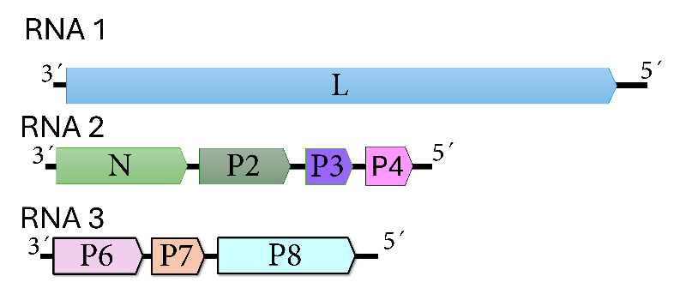
Figure 1. Genome graphs depicting gene products of the viruses (Chenopodium trirhavirus 1, goji trirhavirus 1 and Humulus trirhavirus 1 ) to be included as new species within the genus Trirhavirus. Abbreviations: N: nucleoprotein; L: RNA-dependent RNA polymerase; P2: protein 2; P3: protein 3; P4: protein 4; P6: protein 6; P7: protein 7; P8: protein 8.

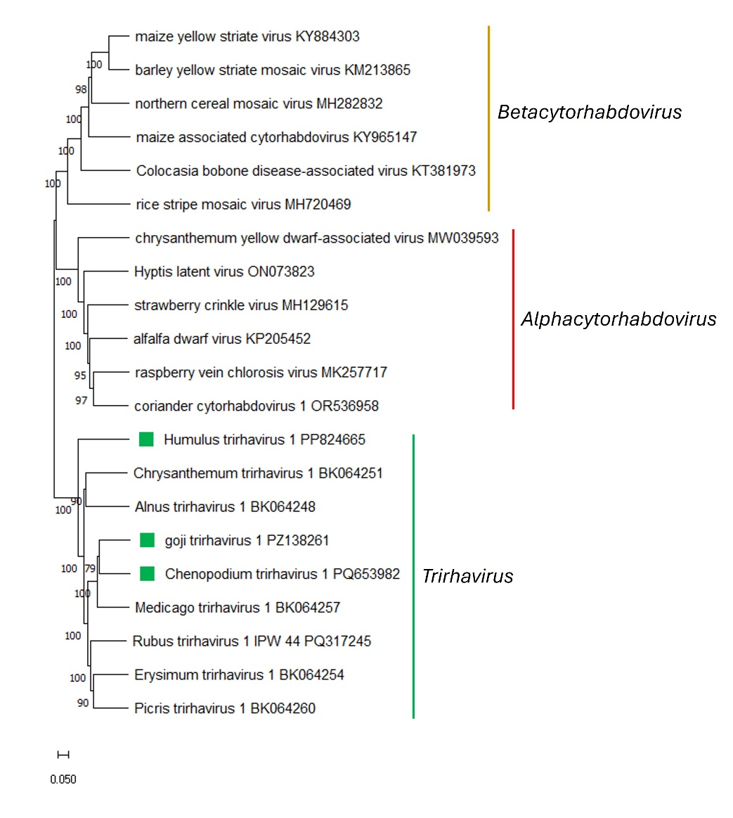
Figure 2. Maximum Likelihood (ML) phylogenetic tree of plant-infecting rhabdovirid L polymerase protein sequences. Amino acid sequences were aligned using MUSCLE. The resulting alignment was used to generate a phylogenetic tree using Mega11 with the best-fit model LG + G + I +F. The viruses (Chenopodium trirhavirus 1, goji trirhavirus 1 and Humulus trirhavirus 1)proposed to be included as new trirhavirus members are indicated with green squares. Numbers at the nodes indicate bootstrap support (1000 replicates).

