

The International Committee on Taxonomy of Viruses
Taxonomy Proposal Form, 2026

Part 1a: Details of taxonomy proposals

Title: | Create three new species and rename one species in the genus Varicosavirus, subfamily Betarhabdovirinae (Mononegavirales: Rhabdoviridae)
Code assigned: | 2026.023P.N.v1.Rhabdoviridae_Varicosavirus_3nsp

Author(s), affiliation and email address(es):
Given name (+middle initial(s)) | Surname | Affiliation | Email address | Corr. author(s)
Nicolas | Bejerman | UFyMA INTA-CONICET, Argentina | bejerman.nicolas@inta.gob.ar | X
Humberto | Debat | UFyMA INTA-CONICET, Argentina | debat.humberto@inta.gob.ar
Ralf G | Dietzgen | QAAFI, UQ, Australia | r.dietzgen@hotmail.com
Juliana | Freitas-Astua | EMBRAPA Mandioca e Fruticultura, Brazil | juliana.astua@embrapa.br
Hideki | Kondo | Okayama University, Japan | hkondo@rib.okayama-u.ac.jp
Pedro Luis | Ramos-Gonzalez | Instituto Biológico de São Paulo, Brazil | pedro.gonzalez@sp.gov.br
Anna E | Whitfield | NC State University, USA | awhitfi@ncsu.edu
Peter J | Walker | School of Chemistry and Molecular Biosciences, The University of Queensland, St Lucia, Australia | peter.walker@uq.edu.au

Part 1b: Taxonomy Proposal Submission
ICTV Subcommittee:
Animal DNA Viruses and Retroviruses |  | Bacterial viruses
Animal minus-strand and dsRNA viruses |  | Fungal and protist viruses
Animal positive-strand RNA viruses |  | Plant viruses | X
Archaeal viruses |  | General

List the ICTV Study Group(s) that have seen or have been involved in creating this proposal:
Rhabdoviridae study group

Optional – complete only if formally voted on by an ICTV Study Group:
Study Group | Number of members
Study Group | Votes in support | Votes against | No vote
Rhabdoviridae | 12 |  | 2

Submission date: | 12/08/2026

Part 1c: Feedback from ICTV Executive Committee (EC) meeting
Executive Committee Meeting Decision code: | X
A – Accept
Ac – Accept subject to revision by relevant subcommittee chair. No further vote required
U – Accept without revision but with re-evaluation and email vote by the EC
Uc – Accept subject to revision and re-evaluation and email vote by the EC
Ud – Deferred to the next EC meeting, with an invitation to revise based on EC comments
J - Reject
W - Withdrawn

Comments from the Executive Committee:

Part 1d: Revised Taxonomy Proposal Submission
Response of proposer:
Revision date:

Part 3: TAXONOMIC PROPOSAL

Taxonomic changes proposed:
Establish new taxon | X | Split taxon
Abolish taxon |  | Merge taxon
Move taxon |  | Promote taxon
Rename taxon | X | Demote taxon
Move and rename

Etymology (origin) of proposed taxonomic names:
Taxon name | Etymology of the term
“Varicosavirus betaartemisiae” | From Artemisia, the scientific name of the plant host genus from which the sequence of the virus was obtained, and from the second letter of the Greek alphabet.
“Varicosavirus betae” | From Beta, the scientific name of the plant host genus from which the sequence of the virus was obtained.
“Varicosavirus cucurbitae” | From Cucurbita, the scientific name of the plant host genus from which the sequence of the virus was obtained.

Permission for use of names derived from a living person:
Taxon name | Full name of person from whom the name is derived | Attached X

Abstract of Taxonomy Proposal:

Description of current taxonomy:
Viruses classified into species in the genus Varicosavirus have bi-segmented genomes and infect a wide range of plants. The genus is currently comprised of 46 species. The assignment of viruses to this genus is based on the placement of the viruses on Maximum Likelihood trees inferred from complete L protein sequences.

Proposed taxonomic change(s):
Create three new species and rename one existing species in the genus Varicosavirus, subfamily Betarhabdovirinae, family Rhabdoviridae. These species are proposed to be named “Varicosavirus betaartemisiae”, “Varicosavirus betae” and “Varicosavirus cucurbitae”. The species Varicosavirus artemisiae is proposed to be renamed “Varicosavirus alphaartemisiae”.

Demarcation criteria for new taxon/taxa:
Viruses assigned to different species within the genus Varicosavirus should have several of the following characteristics:
- nucleotide sequence identity lower than 80% for the L ORF
- nucleotide sequence identity lower than 80% in RNA2
C) occupy different ecological niches as evidenced by differences in hosts

Justification:
Three new rhabdoviruses were identified in Artemisia vulgaris [1], sugar beet [Wintermantel and Hladky, unpublished (OR397269; OR397270)], and zucchini [2]. The characterization of these three viruses showed that they should be classified into new species within the genus Varicosavirus based on the nucleotide sequence divergence from previously reported varicosaviruses and phylogenetic placement.

Text of Taxonomy proposal:
Description of current taxonomy:
Viruses classified into species in the genus Varicosavirus have bi-segmented genomes and infect a wide range of plants. The assignment of viruses to this genus is based on the placement of the viruses on Maximum Likelihood trees inferred from complete L protein sequences.

Proposed taxonomic change(s):
Create three new species in the genus Varicosavirus, subfamily Betarhabdovirinae, family Rhabdoviridae. Rename Varicosavirus artemisiae as “Varicosavirus alphaartemisiae”.

Demarcation criteria for new taxon/taxa:
Viruses assigned to different species within the genus Varicosavirus should have several of the following characteristics:
A) nucleotide sequence identity lower than 80% for the L ORF
B) nucleotide sequence identity lower than 80% in RNA2
C) occupy different ecological niches as evidenced by differences in hosts

Justification:
Three new rhabdoviruses were identified in Artemisia vulgaris [1], sugar beet [Wintermantel and Hladky, unpublished (OR397269; OR397270)], and zucchini [2]. The characterization of these three viruses showed that they should be classified into new species within the genus Varicosavirus, based on the nucleotide sequence divergence from previously reported varicosaviruses and phylogenetic placement (see below).

- Artemisia varicosavirus 2 (ArtVV2) was identified from common mugwort (Artemisia vulgaris) samples collected in the Netherlands. The coding-complete genomes (CCG) of ArtVV2 is bi-segmented, with an RNA1 of 6,611 nucleotides and RNA2 of 5,777 nucleotides (PX121439 and PX121440) [1]. RNA1 contains one large ORF for the L polymerase protein, while RNA2 contains five ORFs (Figure 1). The nucleotide sequence of ArtVV2 L protein has the highest identity value with that of Xinjiang varicosavirus (XVV; 62.4 %), while the ArtVV2 RNA2 has the highest nt identity value with that of XVV with 54% [1]. Based on ML trees generated from complete L protein sequences, ArtVV2 is placed within a subclade of varicosaviruses with XVV and lettuce big-vein associated virus (Figure 2).
- beet oak leaf virus (BOLV) was identified from sugar beet (Beta vulgaris) samples collected in California, USA. The complete genome (CG) of BOLV is bi-segmented, with an RNA1 of 6,475 nucleotides and RNA2 of 5,666 nucleotides (OR397269 and OR397270) [Wintermantel and Hladky, unpublished]. RNA1 contains one large ORF for the L polymerase protein, while RNA2 contains five ORFs (Figure 1). The nucleotide sequence of BOLV L protein has the highest identity value with that of cucurbit yellow vein associated virus (CYVaV; 65.1 %), while the BOLV RNA2 has the highest nt identity value with that of CYVaV with 51.8%. Based on ML trees generated from complete L protein sequences, BOLV is placed within a subclade of varicosaviruses with CYVaV (Figure 2).
- cucurbit yellow vein associated virus (CYVaV) was identified from zucchini (Cucurbita pepo) samples collected in Greece. The complete genome (CG) of CYVaV bi-segmented, with an RNA1 of 6,498 nucleotides and RNA2 of 6,243 nucleotides (PX068890 and PX068891) [2]. RNA1 contains one large ORF for the L polymerase protein, while RNA2 contains six ORFs (Figure 1). The nucleotide sequence of CYVaV L protein has the highest identity value with that of beet oak leaf virus (BOLV; 65.1 %), while the CYVaV RNA2 has the highest nt identity value with that of BOLV, with 51.8%. Based on ML trees generated from complete L protein sequences, CYVaV is placed within a subclade of varicosaviruses with BOLV (Figure 2).

ArtVV2, BOLV and CYVaV meet the demarcation criteria A, B and C. Thus, we propose to classify ArtVV2, BOLV and CYVaV into the new species “Varicosavirus betaartemisiae”, “Varicosavirus betae” and “Varicosavirus cucurbitae”, subfamily Betarhabdovirinae, family Rhabdoviridae.

Moreover, species Varicosavirus artemisiae was renamed as “Varicosavirus alphaartemisiae”, because a second varicosavirus was discovered in Artemisia.
References:
[1] Botermans M, de Koning P, Westenberg M, Adams I, Ben Mansour K, et al. (2026). Expanding insights into plant rhabdovirus diversity through the discovery of viruses representing 32 putative novel species. Arch Virol 171:156. PMID: 41951987. DOI: 10.1007/s00705-026-06609-1.
[2] Orfanidou C, Palla E, Georgousi M, Aristeidou E, Tziros G, et al. (2026). High-Throughput Sequencing Analysis Reveals a Novel Varicosavirus Associated With Vein Yellowing Disease in Cucurbita pepo. Plant Pathol 75:e70248. https://doi.org/10.1111/ppa.70248

Accompanying files:

Filename | Description of contents

Tables, Figures:

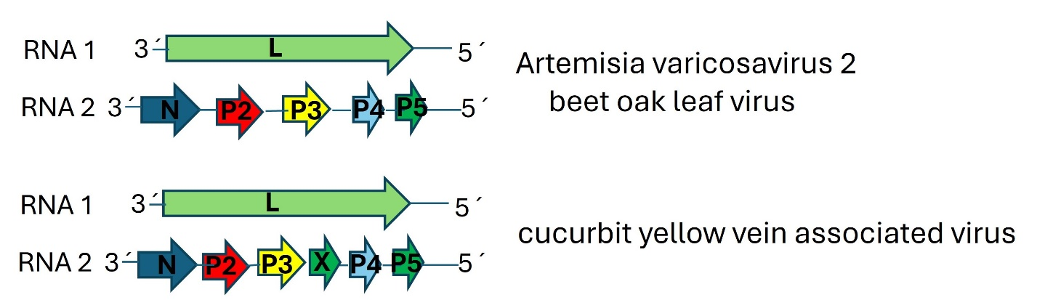

Figure 1. Genome graphs depicting the architecture and gene products of viruses proposed to be included as new species in the genus Varicosavirus. Abbreviations: N: nucleoprotein; P2: protein 2; P3: protein 3; X: Protein X; P4: protein 4; P5: protein 5; L: RNA-dependent RNA polymerase.

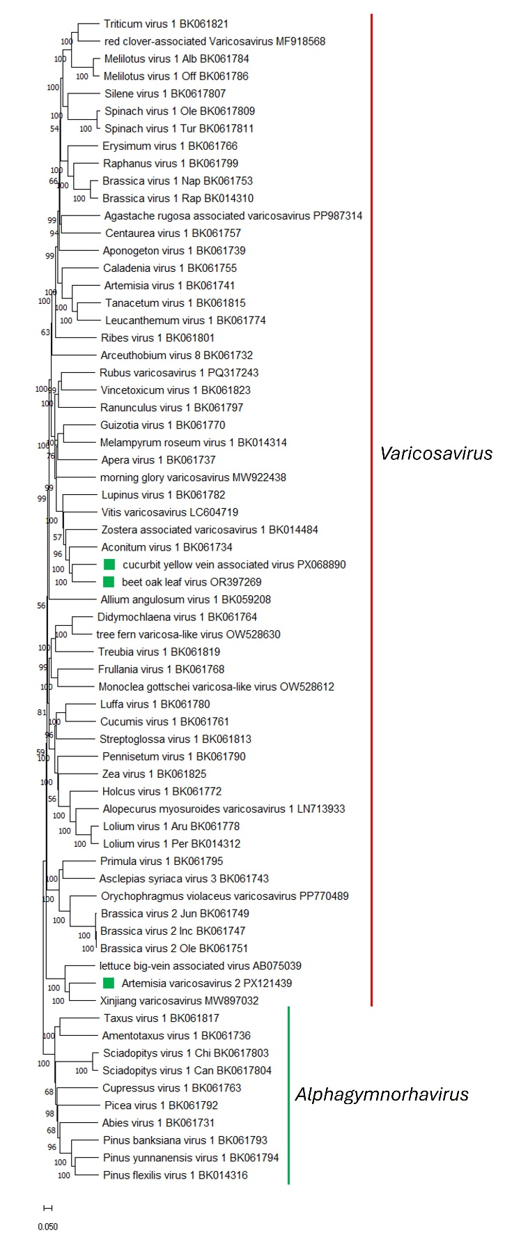
Figure 2. Maximum Likelihood (ML) phylogenetic tree of plant-infecting rhabdovirid L polymerase protein sequences. Amino acid sequences were aligned using MUSCLE. The resulting alignment was used to generate a phylogenetic tree using Mega11 with the best-fit model LG + G + I +F. The viruses potentially belonging to the new species are indicated with green squares. Numbers at the nodes indicate bootstrap support (1000 replicates).

