

The International Committee on Taxonomy of Viruses
Taxonomy Proposal Form, 2026

Part 1a: Details of taxonomy proposals

Title: | Create two new species in the family Pospiviroidae
Code assigned: | 2026.027P.N.v1.Pospiviroidae_2nsp

Author(s), affiliation and email address(es):
Given name (+middle initial(s)) | Surname | Affiliation | Email address | Corr. author(s)
Francesco | Di Serio | Istituto per la Protezione Sostenibile delle Piante,  Consiglio Nazionale delle Ricerche, Torino, Italy | francesco.diserio@cnr.it | X
Michela | Chiumenti | Istituto per la Protezione Sostenibile delle Piante  Consiglio Nazionale delle Ricerche, Bari, Italy | michela.chiumenti@cnr.it
Shi-Fang | Li | Center for Biosafety  Chinese Academy of Inspection and Quarantine  Yazhou, Sanya, China | lishifang@caas.cn
Beatriz | Navarro | Istituto per la Protezione Sostenibile delle Piante,  Consiglio Nazionale delle Ricerche, Bari, Italy | beatriz.navarro@cnr.it
Vicente | Pallás | Instituto de Biología Molecular y Celular de Plantas, Universidad Politécnica de Valencia-Consejo Superior de Investigaciones Científicas, Valencia, Spain | vpallas@ibmcp.upv.es
John W. | Randles | School of Agriculture, Food and Wine, The University of Adelaide, Australia | john.randles@adelaide.edu.au
Teruo | Sano | Faculty of Agriculture and Life Science, Hirosaki University,  Hirosaki, Japan | sano@hirosaki-u.ac.jp
Dijana | Škorić | Department of Biology,  Faculty of Science,  University of Zagreb, Zagreb, Croatia | dijana.skoric@biol.pmf.unizg.hr
Georgios | Vidalakis | Department of Microbiology and Plant Pathology  University of California, Riverside, U.S.A. | vidalg@ucr.edu
Robert A. | Owens | Molecular Plant Pathology Laboratory, U.S. Department of Agriculture, Beltsville, USA  (retired) | owensj301@hotmail.com

Part 1b: Taxonomy Proposal Submission
ICTV Subcommittee:
Animal DNA Viruses and Retroviruses |  | Bacterial viruses
Animal minus-strand and dsRNA viruses |  | Fungal and protist viruses
Animal positive-strand RNA viruses |  | Plant viruses | X
Archaeal viruses |  | General

List the ICTV Study Group(s) that have seen or have been involved in creating this proposal:
Avsunviroidae and Pospiviroidae Study Group
Optional – complete only if formally voted on by an ICTV Study Group:
Study Group | Number of members
Study Group | Votes in support | Votes against | No vote

Submission date: | 03/09/2026

Part 1c: Feedback from ICTV Executive Committee (EC) meeting
Executive Committee Meeting Decision code: | X
A – Accept
Ac – Accept subject to revision by relevant subcommittee chair. No further vote required
U – Accept without revision but with re-evaluation and email vote by the EC
Uc – Accept subject to revision and re-evaluation and email vote by the EC
Ud – Deferred to the next EC meeting, with an invitation to revise based on EC comments
J - Reject
W - Withdrawn

Comments from the Executive Committee:

Part 1d: Revised Taxonomy Proposal Submission
Response of proposer:
Revision date:

Part 3: TAXONOMIC PROPOSAL

Taxonomic changes proposed:
Establish new taxon | X | Split taxon
Abolish taxon |  | Merge taxon
Move taxon |  | Promote taxon
Rename taxon |  | Demote taxon
Move and rename

Etymology (origin) of proposed taxonomic names:
Taxon name | Etymology of the term
“Apscaviroid opuntiae” | Apscaviroid Identified for the first time in Opuntia sp.
“Pospiviroid opuntiae” | Pospiviroid Identified for the first time in Opuntia sp.

Permission for use of names derived from a living person:
Taxon name | Full name of person from whom the name is derived | Attached

Abstract of Taxonomy Proposal:
Description of current taxonomy: Currently, 40 viroid species are classified in the family Pospiviroidae. They are grouped into the following five genera: Apscaviroid (19 species), Cocadviroid (4 species), Coleiviroid (5 species), Hostuviroid (2 species), Pospiviroid(10 species). Two new viroids (Opuntia viroid 2, OVd2, and Mexican opuntia viroid, MOVd) have been reported to be potential members of two new species in the genera Apscaviroid and Pospiviroid, respectively.

Proposed taxonomic changes:
- To classify Opuntia viroid 2 as a member of the new species “Apscaviroid opuntiae” in the genus Apscaviroid, family Pospiviroidae.
- To classify Mexican opuntia viroid as a member of the new species “Pospiviroid opuntiae” in the genus Pospiviroid, family Pospiviroidae

Demarcation criteria for new taxa:
Current species demarcation criteria for viroids require that the highest pairwise identity score (PWIS) between the viroid under classification and all sequence variants assigned to a given genus be lower than the threshold identity score (TIS) established for that genus. Because sequence diversity varies among genera, TIS values are genus-specific.

Justification:
OVd2 and MOVd are new viroids fulfilling the ICTV criteria for classification as new viroid species in the genera Apscaviroid and Pospiviroid.

Text of Taxonomy proposal:
Description of current taxonomy:
Currently, 40 viroid species are classified in the family Pospiviroidae. They are grouped into the following five genera: Apscaviroid (19 species), Cocadviroid (4 species), Coleiviroid (5 species), Hostuviroid (2 species), Pospiviroid(10 species).

Viroids in the family Pospiviroidae are assigned to one of five genera based on the presence of characteristic structural features, including the central conserved region (CCR) and additional motifs such as the terminal conserved region (TCR) or the terminal conserved hairpin (TCH) [1]. Species demarcation within each genus is currently based primarily on a genus-specific threshold identity score (TIS). The classification process involves calculating a pairwise sequence identity score (PWIS) matrix using the candidate genomic sequences of the candidate viroid and all reported sequence variants of viroid species already assigned to the corresponding genus.

Proposed taxonomic change(s):
Opuntia viroid 2 (OVd2) and Mexican opuntia viroid (MOVd) [2] are two new viroids recently isolated from Opuntia spp. that display features typical of members of the genus Apscaviroid (OVd2) or Pospiviroid (MOVd), respectively. Indeed, OVd2 and MOVd contain the terminal conserved region (TCR) and the CCR conserved in members of the genus Apscaviroid and Pospiviroid, respectively. These viroids have been proposed to be members of two new species in these genera [2]. Here we show that indeed these viroids fulfil the species demarcation criteria established by ICTV and should be classified as representative members of two new species belonging to the genera Apscaviroid and Pospiviroid (family Pospiviroidae), respectively.

Demarcation criteria for new taxon/taxa:
The species demarcation criteria for the members of genera Apscaviroid and Pospiviroid of the family Pospiviroidae are the following:
- Genus Apscaviroid:
Viroids with rod-like or quasi rod-like conformation, with the TCR, a CCR identical to that of members of the other species of the genus and less than 78% pairwise sequence identity with respect to the members of the genus are classified in different species. For viroids with PWIS close to 78%, evidence of distinct biological properties should be provided.
- Genus Pospiviroid:
Viroids with a rod-like conformation, with the TCH, with the CCR identical to that of members of the other species of the genus and less than 83% pairwise sequence identity with respect to the other members of the genus, should be classified in different species. For viroids with PWIS close to 83%, evidence of distinct biological properties should be provided.

Justification:
OVd2 contains the TCR and the CCR shared by all the members of the genus Apscaviroid, therefore it can be classified as a member of this genus. The PWSI calculated using the Opuntia viroid 2 (PP579661) sequence and the reported sequences of all the other Apscaviroid species (1011 sequences), showed the highest sequence identity value of 58.6% with apple dimple fruit viroid (X99487; species Apscaviroid fossulamali). Because this value is below the TIS determined for the genus Apscaviroid (78%, Figure 1), OVd2 fulfills the criteria to be classified as a member of a new species in the genus Apscaviroid. The proposed name for this species is “Apscaviroid opuntiae”.

MOVd contains the TCR and the CCR shared by all the members of the genus Pospiviroid, therefore it fulfils the criteria to be classified as a member of this genus. The pairwise identity matrix calculated using the Mexican opuntia viroid sequence (PP579660) and the reported sequences of all the other pospiviroid species (945 sequences), showed the highest sequence identity value of 76.8% with Iresine viroid 1 (GU911350; species Pospiviroid alphairesinis). Because this value is below the TIS determined for the genus Pospiviroid (83%, Figure 2), MOVd fulfills the criteria to be classified as a member of a new species in the genus Pospiviroid. The proposed name for this species is “Pospiviroid opuntiae”.

The proposal is supported by phylogenetic analyses showing that OVd2 and MOVd cluster together with other members of the genera Apscaviroid and Pospiviroid, respectively (Figure 3).

References:
[1] Chiumenti M, Navarro B, Candresse T, Flores R, Di Serio F. . Reassessing species demarcation criteria in viroid taxonomy by pairwise identity matrices. Virus Evolution 2021; 7(1): veab001.
[2] Ortega-Acosta C, Ochoa-Martínez DL, Rodríguez-Leyva,E. . High-throughput sequencing reveals new viroid species in Opuntia in Mexico. Viruses 2024; 16(8): 1177.

Accompanying files:

Filename | Description of contents

Tables, Figures:

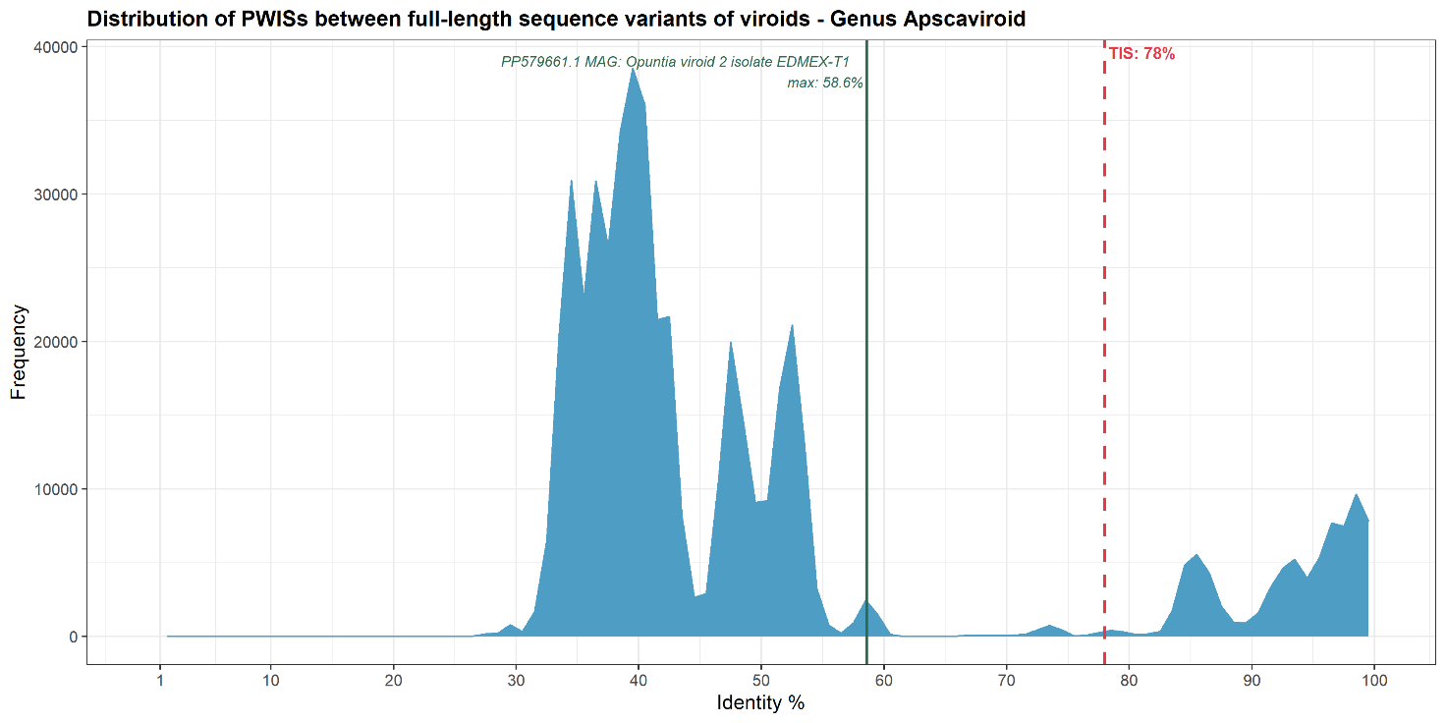
Figure 1. Distribution of PWISs between full-length sequences of members of the genus Apscaviroid, including Opuntia viroid 2. The highest PWIS between OVd2 and the other apscaviroid species variants, is with a sequence of apple fruit dimple viroid (58.6%, green vertical line), which is below the threshold identity score (TIS) determined for the genus Apscaviroid (78%) (red dashed line).

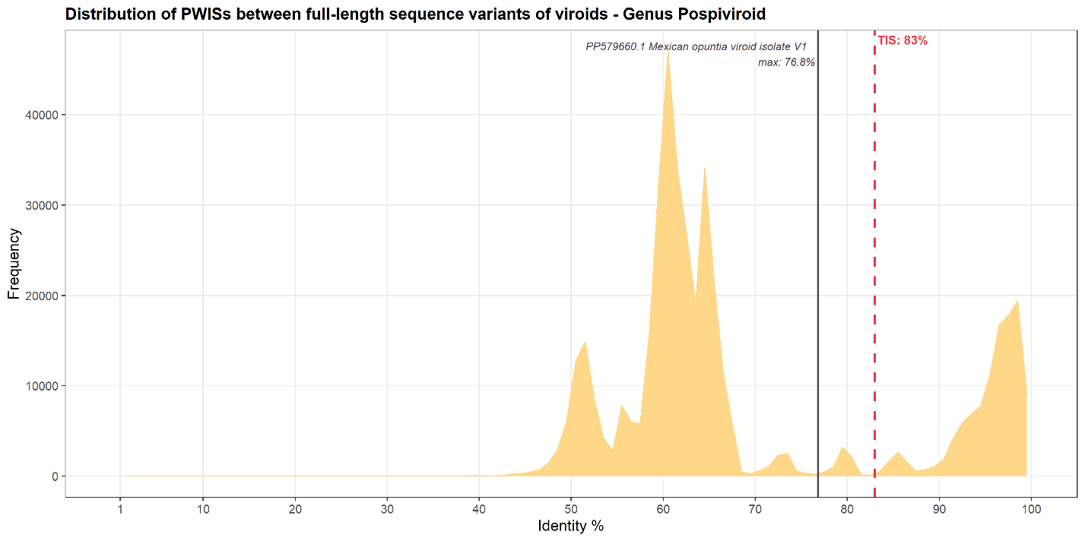
Figure 2. Distribution of PWISs between full-length sequences of members of the genus Pospiviroid, including Mexican opuntia viroid. The highest PWIS in the matrix is the one between MOVd and a sequence of Iresine viroid 1 (76.8%, brown vertical line), which is below the threshold identity score determined (TIS) for the genus Pospiviroid (83%) (red dashed line).

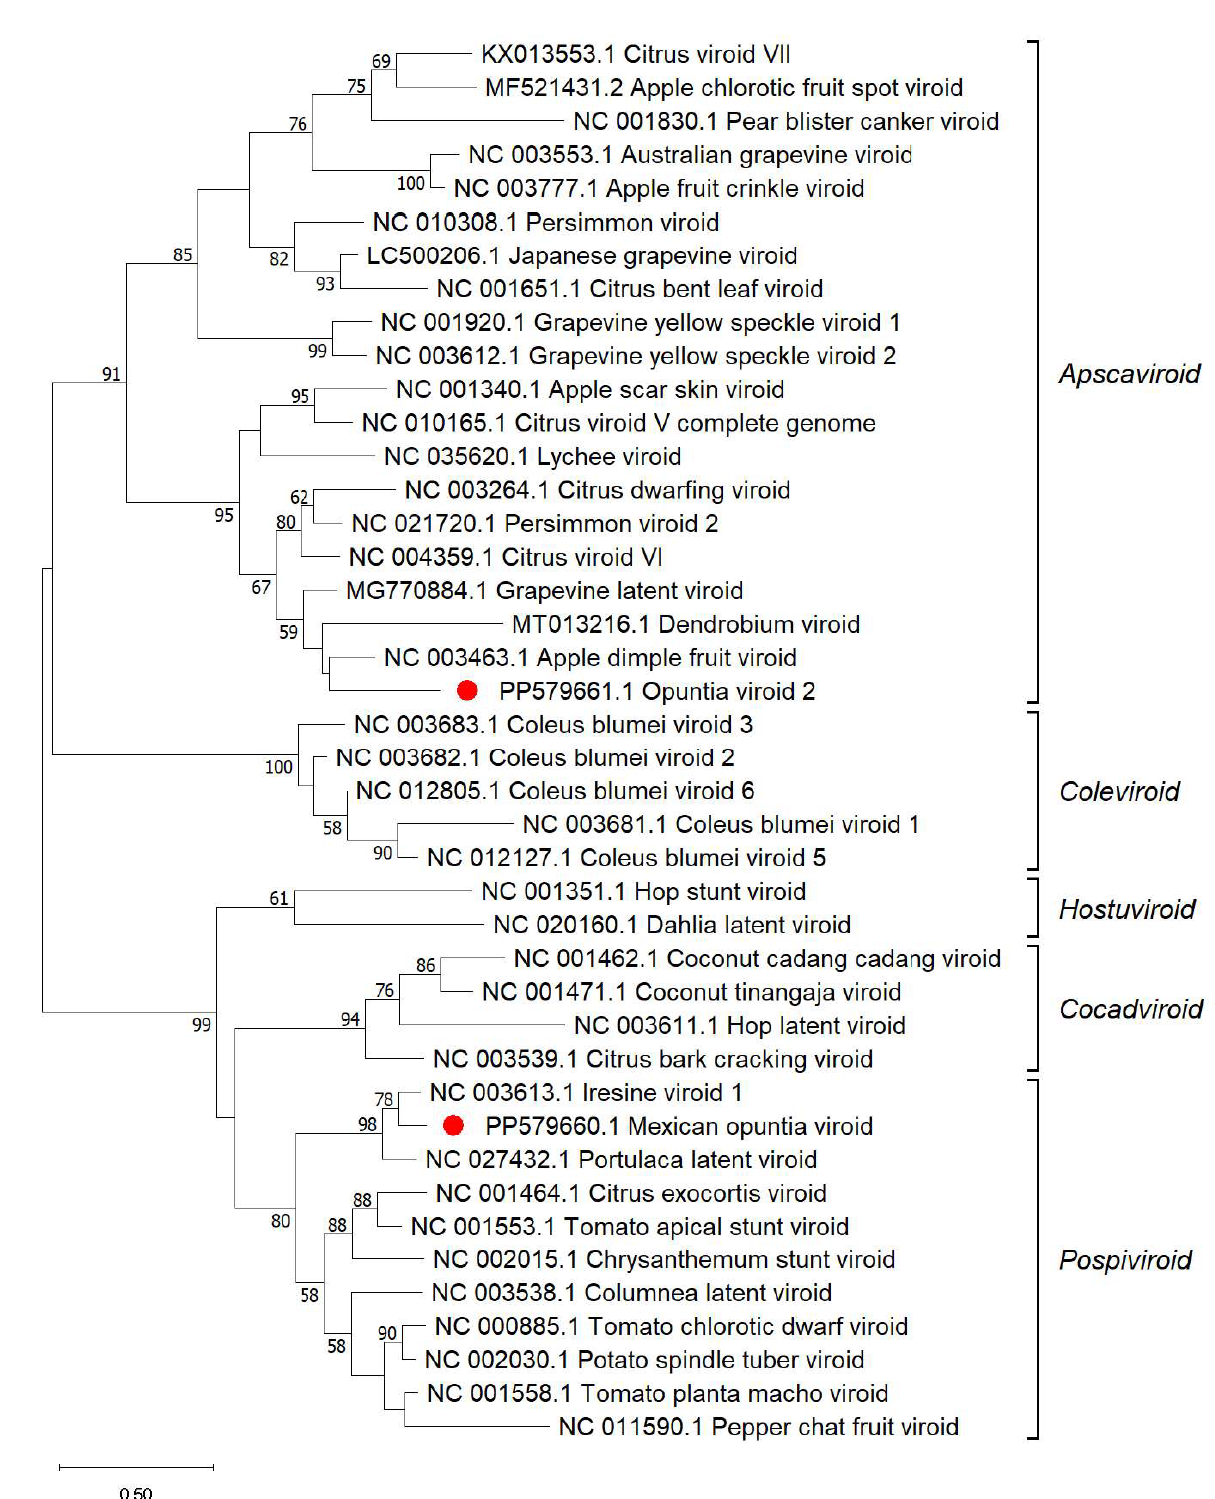
Figure 3. Maximum likelihood phylogenetic tree inferred with the reference sequences of the species currently classified in the five genera of the family Pospiviroidae and of the viroids that are not yet classified (red dots). Bootstrap values (generated by 1,000 replicates) are shown next to the nodes. The tree is drawn to scale, with the of the branches lengths proportional to the number of substitutions per site. Genera are reported on the left.

